Assessment task
Year level | 7
Learning area | Mathematics
Subject | Statistics and Probability
Title of task | Probability of a variety of events
Task details
Description of task | Students will construct sample spaces, interpret and determine probabilities for a variety of events. They will be assigning probabilities using simple fractions, decimals or percentages.
Type of assessment | Summative
Purpose of assessment | To inform moderation practices
Assessment strategy | Written
Evidence to be collected | Responses to tasks
Suggested time | 50 minutes
Content description
Content from the Western Australian Curriculum | Construct sample spaces for single-step experiments with equally likely outcomes  Assign probabilities to the outcomes of events and determine probabilities for events
Proficiencies | Understanding | Fluency | Problem solving | Reasoning
Task preparation
Prior learning | Students will have experience in observing and listing outcomes of chance experiments with equally likely outcomes and assigning probabilities between 0 and 1. They will have conducted experiments of chance that demonstrated the larger the number of trials the closer the percentage frequency calculated from the experiment is likely to be the real or theoretical probability.
Assessment task
Assessment conditions | This is an individual, in-class assessment
Resources | Blue, red and green colour pencils

Instructions for teacher

This assessment tasks involves students responding to a series of activities which require them to construct sample spaces and interpret the results of simple single step chance experiments. They will be describing probabilities using simple fractions, percentages or decimals. Throughout the tasks, students are required to explain decisions or conclusions.

During previous teaching it should be pointed out and modelled that explanations are not necessarily given only in words, but should incorporate diagrams, mathematical calculations and/or results, where appropriate. Such comprehensive explanations are a true sign of increasingly sophisticated performance.

Instructions to students
You are to complete the following activities, working on your own.

Student Booklet - Mathematics
Task title | Probability of a variety of events
Student name
School
Year level | 7
Date

Dice experiment

A probability experiment involves rolling a fair, 6-sided dice.
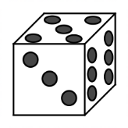

Is the probability of getting an even number more likely than throwing a number less than 5?
Construct a sample space as part of your answer. Use reasoning to explain your decision.

4 marks
Spinner experiment
A class uses this spinner to conduct an experiment.

(a) Out of 100 spins, how many times do you think the spinner will land on the shaded part? Use reasoning to explain why you think this?

(b) Suppose that you were to do 6 sets of 50 spins. Complete the table below to show what might happen for the number of times the spinner would land on the shaded part.

Set | 1 | 2 | 3 | 4 | 5 | 6
Number of times spinner lands on shaded part

4 marks

- A class did 50 spins of the spinner above many times, and the results for the number of times it landed on the shaded part are recorded below.

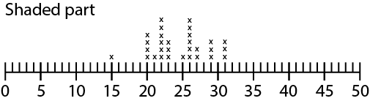
Three other classes produced graphs for the same spinner. In some cases, the results were just made up without actually doing the experiment.
Use the boxes next to each class graph to rank the graphs in order of ‘most likely data to be made up’ to ‘least most likely to be made up’ and give reasons for your answers.
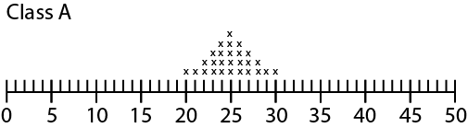

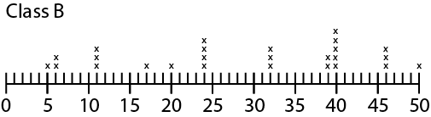

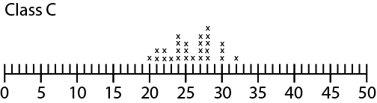

4 marks

Bubble gum machines
Look at the bubble gum machines below. There are white bubble gum balls and black bubble gum balls. No gum balls are hidden.
When the lever on the machine is pressed, the bubble gum balls are thoroughly mixed and one bubble gum drops out.

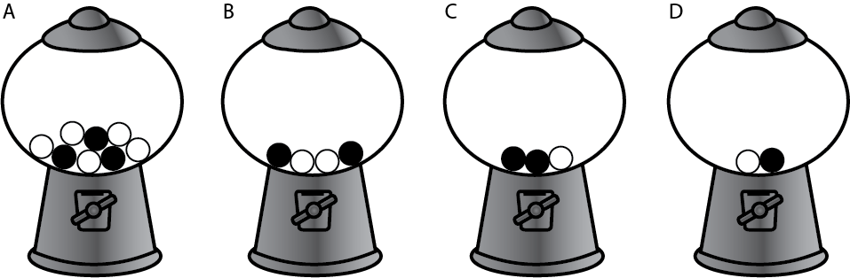

- Which machine/s would give the greatest chance of obtaining a black bubble gum when the lever is pressed? Explain why you think so.

- Which machine/s would give the least chance of obtaining a black bubble gum when the lever is pressed? Explain why you think so.

- Do any of the machines give the same chance of obtaining a black bubble gum ball when the lever is pressed? Explain why you think so.

6 marks
Discs in a bag
Some coloured discs are put in a bag and you select one without being able to see which one you are selecting.

- Colour the following diagram to show that you would be equally likely to get red, green or blue, but could not get any other colour. Use your diagram to determine the probability of selecting a red disc from the bag.
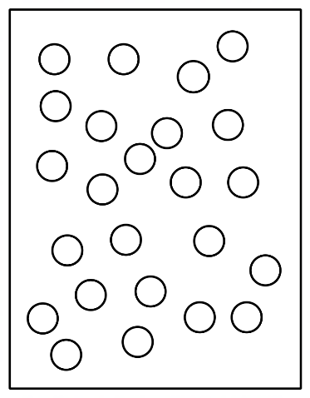
3 marks
2. Colour the following diagram to show that you would be more likely to get red than green, and more likely to get green than blue. Use your diagram to help calculate the probability of selecting a red disc from the bag.
4 marks
3. Colour the following diagram to show that you would be twice as likely to get red than blue, three times as likely to get blue than green, and impossible to get yellow. Explain what decisions you made to work out how many discs would be coloured in red, blue and green.

8 marks

Marking key
Description | Marks
Dice experiment
Shows all possible outcomes for throwing a dice (the sample space). | 1
Correctly determines the probability of one event. | 1
Correctly determines probabilities for both events. | 1
Correctly compares the probabilities to determine likelihood. | 1
Subtotal | 4
Description | Marks
Spinner experiment
Q1(a) Recognises that experiment involves equally like outcomes. | 1
Q1(a) Refers to correct equal fraction, decimal or percentage. | 1
Q1(b) Acknowledges some variation in the outcome for each set due to the size of the sample. | 1
Q1(b) Shows values to be both above and below 50. | 1
Q2 Identifies data from Class C as being from a real experiment. | 1
Refers to appropriate variation in Class C. | 1
Refers to data for class A showing a perfectly symmetrical triangular shape and therefore is made up. | 1
Refers to large spread of data for Class B and therefore made up. | 1
Subtotal | 8
Description | Marks
Bubble gum machines
Compares the number of black balls to white balls in two machines. | 1
Compares the number of black balls to white balls in all machines. | 1
Represents a proportion of black to white balls using fractions or percentages. | 1
Includes a reference to proportion in all explanations. | 1
Gives a clear and systematic explanation to arrive at a conclusion. | 1
Gives clear and systematic explanations to arrive at all conclusions. | 1
Subtotal | 6

Description | Marks
Discs in a bag
Q1 Shows the same number of discs for each colour. | 1
Colours 8 discs for each colour red, green and blue. | 1
Represents probability of red as 8/24 or 1/3 or equivalent fraction based on colouring of discs. | 1
Q2 Recognises the number of red must be more than green. | 1
Recognises the number of green must be more than blue. | 1
Shows that red is more than green and green is more than blue. | 1
Represents probability for an unequally likely outcome. | 1
Q3 Shows twice as many red discs as blue. | 1
Shows three times as many blue discs as green. | 1
Recognises that not all discs need to be coloured. | 1
Colours discs in ratio 6:3:1 | 1
Colours maximum number of discs (20) in ratio 6:3:1 | 1
Provides a mathematical explanation to arrive at number of discs for each colour. | 1-3
Subtotal | 15
Total | 31

