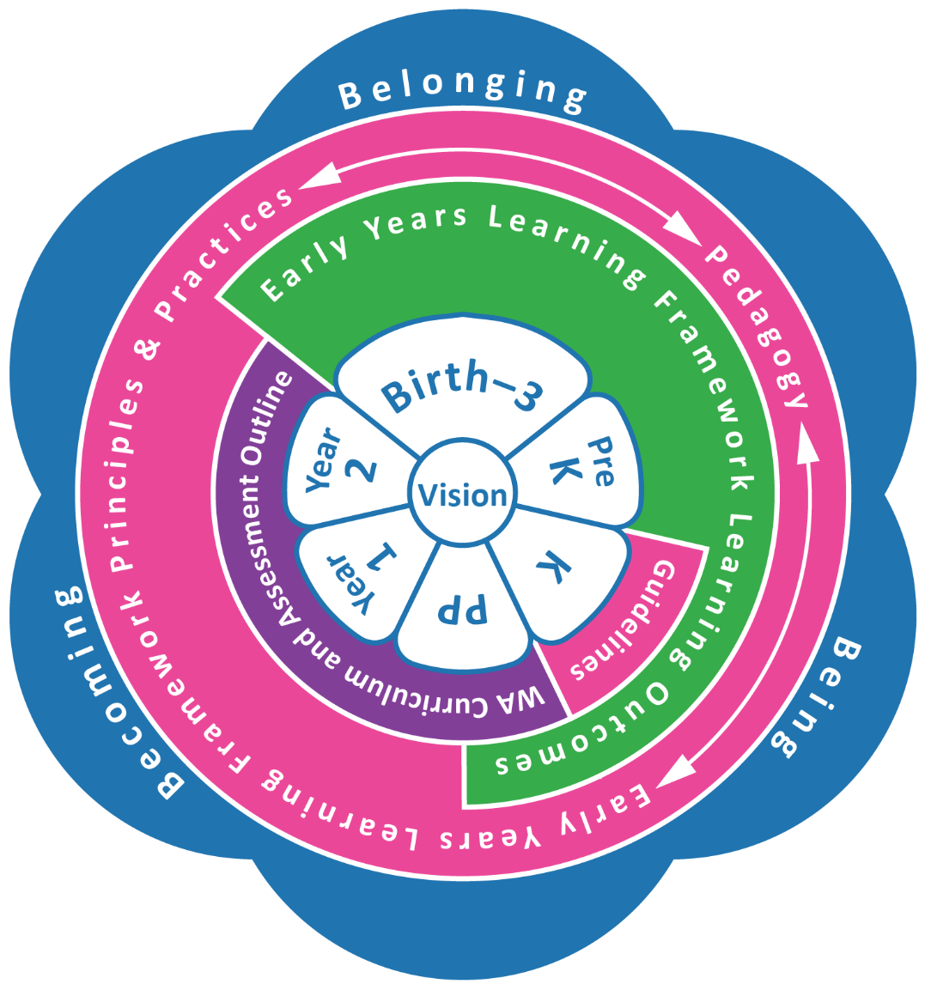
Early Years Learning Framework (EYLF) v2.0: Kindergarten–Year 2

A vision for young children’s learning
All children engage in learning that promotes confident individuals and successful lifelong learners.
All children are active and informed members of their communities with knowledge of Aboriginal and Torres Strait Islander perspectives.

EYLF Principles
The following eight Principles reflect contemporary theories, perspectives and research evidence concerning children’s learning and effective early childhood pedagogy. The Early Years Learning Framework (EYLF) v2.0 Principles underpin the Practices focused on assisting all children to achieve positive learning outcomes as outlined in the Kindergarten Curriculum Guidelines. Educators consider ethical, socially just and inclusive principles when they:
- build secure, respectful and reciprocal relationships
- develop partnerships
- are respectful of diversity
- embed Aboriginal and Torres Strait Islander perspectives
- commit to equity, inclusion and high expectations
- consider sustainability in all its forms
- engage in critical reflection and professional learning
- exercise collaborative leadership and work as a team.

Figure 1: EYLF, Kindergarten Curriculum Guidelines and the Western Australian curriculum.
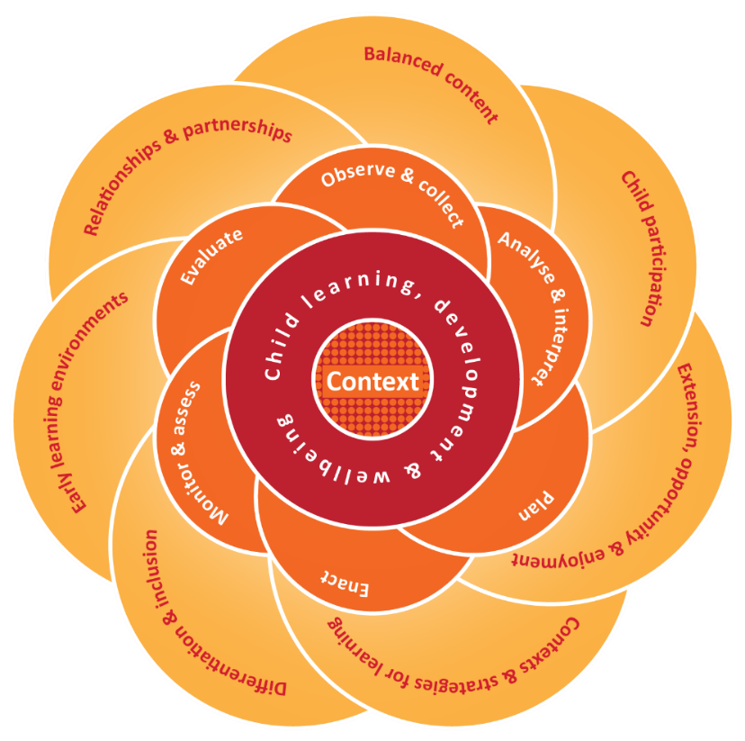

EYLF Practices
The principles of evidence-based early childhood pedagogy underpin practice. Educators draw on a rich repertoire of pedagogical practices to promote children’s learning, borrowing from relational, place-based and play-based pedagogical approaches. These Practices inform curriculum for children’s learning, development and wellbeing by:
- adopting holistic approaches
- being responsive to children
- planning and implementing play-based learning with intentionality
- creating physical, temporal, intellectual, social and emotional environments
- valuing the cultural and social contexts of children and their families
- providing for continuity in experiences and enabling effective transitions
- analysing, assessing, monitoring and evaluating children’s learning, development and wellbeing in ways to understand, acknowledge and document children’s progress and their achievement of Learning Outcomes.

Figure 2: Curriculum decisions and components.

Learning Outcomes in the Kindergarten Curriculum Guidelines
Outcome 1:  Identity  Children have a strong sense of identity when they are: | Outcome 2:  Connecting and Contributing  Children are connecting and contributing to their world when they are: | Outcome 3:  Wellbeing  Children have a strong sense of wellbeing when they are: | Outcome 4:  Learning and Thinking  Children are confident and involved learners when they are: | 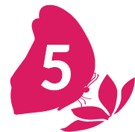  Outcome 5:  Communication  Children are effective communicators when they are:
1.1 Feeling safe, secure, accepted and supported  - Building a sense of stability and trust  - Building a sense of belonging | 2.1 Developing a sense of connectedness to groups and communities and an  understanding of reciprocal rights and responsibilities as active and informed citizens  - Developing skills for working with others and as active and informed citizens  - Developing inquiry and communication skills when exploring and connecting with groups | 3.1 Becoming strong in their social, emotional and mental wellbeing  - Interacting positively to form relationships and friendships  - Recognising simple emotions, building self-regulation and expressing feelings appropriately | 4.1 Developing a growth mindset and positive dispositions for learning  - Building knowledge, confidence, cooperation, commitment and persistence to foster  a growth mindset for learning  - Developing curiosity, enthusiasm, resourcefulness and reflexivity | 5.1 Interacting verbally and non-verbally with others for a range of purposes  - Building aural and oral language and active listening  - Developing phonological awareness skills  - Conveying and constructing messages for a range of purposes in a variety of contexts
1.2 Acting with increasing autonomy, interdependence, resilience and agency  - Showing resilience and focusing attention  - Making choices and decisions (by themselves and with others)  - Managing routines and organising self and belongings | 2.2 Exploring diversity and responding with respect  - Exploring the diversity of cultures, heritages, backgrounds and traditions to broaden their understanding of the world  - Responding respectfully to diversity | 3.2 Taking increasing responsibility for their own health and mental and physical wellbeing  - Building knowledge, skills and positive attitudes to physical movement and mental wellbeing | 4.2 Developing a range of skills and processes for learning and thinking  - Developing problem-solving, investigation and inquiry strategies  - Reflecting on learning and thinking and transferring and adapting what they have learned from one context to another  - Making choices and organising self for learning | 5.2 Engaging in and extending literacy practices in personally meaningful ways  - Developing understanding of purpose and meanings of a range of texts  - Engaging in reading, writing and viewing behaviours
1.3 Building knowledgeable, confident self-identities and a positive sense of self-worth  - Showing confidence in their own learning and capabilities  - Displaying a positive image of self, their family, culture and communities | 2.3 Becoming aware of fairness  - Developing an understanding of fairness and how to respond to unfairness | 3.3 Aware of and developing strategies to support their own mental and physical health and personal safety  - Exploring ways to promote own and others’ health and safety  - Developing simple strategies to foster positive mental wellbeing | 4.3 Engaging in creative and inventive ways of thinking and doing  - Using experimentation, imagination and innovation  - Representing ideas, feelings and experiences in creative ways | 5.3 Understanding how symbols and pattern systems work  - Developing concepts of print  - Investigating symbols and pattern systems
1.4 Interacting in relation with others with care, empathy and respect  - Participating positively as part of a group  - Responding to others appropriately | 2.4 Showing social responsibility and respect for the environment  - Exploring natural and constructed environments  - Investigating interactions between the environment and its people  - Respecting, caring for and sustaining the environment |  | 4.4 Engaging in and extending numeracy in personally and culturally meaningful ways  - Exploring and developing curiosity and knowledge of number and algebra  - Exploring and developing curiosity and knowledge of measurement and geometry  - Exploring and developing curiosity and knowledge of statistics and probability | 5.4 Expressing ideas and making meaning using a range of media and materials  - Viewing and creating with media and materials  - Investigating the properties of a range of media and materials

5.5 Using digital technologies and media to access information, investigate ideas and represent their thinking
- Using tools, resources and technologies in play, learning and thinking
- Developing simple digital skills

