Health and Physical Education:  
Physical Education

Teaching, learning and assessment exemplar

Year 9

Handball

**Acknowledgement of Country**

Kaya. The School Curriculum and Standards Authority (the Authority) acknowledges that our offices are on Whadjuk Noongar boodjar and that we deliver our services on the country of many traditional custodians and language groups throughout Western Australia. The Authority acknowledges the traditional custodians throughout Western Australia and their continuing connection to land, waters and community. We offer our respect to Elders past and present.

**Background**

This Teaching and Learning Exemplar (the exemplar) has been developed by the School Curriculum and Standards Authority (the Authority) as part of the *School Education Act Employees (Teachers and Administrators) General Agreement 2017* (Clause 61.1–61.3).

**Copyright**

© School Curriculum and Standards Authority, 2024

This document – apart from any third-party copyright material contained in it – may be freely copied, or communicated on an intranet, for non-commercial purposes in educational institutions, provided that the School Curriculum and Standards Authority (the Authority) is acknowledged as the copyright owner, and that the Authority’s moral rights are not infringed.

Copying or communication for any other purpose can be done only within the terms of the *Copyright Act 1968* or with prior written permission of the Authority. Copying or communication of any third-party copyright material can be done only within the terms of the *Copyright Act 1968* or with permission of the copyright owners.

Any content in this document that has been derived from the Australian Curriculum may be used under the terms of the [Creative Commons Attribution 4.0 International licence](https://creativecommons.org/licenses/by/4.0/).

**Disclaimer**

Any resources such as texts, websites and so on that may be referred to in this document are provided as examples of resources that teachers can use to support their learning programs. Their inclusion does not imply that they are mandatory or that they are the only resources relevant to the course. Teachers must exercise their professional judgement as to the appropriateness of any they may wish to use.

Contents

The Western Australian Curriculum 1

The Health and Physical Education curriculum 1

This exemplar 2

Catering for diversity 2

Using this exemplar 3

Best practice 4

Teaching and learning 4

Assessing 4

Reflecting 4

Handball skills and strategies | Assessment 5

Western Australian Curriculum | What will be taught 6

Achievement standard | What is assessed 7

Lessons 1–10 9

Appendix A: Teaching and learning – resources 25

Appendix B: Assessment task (summative) 57

# 

# The Western Australian Curriculum

The *Western Australian Curriculum and Assessment Outline* (the *Outline* – <https://k10outline.scsa.wa.edu.au/>) sets out the mandated curriculum, guiding principles for teaching, learning and assessment, and support for teachers in their assessment and reporting of student achievement. The *Outline* recognises that all students in Australian schools, or international schools implementing the Western Australian curriculum, are entitled to be given access to the eight learning areas described in the *Alice Springs* (*Mparntwe*) *Education Declaration*, December 2019.

## The Health and Physical Education curriculum

The mandated curriculum is presented in the year-level curriculum documents.

The year-level syllabuses for each learning area deliver a sequential and age-appropriate progression of learning and have the following key elements:

* a year-level description that provides an overview of the context for teaching and learning in the year
* a series of content descriptions, populated through strands and sub-strands, that sets out the knowledge, understanding and skills that teachers are expected to teach and students are expected to learn
* an achievement standard that describes an expected level that the majority of students are achieving by the end of a given year of schooling. An achievement standard describes the quality of learning (e.g. the depth of conceptual understanding and the sophistication of skills) that would indicate the student is well-placed to commence the learning required in the next year.

# This exemplar

This Year 9 Physical Education exemplar articulates the content in the *Outline* and approaches to teaching, learning and assessment reflective of the Principles of Teaching, Learning and Assessment. This exemplar demonstrates a sequence of teaching and learning, including suggested assessment points, for ten lessons.

The Health and Physical Education curriculum has been shaped by five interrelated propositions that are informed by a strong evidence base. This Physical Education exemplar has been informed by these same propositions:

* Focus on educative purposes
* Take a strengths-based approach
* Value movement
* Develop health literacy
* Include a critical inquiry approach.

Consistent with a strengths-based approach, a successful Health and Physical Education program is where teachers select ongoing contexts that are accessible and meaningful to students as a focus for building on their strengths and interests.

While the exemplar has been written for one hour per week, school systems/sector, including the Department of Education, Catholic Education Western Australia, and the Association of Independent Schools of Western Australia, may have programs additional to the Western Australian Health and Physical Education curriculum that are taught in schools.

## Catering for diversity

This exemplar provides a suggested approach for the delivery of the curriculum and reflects the rationale, aims and content structure of the learning area. When planning the learning experiences, consideration has been given to ensuring that they are inclusive and can be used in, or adapted for, individual circumstances. It is the classroom teacher who is best placed to consider and respond to (accommodate) the diversity of their students. Reflecting on the learning experiences offered in this exemplar will enable teachers to make appropriate adjustments (where applicable) to better cater for students’ gender, personal interests, achievement levels, socio-economic, cultural and language backgrounds, experiences and local area contexts.

## Using this exemplar

This teaching, learning and assessment exemplar provides suggestions to support the delivery of the mandated curriculum content. The exemplar provides:

* a teaching and learning sequence
* the mandated curriculum content to be taught at each point of the teaching and learning sequence, suggested resources, sample assessment tasks and marking keys
* the number of lessons to deliver the teaching and learning experiences
* learning intentions and support notes that may provide focus questions and additional information and/or examples to assist with the interpretation of curriculum content
* support notes to assist teachers to unpack the content and support teaching and learning experiences
* teaching and learning experiences that outline the structure of the lesson. These explicitly state each activity that the lesson will progress through and the key focus area for that activity.

### Links to electronic resources

This sequence of lessons may utilise electronic web-based resources, such as videos and image galleries. Teachers should be present while an electronic resource is in use and close links immediately after a resource, such as a video has played to prevent default ‘auto play’ of additional videos. Where resources are referred for home study, they should be uploaded through Connect, or an equivalent system, that filters advertising content.

# Best practice

## Teaching and learning

The teaching and learning opportunities offered in this exemplar are not exhaustive. Thus, teachers are encouraged to make professional decisions about which learning experiences, and the sequence in which they are delivered, are best suited to their classroom context, taking into account the availability of resources and student ability.

Teachers may find opportunities to incorporate the General capabilities and the Cross-curriculum priorities into the teaching and learning program.

**Ways of teaching** – teachers can locate additional information on the Ways of teaching from the School Curriculum and Standards Authority (the Authority) website  
<https://k10outline.scsa.wa.edu.au/home/wa-curriculum/learning-areas/health-and-physical-education/p-10-hpe-teaching/health-and-physical-education-ways-of-teaching>.

## Assessing

Assessment, both formative and summative, is an integral part of teaching and learning. Assessment should arise naturally out of the learning experiences provided to students. In addition, assessment should provide regular opportunities for teachers to reflect on student achievement and progress. As part of the support it provides for teachers, this exemplar includes suggested assessmentpoints. It is the teacher’s role to consider the contexts of their classroom and students, the range of assessments required, and the sampling of content descriptions selected to allow their students the opportunity to demonstrate achievement in relation to the year-level achievement standard.

**Ways of assessing** – a range of assessment strategies that can enable teachers to understand where students are in their learning is available on the Authority website <https://k10outline.scsa.wa.edu.au/home/wa-curriculum/learning-areas/health-and-physical-education/p-10-hpe-assessing/health-and-physical-education-ways-of-assessing>.

## Reflecting

Reflective practice involves a cyclic process during which teachers continually review the effects of their teaching and make appropriate adjustments to their planning. The cycle involves planning, teaching, observing, reflecting and replanning.

Teachers may choose to expand or contract the amount of time spent on developing the required understandings and skills according to their reflective processes and professional judgements about their students’ evolving learning needs.

# Handball skills and strategies | Assessment

This teaching, learning and assessment exemplar aims to develop students’ understanding and application of the theory and fundamental skills of handball in various game settings. Students will experience a range of game-related skills in a variety of competitive and non-competitive environments, with opportunities to refine and apply skills at a game-like intensity.

Students are provided with opportunities to explore invasion game related skills and demonstrate their application of these actions/skills in a handball context. In addition to explicit teaching, students will develop their understanding and application of each skill through a variety of learning experiences. Students will demonstrate their progression through the lesson sequence, developing their proficiency, skill selection and application, offensive and defensive tactical application in game situations. They will also develop interpersonal skills and strategies for effective leadership, such as communication and time management, characteristics of fair play and application of fair and ethical behaviour in physical activity, and strategies for decision-making when working in groups or teams that demonstrate leadership and collaboration skills.

If the suggested learning experiences and relevant syllabus content for this lesson sequence have been followed, students will be well positioned to address the requirements of the assessment task to the best of their ability.

# Western Australian Curriculum | What will be taught

In the middle adolescence phase of schooling, teaching and learning programs encourage students to develop an open and questioning view of themselves as active participants in their society and the world.

Health and Physical Education provides opportunities for students to refine their understanding of how they can contribute to individual and community health and wellbeing. Students have frequent opportunities to participate in physical activities, including in outdoor settings, to value the importance of active recreation as a way of enhancing their health and wellbeing throughout their lives.

In Year 9, students take into consideration the influence of external factors on their ability to make safe and informed choices, which may impact their capacity to achieve a healthy lifestyle. They continue to develop knowledge, skills and understandings in relation to respectful relationships, with a focus on skills that promote positive interactions and resolving conflict. Students examine effective strategies that may be implemented in situations where the giving or denying of consent is required.

Students focus on elements of speed and accuracy in different movement environments, while continuing to develop the efficiency of movement skills. They explore ways to evaluate performances, through analysis of skills and movement, and measure a number of the body’s responses to physical activities. They transfer previous knowledge of outcomes in movement situations to inform and refine skills, strategies and tactics to maximise success. Opportunities are provided for students to refine and consolidate skills and strategies for effective leadership and teamwork, and consistently apply ethical behaviour across a range of movement contexts.

# Achievement standard | What is assessed

By the end of the year:

**Health Education**

Students identify and apply relevant criteria to determine the effectiveness of various strategies that may be used to enhance health and wellbeing. They determine the appropriateness and reliability of health information and whether it is suitable for use in a particular context. Students examine a range of characteristics of respectful relationships. They describe and apply appropriate skills and strategies to resolve and manage conflict within different environments.

**Physical Education**

Students select and use individual movement skills and sequences that increase in complexity and perform them with increased speed and control and improved accuracy. They implement tactics and adapt them in response to previous performances. Students measure a number of the body’s responses to physical activity. In competitive contexts, students participate ethically and demonstrate leadership and ways to build motivation. They encourage teamwork in various contexts toward inclusive, lifelong participation.

Lessons 1–10

Lesson 1: Introduction to handball – skill development

The Western Australian Curriculum content addressed in this lesson is below.

Movement skills

* Movement skills and sequences within different physical activity contexts and settings reflecting increased speed and accuracy, improved efficiency and increased complexity
* Skills, strategies and tactics in new or challenging movement situations and the impact of each on movement outcomes

Learning intentions

Demonstrate proficiency in ball handling, passing, receiving and the bounce in drill and gameplay situations

Demonstrate proficiency in using the non-dominant side in drill and gameplay situations

Focus questions

* What are the key teaching points to execute holding the ball, the pass and the bounce/dribble (preparation, execution, completion)?
* What are different ways the ball can be passed to teammates?
* How can you improve your efficiency, speed and accuracy in executing a pass and bounce/dribble?
* How can you demonstrate proficiency with the increased complexity of using your non-dominant side to pass, receive or bounce/dribble the ball?

Support notes

Formative assessment strategies:

* group activities, practical tasks, Physical Education performance (static drills, dynamic drills, modified sports, competitive situations).

Teaching and learning experiences

Warm-up

Focus: describe skills that are required to play handball.

* Introduce ‘Pass and follow drill’ warm-up activity (Appendix A.2).
* Brainstorm with students the skills necessary to play the game of handball. Use this information to gauge the current level of understanding and experience of the class. (passing, dribbling/bouncing, catching, jumping, saving, running, screening).
* Describe the sport of handball.

Activity 1 – circle ball

Focus: demonstrate and explain the key teaching points of passing, receiving and bouncing/dribbling, using the dominant and non-dominant sides.

* Describe and demonstrate the key teaching points for holding the ball, passing (flat, lob, wrist, bounce), receiving and bouncing/dribbling (Appendix A.1).
* Drill-based practice for students (Appendix A.2).
* Provide feedback and check for understanding.

Activity 2 – 4v4 keep ball

Focus: demonstrate proficiency in using the non-dominant side.

* Drill-based practice for students (Appendix A.2).
* Provide feedback and check for understanding.

Concluding activity

* Instruct students to identify, describe and/or demonstrate responses to the focus questions.

Lesson 2: Offence – maintaining possession

The Western Australian Curriculum content addressed in this lesson is below.

Movement skills

* Movement skills and sequences within different physical activity contexts and settings reflecting increased speed and accuracy, improved efficiency and increased complexity
* Skills, strategies and tactics in new or challenging movement situations and the impact of each on movement outcomes

Learning intentions

Describe the basic role of each player in maintaining possession and creating an attacking play

Demonstrate the ability to draw in, dodge opponents and vary the width of the pass

Demonstrate the ability to shadow to intercept the pass and/or restrict the movement of an opponent

Focus questions

* What are the key teaching points to execute the dodge (preparation, execution, completion)?
* How can a player move to lose the opposition?
* How can a player dodge to lose the defending player and get free for a pass?
* What is deception?
* What might increase your chances of intercepting a ball?

Support notes

Formative assessment strategies:

* group activities, practical tasks, Physical Education performance (static drills, dynamic drills, modified sports, competitive situations).

Teaching and learning experiences

Warm-up

Focus: revising and refining skills.

* Introduce ‘rats and rabbits’ warm-up activity (Appendix A.2).
* Revise the teaching points of passing, receiving and bouncing/dribbling learnt in the previous lesson (Appendix A.1).
* Describe and demonstrate the key teaching points of the evading side step and deception

Activity 1 – decision-making 3v1

Focus: demonstrate and explain how to draw in opponents and vary the width of the pass to keep possession of the ball.

* Describe and demonstrate the key teaching points shadowing (Appendix A.1).
* Drill-based practice for students (Appendix A.2).
* Provide feedback and check for understanding.

Activity 2 – keep ball score 4v4

Focus: demonstrate and explain the dodge.

* Describe and demonstrate the key teaching points for the dodge (Appendix A.1).
* Drill-based practice for students (Appendix A.2).
* Provide feedback and check for understanding.

Concluding activity

* Instruct students to identify, describe and/or demonstrate responses to the focus questions.

Lesson 3: Defence – gaining possession

The Western Australian Curriculum content addressed in this lesson is below.

Movement skills

* Movement skills and sequences within different physical activity contexts and settings reflecting increased speed and accuracy, improved efficiency and increased complexity
* Skills, strategies and tactics in new or challenging movement situations and the impact of each on movement outcomes

Learning intentions

Describe the basic role of each player in gaining possession and denying space and options of the defending team

Demonstrate the ability intercept the ball by tackling or stealing

Demonstrate the skills of shadowing and forcing an opponent or ball out of bounds

Focus questions

* What are the key teaching points to execute shadowing (preparation, execution, completion)?
* How can a player move to lose the opposition?
* What can the defending player do to prevent losing the attacking player?
* What might increase your chances of intercepting a ball?

Support notes

Formative assessment strategies:

* group activities, practical tasks, Physical Education performance (static drills, dynamic drills, modified sports, competitive situations).

Teaching and learning experiences

Warm-up

Focus: revising and refining skills.

* Introduce ‘collecting tags’ warm-up activity (Appendix A.2).
* Revise the teaching points of dodge and deception learnt in the previous lesson (Appendix A.1).

Activity 1 – square ball

Focus: demonstrate and explain how to shadow opponents and intercept the ball.

* Revise the key teaching points of shadowing (Appendix A.1).
* Drill-based practice for students (Appendix A.2).
* Provide feedback and check for understanding.

Activity 2 – bonus players

Focus: demonstrate and explain how a defending team can gain possession.

* Drill-based practice for students (Appendix A.2).
* Provide feedback and check for understanding.

Concluding activity

* Instruct students to identify, describe and/or demonstrate responses to the focus questions.

Lesson 4: Offence – creating and using space

The Western Australian Curriculum content addressed in this lesson is below.

Movement skills

* Movement skills and sequences within different physical activity contexts and settings reflecting increased speed and accuracy, improved efficiency and increased complexity
* Skills, strategies and tactics in new or challenging movement situations and the impact of each on movement outcomes

Learning intentions

Demonstrate how to move to maintain possession of the ball

Demonstrate the ability to select and apply appropriate skills to outwit the opposition

Demonstrate the ability to transition from defence to offence after regaining possession

Focus questions

* Why is consistent footwork important?
* What is meant by the term ‘creating space’ when in possession of the ball?
* How can an offensive player effectively lose the defender?

Support notes

Formative assessment strategies:

* group activities, practical tasks, Physical Education performance (static drills, dynamic drills, modified sports, competitive situations).

Teaching and learning experiences

Warm-up

Focus: revising and refining skills.

* Introduce ‘tag ball’ warm-up activity (Appendix A.2).
* Revise the teaching points of dodge and shadow learnt in the previous lesson (Appendix A.1).

Activity 1 – triangle drill pass and move 3v1

Focus: demonstrate and explain how maintain possession by passing and moving while evading a defender.

* Revise the key teaching points of shadowing (Appendix A.1).
* Drill-based practice for students (Appendix A.2).
* Provide feedback and check for understanding.

Activity 2 – offensive endball 4v4 minus 1

Focus: demonstrate and explain how to increase the chances of scoring.

* Drill-based practice for students (Appendix A.2).
* Discuss how to create attacking plays using numerical advantage, creating space, transitional play, pace of the game and team strategy
* Provide feedback and check for understanding.

Concluding activity

* Instruct students to identify, describe and/or demonstrate responses to the focus questions.

Lesson 5: Defence – space

The Western Australian Curriculum content addressed in this lesson is below.

Movement skills

* Movement skills and sequences within different physical activity contexts and settings reflecting increased speed and accuracy, improved efficiency and increased complexity
* Skills, strategies and tactics in new or challenging movement situations and the impact of each on movement outcomes

Learning intentions

Demonstrate how to control space on defence through positioning and strategy

Demonstrate the ability to transition from offence to defence after losing possession

Focus questions

* What is meant by the term ‘denying space’ when not in possession of the ball?
* How can a defender effectively prevent the dodge from being successful?

Support notes

**Formative assessment strategies:**

* group activities, practical tasks, Physical Education performance (static drills, dynamic drills, modified sports, competitive situations).

Teaching and learning experiences

**Warm-up**

Focus: revising and refining skills.

* Introduce ‘coloured tails’ warm-up activity (Appendix A.2).
* Revise the teaching points of dodge and shadow learnt in the previous lesson (Appendix A.1).

**Activity 1 – defenders r us**

Focus: demonstrate and explain how to control space through positioning of teammates and create team strategies to gain possession of the ball.

* Drill-based practice for students (Appendix A.2).
* Provide feedback and check for understanding.

**Activity 2 – defensive endball 3v3 plus 1**

Focus: demonstrate how to regain possession of the ball using numerical advantage, transitional play, pace of the game and/or team strategy (1-on-1 player or zone defence).

* Drill-based practice for students (Appendix A.2).
* Provide feedback and check for understanding.

**Concluding activity**

* Instruct students to identify, describe and/or demonstrate responses to the focus questions.

Lesson 6: The goal – attacking

The Western Australian Curriculum content addressed in this lesson is below.

**Movement skills**

* Movement skills and sequences within different physical activity contexts and settings reflecting increased speed and accuracy, improved efficiency and increased complexity
* Skills, strategies and tactics in new or challenging movement situations and the impact of each on movement outcomes

Learning intentions

Demonstrate how to create space using goal side positioning

Demonstrate how to build an attack to increase greater shooting opportunities

Demonstrate and describe knowledge of basic rules in handball gameplay

Focus questions

* Why is shooting an important skill in handball?
* Which players are allowed to shoot in a handball game?
* What factors will increase the chances of scoring?
* Why is it important to create space when attacking?
* Why is it important to understand the responsibility of each player?
* How can you use the rules of a game to your advantage?

Support notes

Formative assessment strategies:

* group activities, practical tasks, Physical Education performance (static drills, dynamic drills, modified sports, competitive situations).

Teaching and learning experiences

Warm-up

Focus: revising and refining skills.

* Introduce ‘endball’ warm-up activity (Appendix A.2).
* Revise the teaching points of controlling space and gaining possession of the ball learnt in the previous lesson (Appendix A.1).
* Revise basic rules of handball gameplay.

Activity 1 – handball shooting

Focus: demonstrate and explain create space using goal side positioning.

* Drill-based practice for students (Appendix A.2).
* Provide feedback and check for understanding.

Activity 2 – half-court handball

Focus: demonstrate how to build an attack to increase greater shooting opportunities and demonstrate knowledge of basic rules in gameplay.

* Drill-based practice for students (Appendix A.2).
* Provide feedback and check for understanding.

Concluding activity

* Instruct students to identify, describe and/or demonstrate responses to the focus questions.

Lesson 7: The goal – defending

The Western Australian Curriculum content addressed in this lesson is below.

Movement skills

* Movement skills and sequences within different physical activity contexts and settings reflecting increased speed and accuracy, improved efficiency and increased complexity
* Skills, strategies and tactics in new or challenging movement situations and the impact of each on movement outcomes

Learning intentions

Demonstrate how to deny space using goal side positioning

Demonstrate and describe the key teaching points of goalkeeping

Demonstrate and describe knowledge of defensive strategy in handball gameplay

Focus questions

* Why is it important not to obstruct when attempting to defend the ball?
* Why is it important to deny space if you are defending?
* Why is it important to understand the responsibility of each player?
* Why is consistent footwork important?
* How can the defender effectively prevent the dodge being successful?

Support notes

Formative assessment strategies:

* group activities, practical tasks, Physical Education performance (static drills, dynamic drills, modified sports, competitive situations).

Teaching and learning experiences

Warm-up

Focus: revising and refining skills.

* Introduce ‘handball junior’ warm-up activity (Appendix A.2).
* Revise the teaching points of goal shooting learnt in the previous lesson (Appendix A.1).

Activity 1 – 1, 2, 3 play

Focus: demonstrate ability to transition between attack and defensive roles; denying space using goal side positioning.

* Drill-based practice for students (Appendix A.2).
* Provide feedback and check for understanding.

Activity 2 – timed-handball defence

Focus: demonstrate how to develop defensive team strategy and successfully goalkeep

* Introduce the key teaching points of goalkeeping (Appendix A.1).
* Drill-based practice for students (Appendix A.2).
* Provide feedback and check for understanding.

Concluding activity

* Instruct students to identify, describe and/or demonstrate responses to the focus questions.

Lesson 8: Strategies and tactics

The Western Australian Curriculum content addressed in this lesson is below.

Movement skills

* Movement skills and sequences within different physical activity contexts and settings reflecting increased speed and accuracy, improved efficiency and increased complexity
* Skills, strategies and tactics in new or challenging movement situations and the impact of each on movement outcomes

Learning intentions

Describe how offensive and defensive strategies and tactics can improve team performance, specifically set plays and controlling the game pace.

Focus questions

* How does a team control the pace of a game?
* How can you as a player control the pace of a game?
* Why is it important to understand the responsibility of each player?

Support notes

Formative assessment strategies:

* group activities, practical tasks, Physical Education performance (static drills, dynamic drills, modified sports, competitive situations).

Teaching and learning experiences

Warm-up

Focus: revising and refining skills.

* Introduce ‘captured’ warm-up activity (Appendix A.2).
* Revise the teaching points of goalkeeping and denying space learnt in the previous lesson (Appendix A.1).

Activity 1 – handball defence

Focus: demonstrate offensive strategies and tactics to attack and score; demonstrate team defensive strategies and tactics to stop scoring attempts.

* Drill-based practice for students (Appendix A.2).
* Provide feedback and check for understanding.

Activity 2 – handball junior

Focus: demonstrate offensive strategies and tactics to attack and score; demonstrate team defensive strategies and tactics to stop scoring attempts.

* Drill-based practice for students (Appendix A.2).
* Provide feedback and check for understanding.
* This is the drill that will be used to assess students in Lessons 9 & 10 – summative assessment

**Concluding activity**

* Instruct students to identify, describe and/or demonstrate responses to the focus questions.

Lesson 9: Summative assessment – handball gameplay

The Western Australian Curriculum content addressed in this lesson is below.

Movement skills

* Movement skills and sequences within different physical activity contexts and settings reflecting increased speed and accuracy, improved efficiency and increased complexity
* Skills, strategies and tactics in new or challenging movement situations and the impact of each on movement outcomes

Learning intentions

Complete a summative assessment to demonstrate proficiency in participating in a game of handball.

Focus questions

* What are offensive and defensive strategies for handball?

Support notes

Summative assessment (Appendix B)

Physical Education performance (dynamic drills, modified sports, competitive situations)

Teaching and learning experiences

Warm-up

Focus: revising and refining skills.

* Introduce ‘possession tag V2’ warm-up activity (Appendix A.2).
* Revise the summative assessment process and rubric (Appendix B).

Activity 2 – summative assessment – handball junior

Focus: demonstrate offensive strategies and tactics to attack and score; demonstrate team defensive strategies and tactics to stop scoring attempts.

* Drill-based practice for students (Appendix A.2).
* Provide feedback and check for understanding.

Concluding activity

* Instruct students to identify, describe and/or demonstrate responses to the focus questions.

Lesson 10: Summative assessment – handball gameplay

The Western Australian Curriculum content addressed in this lesson is below.

Movement skills

* Movement skills and sequences within different physical activity contexts and settings reflecting increased speed and accuracy, improved efficiency and increased complexity
* Skills, strategies and tactics in new or challenging movement situations and the impact of each on movement outcomes

Learning intentions

Complete a summative assessment to demonstrate proficiency in participating in a game of handball.

Focus questions

* What are offensive and defensive strategies for handball?

Support notes

Summative assessment (Appendix B)

Physical Education performance (dynamic drills, modified sports, competitive situations)

Teaching and learning experiences

Warm-up

Focus: revising and refining skills.

* Introduce ‘captured’ warm-up activity (Appendix A.2).
* Revise the summative assessment process and rubric (Appendix B).

Activity 2 – summative assessment – handball junior

Focus: demonstrate offensive strategies and tactics to attack and score; demonstrate team defensive strategies and tactics to stop scoring attempts.

* Drill-based practice for students (Appendix A.2).
* Provide feedback and check for understanding.

Concluding activity

* Instruct students to identify, describe and/or demonstrate responses to the focus questions.

Appendix A:  
Teaching and learning – resources

Lessons 1–10

Appendix A.1 | Resources

Resources that could be used as support material with this teaching and learning sequence are listed in the following table.

| **Resource** | **Link/information** |
| --- | --- |
| Further handball‑specific information and drills | International Handball Federation – Teaching Handball Volume 1: Teacher Guidelines <https://www.ihf.info/about/handball-at-school/teaching-material?lang=10>  Select H@SBooklet to retrieve PDF. |
| England Handball Association – Introduction to Teaching Handball  [https://www.sasp.co.uk/](https://www.sasp.co.uk/uploads/eha-introduction-to-teaching-handball-literature-september-09.pdf) |
| DragoerHB – Handball for coaches, clubs and players  <http://www.dragoerhb.dk/e_index.html> |
| Resources with a variety of drills for different sports, including handball | Ophea – PlaySport  <https://www.playsport.net/> |
| Sportplan – Sports coaching made easy (Home)  <https://www.sportplan.net/>  A free teacher log-in will need to be created to access these resources. |

Appendix A.2 | Drill and game details and information for teachers

**Diagram key**

|  |  |  |  |  |  |  |  |  |
| --- | --- | --- | --- | --- | --- | --- | --- | --- |
| **Symbol** |  |  |  |  |  |  |  |  |
| **Description** | Players  Team 1 | Players  Team 2 | Players  Team 3 | Players  Team 4 | Marker | Object | Player movement | Object movement |

* Two courts are required for every lesson and activities take place on a:
  + whole court set up
  + half-court set up
  + quarter-court set up.
* Each quarter-court should have four students allocated:
  + Eight groups of four.
* All groups on a whole court should have different coloured bibs to allow for different activities.

Court dimensions

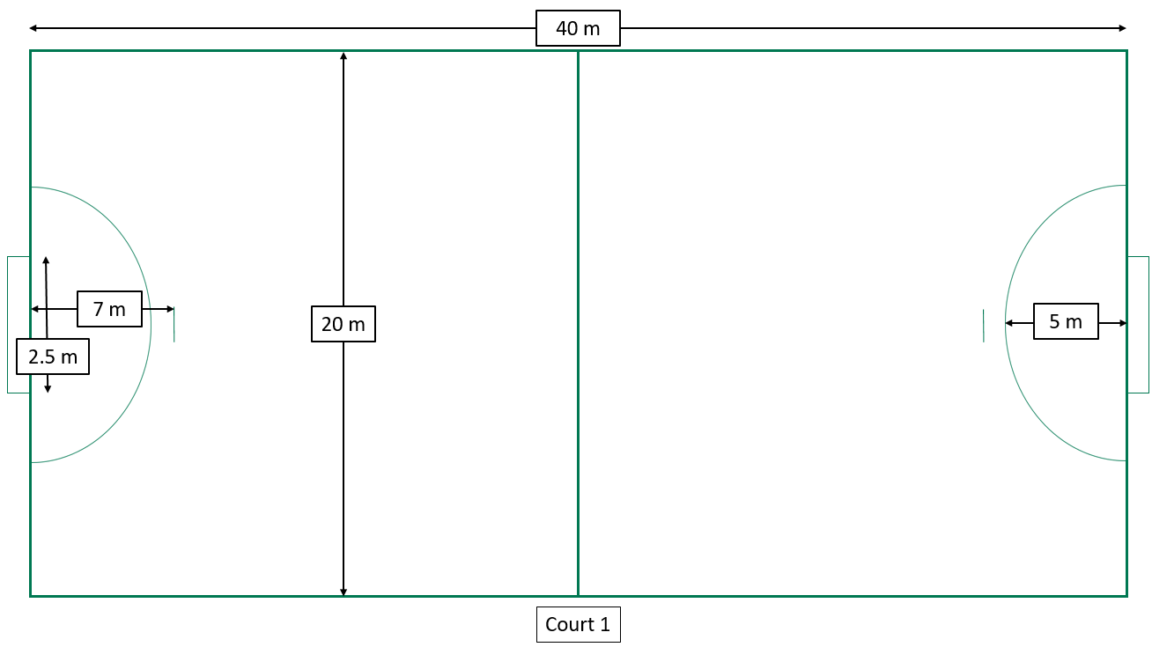

Common court layouts

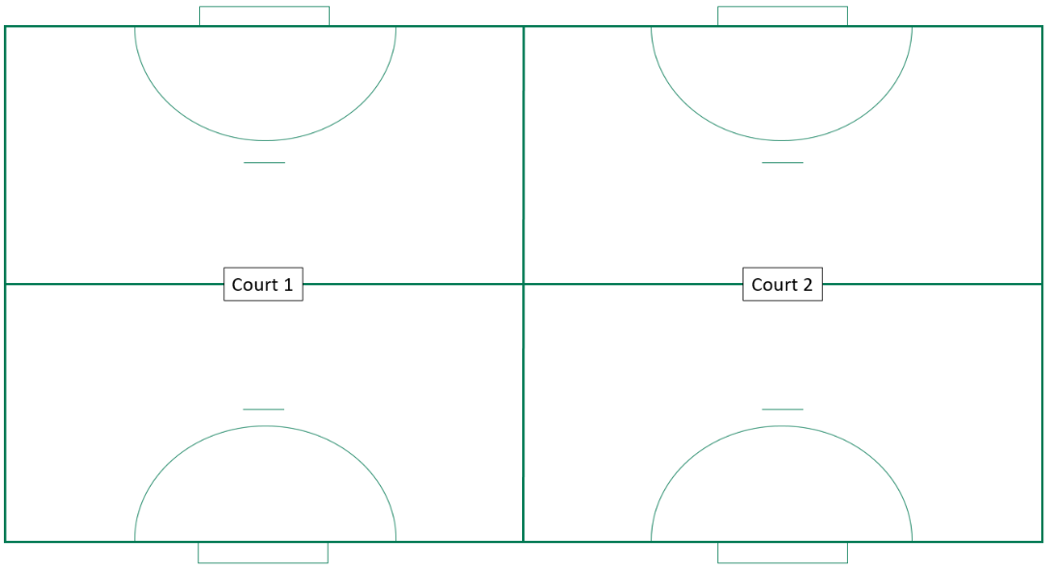Whole court set up

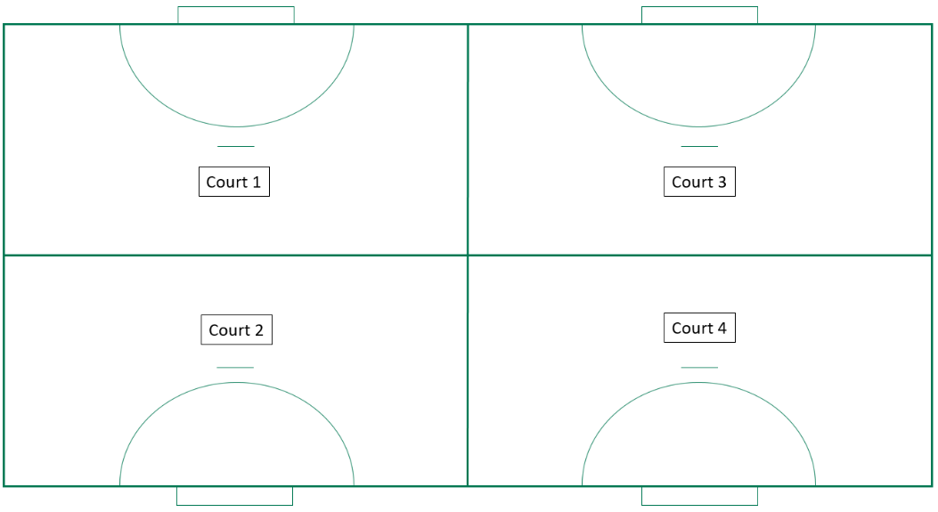Half-court set up

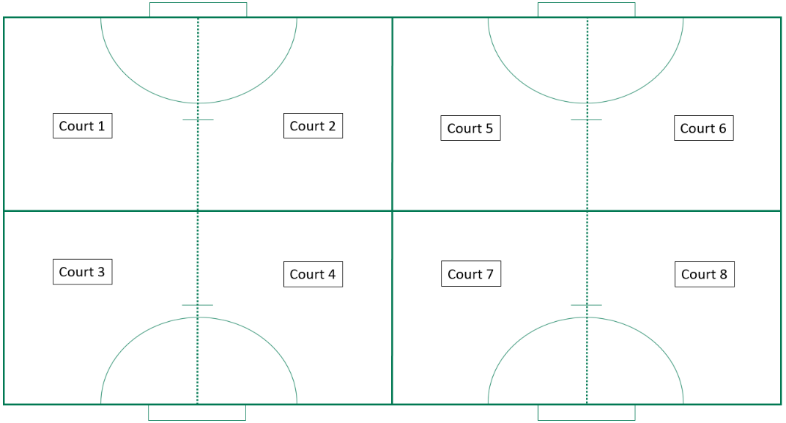Quarter-court set up

Lesson 1

Warm-up – pass and follow drill

* Use quarter-court set up.
* 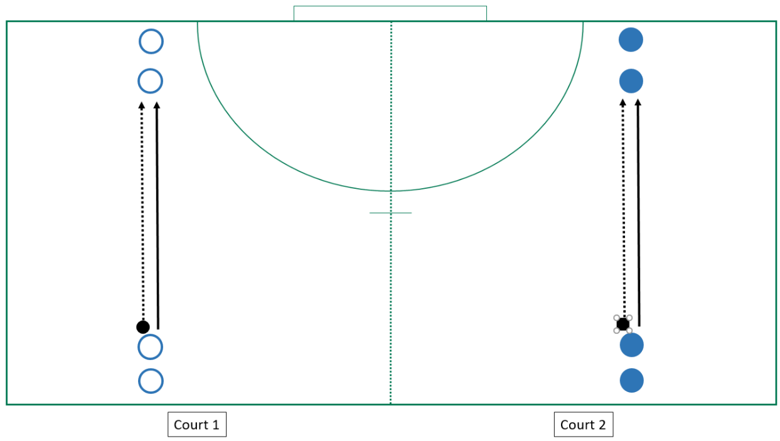Students in groups of four; one handball per group. Two students on each side. Students begin passing ball over 3 m, gradually increasing. Students pass and follow their pass to join the back of the line. (Diagram 1)

Diagram 1 – pass and follow drill

* Change passes to: flat, lob, wrist, bounce.
* Differentiation – Use non-dominant hand, bounce the ball prior to passing, change the distance of the throw.

Activity 1 – circle pass

* Eight students to form a circle (both groups on each half of the court).
* Students pass the ball around the circle, but do not pass to the student next to them, or the student who they received the ball from. (Diagram 2a)
* Differentiation – specify and limit pass type, use non-dominant hand, bounce pass using either hand, add a defender (Diagram 2b), add a time limit on ball possession, expand the circle, add a second defender, add a second ball.

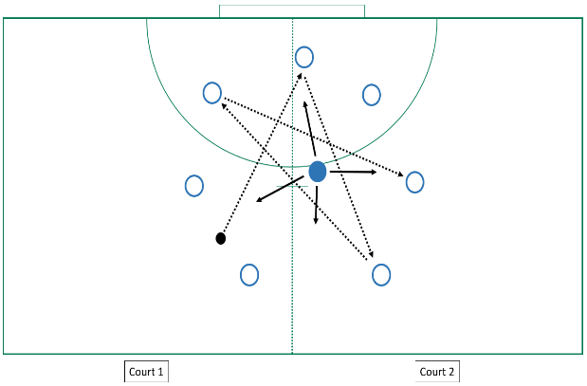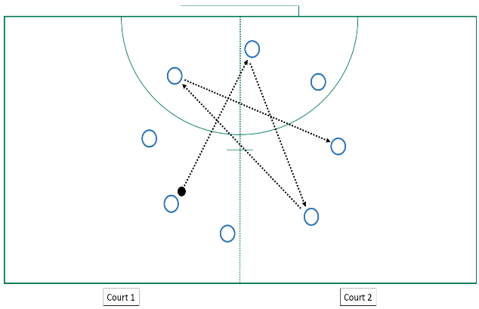

Diagram 2a – circle pass Diagram 2b – circle pass with defender

Activity 2 – 4v4 keep ball

* Each game has two teams of four and one ball; each team has one quarter-court set up, or similar as space allows.
* One team has the ball and has to maintain possession for eight consecutive passes.
* One point is scored when eight passes are achieved, teams then swap over.
* The other teams can attempt to gain possession and make eight consecutive passes once in possession. (Diagram 3)
* Differentiation – specify and limit passes to a single type, increase court size, give each team a scoring line goal, teams start possession in centre court, each player must touch the ball, different number or sequence of passes must be achieved.

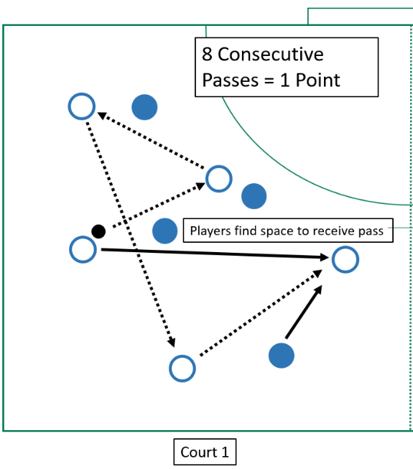

Diagram 3 – 4v4 keep ball

Lesson 2

Warm-up – rats and rabbits

* Students pair up and line up together on court sideline. (Diagram 4)
  + Pairs to stand back-to-back at the base line. In pairs students choose to be number one (rat) or two (rabbit).
* Teacher calls out either rats or rabbits:
  + if rats called
    - rats attempt to run to the other side of the court
    - rabbits attempt to tag them
  + if rabbits called, it’s vice versa.
* Next round starts on the new sideline and return towards the original start line.
* Keep a tally of successful tags.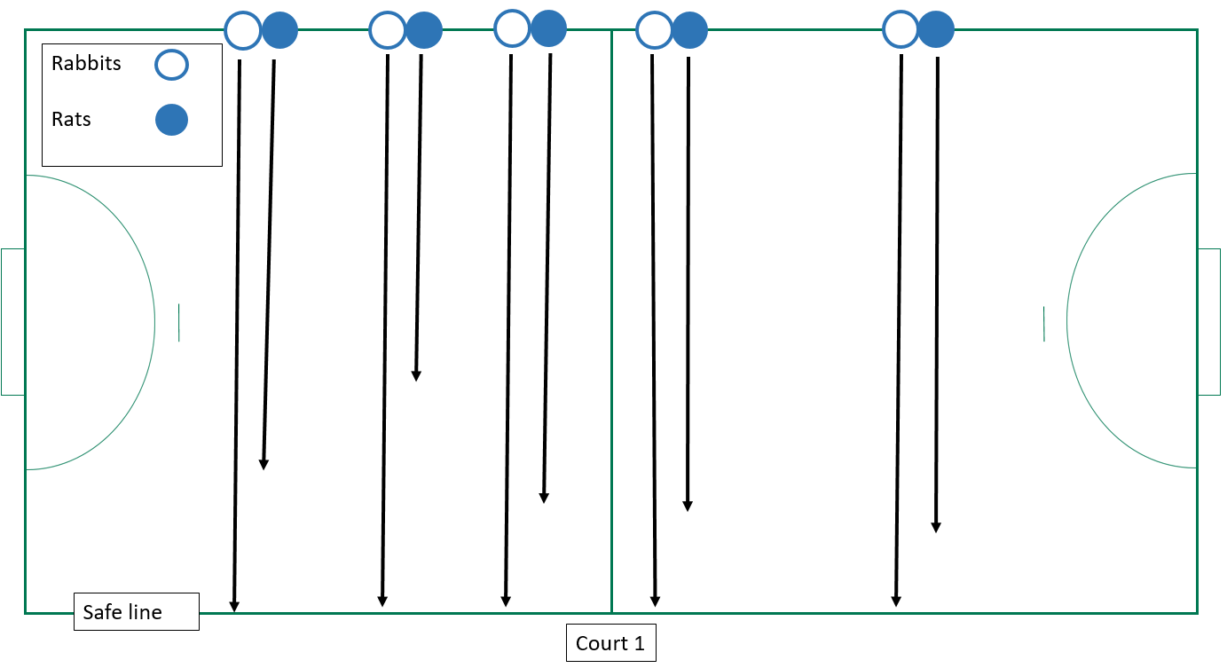

Diagram 4 – rats and rabbits

Activity 1 – decision-making 3v1

* Students in groups of four, one ball per group. Three students form the attacking team; one student is the defender.
* Work in one quarter (or smaller) of the handball court. (Diagram 5)
* Attacking team – maintain possession using sequenced and varied passes as dictated by the teacher.
* Defender – after interception or mistake by attacking team, the defender becomes an attacker.
* Attacking team scores a point for every pass sequence complete.
* Differentiation – allow students to choose which pass and when.

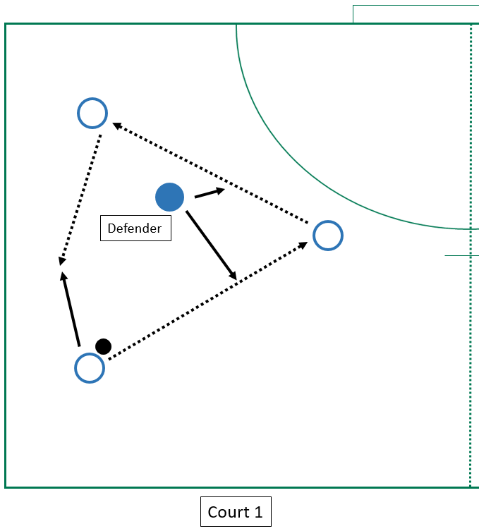

Diagram 5 – decision-making 3v1

Activity 3 – keep ball score 4v4

* Students form two teams of four with one ball.
* Each team has one quarter-court set up, or similar as space allows. (Diagram 6)
* Start with one team in possession of the ball in the centre of the area.
* Attacking team to maintain possession for the five passes, before attempting to receive the ball over the goal line to score a point.
* The other team can attempt to gain possession and begin their five consecutive passes and attempt scoring once in possession.
* Differentiation – specify and limit passes to a single type, increase court size, change team numbers, each player must touch the ball, a different number or sequence of passes must be achieved.

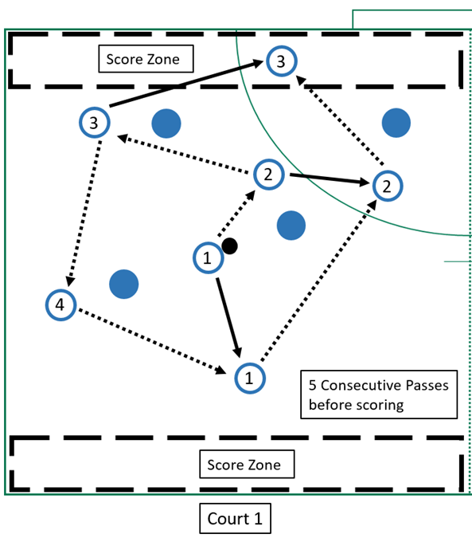

Diagram 6 – keep ball score

**Lesson 3**

**Warm-up – collecting tags**

* Teacher assigns two students as attackers – taggers.
* The remainder of the class finds space in one half-court, or similar space available. (Diagram 7)
* Taggers
  + pass the ball to each other to tag the opponents with the ball
  + cannot run with the ball
  + shadow opponents or move to space to create tag opportunities.
* Tagged students join attackers.
* Game continues until all students are tagged.

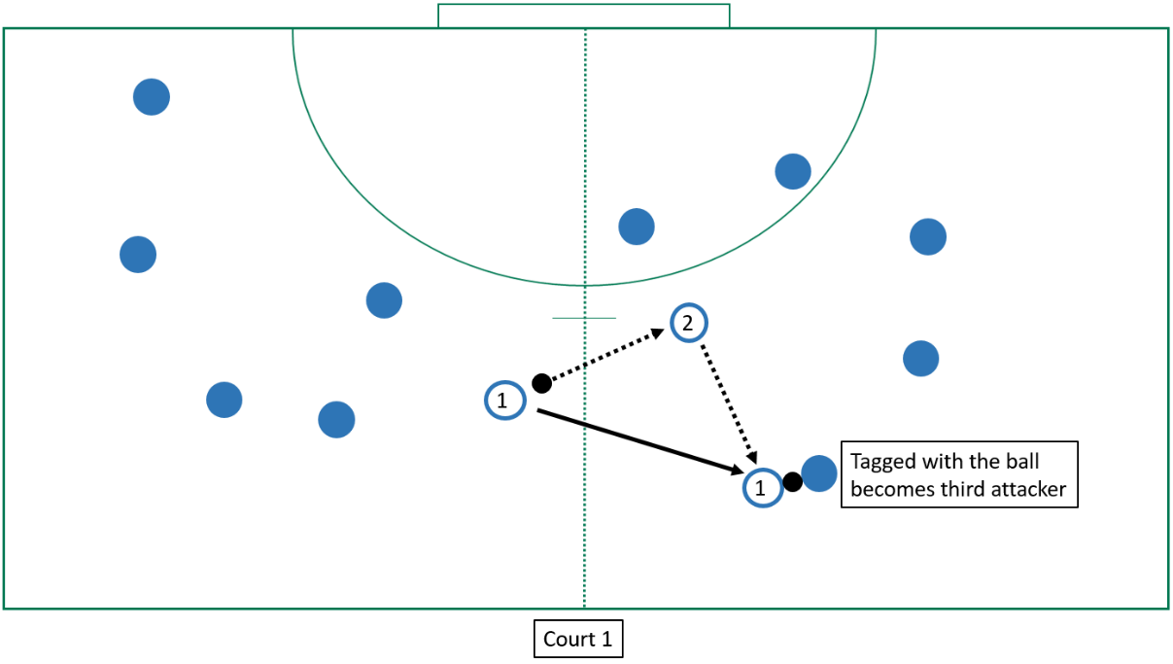

Diagram 7 – collecting tags

Activity 1 – square ball

* Students get into teams of four, one ball for each team.
* Teams work in one quarter (or smaller) of the handball court. Divide court into four quarters. (Diagram 8)
* One member from each team is in a quarter.
* Players cannot:
  + run with the ball
  + make physical contact.
* Attacking team (team with the ball) maintains possession using sequenced and varied passes as dictated by the teacher.
* Defender – after interception or mistake by attacking team, the defender becomes an attacker.
* Attacking team scores a point for every pass completed.
* Team with the most consecutive passes wins.
* Differentiation – pair players of equal ability in each quarter, specify and limit pass type, pass the ball using a non-dominant hand, specify the order of squares passes will follow.

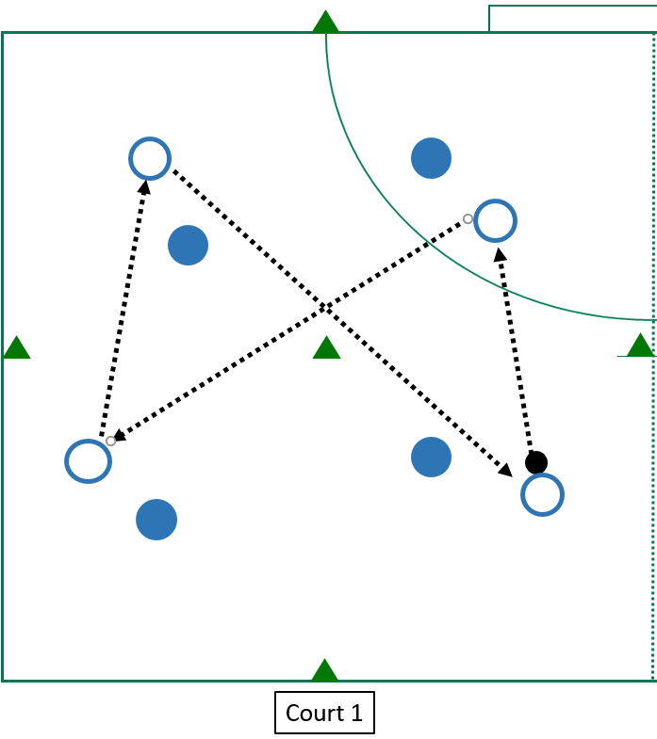

Diagram 8 – square ball

Activity 3 – bonus players

* Each game is allocated one court, or similar as space allows.
* Students form two teams of eight with one ball required per game. (Diagram 9)
* Start with attacking team in possession of the ball in the centre of the area.
* Attacking team to maintain possession for one minute, attempting to complete as many passes as possible.
  + One pass is one point except if made in bonus scoring zone.
  + Students form two teams of eight with one ball required.
  + Start with attacking team in possession of the ball in the centre of the area.
* Defending team attempts to gain possession and places the ball on the ground when successful. Attacker takes possession and continues if time remains.
* Defenders cannot be within 1 m of attacking player.
* Two bonus scoring zones are at each end of the court.
  + Three-point score when a player in bonus scoring zone takes possession of the ball.
  + Only one attacking player is allowed in this area; defenders are all able to enter.
* Differentiation – players bounce the ball every five passes, three points are deducted for interception or turnover, the size or number of bonus zones change, limited defenders are allowed in the bonus zone, the bonus zone is removed and a bonus player scores three points when they take possession, the amount of time a team has to score is changed.

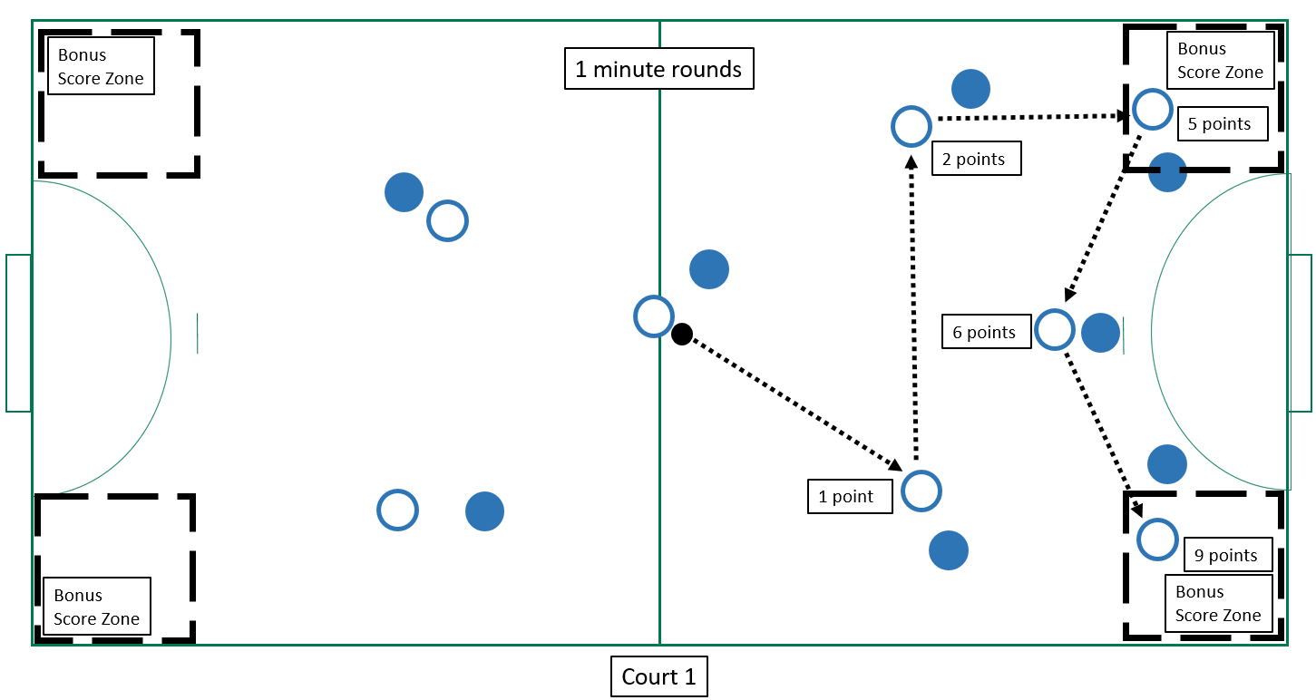Diagram 9 – bonus players

Lesson 4

Warm-up – tag ball

* Divide students into two opposing teams of mixed ability using bibs; use half of a court. (Diagram 10)
* One team begins with possession of the ball, and pass and receive amongst themselves attempting to tag the opposition with the ball.
* If tagged, students stand on the sideline and complete a fitness activity.
* The attacking team will have two minutes to tag as many people as they can, by touching them with the ball, before swapping over.
* The team with the highest number of tags is the winner.
* Differentiation – add a second ball to increase complexity, increase number of players on each team.

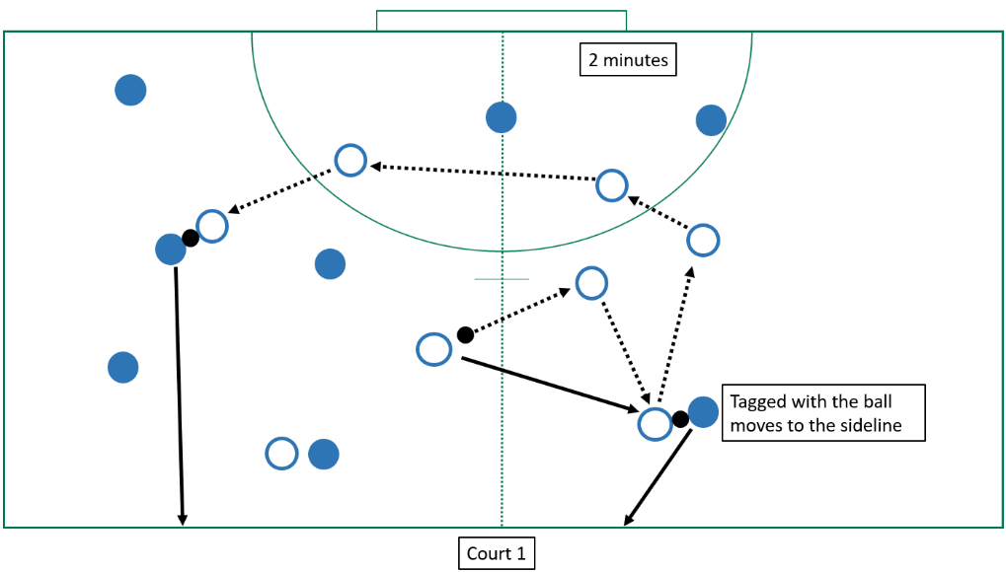

Diagram 10 – tag ball

Activity 1 – triangle drill pass and move 3v1

* Divide the students into groups of four – three attackers and one defender.
* The three attackers make a triangle.
* The attackers will attempt to maintain possession by passing and moving, while the defender attempts to gain possession. (Diagram 11a)
* The attackers must move from their point of the triangle to form a different point after passing the ball. They must not stay where they are, but move constantly into a new space, keeping the triangle formation. (Diagram 11b)
* Attackers must land using a one-two or two-foot landing, and then can only pivot (similar to rules in netball).
* Any footwork violations will result in loss of possession to the defender, who can then swap into the attacking team.
* Differentiation – interceptions also result in the defender swapping into the attacking team, groups are re-formed to align with skill level.

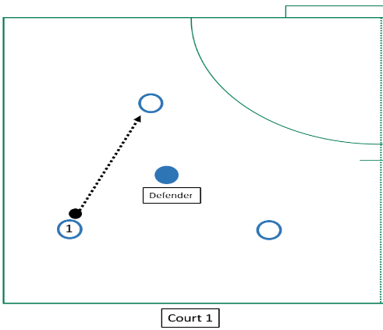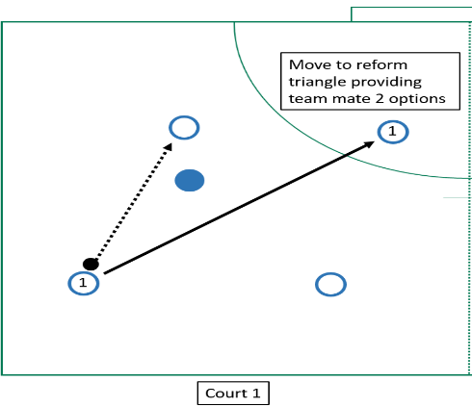

Diagram 11a – triangle drill pass and move 3v1 Diagram 11b

Activity 2 – offensive endball 4v4 minus 1

* Aim of the game is to make five consecutive passes before passing it to a teammate in their goal area to score a point.
* Gameplay with 4v4 with a goalie on one half of the court set up.
  + One player moves to marker on either sideline when team is defending.
* Use markers to create the end zone for scoring. (Diagram 12)
* Players are:
  + not to run when in possession of the ball (only pivot).
  + only able to hold the ball for three seconds.
  + non-contact (some incidental contact will occur).
* No offside rules – players can travel in any direction
* Turnovers – restart at point of rule violation, which include:
  + being out of boundary
  + excessive contact
  + dropped ball.
* Offensive team restarts with ball after an incomplete interception.
* Game starts at the end zone of the attacking team.
* Defence to play one-on-one defence.
* Differentiation – increase number of complete passes before scoring, a bounce included in sequence before scoring can occur, specify and limit pass type, use non-dominant hand only, rush goalie (any player can score the goal, but only one player at a time in the zone), change to zone defence.

Diagram 12 – offensive endball 4v4 minus 1

Lesson 5

Warm-up – coloured tails

* Use half of a court; four teams on each court move to one half.
* Teams start at different corners of the court. (Diagram 13)
* Students wear tag belts with one tail.
* Teams have two minutes to collect tails from as many people as they can.
* Keep collected tails in hand; if tail is taken studentsare to continue to retrieve tails.
* Teams run to corner when time runs out or all tails have been collected.
* Team with the highest number of tails is the winner.
* Differentiation – teams retrieve a tail of each colour, teams have two tails to begin with, two teams work together, students compete individually to see who can collect the most tails.

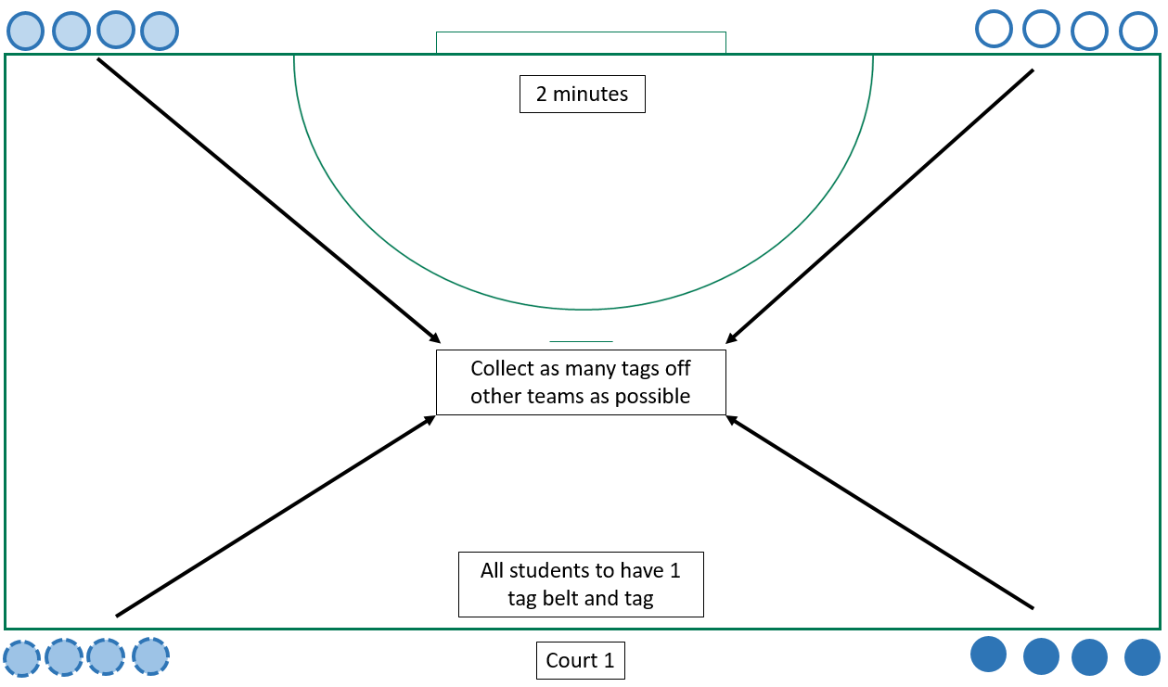Diagram 13 – coloured tails

Activity 1 – defenders r us

Teacher

* The aim of the game is to pass the ball to a teammate in the score zones to score as many points as possible in two minutes.
* Students play 4v4 on one half of the court.
* Use markers to create the scoring zones. (Diagram 14)
* Players can run, bounce or pass when in possession of the ball.
* Non-contact (some incidental contact will occur)**.**
* No offside rules – players can travel in any direction.
* Defenders are not allowed in the score sone.
* If defending team gains possession, they return ball to the attacking team, who restarts from the closest sideline. The point count continues throughout the two minutes.
* Game starts at the centre of the court.
* Differentiation – increase the number of complete passes before scoring, specify and limit pass type, use non-dominant hand only, include a bounce in sequence before scoring can occur, change position and size of the score zone, allow defenders inside the score zone.

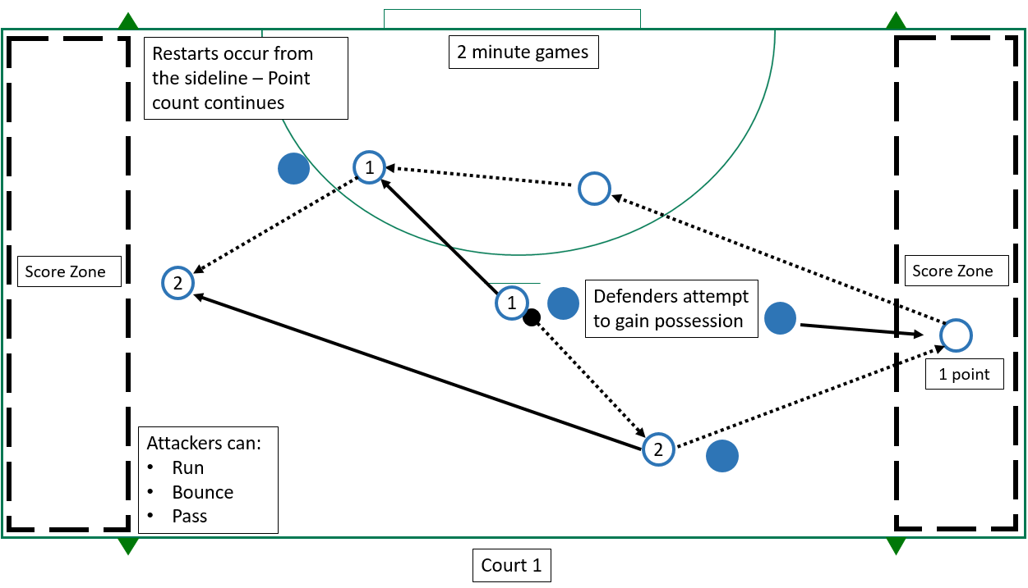

Diagram 14 – defenders r us

Activity 2 – defensive endball 3v3 plus 1

* The aim of the game is to make five consecutive passes before passing it to a teammate in their goal area, to score a point.
* Gameplay with 4v4 with rush goalie on one half of the court set up.
  + One player for each team starts at the sideline markers.
  + Player moves to sideline marker when team is in attack.
  + Rotate sideline players regularly.
* Use markers to create the end zone for scoring. (Diagram 15)
* Players are:
  + not to run when in possession of the ball (only pivot)
  + only allowed to hold the ball for three seconds
  + not allowed in the end zone when defending.
* Non-contact (some incidental contact will occur).
* No offside rules; players can travel in any direction.
* Turnovers – restart at the point of the violation, including:
  + out of bounds
  + excessive contact
  + dropped ball.
* Offensive team restarts with ball after an incomplete interception.
* Game starts at the end zone of the attacking team.
* Differentiation – increase number of passes before scoring, include a bounce in sequence before scoring can occur, specify and limit pass type, use non-dominant hand only.

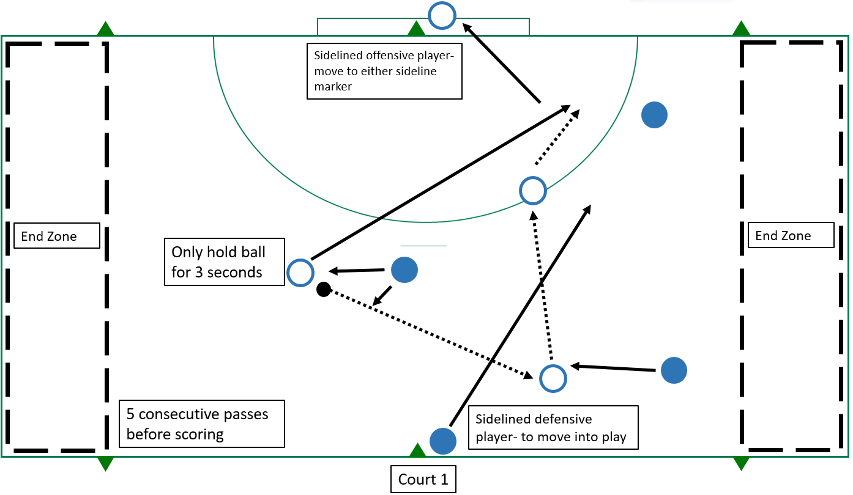

Diagram 15 – defensive endball 3 v 3 plus 1

Lesson 6

Warm-up – endball

* The aim of the game is to make five consecutive passes before passing it to a teammate in their goal area to score a point.
* Students split into teams of 8v8 with a goalie, two teams per one full court. (Diagram 16)
* Use the goal circles as endzones for scoring.
* Players are to:
  + not run when in possession of the ball (only pivot)
  + only hold the ball for three seconds.
* Non-contact (some incidental contact will occur).
* No offside rules – can travel any direction.
* Turnovers – restart at the point of the rule violation, including:
  + out-of-bounds
  + excessive contact
  + dropped ball.
* Offensive team restarts with ball after an incomplete interception.
* Game starts at the end zone of the attacking team.
* Differentiation – increase number of complete passes before scoring, include a bounce in sequence before scoring can occur.

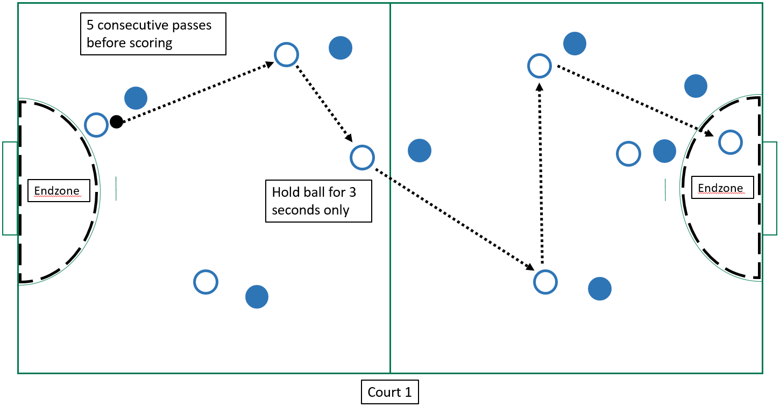Diagram 16 – endball

Activity 1 – handball shooting

* Students form groups of eight with three balls per group.
* Attacking players attempt to score a point for every pass sequence complete.
* Drill sequence (Diagram 17a):
  + player one starts with the ball and passes it to player two
  + player two passes the ball back to player one
  + player one moves to the goal area following handball rules and attempts to score
  + goalie attempts to stop the goal.
* Rotation of players (Diagram 17b):
  + player one retrieves ball, returns it to the back of the line and stands behind the goals
  + the player behind goals moves to goalie position
  + goalie moves to original player two position
  + player two moves to the back of the line.
* Differentiation – add a defender.

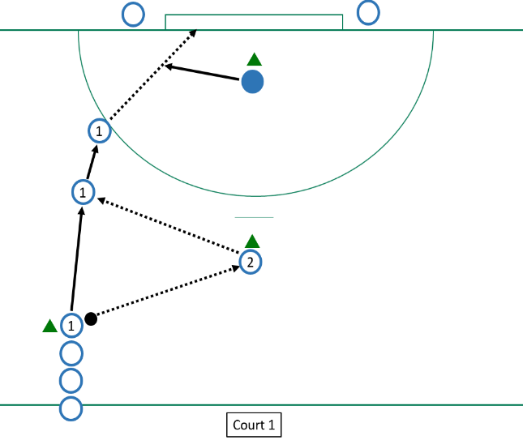

Diagram 17b – shooting drill rotation

Diagram 17a – shooting drill

Activity 2 – half-court handball

Teacher

* The aim of the game is to move the ball up the court, passing it to a teammate and to shoot it into the goal to score a point.
* Gameplay 4v4 including goalie using half-court set up and follow the handball rules. (Appendix A)
* One player moves to goalie position when team is in defence.
* Use markers or netball goal circle markings to create the end zone for scoring. (Diagram 18)
* Team in defence to cross the ball over the half-court line before attempting to score.
* Differentiation – allow students to choose which pass and when, use 1-on-1 defence and zone defence.

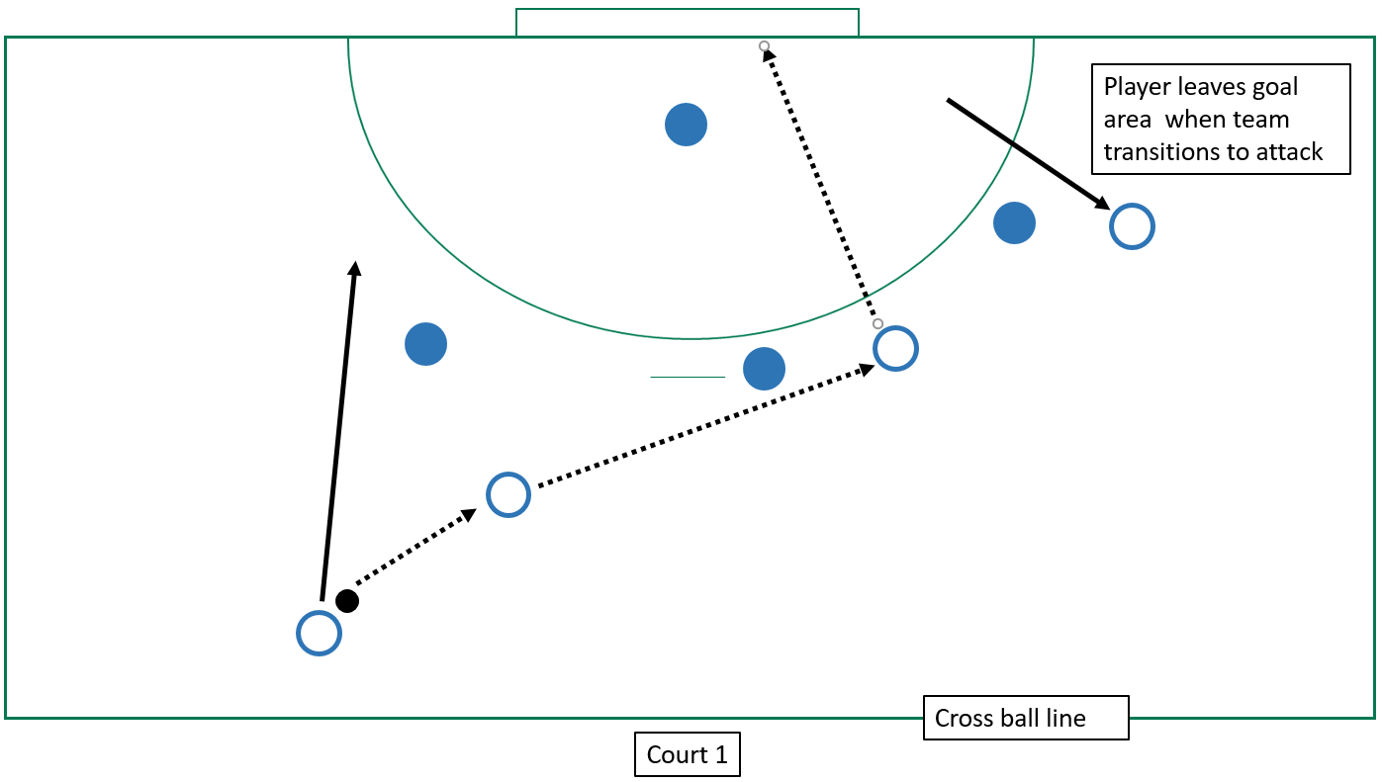

Player leaves goal area when team transitions to attack

Diagram 18 – half-court handball

Lesson 7

Warm-up – handball junior

* The aim of the game is to move the ball up the court passing it to a teammate and then shoot it into the goal to score a point.
* Gameplay 4v4, including goalie using half-court set up; use markers or netball goal circle markings to create the end zone for scoring. (Diagram 19)
* Follow handball rules, focusing on defensive plays (Appendix A.1).

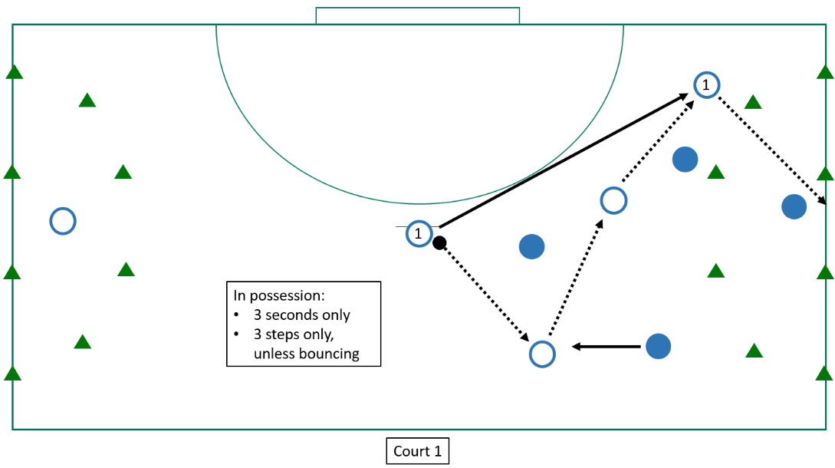

Diagram 19 – handball junior

Activity 1 – 1, 2, 3 play

* Students in two teams of eight per court, each lined up on opposite sidelines and one ball. Students number themselves 1–8.
* There will be two games occurring at the same time at both ends of the court.
* Students work in one half of the handball court with a small goal at one end.
* Teacher or a chosen student randomly calls out three numbers for each game. The students whose numbers are called run from the sideline, around the goals and towards the ball.
* The ball will be placed in the centre of the court when numbers are called out.
* The first team to reach the ball become the attackers and attempt to score. (Diagram 20)
  + In a possession sequence, an attacker must bounce before scoring.
  + If the defending team intercepts the ball, they pass the ball between themselves back to the halfway line. Once they have crossed it, they become the attackers.
* Each round lasts until one team scores or two minutes elapse, whichever occurs first.
* Ball is returned to the centre of the court and different numbers are called out to begin the new round.
* Differentiation – call less than or more than three numbers at a time, players must pass a certain amount of times before scoring, teams must pass to a teammate on the sideline before scoring.

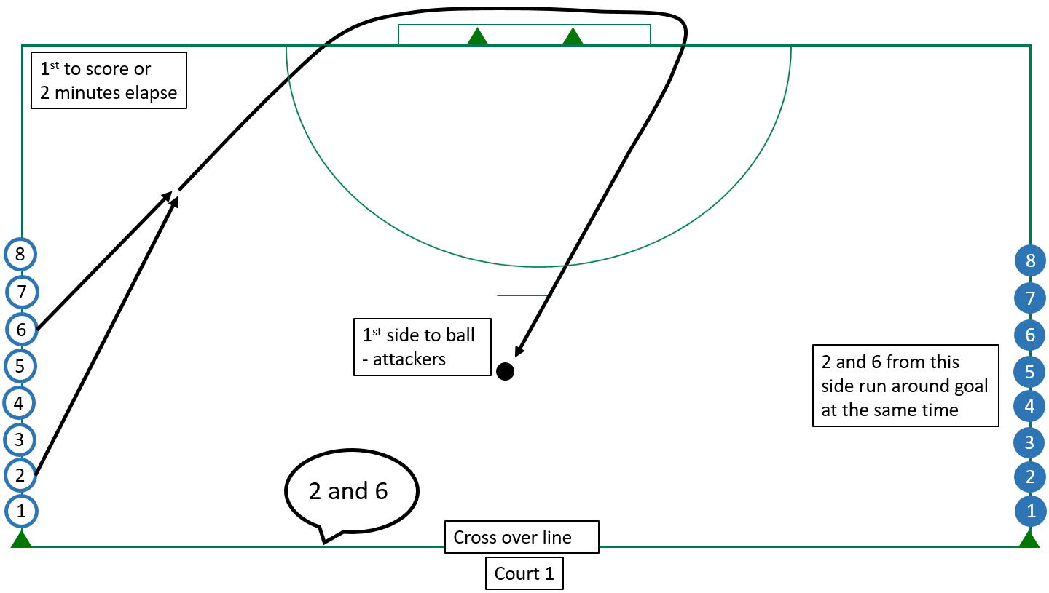Diagram 20 – 1, 2, 3 play

Activity 2 – timed-handball defence

Teacher

* The aim of the timed game is in three minutes, move the ball up the court, passing it to a teammate, and shoot into goal – to score a point. Attacking group scores as many times as they can in the three-minute time period.
* Gameplay 3v5, including goalie using the half-court set up and follow the handball rules (Appendix A).
* The eight players on the half-court break into three attackers and five defenders.
* All positions to be rotated within group.
* Use markers, or netball goal circle markings, to create the end zone for scoring. (Diagram 21)
* Team in attack must reset attack at the half-court line, before attempting to score again.
* Defending group is given time to plan and attempt different strategies to stop scoring attempts.
* Differentiation – attempt to use 1v1 defence or zone defence, return to ‘handball junior’ and practise defensive structures.

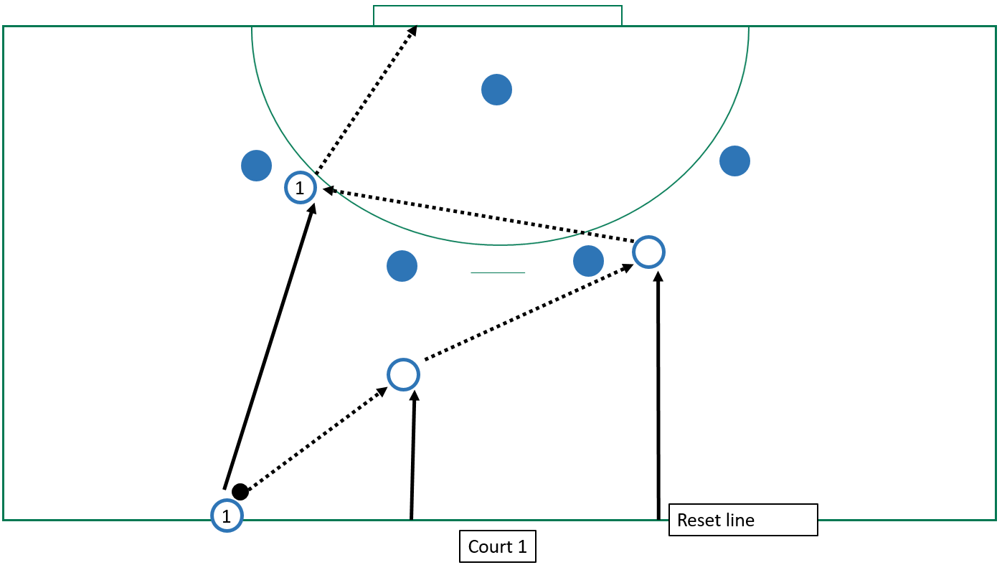

Diagram 21 – timed-handball defence

Lesson 8

Warm-up – captured

* Review defensive tactics and allow attacking players to work out strategies to penetrate defence.
  + Form groups of four, with two balls per group.
  + Game is played with half-court set up. (Diagram 22)
  + Balls are placed on a marker in each team’s goal circle.
  + The aim of each team is to capture the other team’s ball, and get it back to their half.
  + A player in their own half cannot be tagged.
  + A player in the opposition’s half can be tagged. If tagged, player returns to their own half.
  + Players cannot enter their own goal circle. It is a safe zone for attacking players.
  + Once an attacking player has captured the ball they must run or pass the ball to return to the half-way line.
    - Depending on class ability, attacking players are required to pass twice before passing and receiving over the halfway line to win.
    - If an attacker is tagged with the ball it returns to the goal circle and the player returns to their half.
* The attacking team can pass back into the goal circle for safety. If playing two pass variant, the count pass starts again. A diagram of a basketball court

  AI-generated content may be incorrect.

Diagram 22 – captured

Activity 1 – handball defence

* The aim of the activity is to focus on different defensive strategies in order to deny attackers opportunities to score.
* Gameplay 3v5 (including goalie) – using half-court set up and following handball rules  
  (Appendix A).
* The eight players divide into three attackers and five defenders, and begin on markers.
* Attacking groups of three have three chances to score.
  + Reset at half-way line after each unsuccessful attack sequence
* Defending group attempts different strategies to stop scoring.
  + 1-on-1 defence or zone-defence set ups.
* All positions to be rotated within group during activity.
* Attackers to have the bibs on.
* Use markers or netball goal circle markings to create the end zone for scoring. (Diagram 23)
* Team in attack needs to reset attack at the half-court line before attempting to score again.
* Attacking group has three chances to score before rotating positions.
* Differentiation – students attempt to use 1-on-1 defence and zone defence.

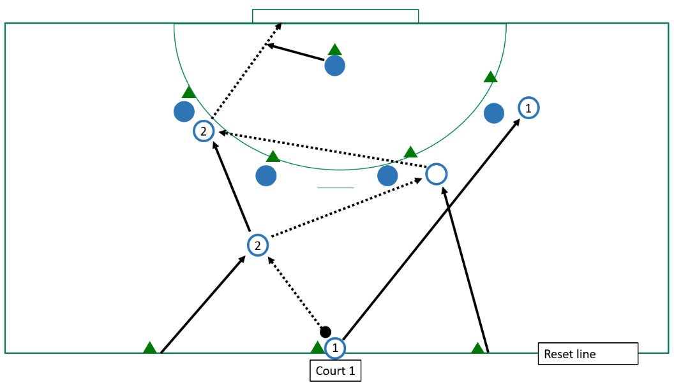

Diagram 23 – handball defence

Activity 2 – handball junior

* The aim of the game is to move the ball up the court passing it to a teammate and then shoot it into the goal to score a point.
* Gameplay 4v4, including goalie using half-court set up; use markers or netball goal circle markings to create the end zone for scoring. (Diagram 24)
* Follow handball rules, focusing on offensive plays and defensive strategies and tactics (Appendix A.1).

Diagram 24 – handball junior

Lesson 9

Warm-up and team allocation – possession tag v2

* Teacher allocates students into teams of four to participate in this task; one ball between two teams. Students can be allocated according to ability within the class, or teams can be representative of a mixture of abilities.
* Each team will be responsible for carrying out the following warm-up task in preparation for the assessment to follow.
* Allocate each team their first game. (Diagram 25)
  + Each game is allocated one half of a court set up, or similar as space allows.
  + Start with one team in possession of the ball in the centre of the area.
  + Games are played for three minutes, then rotate teams to play the three other teams on each court.
  + Attacking players can run and pass the ball in any direction and attempt to receive the ball over the goal line to score a point.
  + Attacking players can only remain in a score zone for three seconds.
  + Dropped ball – with minimal physical contact – ball is contested.
  + Touch
    - offensive player – touched with the ball they have two seconds to pass the ball
    - defensive player – calls ‘touch’ when they tag an offensive player.
* Rule violations result in turnover – defending players move 3 m away to restart.
* Attacking team to maintain possession for the five tags before it results in a turnover.
* The other team can attempt to gain possession, and begin to attempt scoring once in possession.

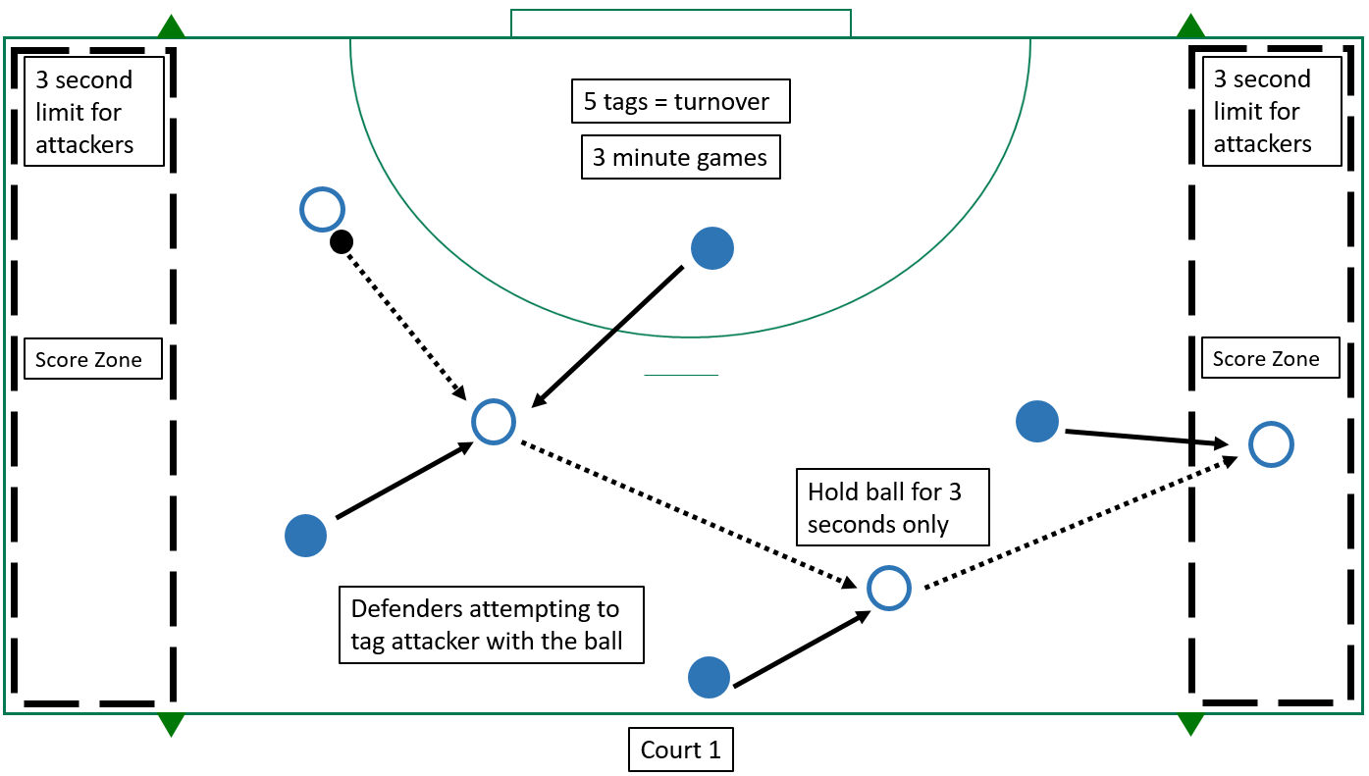

(half-court)

Diagram 25 – possession tag v2

Activity 2 – summative assessment – handball junior

* Review instructions for handball junior.
  + The aim of the game is to move the ball up the court, passing it to a teammate, and then shooting it into the goal to score a point.
  + Gameplay 4v4 (including goalie) – using half-court set up.
  + Follow handball rules (Appendix A.1).
  + At least one team to have bibs on.
  + Use markers or netball goal circle markings to create the end zone for scoring. (Diagram 26)

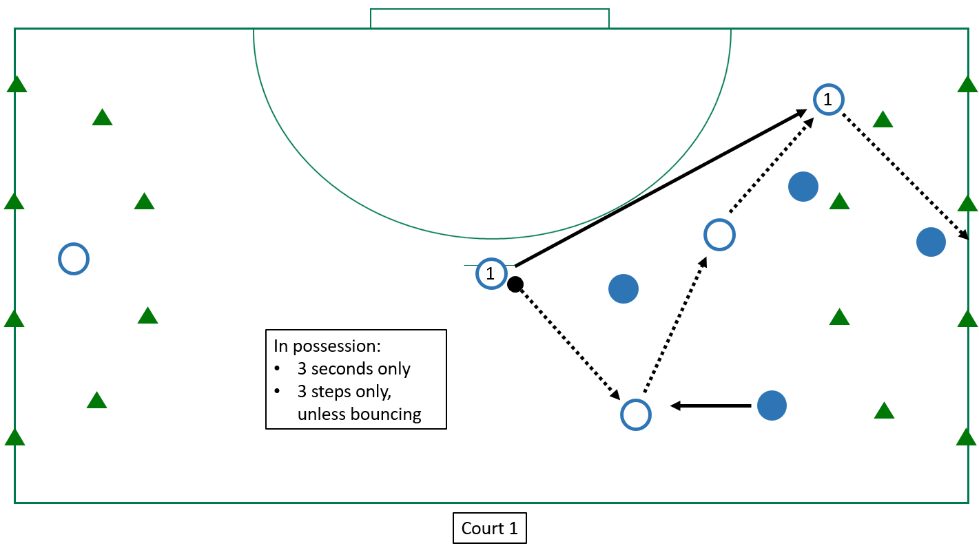

Diagram 26 – handball junior

Note: teachers can determine whether to progress to full-sided games with umpires to complete the program in the final lesson.

Lesson 10

Warm-up and team allocation – captured

* To review learning and prepare in teams:
  + Teacher organises students into four-sided teams to participate in this task. Students can be allocated to teams according to ability within the class, or teams can be representative of a mixture of abilities.
  + Each team will be responsible for carrying out the following warm-up task in preparation for the assessment to follow.
* Allocate each team their first game.
* Review defensive tactics and allow attacking players to work out strategies to penetrate defence.
* Give instructions for capture drill.
  + Organise students into groups of four, two balls per group.
  + The game is played with a half-court set up.
  + The balls are placed on a marker in each team’s goal circle.
  + The aim of each team is to capture the other team’s ball, and get it back to their half.
  + A player in their own half cannot be tagged.
  + A player in the opposition’s half can be tagged. If tagged, player returns to their own half. (Diagram 27)
  + Players cannot enter their own goal circle. It is a safe zone for attacking players.
  + Once an attacking player has captured the ball, they must run, or pass the ball to return to the half-way line.
    - Depending on class ability, attacking players are required to pass twice before passing and receiving over the halfway line to win.
  + If an attacker is tagged with the ball, it is returned to the goal circle and the player returns to their half.
  + The attacking team can pass back into the goal circle for safety. If playing a two-pass variant, the count pass starts again.

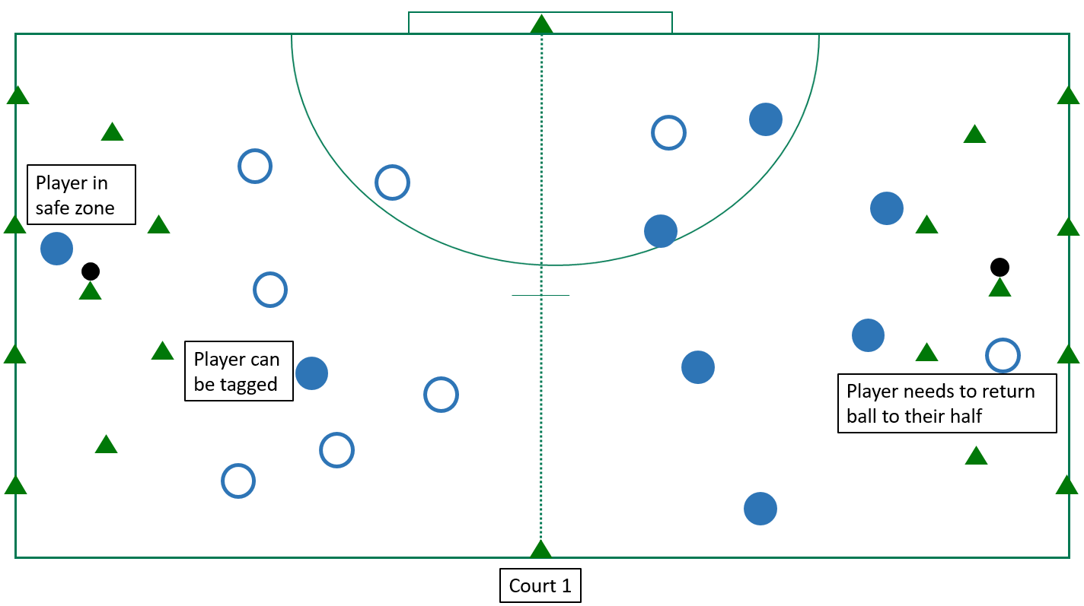

Diagram 27 – captured

Activity 2 – summative assessment – handball junior

* Review instructions for handball junior.
  + The aim of the game is to move the ball up the court, passing it to a teammate, and then shooting it into the goal to score a point.
  + Gameplay 4v4 (including goalie) – using half-court set up.
  + Follow handball rules (Appendix A.1).
  + At least one team to have bibs on.
  + Use markers or netball goal circle markings to create the end zone for scoring. (Diagram 26)

Note: teachers can determine whether to progress to full-sided games with umpires to complete the program in the final lesson.

Appendix B: Assessment task  
(summative)

Invasion games – skills and strategies

Summative assessment

Title of task

Invasion games skills and strategies in a handball context

Task details

**Description of task** Students will participate in a 4v4 half-court handball game to demonstrate a variety of individual and game-based, competitive skills.

**Type of assessment** Summative

**Purpose of assessment** To assess students on proficiency of skills, selection and use of skills offensive and defensive tactical application.

**Assessment strategy** Performance

**Evidence to be collected** Checklist/video footage

**Suggested time** Two lessons:

Weeks 9 and 10

Content description

**Content from the Western Australian Curriculum**

Movement skills

* Movement skills and sequences within different physical activity contexts and settings reflecting:
  + increased speed and accuracy
  + improved efficiency
  + increased complexity
* Skills, strategies and tactics in new or challenging movement situations and the impact of each on movement outcomes

Key concepts

Skill proficiency – Passing, receiving and bouncing

Skills, strategies and tactics

* possession – maintaining and gaining
* space – finding and denying
* goal scoring – scoring and defending

Task preparation

**Prior learning**

Students have participated in the relevant lessons and been instructed in the individual skills, game tactics and rules to effectively compete in a game of handball.

Assessment task

**Assessment conditions**

* Assessment will involve students in game-based, team scenarios.
* Students can be grouped according to ability or maintain mixed ability across the group.

**Differentiation**

Teachers should differentiate their teaching and assessment to meet the specific learning needs of their students, based on their readiness to learn and their need to be challenged.

Where appropriate teachers may scaffold or extend the scope of the assessment tasks.

Resources

* gameplay marking observations
* gameplay marking key
* one half of a handball court
* bibs for each team
* handball (one per game)
* rules of handball (Appendix A.1)
* filming device (if recording evidence)

Instructions for teachers

Students will be assessed using the Gameplay marking key (Appendix C) throughout this sequence on a lesson-by-lesson basis. This use of formative assessment provides the teacher with additional evidence on which to base their final assessment mark.

The purpose of the summative assessment is to finalise the formative assessment, giving students the opportunity to demonstrate all the skills and knowledge they have acquired during this lesson sequence.

**Task**

Students to participate in a 4v4 handball game, as practised throughout the lesson sequence.



* Teacher to organise students into teams of four to participate in this task.
* Students can be allocated according to ability within the class, or teams can be representative of a mixture of abilities.
* Students can stay in the same teams for the duration of the assessment; however, flexibility to move students to different teams will provide an opportunity for students to experience a range of different situations.
* Games will run for a set time (according to fitness and ability levels), with multiple courts running concurrently.
* Teachers to rotate teams, allowing for students’ level of fitness.

Students will be assessed on:

* proficiency of skills
* selection and application of handball skills in the game context
* offensive and defensive strategic and tactical application – creating, using and defending space.

**Assessment notes**

For both lessons of the practical assessment, evidence can be collated through video recording to review, or an observation schedule can be implemented.

Students will be assessed according to the Gameplay marking observations and marking key provided. Teachers will use this table to make a holistic judgement regarding students’ proficiency, selection and application of skills and tactical application in both offence and defence contexts in a game situation.

Students will be awarded a mark out of 10 for each area based on their performance, in accordance with the observation table.

**Gameplay marking observations**

|  |  |  |  |
| --- | --- | --- | --- |
| **Proficiency** | **Selection and application of skills** | **Strategic and tactical application** | **Strategic and tactical application** |
| * execution   + consistency   + control   + fluency   + precision   + force   + speed   + accuracy   + efficiency * efficient sequencing of body parts during kicking * footwork and body position in preparation for next move * appropriateness of pass distance | * selection and transfer of skills and sequences between movement contexts and settings * examples of decisions to be made could include choice of pass to use at the appropriate time | Defence   * regaining possession * anticipates ball movement and moves to defensive position * reads the play to prevent scoring opportunities * appropriate marking of an opponent who may or may not have the ball * transitional play shows attacking flair in turnovers * communication with teammates | Offence   * maintaining possession * leads to open space to create a passing option for a teammate or draw defenders away * creating scoring opportunities * creates options by moving to areas, such as behind a defender or passes to teammate in open position supports teammate with the ball * transitional play – moves to a defensive position when possession is lost * communication with teammates |

Use this table to assist in making a holistic judgement regarding performance in each of the four areas.

Marking key

Demonstration of skills in competitive situations will be assessed taking into account the combination of four elements of an action, i.e. consistency, precision, fluency, control.

Game pressure, pace, skill and intensity of opponent and teammates, playing area, environmental conditions etc. may affect performance, and should be taken into account when marking.

|  |  |  |
| --- | --- | --- |
| Description | | Marks |
| **Proficiency** |  | |
| Consistently performs skills with efficiency, precision and fluency  Consistently controls the flight and delivery of the ball, achieving the desired outcome | | 5 |
| Performs skills with a high degree of precision and fluency  Demonstrates a high-level of control of the delivery and flight of the ball when aiming for a target, with a high degree of success in achieving the desired outcome | | 4 |
| Performs most skills with precision and fluency  Controls the delivery and flight of the ball when aiming for a target most of the time, mostly achieving the desired outcome | | 3 |
| Performs some skills with fluency and precision  Controls the delivery and flight of the ball some of the time when aiming for a target, with some degree of success in achieving the desired outcome | | 2 |
| Performs few skills and demonstrates limited fluency  Demonstrates limited control of the delivery and flight of the ball when aiming for a target, with a low degree of success in achieving the desired outcome | | 1 |
| **Subtotal** | | **/5** |
| **Selection and application of skills** |  | |
| Consistently makes the correct decision and selects a variety of skills that range from simple to complex and are appropriate to the situation, achieving the desired outcome | | 5 |
| Selects a broad range of simple and complex skills that are mostly appropriate for the situation, with a high degree of success in achieving the desired outcome | | 4 |
| Selects and uses mainly simple skills that are mostly appropriate for the situation, usually achieving the desired outcome | | 3 |
| Uses the appropriate skills in some situations, giving preference to more familiar and less complex skills | | 2 |
| Performs a limited range of simple skills regardless of the situation, with a low degree of success in achieving the desired outcome | | 1 |
| **Subtotal** | | **/5** |
| **Strategic and tactical application in offence** |  | |
| Performs required skills appropriate to the competitive situation to an exceptional level, demonstrating creativity, deception and anticipation while maintaining intensity under game-like pressure | | 5 |
| Performs required skills appropriate to the competitive situation with some consistency to a high-level, usually demonstrating creativity, deception and anticipation, while maintaining intensity under game-like pressure on most occasions | | 4 |
| Often performs required skills appropriate to the competitive situation, at times demonstrating creativity, deception and anticipation at a reduced intensity | | 3 |
| Sometimes performs required skills appropriate to the competitive situation, occasionally demonstrating a low degree of creativity, deception or anticipation at a low intensity | | 2 |
| At times performs required skills appropriate to the competitive situation, with little or no creativity, deception or anticipation at a minimal intensity | | 1 |
| **Subtotal** | | **/5** |
| **Strategic and tactical application in defence** |  | |
| Performs required skills appropriate to the competitive situation to an exceptional level, demonstrating creativity, deception and anticipation while maintaining intensity under game-like pressure | | 5 |
| Performs required skills appropriate to the competitive situation with some consistency to a high-level, usually demonstrating creativity, deception and anticipation, while maintaining intensity under game-like pressure on most occasions | | 4 |
| Often performs required skills appropriate to the competitive situation, at times demonstrating creativity, deception and anticipation at a reduced intensity | | 3 |
| Sometimes performs required skills appropriate to the competitive situation, occasionally demonstrating a low degree of creativity, deception or anticipation at a low intensity | | 2 |
| At times performs required skills appropriate to the competitive situation, with little or no creativity, deception or anticipation at a minimal intensity | | 1 |
| **Subtotal** | | **/5** |
| **Total** | | **/20** |

