Assessment task
Year level | 6
Learning area | The Arts
Subject | Visual Arts
Title of task | The Imagined World
Task guidelines
Description of task | Referencing the style and artwork of WA artist Yvonne Zago, students will explore the natural world and the concept of imaginary adventure through drawing and design to create an artwork (either 2D or 3D) inspired by the theme The Imagined World.
Type of assessment | Making and Responding
Purpose of assessment | To determine student progress against the Achievement standard, through both formative and summative tasks.
Assessment strategy | Observational drawings, teacher observations, design documentation, annotated notes, final artwork and written responses.
Evidence to be collected | Making  Students will complete and submit a final artwork (either 2D or 3D) accompanied by teacher directed inquiry and design documentation, inclusive of:  - observational drawings of flora and/or fauna  - stylised character/figure drawing  - one final colour design with annotated notes  - one final artwork (either 2D or 3D).  Responding  - Written analysis – Postcard
Suggested time | 10 weeks
Content description
Content from the Western Australian Curriculum | Making  Ideas  Exploration of artwork inspired by observation or imagination from various artists and cultures that use materials and techniques to enhance the artist’s belief or viewpoint  Application of visual art elements and selection of materials, media and/or technologies, to communicate an idea, belief or viewpoint  Skills  Development and application of artistic techniques and processes with:  - shape (exaggerated proportions; motifs; fonts)  - colour (colour wheel; tertiary colour)  - line (lines that create an illusion)  - space (focal point and one-point perspective; basic facial proportions; horizontal and vertical symmetry)  - texture (real and simulated)  - value (highlights; shadows; form)  to create artwork  Use of a variety of techniques, art processes and art forms, such as digital imaging, lino printing or stencils to suit purpose.
Production
Presentation and reflection of ideas, feelings, beliefs and viewpoints expressed in artwork, including consideration of audience and feedback
Responding
Personal responses, using visual art terminology, about how visual art elements, techniques and symbolic meaning communicate ideas and messages; and identifying factors that influence artwork from different social, cultural and historical times
Task preparation
Prior learning | Students may have been introduced to diverse styles, techniques and processes by other artists, and how this can influence their own artwork.
Assessment differentiation | Teachers should differentiate their teaching and assessment to meet the specific learning needs of their own students, based on their level of readiness to learn or to be challenged. Where appropriate, teachers may either scaffold or extend the scope of the assessment tasks.
Assessment task
Assessment conditions | This assessment is a whole class experience with students producing individual artwork. It is recommended that the final artwork be more micro than macro, to accommodate possible time restraints. Art making Ideas, Skills, Production and Responding tasks to be completed within class time.
Resources | Resources will vary depending on the specific art form chosen by teacher/student.  Suggested resources may include:  Painting:  - watercolour paints  - acrylic paints  - paint pens (POSCA)  - inks  - spray paint  - brushes, supports, newspaper, palettes, dust masks, jars, aprons, rags.  Drawing:  - paper  - pencil (lead pencil, colour pencil, watercolour pencil)  - charcoal  - soft pastel  - crayons (oil pastels, wax crayons, water soluble oil pastels)  - coloured markers, fine liner etc.  Printmaking:  - paper  - pencil (lead pencil, colour pencil, watercolour pencil)  - charcoal  - soft pastel  - crayons (oil pastels, wax crayons, water soluble oil pastels)  - coloured markers, fine liner etc.  Sculpture:  - ceramics – paper clay, clay, air dry clay, clay tools  - papier-machê – newspaper, junk mail, tissue paper, glue, tape  - mobile – found objects, cut paper, streamers, fishing line, string, coat hanger.

Task instructions
Responding (1.5 hours)
Responding Task – Postcard
Introduce students to the artwork of Western Australian artist Yvonne Zago.
Using source images of artworks by Yvonne Zago, discuss the artist’s style and selected artwork/s.
Focus questions could include:
- What do you see?
- How do you feel when you look at it?
- What is happening in the artwork?
- What type of lines can you see?
- What type of shapes can you see?
- Where does your eye go to first? Why?
- List three words to describe the artwork.
- What do you notice about the colour in the artwork?
- How has the artist shown each of the key features (listed below)?
Characterisation: facial expression, face shape and features, proportion, body language, body silhouette, realism/idealisation, character traits, visual stereotypes, simplification, drawing style.
Suggested reading material for teachers who wish to look at characterisation and stylised art:
https://www.creativebloq.com/illustration/pro-tips-creating-stylised-art-91516795
https://design.tutsplus.com/articles/cartoon-fundamentals-how-to-draw-a-cartoon-body--vector-18651
https://www.21-draw.com/wp-content/uploads/2020/04/The-Character-Designer-ebook-2019-SAMPLE-21-Draw.pdf
Pattern/Repetition: repeated shapes, lines and colour – the repetition of one or more art elements to create a sense of unity, e.g. leaves, lacework, feathers
Distortion/Exaggeration: visual changes in size, proportion or general character – e.g. size of facial features (elongated limbs, big hair, posture, eyes). Alteration of anything from the realistic.
Provide the following scenario to students
You are holidaying and have just visited the local art gallery displaying the artwork of the artist Yvonne Zago. As you leave the exhibition, you are drawn to the art gallery shop and see postcards of the artist’s work. You were so absorbed and intrigued by the work of this artist that you decide to purchase a postcard.
From the postcard templates (attached) provided by your teacher, choose the one that most appeals to you:
Postcard Option 1: Artwork 1 (Yvonne Zago, Taking the Time 2014)
Postcard Option 2: Artwork 2 (Yvonne Zago, The Boy and His Donkey 2014)
As you venture back to your hotel, you decide to write to a relative/friend who you think might also appreciate the artist’s artwork. Using visual art terminology, write about your experience by describing what the artwork looked like, how it made you feel and what you thought it was about.
Steps:
- Students choose from photocopied postcard templates.
- Students write a response to the artwork, including a detailed description of the key features, the artist’s use of art elements (supported with evidence), the meaning of the artwork and their own personal opinion.
- Teacher assesses using Responding task: Postcard Marking key (provided).
Postcard Option 1 : Yvonne Zago – Taking the Time

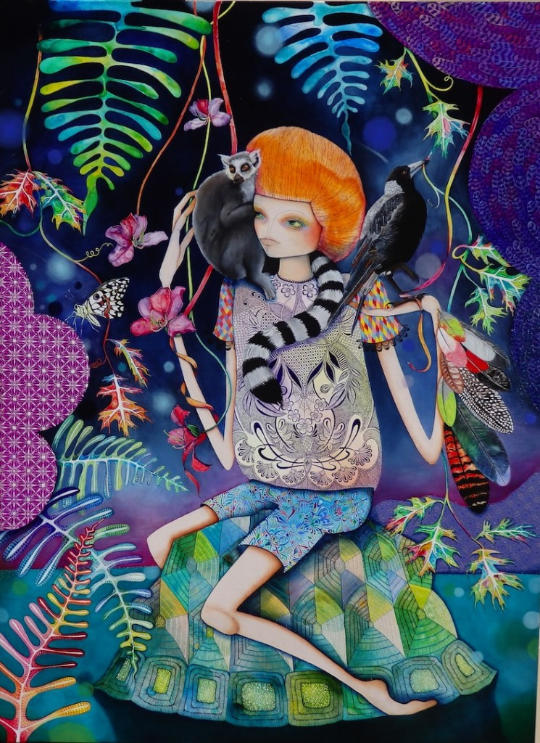
Yvonne Zago
Taking the Time
(edition of 20)
2014
Print on ragpaper
76 x 56 cm

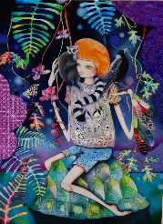
Postcard Option 2 : Yvonne Zago - The Boy and His Donkey

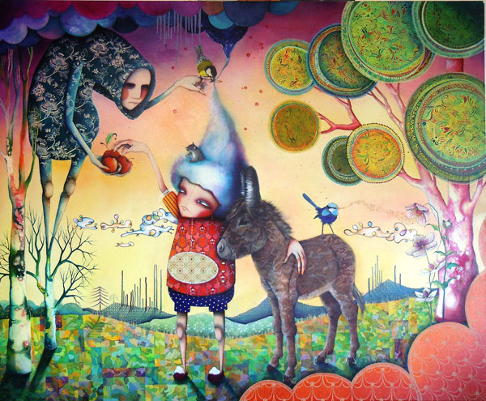

Yvonne Zago
The Boy and His Donkey
2014
Oil, acrylic and pigment ink on canvas
138 x 168cm
76 x 56 cm

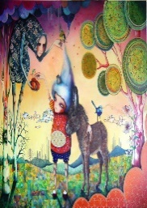

Responding Task: Postcard marking key
Description | Marks
Description of key features with art terminology
Describes the key features of the artwork in detail using art terminology | 3
Describes the key features of the artwork in some detail using some art terminology | 2
Describes the key features briefly with little or no art terminology | 1
Subtotal | /3
Description of the artist’s use of visual art elements in the artwork with evidence
Accurately describes the artist’s use of visual art elements in the artwork with evidence | 4
Describes the artist’s use of visual art elements in the artwork with some evidence | 3
Describes some visual art elements in the artwork | 2
Identifies few visual art elements in the artwork | 1
Subtotal | /4
Meaning associated with artwork
Makes a considered comment about the meaning of the artwork | 3
Makes a straightforward comment about the meaning of the artwork | 2
Makes a superficial or incomplete comment about the artwork | 1
Subtotal | /3
Personal opinion about the artwork of chosen artist
Provides a considered personal opinion about the artwork | 3
Provides a simple personal opinion about the artwork | 2
Provides little or no personal opinion about the artwork | 1
Subtotal | /3
Total | /13
Comment

Making
Making Task
IDEAS
Discussion (15 minutes)
As a class, students consider and brainstorm what an imaginary place/scene might look like. Discuss the importance of imaginative thinking and what inspires artists’ imagination. To prompt group discussion, teachers may need to provide visual exemplars about how artists use visual art language to emphasise their idea of fantasy and the invented, e.g. distorted or exaggerated shapes in a landscape, unusual placement or scale of objects, quirky characters etc.
Ask students to close their eyes and think about an imaginary place. Focus questions to promote discussion may include:
- What does your imaginary place look like?
- Is it an island, a room, a cave or in the desert?
- What is unusual or fantastic about your imaginary place?
- What is familiar?
- What shapes, colours and objects might be there?
- Is anything distorted or altered?
- How does your imaginary place make you feel?
- Describe the character/s in this imaginary place.
SKILLS
Part A — Observational drawing (40 minutes)
Teacher to source and provide images of flora and/or fauna to use as drawing stimulus or, alternatively, teacher may take students out into the school grounds or local environment, to observe and draw from the natural environment. Where possible, students may also document their sensory experiences, by including notes about sounds, smells and textures. Teacher to demonstrate the following drawing techniques: blind contour, contour line and tonal drawing.

Using the Observational drawing template (print to A3), students complete three drawings of flora and/or fauna, using 2B pencil:
- Blind contour (3 minutes). Encourage students to:
- keep eye on the object/image and using one continuous line draw the object without lifting the pencil or looking at the page
- draw slowly and imagine that the pencil is touching the object as the eye travels around it
- include as much detail as possible.
- Contour line drawing (7 minutes) – as above, but students can look at their drawing as they go.
- Tonal drawing (30 minutes) – complete a detailed drawing using line to identify shape and tonal rendering to create three-dimensional form. Consider areas of light, medium and dark tones when indicating form.

Part B — Character/Figure Drawing (30 minutes)
With reference to Zago’s style, teacher to demonstrate how to create a simple character, discussing the importance of facial expression, face shape and features, proportion, character traits, body language and exaggeration/distortion. Adapting Zago’s style, students will complete one character/figure drawing, in the provided Adventure time character template. Drawing to be completed using 2B pencil and rendered in black fine liner.
IDEAS
Part C — Design documentation (1.5 hours)
Based on school budget, time frame and expertise, teacher to decide whether students will create a 2D or 3D artwork. See table below for possible options.
2D |  | 3D
Painting/Drawing | Printmaking | Sculpture
- Illustration – pencil, watercolour pencil, rendered marker drawing or crayons  - Painting – acrylic paints, paint pens or watercolour paints | - Reduction printing using lino or foam board  - Etching  - Screen printing | - Ceramic form using either clay, air dry clay, model magic or plasticine  - Papier-machê  - Mobile
Teacher to distribute design template sheet (print to A3) to students.
Students select one of their observational drawings from Part A and their character/figure drawing from Part B, and redraw these inside the design box in the Annotated Final Design Template. Discuss the elements of colour, space, line, shape and how to adapt Zago’s signature style and bright palette. You may also like to discuss focal point and pattern as you demonstrate the design process. Students should incorporate one or more of the following key features in their design:
- characterisation
- pattern/repetition
- distortion/exaggeration
and should consider:
- the position of their drawing in the box
- elements: colour, space, line and shape
- the relationship between positive and negative space.
Students render the final design using coloured pencils, markers or watercolour and include annotations that identify:
- one strength in their design
- colour palette (using art terminology)
- key feature (reason/s for choice).

PRODUCTION
Part D – Final artwork (6 hours)
Students use their final design to commence final artwork. Teacher to demonstrate technique/s specific to selected art form – some examples listed below.
- Ceramics – simple pinch pot construction, joining and storage of clay work.
- Papier-machê – armature construction techniques, papier-machê techniques, including how to apply paper layers correctly to create a smooth surface and build form.
- Mobile – joining and hanging sculptural elements to create mobile.
- Drawing/Rendering – techniques of hatching, cross-hatching, blending, rendering using an eraser, contour and cross-contour, stippling.
- Painting – differences in application of paint: pressure, transparency, opacity and stroke direction, brush techniques of blending, dry brush, sgraffito, double-loading, and wet-on-dry.

Teacher to demonstrate safe work practices associated with selected art form.
Students refer to final design to commence and complete final artwork in allocated timeframe.
Teacher to use Making task: The Imagined World Marking key (provided) to assess drawings, design and final artwork.

Part A — Observational drawing template – Year 6 Visual Arts – The Imagined World
Name:
Blind contour drawing | Contour line drawing
Tonal drawing (detailed)

Part B— Adventure time character template – Year 6 Visual Arts – The Imagined World
Name:

Part C — Annotated final design template Year 6 Visual Arts – The Imagined World Name:
Annotate your final design to identify one strength, your choice of colour palette (use art terminology) and reason for choosing the key feature
Design 1: | STRENGTH  A strength in my final design is …
COLOUR PALETTE
My selected colour palette for my final design is …
KEY FEATURE
I selected (circle one below) …
- characterisation
- pattern/repetition
- distortion/exaggeration
to incorporate into my final design because …

Making task: The Imagined World marking key (Parts A, B, C and D)
Description | Marks
Ideas
Communication of ideas, drawings, and designs
Communicates clear and effective ideas, drawings and design | 3
Communicates simple and adequate ideas, drawings and design | 2
Communicates undeveloped ideas, drawings and design | 1
Subtotal | /3
Skills and Production
Use of visual art elements and techniques to convey ideas
Applies visual art elements effectively to convey ideas | 4
Applies visual art elements appropriately to convey ideas | 3
Applies some visual art elements to convey ideas | 2
Applies few visual art elements to convey ideas | 1
Subtotal | /4
Annotations to show planning of design ideas
Provides relevant annotations in written and/or visual form to show planning of design ideas | 3
Provides some annotations in written and/or visual form to show planning of design ideas | 2
Provides superficial or incomplete annotations in written and/or visual form of design ideas | 1
Subtotal | /3
Use of media and/or materials to enhance ideas
Demonstrates effective use of media and/or materials to enhance ideas | 4
Demonstrates appropriate use of media and/or materials to enhance ideas | 3
Demonstrates simple use of media and/or materials to represent ideas | 2
Demonstrates rudimentary use of media and/or materials to represent ideas | 1
Subtotal | 4/
Application of techniques and processes to resolve artwork
Demonstrates effective application of techniques and/or processes in final artwork | 4
Demonstrates appropriate application of techniques and/or processes in final artwork | 3
Demonstrates consistent application of techniques and/or processes in final artwork | 2
Demonstrates rudimentary application of techniques and/or processes in final artwork | 1
Subtotal | /4
Total | /18
Comment

Acknowledgements
Postcards
Option 1 Zago, Y. (2014). Taking the time [Oil and acrylic on canvas]. Linton & Kay Galleries, Western Australia. Retrieved February, 2021, from https://www.
lintonandkay.com.au/wp-content/uploads/2014/10/TAKING-THE-TIME-154-X-113CM-2014-745x1024.jpg

Option 2 Zago, Y. (2012). The boy and his donkey [Oil, acrylic and pigmented ink on canvas]. Linton & Kay Galleries, Western Australia. Retrieved February, 2021, from https://www.lintonandkay.com.au/wp-content/uploads/2013/05/
1476-image5.jpg
A3 sheet
Image 1 Zago, Y. (2014). Taking the time [Oil and acrylic on canvas]. Linton & Kay Galleries, Western Australia. Retrieved February, 2021, from https://www.
lintonandkay.com.au/wp-content/uploads/2014/10/TAKING-THE-TIME-154-X-113CM-2014-745x1024.jpg

Image 2 Zago, Y. (2016). Finding new places [Synthetic polymer and oil on canvas]. Linton & Kay Galleries, Western Australia. Retrieved February, 2021, from https://www.lintonandkay.com.au/wp-content/uploads/2016/07/1476-20160714033847-Zago_Finding%20New%20Places_%2062%20x%2092cm_
2016.jpg

Image 3 Zago, Y. (2014). Can one see all that is and all that may and not be changed eternally [Acrylic and oil on canvas]. Linton & Kay Galleries, Western Australia. Retrieved February, 2021, from https://www.lintonandkay.com.
au/wp-content/uploads/2014/10/1476-20141020083345-Can%20one%20
see%20all%20that%20is%20and%20all%20that%20may%20and%20not%20be%20changed%20eternally-746x1024.jpg

Image 4 Zago, Y. (2013). There is no such thing as false hope [Oil, acrylic and pigmented ink on canvas]. Linton & Kay Galleries, Western Australia. Retrieved February, 2021, from https://www.lintonandkay.com.au/wp-content/uploads/2013/12/there-is-no-such-thing-as-false-hope-122-x-107-cm1-1024x897.jpg

Image 5 Zago, Y. (2013). And forget not that the earth delights to feel your bare feet and the winds long to play with your hair [Mixed media on canvas]. Linton & Kay Galleries, Western Australia. Retrieved February, 2021, from https://
www.lintonandkay.com.au/wp-content/uploads/2013/06/web-and-forget-not-that-the-earth-delights-199-x-153-cm.jpg

Image 6 Zago, Y. (2015). You are my heartstrings [Synthetic polymer and oil on canvas]. Linton & Kay Galleries, Western Australia. Retrieved February, 2021, from https://www.lintonandkay.com.au/wp-content/uploads/2016/07/1476
-20160714033845-You%20are%20my%20heartstrings%20122%20x%20122
cm%20Web.jpg

Image 7 Zago, Y. (2010). The kindness of small friends [Oil, acrylic and pigmented ink on linen]. Linton & Kay Galleries, Western Australia. Retrieved February, 2021, from https://www.lintonandkay.com.au/wp-content/uploads/2013/
07/1476-20130710125309-image31.jpg

Image 8 Zago, Y. (2012). The boy and his donkey [Oil, acrylic and pigmented ink on canvas]. Linton & Kay Galleries, Western Australia. Retrieved February, 2021, from https://www.lintonandkay.com.au/wp-content/uploads/2013/05/
1476-image5.jpg

Image 9 Zago, Y. (2014). Swampland of the soul [Acrylic and oil on canvas]. Linton & Kay Galleries, Western Australia. Retrieved February, 2021, from https://
www.lintonandkay.com.au/wp-content/uploads/2014/10/1476-2014102008
3350-Swampland%20of%20the%20soul.jpg

Image 10 Zago, Y. (2012). Theo and Lady [Oil, acrylic and pigmented ink on canvas]. Linton & Kay Galleries, Western Australia. Retrieved February, 2021, from https://www.lintonandkay.com.au/wp-content/uploads/2013/05/1476-image3.jpg

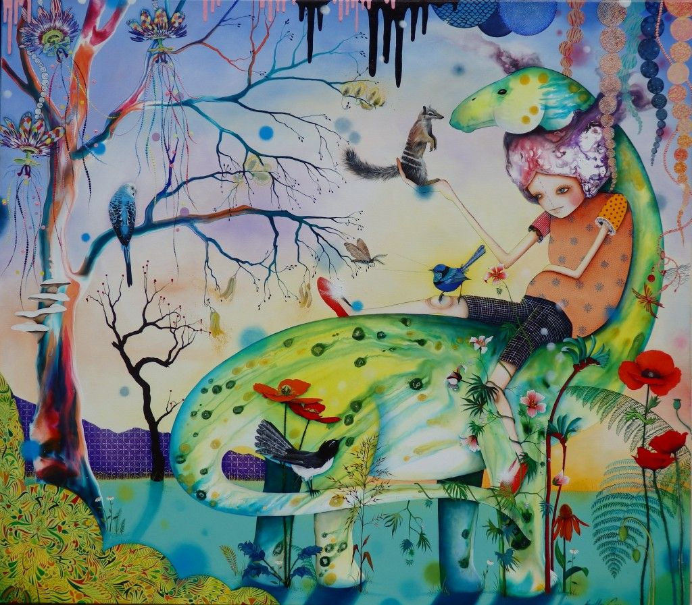
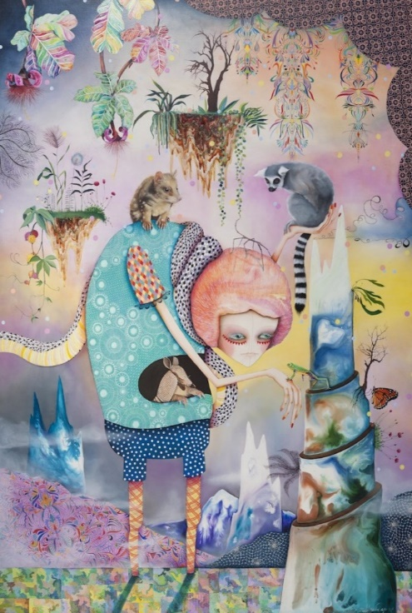
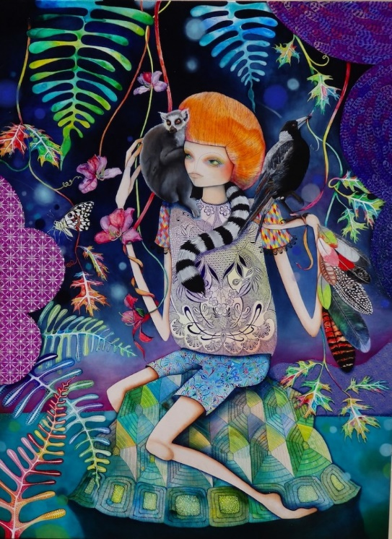
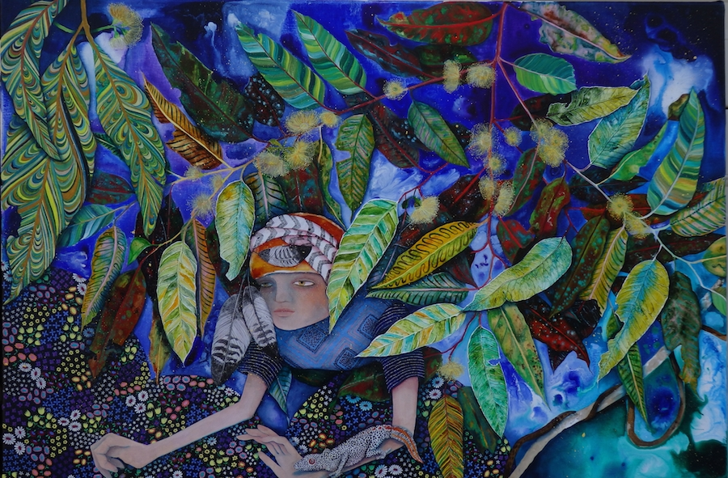
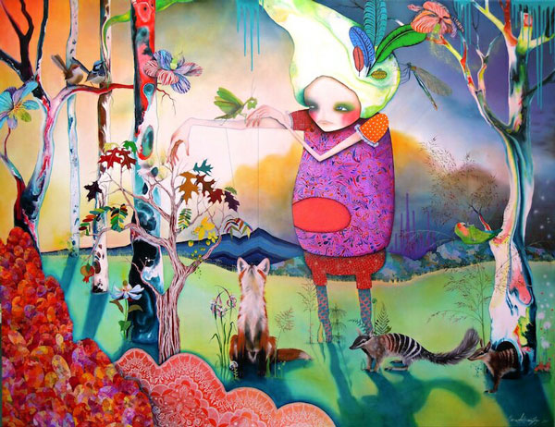
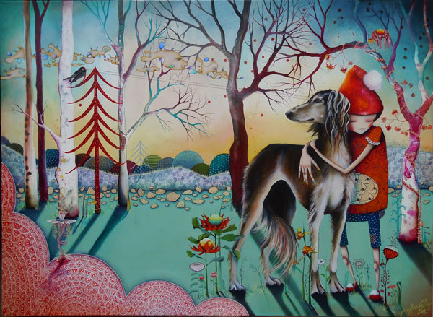
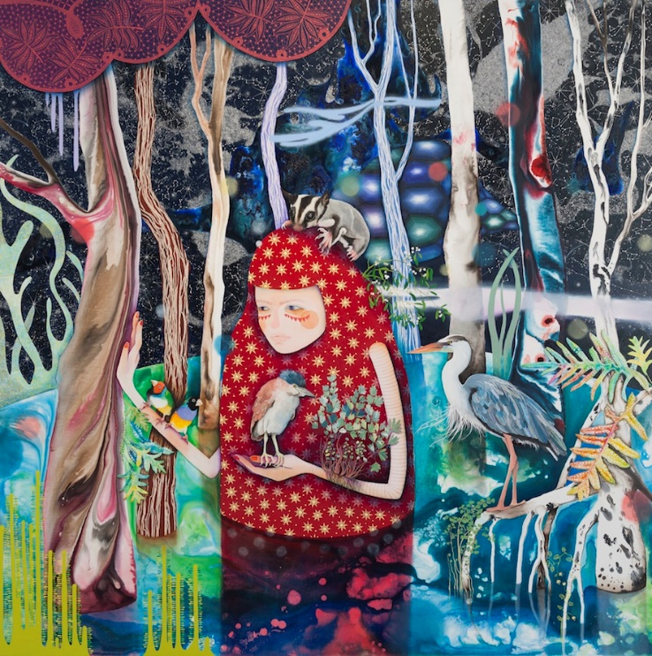
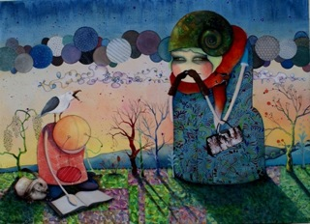
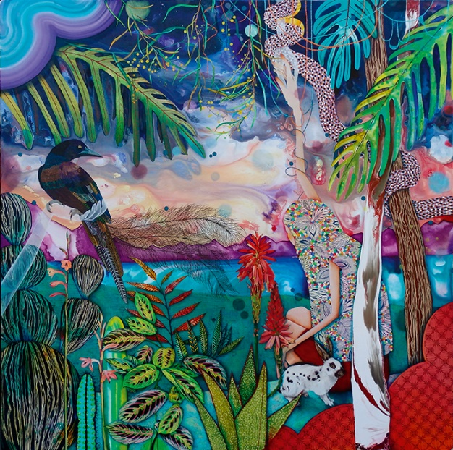
Yvonne Zago
Western Australian
artist

