Assessment task
Year level | 7
Learning area | The Arts
Subject | Visual Arts
Title of task | The Imagined World
Task guidelines
Description of task | Referencing the style and artwork of contemporary artist Yvonne Zago, Seth (Globepainter) or Fleur Schell, students will explore the natural world and the concept of imaginary adventure through drawing and design to create an artwork (either 2D or 3D), inspired by the theme The Imagined World.
Type of assessment | Making and Responding
Purpose of assessment | To determine student progress against the Achievement standard, through both formative and summative tasks.
Assessment strategy | Observational drawings, teacher observations, design documentation, annotated notes, final artwork and written responses.
Evidence to be collected | Making  Students will complete and submit a final artwork (either 2D or 3D) accompanied by teacher directed inquiry and design documentation, inclusive of:  - observational drawings of flora and/or fauna  - stylised character/figure drawing  - two design concepts  - one final colour design with annotated notes  - one final artwork (either 2D or 3D).  Responding  - Written analysis – Postcard
Suggested time | 10 weeks
Content description
Content from the Western Australian Curriculum | Making  Inquiry  Ideas and design development for art-making (e.g. brainstorm, mind map, annotation/sketches, media testing)  Application of techniques and processes suited to 2D and/or 3D artwork (e.g. one-colour lino print, observational drawing)  Visual art language (visual art elements and principles of design) used in the development of artwork (e.g. using repetitive shapes and colour to create a pattern)  Art-making intentions identified through annotations or conversations (e.g. keeping a written or digital journal, or portfolio or question/answer; one-to-one, or group debriefs; discussing responses to artwork)  Art Practice  Processes to develop and produce artwork  Processes and finished artwork appraised; ways to improve art practice; reflection  Techniques and processes to support representation of ideas in their art-making  Responding  Analysis  Use of visual art elements (line, tone/value, colour, shape, texture, form and space;  principles of design (movement, balance, rhythm, harmony, pattern, contrast, unity,  repetition, scale); visual conventions and visual art terminology to respond to artwork (e.g. dot point form, discussion or written format)  Interpretation/Response  Personal opinions about their own artwork and the work of others’, supported by examples within artwork
Task preparation
Prior learning | Students may have been introduced to diverse styles, techniques and processes by other artists, and how this can influence their own artwork.
Assessment differentiation | Teachers should differentiate their teaching and assessment to meet the specific learning needs of their own students, based on their level of readiness to learn or to be challenged. Where appropriate, teachers may either scaffold or extend the scope of the assessment tasks.
Assessment task
Assessment conditions | This assessment is a whole class experience with students producing individual artwork. It is recommended that the final artwork be more micro than macro, to accommodate possible time restraints. Inquiry, Art practice and Responding to be completed within class in the stipulated time
Resources | Resources will vary depending on specific art form chosen by teacher/student.  Suggested resources may include:  Painting:  - watercolour paints  - acrylic paints  - paint pens (POSCA)  - inks  - spray paint  - brushes, supports, newspaper, palettes, dust masks, jars, aprons, rags.  Drawing:  - pencil and markers (lead pencil, colour pencil, watercolour pencil, fine liner pens)  - charcoal  - soft pastel  - crayons (Oil Pastels, Wax Crayons, water soluble oil pastels)  - eraser, blending stump.  Collage:  - paper collage using painted paper, patterned paper, newspaper etc.  - textured surfaces, e.g. sandpaper, fabric, wool, cardboard  - adhesives, scissors etc.  Printmaking:  - relief printing – lino or printing foam (carving tools, lino, acrylic paint or block printing ink, brayer, foam), collagraph (recycled materials, strawboard, printing ink, shellac)  - serigraphy – screen printing (paper, screen printing ink, squeegee, screens, fabric, paper)  - intaglio printing – drypoint etching (printing press, etching plate/etching paper, etching press, etching needle tools).  Sculpture:  - ceramics – paper clay, clay, air dry clay, clay tools  - papier-machê – newspaper, junk mail, tissue paper, celmix or PVA glue, tape  - mobile – found objects, cut paper, streamers, fishing line, string, coat hanger  Wearable Art:  - jewellery – wire, paper, found objects, beads etc.  - shoe – recycled shoe, blank canvas shoe, cardboard  - clothing – plastics, fabric, recycled objects/items etc.

Task instructions
Responding (1.5 hours)
Responding Task – Postcard
Introduce students to the artwork of three contemporary artists:
- Yvonne Zago https://www.lintonandkay.com.au/artists/yvonne-zago/
- Seth (Globepainter) https://seth.fr/en/
- Fleur Schell http://www.fleurschell.com/
Using source images of artworks by the contemporary artists, discuss the artist’s style and selected artwork/s. Focus questions could include:
- What do you see?
- How do you feel when you look at it?
- What is happening in the artwork?
- What type of lines can you see?
- What type of shapes can you see?
- Where does your eye go to first? Why?
- List three words to describe the artwork.
- What do you notice about the colour in the artwork?
- How has the artist shown each of the key features (listed below)?
Characterisation: facial expression, face shape and features, proportion, body language, body silhouette, realism/idealisation, character traits, visual stereotypes, simplification, drawing style.
Suggested reading material for teachers who wish to look at characterisation and stylised art:
https://www.creativebloq.com/illustration/pro-tips-creating-stylised-art-91516795
https://design.tutsplus.com/articles/cartoon-fundamentals-how-to-draw-a-cartoon-body--vector-18651
https://www.21-draw.com/wp-content/uploads/2020/04/The-Character-Designer-ebook-2019-SAMPLE-21-Draw.pdf
Pattern/Repetition: repeated shapes, lines and colour – the repetition of one or more art elements to create a sense of unity, e.g. leaves, lacework, feathers, organic shapes
Distortion/Exaggeration: visual changes in size, proportion or general character – e.g. size of facial features (elongated limbs, big hair, posture, eyes,). Alteration of anything from the realistic.
Provide the following scenario to students
You are holidaying and have just visited the local art gallery displaying the artwork of the artists Yvonne Zago, Seth (Globepainter) and Fleur Schell. As you leave the exhibition, you are drawn to the art gallery shop and see postcards of the artists’ work. You were so absorbed and intrigued by the artwork, that you decide to purchase a postcard.
From the postcard templates (attached) provided by your teacher, choose the one that most appeals to you:
Postcard Option 1: Artwork 1 (Yvonne Zago, The Boy and his Donkey, 2014)
Postcard Option 2: Artwork 2 (Seth [Globepainter], The Wire, 2017 )
Postcard Option3: Artwork 3 (Fleur Schell, Heidi’s Bedroom – wall diorama G, 2018
As you venture back to your hotel, you decide to write to a relative/friend who you think might also appreciate your chosen artist’s artwork. Using visual art terminology, write about your experience, structuring your response by using the STICI framework.
Teacher may choose to use the STICI framework and guided questions handout for students to refer when responding to selected artwork.
Steps
- Students choose from photocopied postcard templates.
- Students write a response to the artwork, using the STICI framework.
- Students include a personal opinion supported by evidence from the artwork in their postcard response
- Teacher assesses using Responding task: Postcard Marking key (provided)
Timed assessment duration of 50 minutes
STICI FRAMEWORK
Students may select from the guiding questions to make notes about the selected artwork, to help prepare their postcard response.
S | Subject | Describe the subject matter of the artwork in detail, using art terminology. What can you see in the artwork? What are the key features of the artwork? List two key features. What do you notice first? What themes or ideas are being communicated in the artwork? Is the subject matter imagined, remembered or observed? What makes you think this or how do you know this?
T | Technique | What media, materials, skills and processes have been used to create the artwork? How has the artist executed the artwork? What effects have been achieved in the artwork?
I | Influences | Do you see any evidence or reference to other art movements or styles in the artwork? Is there any evidence of personal, cultural or environmental influences in the artwork?
C | Composition | Discuss composition and how the artwork has been arranged. Using art terminology, describe how the artist has used the following elements and principles, and refer to examples of where it can be seen – shape, colour, line, pattern, movement and contrast.
I | Intention | What message is conveyed in the artwork? What mood, feeling or atmosphere is created in the artwork? What is the purpose of the artwork? Is the artist successful in portraying your interpretation?

*Notes will not be assessed

Make notes below about the artwork you have selected, using the STICI framework.
S
T
I
C
I

Postcard Option 1 : Yvonne Zago – The Boy and His Donkey Name: __________________________

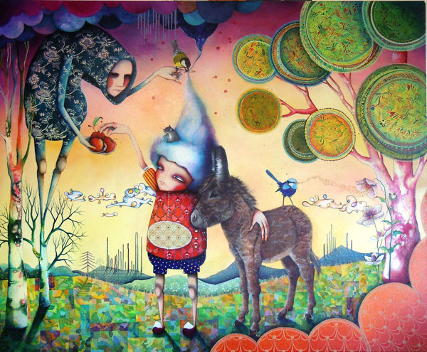
Yvonne Zago
The Boy and His Donkey
2014
Oil, acrylic and pigment ink on canvas
138 x 168cm
76 x 56 cm
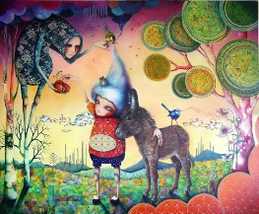

Postcard Option 2 : Seth (Globepainter) – The Wire Name: __________________________

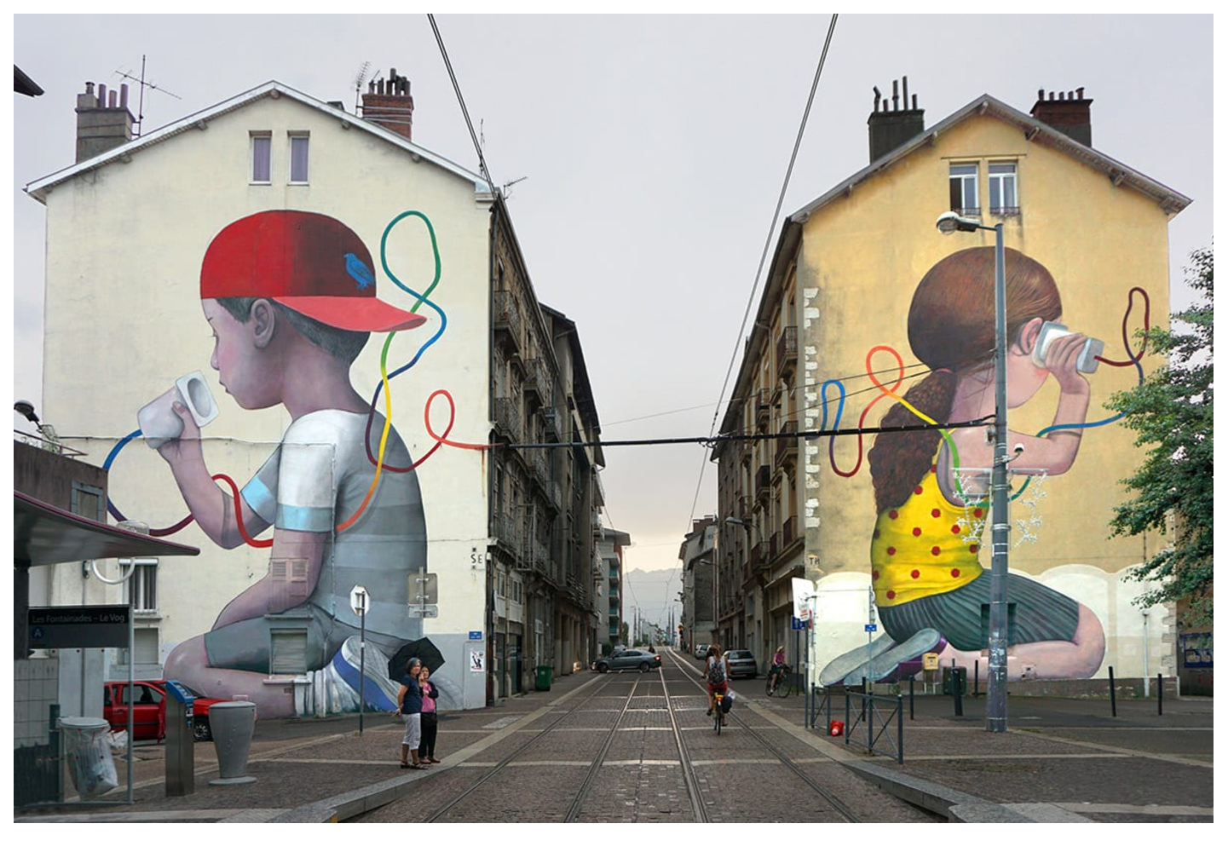
Seth (Globepainter)
The Wire
2017
Mural
Grenoble Street Art Festival
France
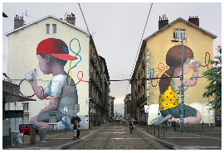

Postcard Option 3 : Fleur Schell – Heidi’s Bedroom –wall diorama G Name: __________________________

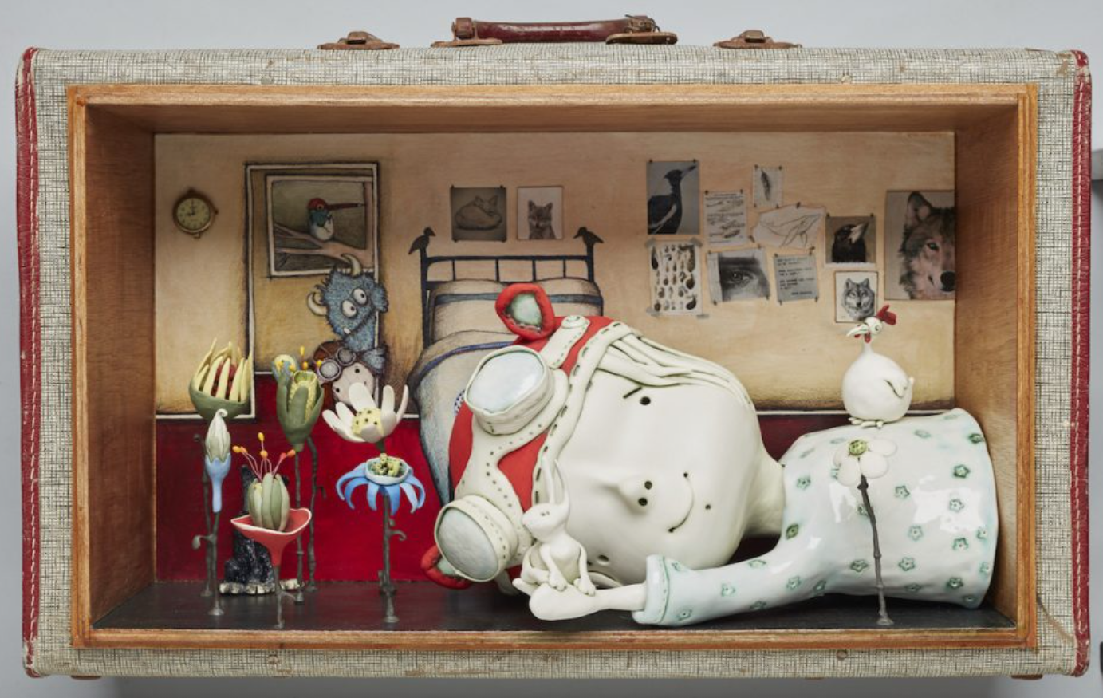
Fleur Schell
Heidi’s Bedroom –wall diorama G
2018
Porcelain, Illustration on archival paper, wood, wire and recycled suitcase
73 x 45 x 30 cm
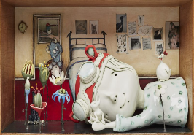

Responding task: Postcard marking key
Description | Marks
Description of the artwork with art terminology
Provides a detailed description of the artwork with correct art terminology | 3
Provides a clear description of the artwork with some art terminology | 2
Provides a brief description with little or no art terminology | 1
Subtotal | /3
Description of the artist’s use of elements and principles in the artwork with evidence
Accurately describes how the elements and principles have been used in the artwork with specific evidence | 4
Describes how the elements and principles have been used in the artwork with some evidence | 3
Describes how the elements and principles have been used in the artwork | 2
Identifies few elements and principles in the artwork | 1
Subtotal | /4
Meaning associated with artwork
Makes a considered comment about the meaning of the artwork | 3
Makes a straightforward comment about the meaning of the artwork | 2
Makes a superficial or incomplete comment about the artwork | 1
Subtotal | /3
Personal opinions about the artwork of selected artist with examples
Provides a considered personal opinion about the artwork with specific evidence | 4
Provides a clear personal opinion about the artwork with some evidence | 3
Provides simple personal opinions about the artwork | 2
Provides little or no personal opinions about the artwork | 1
Subtotal | /4
Total | /14
Comment

Making
Making Task
IDEAS
Discussion (15 minutes)
As a class, students consider and brainstorm what an imaginary place/scene might look like. Discuss the importance of imaginative thinking and what inspires artists’ imagination. To prompt group discussion, teachers may need to provide visual exemplars about how artists use visual art language to emphasise their idea of fantasy and the invented, e.g. distorted or exaggerated shapes in a landscape, unusual placement or scale of objects, quirky characters etc.
Ask students to close their eyes and think about an imaginary place. Possible focus questions to promote discussion may include:
- What does your imaginary place look like?
- Is it an island, a room, a cave or in the desert?
- What is unusual, unexpected or fanciful about your imaginary place?
- What is familiar?
- What shapes, colours and objects might be there?
- Is anything distorted or altered?
- How does your imaginary place make you feel?
- Describe the character/s in this imaginary place.
SKILLS
Part A — Observational drawing (40 minutes)
Teacher to source and provide images of flora and/or fauna to use as drawing stimulus or, alternatively, teacher may take students out into the school grounds or local environment to observe and draw from the natural environment. Where possible, students may also document their sensory experiences by including notes about sounds, smells and textures. Teacher to demonstrate the following drawing techniques: blind contour, contour line and tonal drawing.
Using the Observational drawing template (print to A3), students to complete three drawings of flora and/or fauna, using 2B pencil:
- Blind contour (3 minutes). Encourage students to:
- keep eye on the object/image and using one continuous line draw the object without lifting the pencil or looking at the page
- draw slowly and imagine that the pencil is touching the object as the eye travels around it
- include as much detail as possible.
- Contour line drawing (7 minutes) – as above, but students can look at their drawing as they go.
- Tonal drawing (30 minutes) – complete a detailed drawing using line to identify shape and tonal rendering to create three-dimensional form. Consider areas of light, medium and dark tones when indicating form.
Part B — Character/Figure Drawing (30 minutes)
With reference to Zago, Seth (Globepainter) or Schell’s style, teacher to demonstrate how to create a simple character, discussing the importance of facial expression, face shape and features, proportion, character traits, body language and exaggeration/distortion. Adapting the chosen artist’s style, students will complete one character/figure drawing, in the provided Adventure time character template. Drawing to be completed using 2B pencil and rendered in black fine liner.
IDEAS
Part C — Design documentation (2 hours)
Based on school budget, time frame and expertise, teacher to decide whether they are going to create a 2D or 3D artwork. See table below for possible options.
2D |  |  | 3D
Painting/Drawing | Collage/Mixed-media | Printmaking | Sculpture | Wearable art
- Illustration –watercolour pencil, rendered marker drawing or crayons  - Painting – acrylic paints, paint pens or watercolour paints | - Paper collage using torn paper  - Collage using a variety of pens, surfaces, paints, fabric | - Reduction printing using lino or foam board  - Etching  - Screen printing | - Ceramic form  - Papier-machê  - Assemblage  - Organic form made from plaster bandage  - Mobile | - Jewellery  - Headpiece  - Shoe  - Clothing
Teacher to distribute design template sheet (print to A3) to students.
With reference to their observational and character/figure drawings, students will sketch two possible design concepts using 2B pencil on the Design Concepts template handout. Students should apply the style of one of the contemporary artists studied.
Students select one of their drawings from the design concepts sketches and redraw it in detail inside the central box on the Final Design handout (enlarged to A3).
If the final artwork is 2D, students should consider how they place the design in the box, for example, placement of focal point, relationship between object, positive and negative space etc.
If the final artwork is 3D, students should consider the whole form of the object and draw a sketch in the round (three smaller thumbnail sketches of front, side and back view inside the box provided). The design should consider scale, space and any other considerations, such as presentation, e.g. placement of wearable art on body.
Teacher to discuss elements and principles as you demonstrate the design documentation process. Students should incorporate one or more of the following key features in their design:
- characterisation
- pattern/repetition
- distortion/exaggeration.
Students render the final design on the Final Design handout (provided) using coloured pencils, markers or watercolour and using art terminology, include annotations that comment on:
- elements and principles
- colour palette
- choices about material, media and/or techniques
- key feature/s (reasons for choice).

PRODUCTION
Part D – Final artwork (6 hours)
Students use their final design to commence final artwork. Teacher to demonstrate technique/s specific to selected art form – some examples listed below.
- Ceramics – simple pinch pot construction, joining and storage of clay work.
- Papier-machê – armature construction techniques, papier-machê techniques, including how to apply paper layers correctly to create a smooth surface and build form.
- Mobile – joining and hanging sculptural elements to create mobile.
- Drawing/Rendering – techniques of hatching, cross-hatching, blending, rendering using an eraser, contour and cross-contour, stippling.
- Painting – differences in application of paint: pressure, transparency, opacity and stroke direction, brush techniques of blending, dry brush, sgraffito, double-loading, and wet-on-dry.
- Wearable art – techniques associated with textiles, sewing, felting or jewellery making.
Teacher to demonstrate safe work practices associated with selected art form.
Students refer to final design to commence and complete final artwork in allocated timeframe.
Teacher to use Making: The Imagined World Marking key to assess drawings, designs and final artwork.

Part A — Observational drawing template – Year 7 Visual Arts – The Imagined World
Name:
Blind contour drawing | Contour line drawing
Tonal drawing (detailed)
Part B— Adventure time character template – Year 7 Visual Arts – The Imagined World
Name:

Part C — Design concepts template – Year 7 Visual Arts – The Imagined World Name:
With reference to your observational drawings, use a 2B pencil to sketch TWO possible designs for your final artwork.

Element & principles

Key feature/s
Colour palette
Media, materials and/or techniques
FINAL DESIGN
Handout
Draw final design here:

Making Task: The Imagined World marking key (Parts A, B, C and D)
Description | Marks
Inquiry
Communication of ideas, drawings, and designs
Communicates coherent and effective ideas, drawings and designs | 4
Communicates clear and appropriate ideas, drawings and designs | 3
Communicates simple and adequate ideas, drawings and designs | 2
Communicates undeveloped ideas, drawings and design | 1
Subtotal | /4
Use of visual art language in the development of ideas
Applies visual art language effectively to develop ideas | 4
Applies visual art language appropriately to develop ideas | 3
Applies some visual art language to develop ideas | 2
Applies minimal visual art language to develop ideas | 1
Subtotal | /4
Documenting and planning of ideas and intentions
Provides specific and relevant annotations in written and/or visual form to show planning of design ideas | 4
Provides relevant annotations in written and/or visual form to show planning of design ideas | 3
Provides some annotations in written and/or visual form to show planning of design ideas | 2
Provides superficial or incomplete annotations in written and/or visual form to show planning of design ideas | 1
Subtotal | /4
Art practice
Selection and use of media and/or materials to enhance own ideas
Demonstrates effective use of media and/or materials to enhance own ideas | 4
Demonstrates appropriate use of media and/or materials to enhance own ideas | 3
Demonstrates simple use of media and/or materials to enhance own ideas | 2
Demonstrates rudimentary use of media and/or materials to enhance own ideas | 1
Subtotal | /4
Application of techniques and/or processes in final artwork
Demonstrates correct and effective application of techniques and/or processes in final artwork | 4
Demonstrates competent application of techniques and/or processes in final artwork | 3
Demonstrates consistent application of techniques and/or processes in final artwork | 2
Demonstrates rudimentary application of techniques and/or processes in final artwork | 1
Subtotal | /4
Total | /20
Comment
Acknowledgements

Postcards
Option 1 Zago, Y. (2012). The boy and his donkey [Oil, acrylic and pigmented ink on canvas]. Linton & Kay Galleries, Australia. Retrieved February, 2021, from https://www.lintonandkay.com.au/wp-content/uploads/2013/05/
1476-image5.jpg

Option 2 Seth. (2017). The wire [Mural]. Grenoble Street Art Festival, France. Retrieved February, 2021, from https://seth.fr/wp/wp-content/uploads/
2018/11/grenoble_2_e-768x518.jpg

Option 3 Schell, F. (2018). Heidi’s bedroom [Diorama]. Retrieved February, 2021, from
https://images.squarespace-cdn.com/content/v1/55e59947e4b0bf232d938
d7e/1542254086216-PQP6WPIFYT0FDVZN0WWR/ke17ZwdGBToddI8pDm48
kEiM2XgUSn4c20ey40mPOrRZw-zPPgdn4jUwVcJE1ZvWQUxwkmyExglNqGp
0IvTJZamWLI2zvYWH8K3-s_4yszcp2ryTI0HqTOaaUohrI8PICRlF-6xx9gVJ3PjBlq
yNBrmQvlsWIqFZ3uNa8YaOKpwKMshLAGzx4R3EDFOm1kBS/Fleur-Schell-Heidis-room.jpg?format=750w

