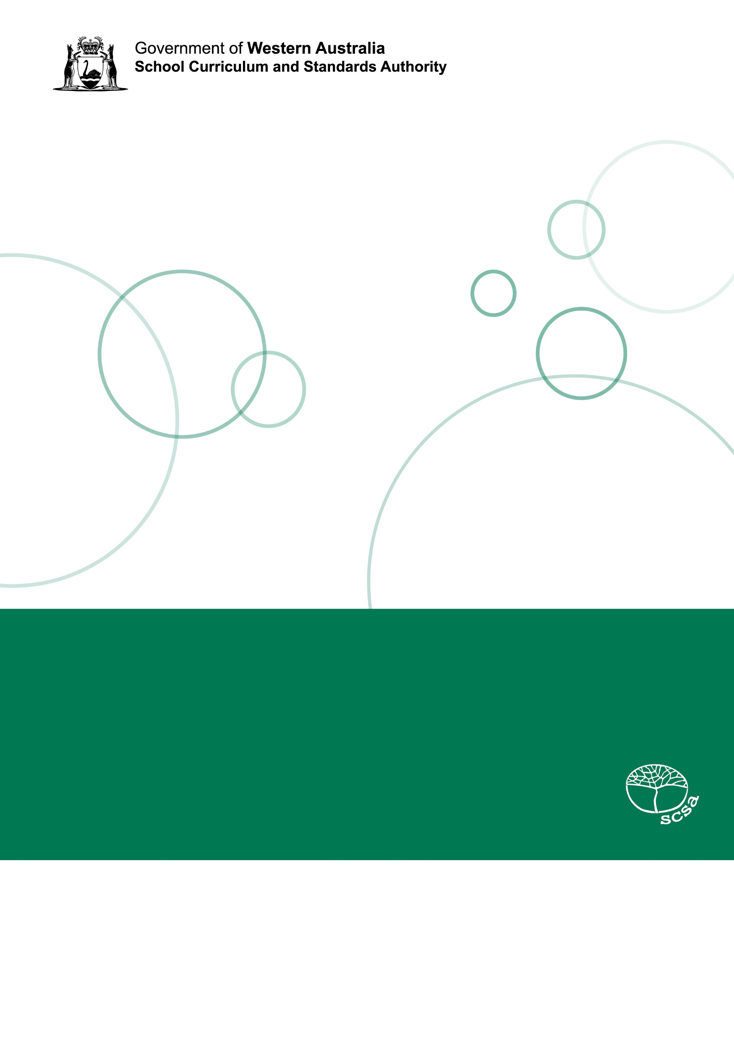
Health and Physical Education:
Physical Education
Teaching, learning and assessment exemplar
Year 8
Kicking

Acknowledgement of Country
Kaya. The School Curriculum and Standards Authority (the Authority) acknowledges that our offices are on Whadjuk Noongar boodjar and that we deliver our services on the country of many traditional custodians and language groups throughout Western Australia. The Authority acknowledges the traditional custodians throughout Western Australia and their continuing connection to land, waters and community. We offer our respect to Elders past and present.
Background
This teaching, learning and assessment exemplar (the exemplar) has been developed by the School Curriculum and Standards Authority (the Authority) as part of the School Education Act Employees (Teachers and Administrators) General Agreement 2017 (Clause 61.1–61.3).
Copyright
© School Curriculum and Standards Authority, 2024
This document – apart from any third-party copyright material contained in it – may be freely copied, or communicated on an intranet, for non-commercial purposes in educational institutions, provided that the School Curriculum and Standards Authority (the Authority) is acknowledged as the copyright owner, and that the Authority’s moral rights are not infringed.
Copying or communication for any other purpose can be done only within the terms of the Copyright Act 1968 or with prior written permission of the Authority. Copying or communication of any third-party copyright material can be done only within the terms of the Copyright Act 1968 or with permission of the copyright owners.
Any content in this document that has been derived from the Australian Curriculum may be used under the terms of the Creative Commons Attribution 4.0 International licence.
Disclaimer
Any resources such as texts, websites and so on that may be referred to in this document are provided as examples of resources that teachers can use to support their learning programs. Their inclusion does not imply that they are mandatory or that they are the only resources relevant to the course. Teachers must exercise their professional judgement as to the appropriateness of any they may wish to use.
Contents
The Western Australian Curriculum 5
The Health and Physical Education curriculum 5
This exemplar 6
Catering for diversity 6
Using this exemplar 7
Links to electronic resources 7
Best practice 8
Teaching and learning 8
Assessing 8
Reflecting 8
Kicking skills 9
Year level description 10
Achievement standard 11
Lessons 1–10 13
Appendix A 31
Appendix B 59
Appendix C 69

The Western Australian Curriculum
The Western Australian Curriculum and Assessment Outline (the Outline –https://k10outline.scsa.wa.edu.au) sets out the mandated curriculum, guiding principles for teaching, learning and assessment and support for teachers in their assessment and reporting of student achievement. The Outline recognises that all students in Australian schools, or international schools implementing the Western Australian Curriculum, are entitled to be given access to the eight learning areas described in the Alice Springs (Mparntwe) Education Declaration, December 2019.

The Health and Physical Education curriculum
The mandated curriculum is presented in the year level curriculum documents.
The Health and Physical Education curriculum delivers a sequential and age-appropriate progression of learning with the following key elements:
- a year level description that provides an overview of the context for teaching and learning in
the year
- a series of content descriptions, populated through strands and sub-strands, that sets out the knowledge, understanding and skills that teachers are expected to teach and students are expected to learn
- an achievement standard that describes an expected level that the majority of students are achieving by the end of a given year of schooling. An achievement standard describes the quality of learning (e.g. the depth of conceptual understanding and the sophistication of skills) that would indicate the student is well placed to commence the learning required in the next year.

This exemplar
This Year 8 Physical Education exemplar articulates the content in the Outline and approaches to teaching, learning and assessment reflective of the Principles of Teaching, Learning and Assessment. This exemplar demonstrates a sequence of teaching and learning, including suggested assessment points, for 10 lessons.
The Health and Physical Education curriculum has been shaped by five interrelated propositions that are informed by a strong evidence base. This Physical Education exemplar has been informed by these same propositions:
- Focus on educative purposes
- Take a strengths-based approach
- Value movement
- Develop health literacy
- Include a critical inquiry approach.
Consistent with a strengths-based approach, a successful Health and Physical Education program is where teachers select ongoing contexts that are accessible and meaningful to students as a focus for building on their strengths and interests.
While the exemplar has been written for one hour per week, school systems/sector, including the Department of Education, Catholic Education Western Australia, and the Association of Independent Schools of Western Australia, may have programs additional to the Western Australian Health and Physical Education curriculum that are taught in schools.

Catering for diversity
This exemplar provides a suggested approach for the delivery of the curriculum and reflects the rationale, aims and content structure of the learning area. When planning the learning experiences, consideration has been given to ensuring that they are inclusive and can be used in, or adapted for, individual circumstances. It is the classroom teacher who is best placed to consider and respond to (accommodate) the diversity of their students. Reflecting on the learning experiences offered in this exemplar will enable teachers to make appropriate adjustments (where applicable) to better cater for students’ gender, personal interests, achievement levels, socio-economic, cultural and language backgrounds, experiences and local area contexts.

Using this exemplar
This teaching and learning exemplar provides suggestions to support the delivery of the mandated curriculum content. The exemplar provides:
- a teaching and learning sequence
- the mandated curriculum content to be taught at each point of the teaching and learning sequence, suggested resources, sample assessment tasks and marking keys
- the number of lessons to deliver the teaching and learning experiences
- learning intentions and support notes that may provide focus questions and additional information and/or examples to assist with the interpretation of curriculum content
- support notes to assist teachers to unpack the content and support teaching and
learning experiences
- teaching and learning experiences that outline the structure of the lesson. These explicitly state each activity that the lesson will progress through and the key focus area for that activity.

Links to electronic resources
This sequence of lessons may utilise electronic web-based resources, such as videos and image galleries. Teachers should be present while an electronic resource is in use and close links immediately after a resource, such as a video, has played to prevent default ‘auto play’ of additional videos. Where resources are referred for home study, they should be uploaded through Connect, or an equivalent system, that filters advertising content.

Best practice

Teaching and learning
The teaching and learning opportunities offered in this exemplar are not exhaustive. Thus, teachers are encouraged to make professional decisions about which learning experiences, and the sequence in which they are delivered, are best suited to their classroom context, taking into account the availability of resources and student ability.
Teachers may find opportunities to incorporate the General Capabilities and the Cross-curriculum Priorities into the teaching and learning program.
Ways of teaching – teachers can locate additional information on the Ways of teaching from the School Curriculum and Standards Authority (the Authority) website
https://k10outline.scsa.wa.edu.au/home/wa-curriculum/learning-areas/health-and-physical-education/p-10-hpe-teaching/health-and-physical-education-ways-of-teaching.

Assessing
Assessment, both formative and summative, is an integral part of teaching and learning. Assessment should arise naturally out of the learning experiences provided to students. In addition, assessment should provide regular opportunities for teachers to reflect on student achievement and progress. As part of the support it provides for teachers, this exemplar includes suggested assessment points. It is the teacher’s role to consider the contexts of their classroom and students, the range of assessments required, and the sampling of content descriptions selected to allow their students the opportunity to demonstrate achievement in relation to the year level achievement standard. Teachers are best placed to make decisions about whether the suggested assessment/s are used as formative or summative assessment and/or for moderation purposes.
Ways of assessing – a range of assessment strategies that can enable teachers to understand where students are in their learning is available on the Authority website https://k10outline.scsa.wa.edu.au/home/wa-curriculum/learning-areas/health-and-physical-education/p-10-hpe-assessing/health-and-physical-education-ways-of-assessing.

Reflecting
Reflective practice involves a cyclic process during which teachers continually review the effects of their teaching and make appropriate adjustments to their planning. The cycle involves planning, teaching, observing, reflecting and replanning.

Kicking skills
This teaching, learning and assessment exemplar aims to develop students’ understanding and application of the theory and fundamental skills of kicking in a modified game setting. Students will experience a range of kicking-related skills in a variety of competitive and non-competitive environments, with opportunities to refine and apply skills at a game-like intensity.
Students are provided with opportunities to explore kicking-related skills and demonstrate their application of these actions/skills. In addition to explicit teaching, students will develop their understanding and application of each skill through a variety of learning experiences. Students will demonstrate their progression through the lesson sequence, developing proficiency, skill selection and application, and tactical application in modified game situations. They will develop interpersonal skills, such as communication skills that support and enhance team cohesion and inclusion of all participants. They will also demonstrate ethical behaviour and fair play when participating in
physical activities
If the suggested learning experiences and relevant syllabus content for this lesson sequence have been followed, students will be well positioned to address the requirements of the assessment task to the best of their ability.

Year level description
In the early adolescence phase of schooling, students align with their peer group and begin to question established conventions, practices and values. Learning and teaching programs assist students to develop a broader and more comprehensive understanding of the contexts of their lives and the world in which they live.
Health and Physical Education provides opportunities for students to build on their prior learning. A major influence on students is the world around them, and during this time their peers become a key source of motivation and support when managing their health and wellbeing.
In Year 8, students develop skills and strategies to promote health, safety and wellbeing, including assertive responses and refusal skills, and apply them to a range of situations, including online environments. They investigate health-promotion activities that aim to improve the health and wellbeing of young people and continue to develop critical health literacy skills, including the ability to distinguish between credible and less credible sources of health information.
Students continue to broaden their repertoire of movement skills and knowledge of tactical thinking and apply these to an expanding array of physical activity contexts. They build on skills to analyse performance and describe the impact of regular participation on health, fitness and wellbeing. Students continue to reflect on, and refine, personal and social skills that support inclusive participation and fair play and contribute to positive team cohesion.

Achievement standard
By the end of the year:
Health Education
Students identify skills and strategies to manage change, and promote all aspects of their own and others’ health. They make informed decisions, using assertive responses, and make contingency plans to avoid and prevent risks to health. Students identify the impact power and coercion can have on relationships and describe how these can be influenced by stereotypes.
Physical Education
Students perform a variety of individual movement skills and sequences demonstrating improved control, accuracy and efficiency in their performance. In various contexts, they implement a range of tactics to achieve an intended outcome. Students provide simple descriptions of how to measure heart rate and breathing rate in response to changes in physical activity. They implement or interpret verbal, physical or situational cues to appropriately respond to others when working in a group.


Lessons 1–10

Lesson 1: Introduction to soccer – kicking, receiving and dribbling
The Western Australian Curriculum content addressed in this lesson is below.
Movement skills
- Movement skills and sequences within different physical activity contexts and settings with a focus on increased efficiency in skill performance and control of balance and stability
- Selection of strategic and tactical skills used in the manipulation of effort, space, time, objects and people in a variety of movement contexts

Learning intentions
- Demonstrate proficiency in kicking and receiving in drill and gameplay situations
- Demonstrate proficiency in dribbling in drill and gameplay situations
Focus questions
- What activities or sports have a kicking component?
- What are the key teaching points to execute the short pass (preparation, execution, completion)?
- What are the key teaching points to execute control – low ball (preparation, execution, completion)?
- What are the key teaching points to execute dribbling (preparation, execution, completion)?
Support notes
Formative assessment strategies
- group activities, practical tasks, Physical Education performance (static drills, dynamic drills, modified sports, competitive situations).
Teaching and learning experiences
Warm-up
Focus: describe skills that are required to play soccer.
- Introduce the ‘octopus soccer’ warm-up activity (Appendix A.2).
- Brainstorm with students the skills necessary to play the game of soccer. Use this information to gauge the current level of understanding and experience of the class. (Examples include passing, dribbling, shooting, control, volleying, heading, throw in, goalkeeping).
- Describe the sport of soccer.
Activity 1 – kick-to-kick passing
Focus: demonstrate and explain the key teaching points of the short pass and control – low ball.
- Describe and demonstrate the key teaching points for the short pass and control – low ball (Appendix A.1).
- Implement drill-based practice for students (Appendix A.2).
- Provide feedback and check for understanding.
Activity 2 – pass, go and find
Focus: demonstrate and explain the key teaching points of dribbling.
- Describe and demonstrate the key teaching points for a bounce pass and shoulder pass and effective catching technique (Appendix A.1).
- Implement drill-based practice for students (Appendix A.2).
- Provide feedback and check for understanding.
Concluding activity
- Instruct students to identify, describe and/or demonstrate responses to the focus questions.

Lesson 2: Soccer – maintaining possession and creating space
The Western Australian Curriculum content addressed in this lesson is below.
Movement skills
- Movement skills and sequences within different physical activity contexts and settings with a focus on increased efficiency in skill performance and control of balance and stability
- Selection of strategic and tactical skills used in the manipulation of effort, space, time, objects and people in a variety of movement contexts

Learning intentions
- Demonstrate increased efficiency in skill performance and control of balance and stability in kicking, passing, dribbling and receiving in drill and gameplay situations
- Describe how players can maintain possession and create space in offence and defence through using the soccer ball, player effort and position location
Focus questions
- How can a player create space through manipulation of the soccer ball, space and time?
- How can a player maintain possession of the soccer ball?
- How can a player defend space?
- How can a player increase efficiency, control of balance and stability in kicking, passing, dribbling and receiving?
Support notes
Formative assessment strategies:
- group activities, practical tasks, Physical Education performance (static drills, dynamic drills, modified sports, competitive situations).
Teaching and learning experiences
Warm-up
Focus: revise and refine skills.
- In pairs, students warm up using the ‘octopus soccer’ activity from the previous lesson (Appendix A.2).
- Revise the teaching points of dribbling learnt in the previous lesson (Appendix A.1).
Activity 1 – kick-to-kick passing
Focus: revise the key teaching points of the short pass and control – low ball (Appendix A.1).
- Implement drill-based practice for students (Appendix A.2).
- Provide feedback and check for understanding.
Activity 2 – keep ball 4v1
Focus: demonstrate how players can use strategic and tactical skills to create and defend space.
- Implement drill-based practice for students (Appendix A.2).
- Provide feedback and check for understanding.
Concluding activity
- Instruct students to identify, describe and/or demonstrate responses to the focus questions.

Lesson 3: Soccer – using space
The Western Australian Curriculum content addressed in this lesson is below.
Movement skills
- Movement skills and sequences within different physical activity contexts and settings with a focus on increased efficiency in skill performance and control of balance and stability
- Selection of strategic and tactical skills used in the manipulation of effort, space, time, objects and people in a variety of movement contexts
Interpersonal skills
- Modification of rules, equipment or scoring systems to allow for fair play, safety and inclusion of all participants

Learning intentions
- Describe how players can maintain possession and manipulate space in offence and defence through using the soccer ball, player effort and position location
- Demonstrate how to allow for fair play, safety and inclusion of all participants with a modification of the rules
- Utilise verbal, physical and situational cues to respond to others while working in a group
Focus questions
- What are the key components of a successful kick?
- How can players maintain possession of the soccer ball?
- How can a player and/or team manipulate space in offence and defence?
- How can players allow for fair play, safety and inclusion of others with a rule modification?
Support notes
Formative assessment strategies:
- group activities, practical tasks, Physical Education performance (static drills, dynamic drills, modified sports, competitive situations).
Teaching and learning experiences
Warm-up
Focus: revise and refine skills – kicking and short pass.
- Introduce the ‘knock the ball off the cone’ warm-up activity (Appendix A.2).
- Revise the teaching points of kicking learnt in the previous lesson (Appendix A.1).
Activity 1 – team keep ball
Focus: manipulate space to maintain possession of the ball (Appendix A.1).
- Implement drill-based practice for students (Appendix A.2).
- Provide feedback and check for understanding.
Activity 2 – end-zone pass
Focus: demonstrate and describe how to allow for fair play, safety and inclusion of all participants with a modification of the rules.
- Implement drill-based practice for students (Appendix A.2).
- Include scenarios leading to rule modifications.
- Provide feedback and check for understanding.
Concluding activity
- Instruct students to identify, describe and/or demonstrate responses to focus questions.

Lesson 4: Soccer – strategies and tactics
The Western Australian Curriculum content addressed in this lesson is below.
Movement skills
- Selection of strategic and tactical skills used in the manipulation of effort, space, time, objects and people in a variety of movement contexts
Interpersonal skills
- Modification of rules, equipment or scoring systems to allow for fair play, safety and inclusion of all participants
- Verbal, physical and situational cues to identify and appropriately respond to the feelings and motives of others when working in a team or group

Learning intentions
- Demonstrate and describe how players can apply strategic and tactical skills in the manipulation player effort, space, time, soccer ball and people in a modified game
- Demonstrate how to allow for fair play, safety and inclusion of all participants with a modification of the rules
- Use verbal, physical and situational cues to respond to others while working in a group
Focus questions
- How can a player increase their efficiency, control of balance and stability when dribbling?
- How can a player manipulate their game speed, ball or another player as a strategy or tactic?
- How can players allow for fair play, safety and inclusion of others with a rule modification?
- How can a player appropriately respond to a group member who is motivated to improve their kicking skills?
Support notes
Formative assessment strategies:
- group activities, practical tasks, Physical Education performance (static drills, dynamic drills, modified sports, competitive situations).
- Formative assessment (Appendix B)
Teaching and learning experiences
Warm-up
Focus: Revising and refining skills; introduction of self-reflection and peer evaluation.
- Introduce the ‘rats and rabbits’ warm-up activity (Appendix A.2).
- Introduce the self-reflection and peer evaluation formative assessment.
Activity 1 – Change speed and direction
Focus: increase dribbling efficiency, control of balance and stability (Appendix A.1).
- Implement drill-based practice for students (Appendix A.2).
- Provide feedback and check for understanding.
Activity 2 – end-zone goal
Focus: demonstrate and describe how to allow for fair play, safety and inclusion of all participants with a modification of the rules.
- Implement drill-based practice for students (Appendix A.2).
- Include scenarios leading to rule modifications.
- Provide feedback and check for understanding.
Concluding activity
- Students complete self-reflection and get into pairs with a member of their team to complete the peer evaluation (Appendix B).
- Instruct students to identify, describe and/or demonstrate responses to focus questions.

Lesson 5: Soccer – Summative assessment
The Western Australian Curriculum content addressed in this lesson is below.
Movement skills
- Movement skills and sequences within different physical activity contexts and settings with a focus on increased efficiency in skill performance and control of balance and stability
- Selection of strategic and tactical skills used in the manipulation of effort, space, time, objects and people in a variety of movement contexts

Learning intentions
- Demonstrate increased efficiency and control of balance and stability in kicking
- Demonstrate and describe how players can apply strategic and tactical skills in the manipulation of player effort, space, time, soccer ball and people in a modified soccer game
Focus questions
- What are the key teaching points of kicking?
- How can a player increase efficiency and control of balance and stability in kicking?
- What are some offensive and defensive strategies for soccer?
Support notes
Formative assessment strategies:
- group activities, practical tasks, Physical Education performance (static drills, dynamic drills, modified sports, competitive situations).
Summative assessment (Appendix C)
Teaching and learning experiences
Warm-up
Focus: Revising and refining skills; introducing Summative assessment.
- Revise ‘kick-to-kick passing’ warm-up activity (Appendix A.2).
- Review key teaching points of ‘kicking’ (Appendix A.1).
- Introduce the Summative assessment (Appendix C).
Activity 1 – keep ball 4v1
Focus: increase kicking efficiency, control of balance and stability (Appendix A.1).
- Implement drill-based practice for students (Appendix A.2).
- Provide feedback and check for understanding.
Activity 2 – soccer game performance
Focus: demonstrate soccer skills related to game performance through Summative assessment.
- Introduce and explain the game performance drill (Appendix A.2).
- Conduct Summative assessment (Appendix C).
Concluding activity
- Instruct students to identify, describe and/or demonstrate responses to focus questions.

Lesson 6: Introduction to Australian Rules football – drop punt
The Western Australian Curriculum content addressed in this lesson is below.
Movement skills
- Movement skills and sequences within different physical activity contexts and settings with a focus on increased efficiency in skill performance and control of balance and stability
- Selection of strategic and tactical skills used in the manipulation of effort, space, time, objects and people in a variety of movement contexts
Interpersonal skills
- Verbal, physical and situational cues to identify and appropriately respond to the feelings and motives of others when working in a team or group

Learning intentions
- Demonstrate increased efficiency and control of balance and stability using the drop punt in drill and gameplay situations
- Describe the selection of strategic and tactical skills used in the manipulation of space and people in Australian Rules football situations
- Utilise verbal, physical and situational cues to respond to others while working in a group
Focus questions
- What are the key teaching points to execute the drop punt (preparation, execution, completion)?
- How can a player increase efficiency and control of balance and stability in the drop punt?
- What are strategic and tactical skills used in the manipulation of space and people in a
3v1 situation?
- How can a player appropriately respond to a group member when they feel frustrated with experiencing limited success in skill performance?
Support notes
Formative assessment strategies:
- group activities, practical tasks, Physical Education performance (static drills, dynamic drills, modified sports, competitive situations).
Teaching and learning experiences
Warm-up
Focus: Introduction of Australian Rules football; revise and refine kicking skills.
- Introduce the ‘straight line kicking’ warm-up activity (Appendix A.2).
- Review key teaching points of the drop punt (Appendix A.1).
- Brainstorm with students the skills necessary to play the game of Australian Rules football. Use this information to gauge the current level of understanding and experience of the class. (Examples include drop punt, handball, bounce, chest mark, kick for goal, shepherd, tackle.)
- Describe the sport of Australian Rules football.
Activity 1 – pass, go find
Focus: increase drop punt efficiency, control of balance and stability (Appendix A.1); respond to others.
- Implement drill-based practice for students (Appendix A.2).
- Provide feedback and check for understanding.
- Discuss how a player can appropriately respond to a group member when they feel frustrated with experiencing limited success in skill performance.
Activity 2 – keep ball 3v1
Focus: describe the selection of strategic and tactical skills used in the manipulation of space and people.
- Drill-based practice for students (Appendix A.2).
- Provide feedback and check for understanding.
Concluding activity
- Instruct students to identify, describe and/or demonstrate responses to focus questions.

Lesson 7: Australian Rules football – strategic and tactical skills in modified gameplay
The Western Australian Curriculum content addressed in this lesson is below.
Movement skills
- Movement skills and sequences within different physical activity contexts and settings with a focus on increased efficiency in skill performance and control of balance and stability
- Selection of strategic and tactical skills used in the manipulation of effort, space, time, objects and people in a variety of movement contexts
Interpersonal skills
- Modification of rules, equipment or scoring systems to allow for fair play, safety and inclusion of all participants

Learning intentions
- Describe how players can maintain possession and manipulate space in offence and defence through using the Australian Rules football ball, player effort and time
- Demonstrate how to allow for fair play, safety and inclusion of all participants with a modification of the rules
Focus questions
- What are the key components of a successful drop punt?
- How can players maintain possession of the ball?
- How can a player and/or team manipulate space in offence and defence?
- How can players allow for fair play, safety and inclusion of others with a rule modification?
Support notes
Formative assessment strategies:
- group activities, practical tasks, Physical Education performance (static drills, dynamic drills, modified sports, competitive situations).
Teaching and learning experiences
Warm-up
Focus: revise and refine drop punting skills.
- Introduce the ‘nearest to the pin’ warm-up activity (Appendix A.2).
- Review key teaching points of the drop punt (Appendix A.1).
Activity 1 – team keep ball
Focus: manipulate space to maintain possession of the ball (Appendix A.1).
- Implement drill-based practice for students (Appendix A.2).
- Provide feedback and check for understanding.
Activity 2 – end-zone pass
Focus: demonstrate and describe how to allow for fair play, safety and inclusion of all participants with a modification of the rules.
- Implement drill-based practice for students (Appendix A.2).
- Include scenarios leading to rule modifications.
- Provide feedback and check for understanding.
Concluding activity
- Instruct students to identify, describe and/or demonstrate responses to focus questions.

Lesson 8: Introduction to Gaelic football
The Western Australian Curriculum content addressed in this lesson is below.
Movement skills
- Movement skills and sequences within different physical activity contexts and settings with a focus on increased efficiency in skill performance and control of balance and stability
Interpersonal skills
- Modification of rules, equipment or scoring systems to allow for fair play, safety and inclusion of all participants
- Verbal, physical and situational cues to identify and appropriately respond to the feelings and motives of others when working in a team or group

Learning intentions
- Demonstrate increased efficiency and control of balance and stability using the drop kick, solo and bounce in drill and gameplay situations
- Demonstrate how to allow for fair play, safety and inclusion of all participants with a modification of the rules
- Utilise verbal, physical and situational cues to respond to others while working in a group
Focus questions
- How can a player increase their efficiency, control of balance and stability when performing the drop kick, solo and bounce?
- How can players allow for fair play, safety and inclusion of others with a rule modification?
- How can a player appropriately respond to a group member who is putting down another student due to their limited success with a skill?
Support notes
Formative assessment strategies:
- group activities, practical tasks, Physical Education performance (static drills, dynamic drills, modified sports, competitive situations).
Formative assessment (Appendix B)
Teaching and learning experiences
Warm-up
Focus: revise and refine skills; introduction of self-reflection and peer evaluation.
- Introduce the ‘straight line drop kick’ warm-up activity (Appendix A.2).
- Describe the sport of Gaelic football.
- Introduce the self-reflection and peer evaluation formative assessment.

Activity 1 – pass, go and find
Focus: increase drop kicking, solo and bounce efficiency, control of balance and stability (Appendix A.1); responding to others.
- Review key teaching points.
- Drill-based practice for students (Appendix A.2).
- Provide feedback and check for understanding.
Activity 2 – end-zone goal
Focus: demonstrate and describe how to allow for fair play, safety and inclusion of all participants with a modification of the rules.
- Drill-based practice for students (Appendix A.2).
- Include scenarios leading to rule modifications.
- Provide feedback and check for understanding.
Concluding activity
- Students complete self-reflection and get into pairs with a member of their team to complete the peer evaluation (Appendix B).
- Instruct students to identify, describe and/or demonstrate responses to focus questions.

Lesson 9: Gaelic football – strategic and tactical skills
The Western Australian Curriculum content addressed in this lesson is below.
Movement skills
- Movement skills and sequences within different physical activity contexts and settings with a focus on increased efficiency in skill performance and control of balance and stability
- Selection of strategic and tactical skills used in the manipulation of effort, space, time, objects and people in a variety of movement contexts

Learning intentions
- Demonstrate increased efficiency and control of balance and stability using the drop kick, solo and bounce in drill and gameplay situations
- Describe how players can maintain possession and manipulate space in offence and defence through using the ball, player effort, time and other players
Focus questions
- How can a player increase their efficiency, control of balance and stability when performing the drop kick, solo and bounce?
- How can players maintain possession of the ball?
- How can a player and/or team manipulate space in offence and defence?
Support notes
Formative assessment strategies:
- group activities, practical tasks, Physical Education performance (static drills, dynamic drills, modified sports, competitive situations).
Teaching and learning experiences
Warm-up
Focus: revise and refine skills; introduction of self-reflection and peer evaluation.
- Introduce the ‘drop kick tennis’ warm-up activity (Appendix A.2).
- Review key teaching points of the drop kick, solo and bounce (Appendix A.1)
Activity 1 – team keep ball
Focus: maintain possession on offence through selection of strategic and tactical skills.
- Drill-based practice for students (Appendix A.2).
- Provide feedback and check for understanding.
Activity 2 – end-zone goal
Focus: manipulate effort, space, time, objects and people in modified gameplay.
- Drill-based practice for students (Appendix A.2).
- Provide feedback and check for understanding.
Concluding activity
- Instruct students to identify, describe and/or demonstrate responses to focus questions.

Lesson 10: Gaelic football – Summative assessment
The Western Australian Curriculum content addressed in this lesson is below.
Movement skills
- Movement skills and sequences within different physical activity contexts and settings with a focus on increased efficiency in skill performance and control of balance and stability
- Selection of strategic and tactical skills used in the manipulation of effort, space, time, objects and people in a variety of movement contexts

Learning intentions
- Demonstrate increased efficiency and control of balance and stability in the drop kick
- Demonstrate and describe how players can apply strategic and tactical skills in the manipulation of player effort, space, time, ball and people in a modified Gaelic football game
Focus questions
- What are the key teaching points of the drop kick?
- How can a player increase efficiency and control of balance and stability in the drop kick?
- What are some offensive and defensive strategies for Gaelic football?
Support notes
Formative assessment strategies:
- group activities, practical tasks, Physical Education performance (static drills, dynamic drills, modified sports, competitive situations).
Summative assessment (Appendix C)
Teaching and learning experiences
Warm-up
Focus: revise and refine skills; introduce Summative assessment.
- Introduce the ‘bounce and solo’ warm-up activity (Appendix A.2).
- Review key teaching points of the ‘bounce and solo’ (Appendix A.1).
- Introduce the Summative assessment (Appendix C).
Activity 1 – straight line drop kick and follow
Focus: increase kicking efficiency, control of balance and stability.
- Drill-based practice for students (Appendix A.2).
- Review key teaching points of the ‘drop kick’ (Appendix A.1).
- Provide feedback and check for understanding.
Activity 2 – Gaelic football game performance
Focus: demonstrate Gaelic football skills related to game performance through Summative assessment.
- Introduce and explain the game performance drill (Appendix A.2).
- Conduct Summative assessment (Appendix C).
Concluding activity
- Instruct students to identify, describe and/or demonstrate responses to focus questions.


Appendix A
Resources

Appendix A.1 | Resources
Resources used within this teaching and learning sequence are listed in the following table.
Lesson | Resource | Link/information
1–5 | Soccer context | Football Australia – Coaching sessions  https://www.playfootball.com.au/coaching-sessions
1–5 | Beginner skill level | Football Australia – MiniRoos Kick-Off Sessions  https://www.playfootball.com.au/coach/miniroos-kick-off-sessions
1–5 | Year appropriate skill level | Football Australia – Skill Acquisition Phase Sessions  https://www.playfootball.com.au/coach/skill-acquisition-phase-sessions
1–5 | Advanced skill level | Football Australia – Game Training Phase https://www.playfootball.com.au/coach/game-training-phase-sessions
1–5 | Key teaching points of soccer skills, offence and defence | US Youth Soccer – Bylaws, Policies, and Documents  https://www.usyouthsoccer.org/bylaws-policies-and-documents/  Under ‘Documents’, find and download ‘2017 Skills School Manual’
6–7 | Australian Rules football context | Coach Australian rules football – Junior coaching curriculum  https://coach.afl/junior-coaching  Coach Australian rules football – Coaching youth players  https://coach.afl/resources-youth-coaches
6 | Running drop punt | For technical information on the performance of individual and/or game skills, reference should be made to the resources provided by the National/State organisations. This is available from:  Ways to Play – Coaching Skill Series  https://play.afl/learning-resource/coaches/skills-series#article-0
7 | Maintain possession | For technical information on the performance of individual and/or game skills, reference should be made to the resources provided by the National/State organisations. This is available from:  Ways to Play – Coaching Skill Series  https://play.afl/learning-resource/coaches/skills-series#article-0
8–10 | Gaelic football context | GAA learning – Football skills  https://learning.gaa.ie/footballskills

Appendix A.2 | Drill and game details and information for teachers
Diagram key
Symbol
Description | Players  Team 1 | Players  Team 2 | Marker | Object | Player movement | Object movement | Target area
Lesson 1
Warm-up – octopus soccer
- Set up a large grid (Diagram 1).
- Ask all students, except one, to get a ball each and stand on one side.
  - On the teacher’s signal, the students with a ball dribble it to the other end of the grid without being tackled by the defender (the student without a ball, starting in the middle of the grid).
  - Defenders try to tackle the students with a ball. Note: sliding tackles are not permitted.
  - Tackled students stand still where they lost possession and act as a stationary defender.
  - The game continues until the last player successfully crosses without being tackled.
  - Change the defender each round.
  - Differentiation – increase the number of defenders that can move.
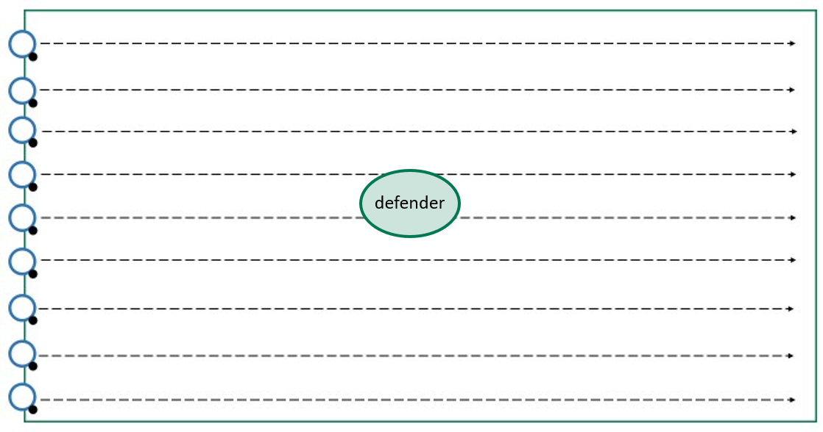
Diagram 1 – octopus soccer

Activity 1 – kick-to-kick passing
- One student stands on one side of the grid with the soccer ball. Their partner stands on the opposite side, facing them (Diagram 2).
- Instruct students to continuously pass the ball with their partner.
- Differentiation – pairs join with other pairs to make groups of four or six. Each group splits in half with one half on one end and the other half facing them. Students take turns in their groups to:
  - pass the ball, follow it and join the back of the opposite group
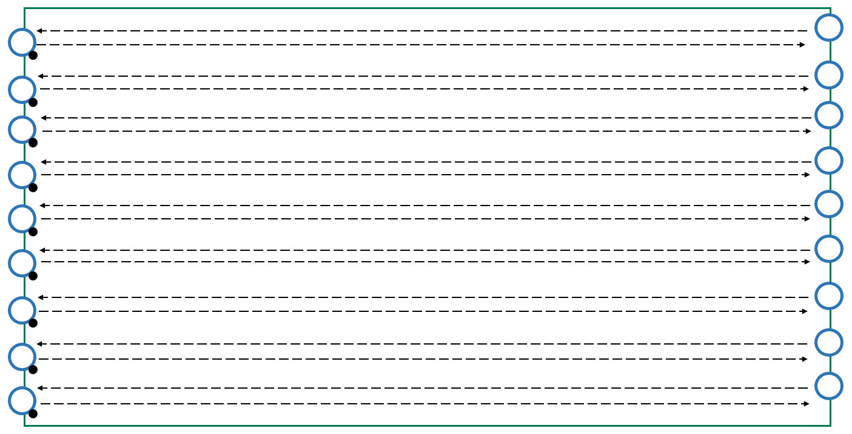
  - perform a one-two pass in the middle and join the back of the opposite group.
Diagram 2 – kick-to-kick passing

Activity 2 – pass, go and find
- Use the same grid as Activity 1 (Diagram 3).
- Create two groups.
  - Group one – each student has a ball inside the grid
  - Group two – students without a ball and are spaced evenly around the outside of the grid.
  - Group one:
    - Dribble the ball inside the grid.
    - Look for an available Group two student on the outside.
    - Pass the ball to them.
    - Find a different Group two student.
    - Receive a pass from them.
  - Group two students:
    - Stand outside the grid.
    - Look for an available Group one student on the inside.
    - Receive a pass from them.
    - Find a different Group one student.
    - Pass the ball to them.
- Differentiation – change the grid size, set up a second grid for two further groups to work in.
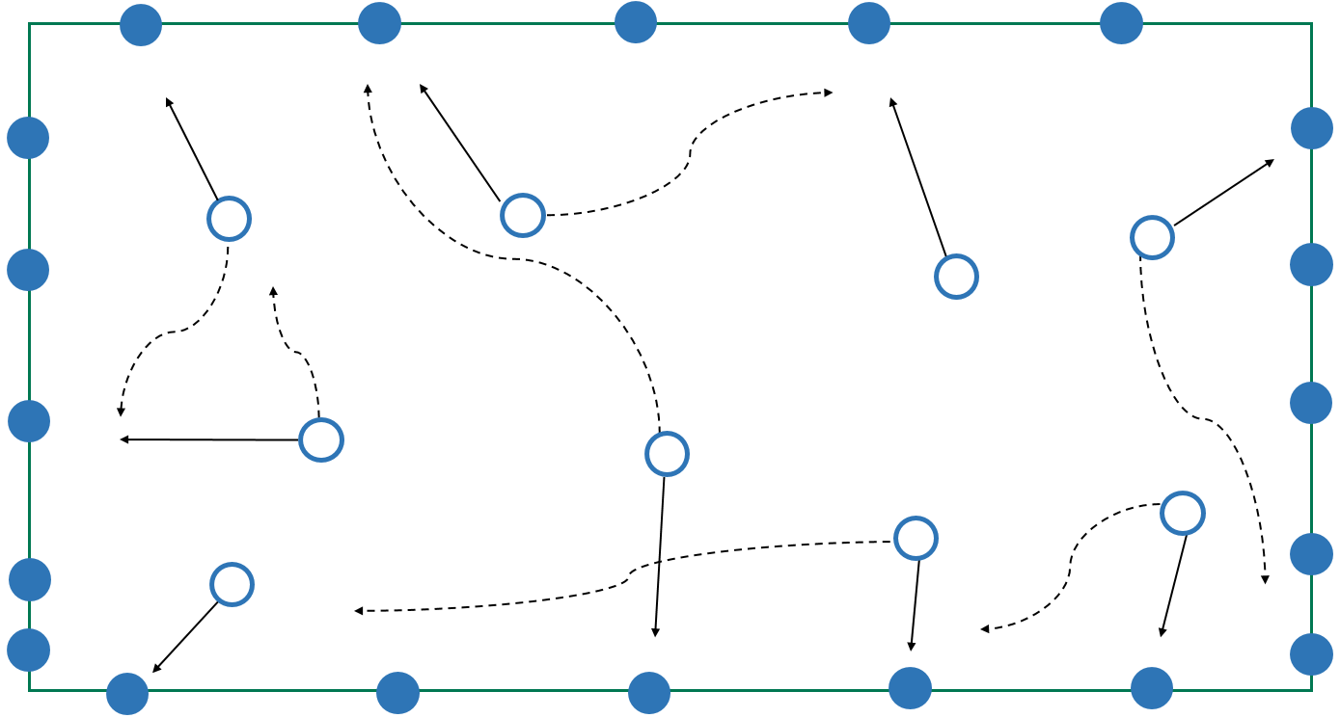
Diagram 3 – pass, go and find

Lesson 2
Activity 2 – keep ball 4v1
- Divide a large grid into smaller grids (Diagram 4).
- Create groups of five:
  - four students are attackers
  - one student is a defender.
- Each group has one soccer ball.
  - Attackers pass the ball between themselves in an attempt to complete as many passes as possible.
  - The defender attempts to intercept or force a misplaced pass.
  - The defender changes position with any attacker who makes a mistake or, after a predetermined time.
- Differentiation – change the grid size, add extra defenders or attackers, restrict the number of touches attackers can have.
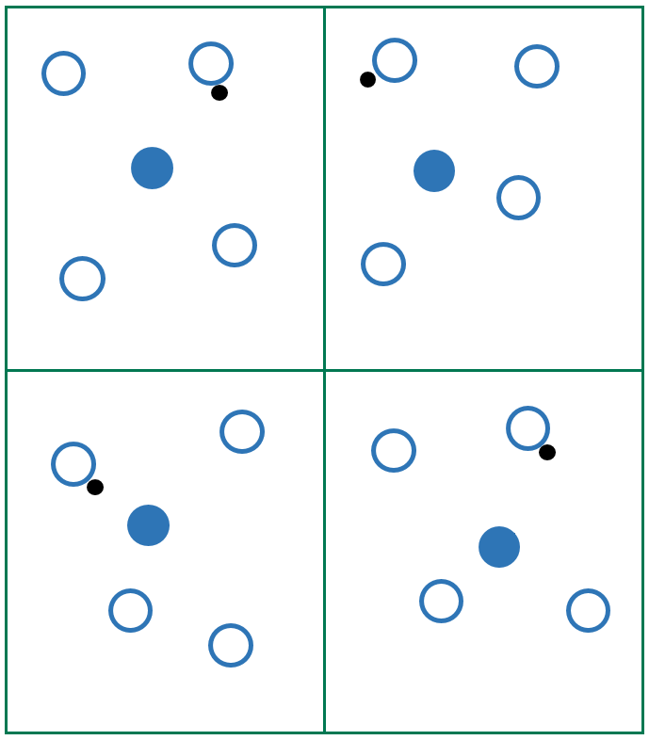
Diagram 4 – keep ball 4v1

Lesson 3
Warm-up – knock the ball off the cone
- Set up equipment as shown (Diagram 5).
  - Find a partner.
  - Get one ball for each pair.
  - Student one starts with the ball.
  - On the teacher’s signal, student one attempts to knock the ball off the cone with a firm pass.
  - If the student is unsuccessful, then their partner (student two) has a chance to knock the ball off the cone with a firm pass.
- Differentiation – change the complexity of the activity to suit the needs of the students; allow students to have multiple attempts, allow students to challenge others in the class.
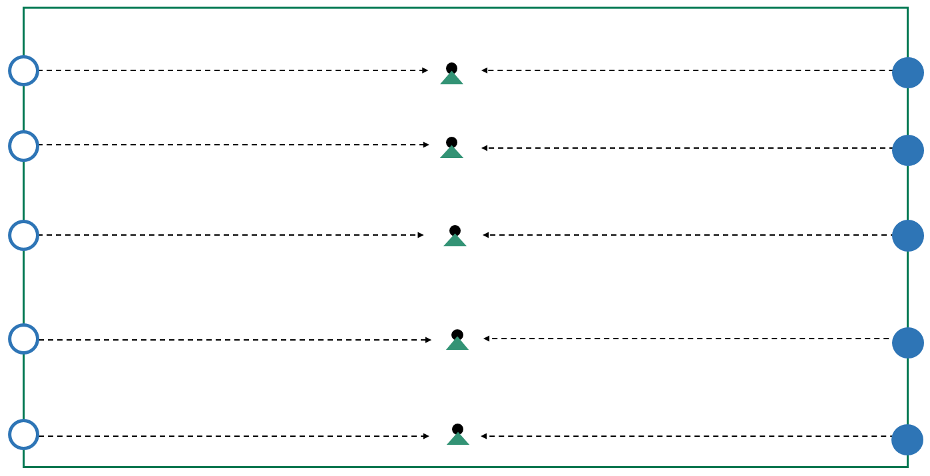
Diagram 5 – knock the ball off the cone

Activity 1 – team keep ball
- Depending on the number of students, split the large grid from Diagram 5 into smaller grids.
- Have 1 ball per grid (Diagram 6).
- Set up equipment and create teams.
  - Teams in possession of the ball pass the ball between themselves to complete a predetermined number of passes. On successful completion of the required number of passes, that team gets a point
  - Teams without the ball work together to intercept, or force a misplaced pass outside the grid. If this occurs the ball is turned over.
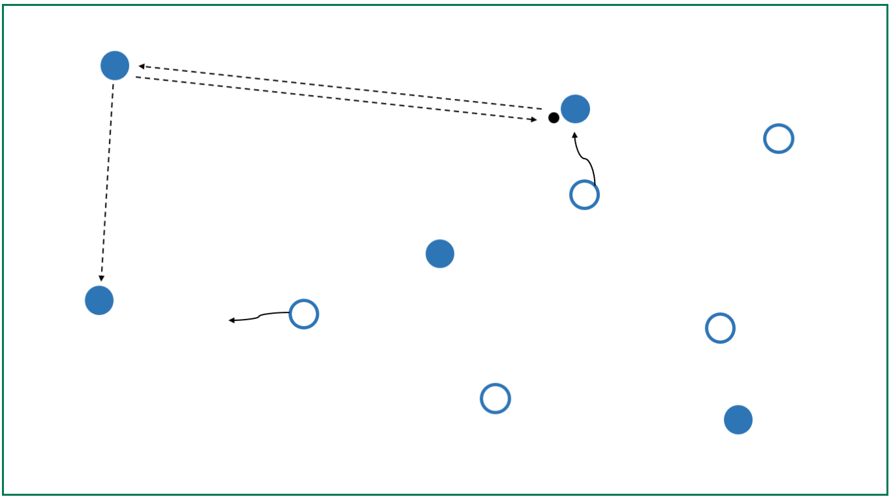
- Differentiation – number of passes required, size of the grid, number of ball touches students are allowed when in possession of the ball, number of players on each team.
Diagram 6 – team keep ball

Activity 2 – end-zone pass
- Adjust grids so they now include an end zone at each end and set up equipment (Diagram 7).
- Keep teams from previous activity.
- Explain activity to students:
  - The teams in possession of the ball, pass the ball between themselves to complete a predetermined number of passes. On successful completion of the required number of passes, that team plays a pass to their teammate, in the end zone, to achieve a point.
  - The team without the ball, work together to intercept, or force a misplaced pass outside the grid. If this occurs the ball is turned over.
- Rule modifications – create a scenario where students must focus on fair play, safety and inclusion, e.g. one of the students was injured (foot, leg, vision). Alternatively, the students must stay in contact at all times with a partner (e.g. 3-legged soccer) and therefore one or more rules must be changed to support their engagement in the game:
  - the number of passes required
  - the size of the grid
  - the number of ball touches students are allowed when in possession of the ball
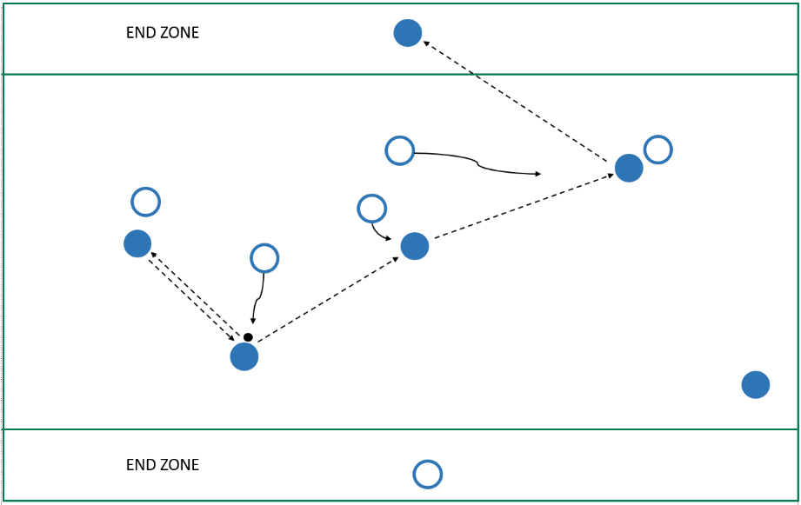
  - the number of players on each team.
Diagram 7 – end-zone pass

Lesson 4
Warm-up – rats and rabbits
- Set up a grid (Diagram 8).
- Separate students into two groups – ‘rats’ and ‘rabbits’.
  - When a group name is called, the students turn and run to the safe zone behind them without being tagged by your partner.
- Introduce a soccer ball. When a group has their name called by the teacher, students turn and dribble their soccer ball into the safe zone behind them without being tackled by their partner.
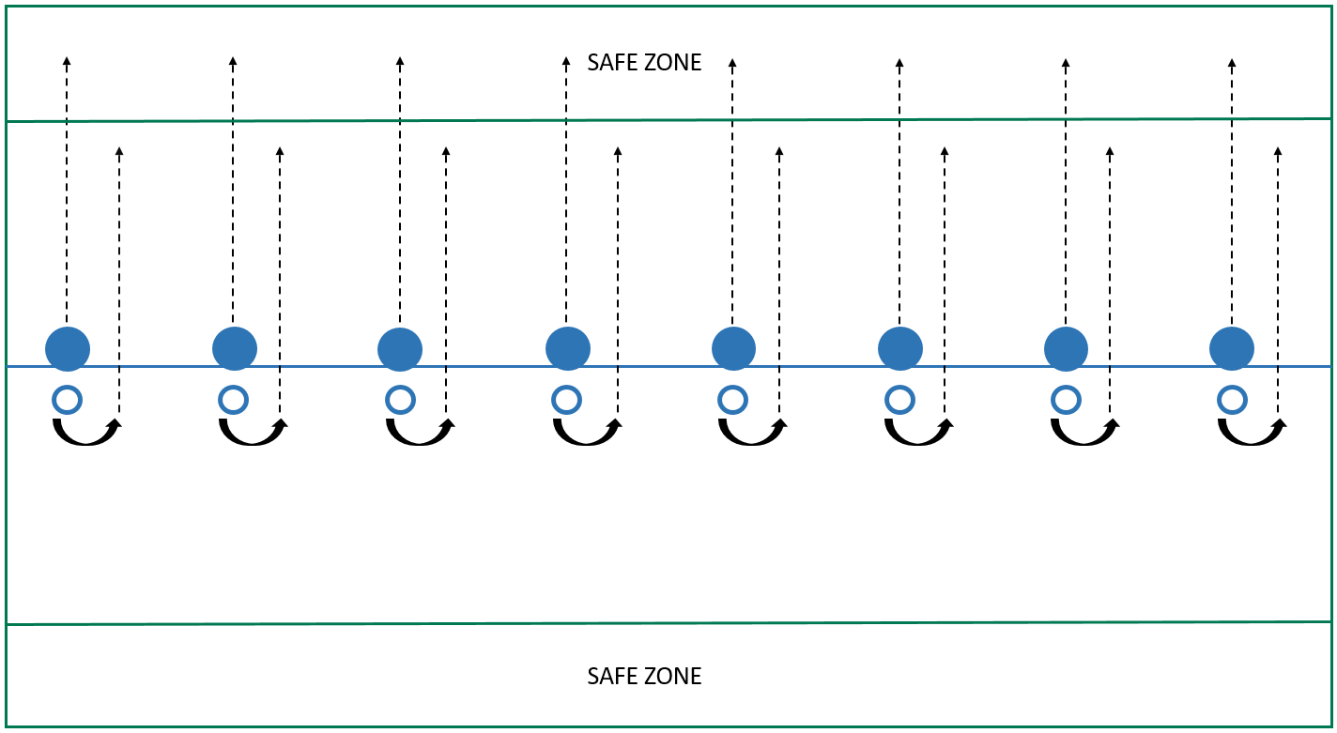
Diagram 8 – rats and rabbits
Activity 1 – change speed and direction
- Set up a grid (Diagram 9).
- One ball per student.
  - Students will dribble around the grid and react to the prompts given to them by the teacher.
  - Instruct students to get a ball each and spread out within the grid.
- Direct students with prompts:
  - ‘accelerate’ – speed up
  - ‘change’ – change direction
  - ‘stop’ – stop the ball and place foot on top
  - ‘pass’ – exchange ball with another student by a pass.
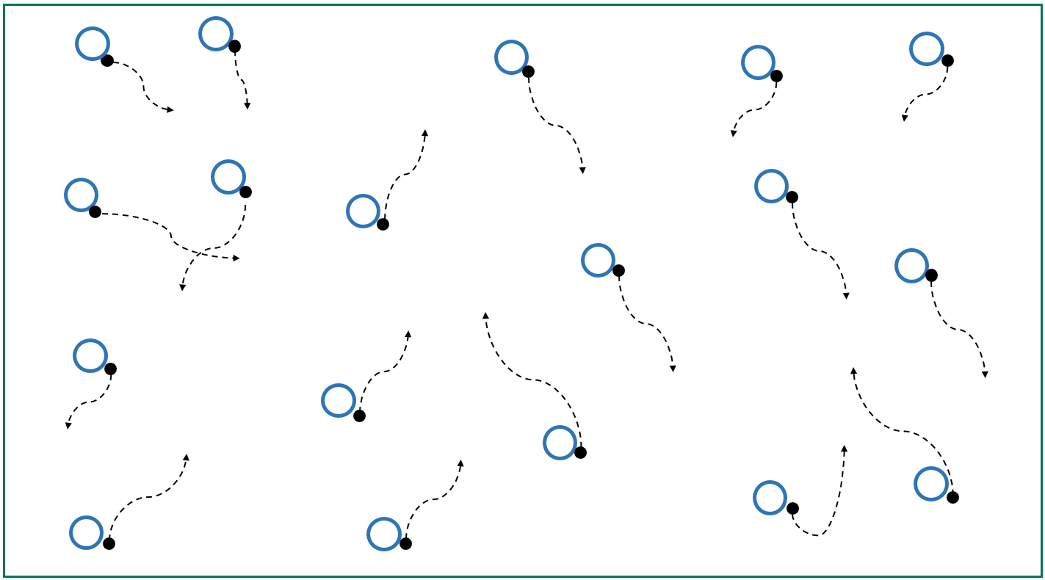
- Differentiation – continue activity but add a competition element to the activity; for example, students attempt to kick an opponent’s ball out of the grid while keeping possession of their own ball (a steal).
Diagram 9 – dribbling with change of speed and direction

Activity 2 – end-zone goal
- Adjust grids to include four goals, two at each end of the grid and set up equipment
(Diagram 10).
- Form groups of 4–6 students.
  - The groups in possession of the ball pass the ball between themselves to complete a predetermined number of passes.
  - On successful completion of the required number of passes, that group can score a goal, in any of the four goals, to achieve a point.
  - The teams without the ball work together to intercept or force a misplaced pass outside the grid. If this occurs, the ball is turned over.
- Rule modifications – create a scenario where students must focus on fair play, safety and inclusion e.g. one of the students was injured (foot, leg, vision). Alternatively, students must stay in contact at all times with a partner (e.g. 3-legged soccer) and therefore one or more rules must be changed to support their engagement in the game:
  - the number of passes required
  - the size of the grid
  - the number of ball touches students are allowed when in possession of the ball
  - the number of players on each team.

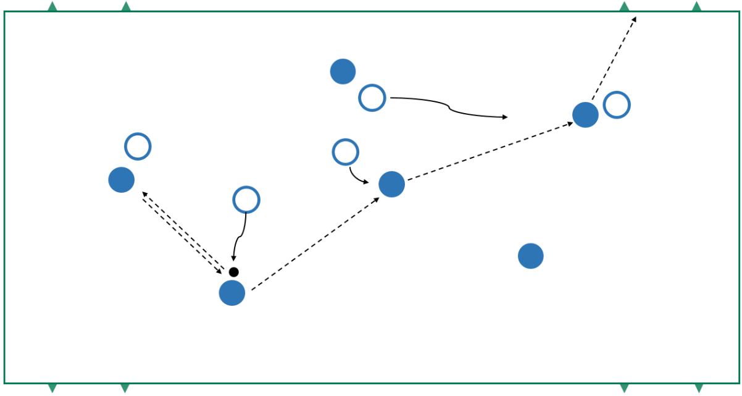
Diagram 10 – end-zone goal

Activity 3 – modified soccer game
- Divide students into equal group, for example 5v5 or 6v6.
- One ball per game.
- Set up equipment.
- Explain activity:
  - the students play a modified game of soccer
  - the students must work in both attacking and defensive areas of their group (Diagram 11).
- Differentiation – modify the number of passes required, size of the grid, number of ball touches students are allowed when in possession of the ball, number of players on each team, and/or size of the goals.
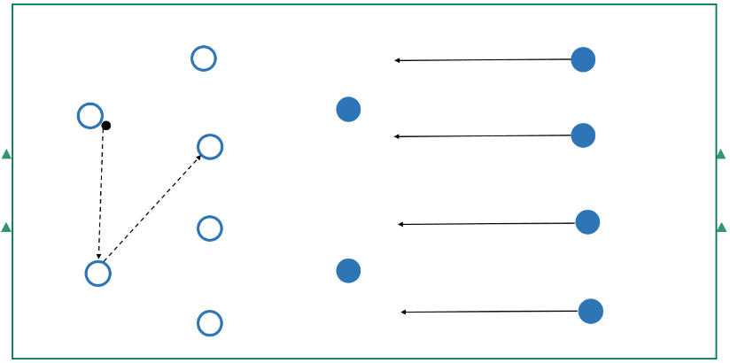
Diagram 11 – modified soccer game
Lesson 6
Warm-up – straight line kicking (kick-to-kick)
- One student stands on one side of the grid with the ball. Their partner stands on the opposite side, facing them (Diagram 12).
- Instruct students to continuously drop-punt the ball with their partner.
- Differentiation – change the number of students within a group to five or six. The students:
  - pass the ball, follow it and join the back of the opposite group
  - pass the ball, follow it and stand on the mark – the receiving student marks the ball and then kicks it over the student on the mark, follows, and stands on the mark
  - increase or decrease distances between students.
Diagram 12 – straight line kick-to-kick
Activity 1 – pass, go and find
- Use the same grid as the warm-up.
- Form two groups.
  - Group one has a ball inside the grid.
  - Group two is without a ball and spaced evenly around the outside grid.
  - Group one students run around inside the grid with the ball in their hands, looking for a ‘free’ student on the outside to drop-punt their ball to them.
  - Group one students then find a Group two student to receive a drop punt pass from (Diagram 13).
- At the teacher’s discretion, students swap roles.
- Differentiation – change the grid size, set up a second grid for two further groups to work in.
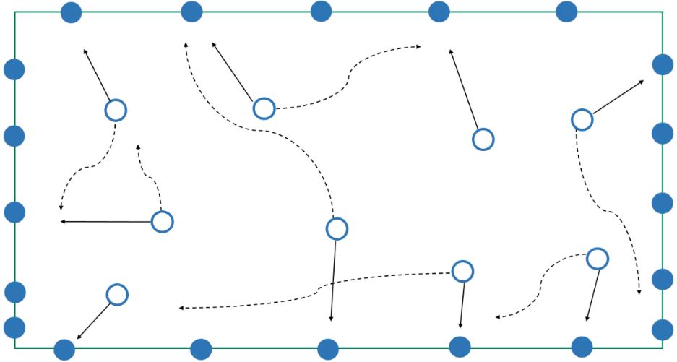
Diagram 13 – pass, go and find

Activity 2 – keep ball 3v1
- Divide a grid into smaller grids (Diagram 14).
- Divide students into groups of four; three students are attackers, and one student is a defender.
- Provide one ball per group.
  - Attackers pass the ball between themselves using the drop kick, in an attempt to complete as many passes as possible
  - A defender will attempt to intercept, or force, a misplaced pass
  - When an attacker makes a mistake, or after a predetermined time, the defender changes position with them.
- Differentiation – change the grid size, add extra defenders or attackers.
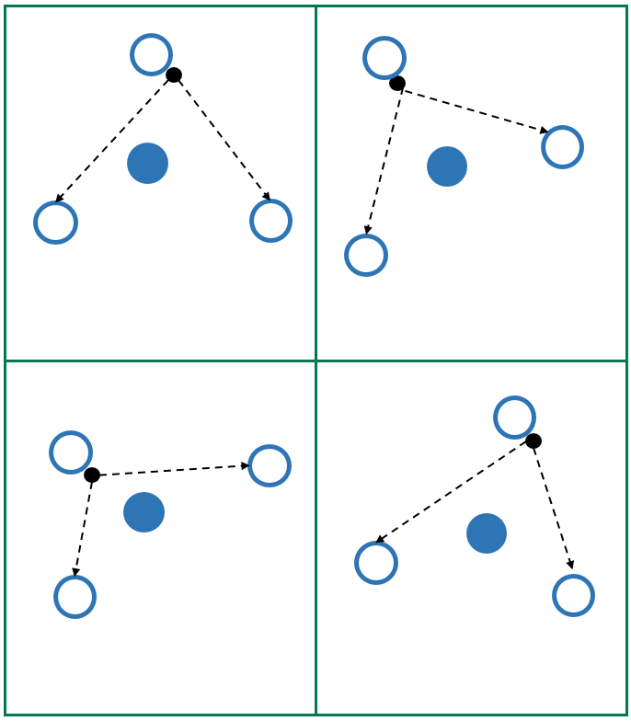
Diagram 14 – keep ball 3v1

Lesson 7
Warm up – nearest to the pin
- Form small groups – approximately four students per group.
- Four balls per group.
- Set cone targets up in front of students at varying distances and angles (Diagram 15).
- Explain warm-up activity to students:
  - One student stands behind a ‘start’ cone and they kick towards the targets.
  - After kicking all four balls, students record their score, collect the balls and pass them to the next student in their group.
  - The next student repeats the activity.
  - Students aim to get the highest score.
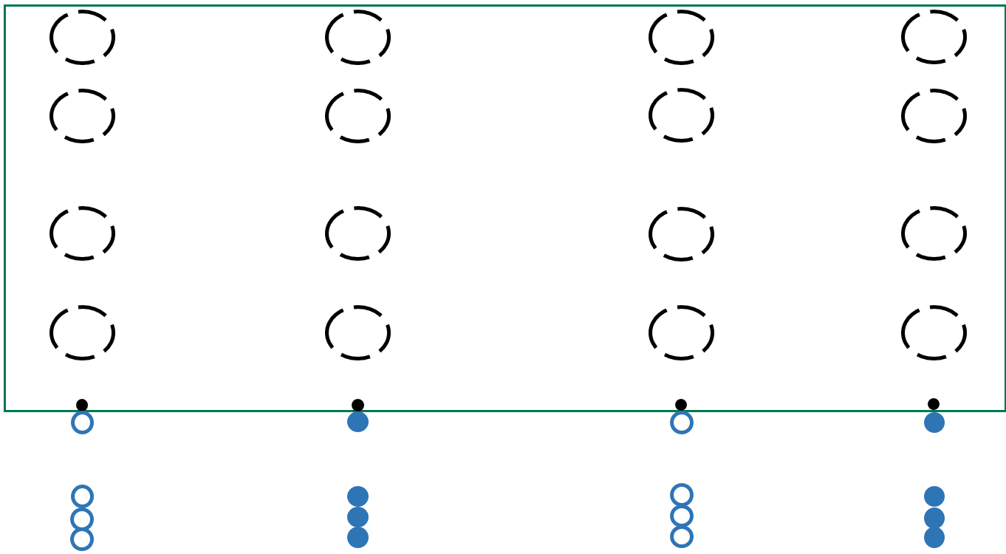
Diagram 15 – nearest to the pin

Activity 1 – team keep ball
- Split the large grid into two or four smaller grids.
- Form students into four–six groups with one ball per grid (Diagram 16).
  - The groups in possession of the ball kick and mark the ball between themselves in an attempt to complete a predetermined number of completed marks.
  - On successful completion of the required number of successful marks, that group gets a point.
  - The groups without the ball work together to intercept or force a misplaced pass outside the grid – if this occurs, the ball is turned over.
- Differentiation – number of marks required, size of the grid, number of players on each team.
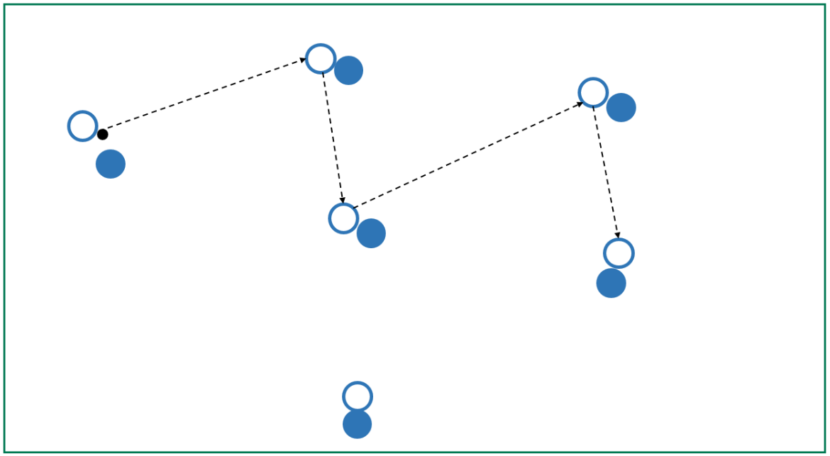
Diagram 16 – team keep ball

Activity 2 – end-zone pass
- Adjust grids to include an end zone at each end (Diagram 17).
  - The group in possession of the ball kicks and marks the ball between themselves in an attempt to complete a predetermined number of completed marks.
  - On the successful completion of the required number of passes, that group must then drop-punt to their teammate in the end zone to achieve a point.
  - The group without the ball work together to intercept or force a misplaced pass outside the grid – if this occurs, the ball is turned over.
- Rule modifications – create a scenario where students must focus on fair play, safety and inclusion, e.g. one of the students was injured (foot, leg, vision). Alternatively, students must stay in contact at all times with a partner (e.g. hand hold or wrist connection) and therefore one or more rules must be changed to support their engagement in the game:
  - the number of marks required
  - the size of the grid
  - the amount of time students are allowed when in possession of the ball
  - the number of players on each team.
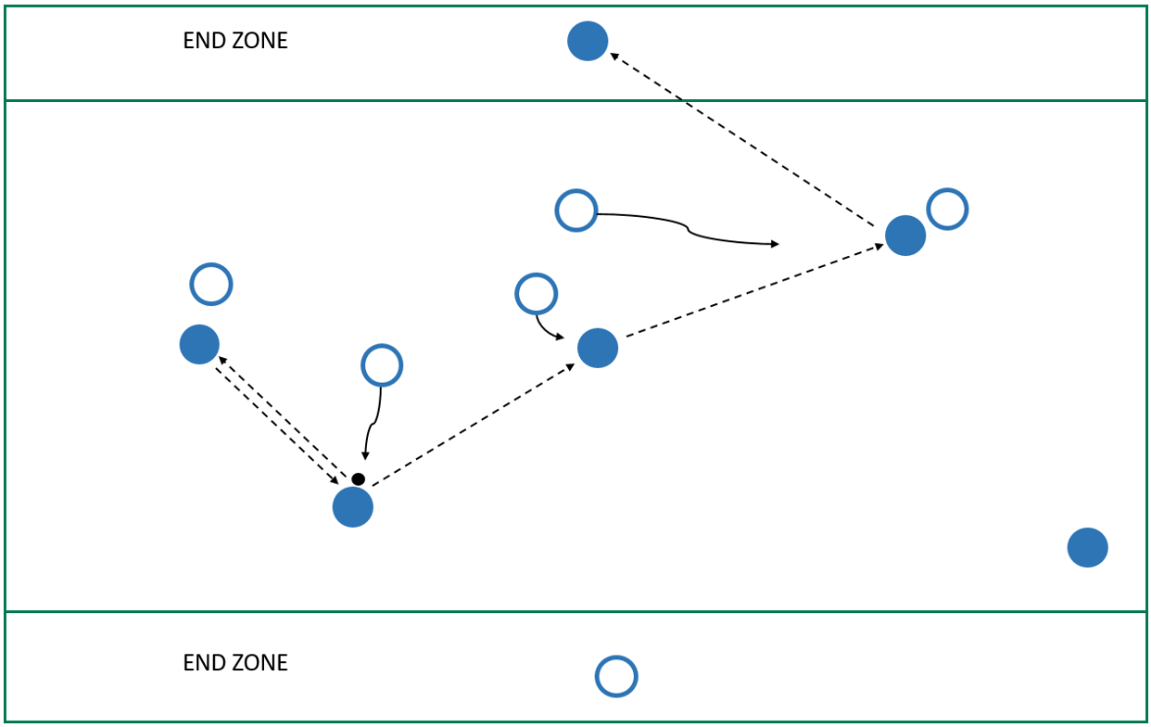
Diagram 17 – end-zone pass

Lesson 8
Warm-up activity – straight line drop kick
- Pair students with one ball between them.
- One student stands on one side of the grid with the soccer ball. Their partner stands on the opposite side, facing them (Diagram 18).
- Instruct students to continuously drop kick the ball with their partner.
- Differentiation – increase or decrease distances between students, change the number of students within a group to five or six. Students:
  - drop-kick the ball, follow it and join the back of the opposite group
  - drop-kick the ball, follow it and stand on the mark – the receiving student marks the ball and then kicks it over student on the mark, follows and stands on the mark.
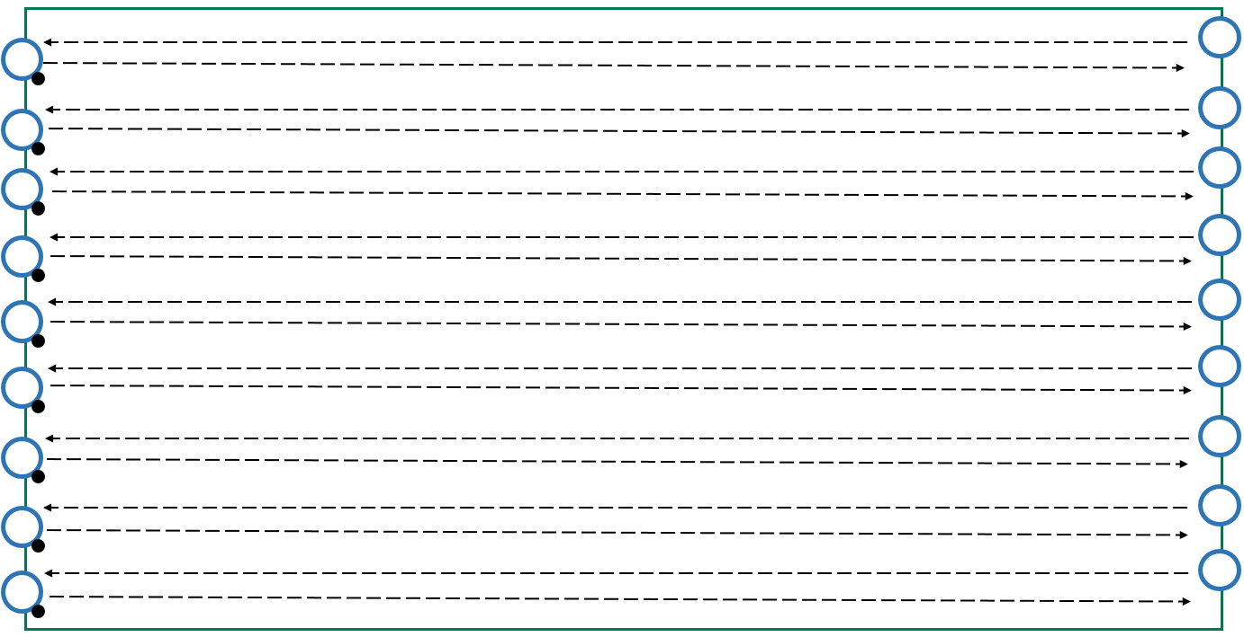
Diagram 18 – line kicking

Activity 1 – pass, go and find
- Form two groups:
  - Group one students have a ball each and position themselves inside the grid.
  - Group two students have no ball and position themselves evenly around the outside of the grid.
- Group one students solo and bounce the ball inside the grid looking for a free student on the outside and drop-kick their ball to them using the drop kick technique used in the warm-up.
- After drop-kicking the ball, Group One students find a different Group Two student to receive a drop kick pass from (Diagram 19).
- At the teacher’s discretion, students swap roles.
- Differentiation – change the grid size, set up a second grid for two additional groups to work in.
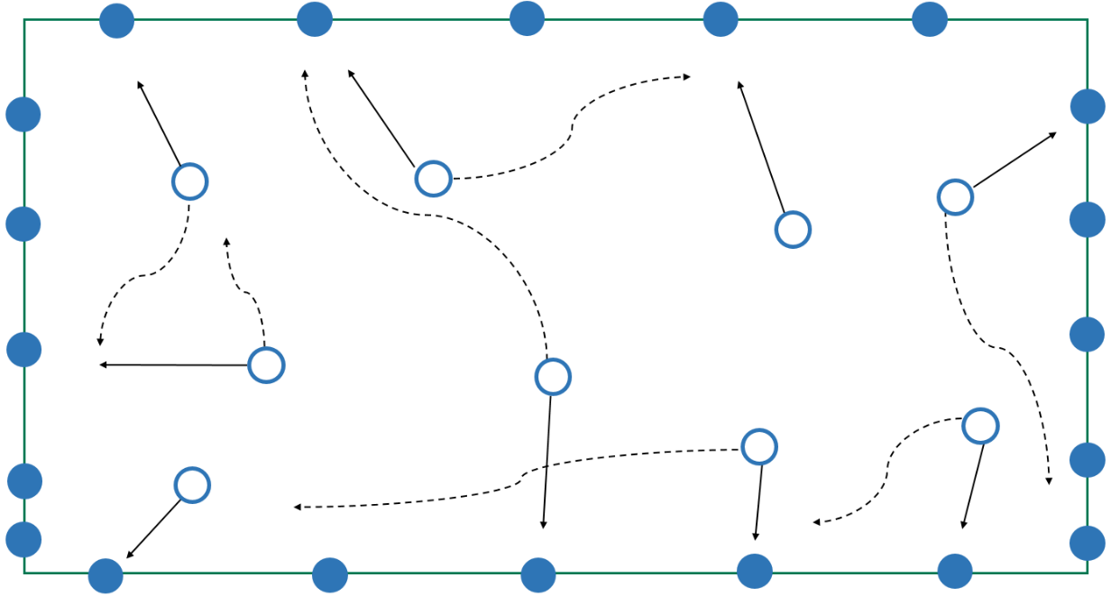
Diagram 19 – pass, go and find

Activity 2 – keep ball 3v1
- Divide a large grid into smaller grids (Diagram 20).
- Form groups of four: three students are attackers and one student is a defender. Provide one ball per group.
  - Attackers pass the ball between themselves in an attempt to complete as many passes as possible.
  - A defender will attempt to intercept, or force a misplaced pass.
  - When an attacker makes a mistake, or after a predetermined time, the defender changes position with them.
- Rule modifications – create a scenario where students must focus on fair play, safety and inclusion, e.g. one of the students was injured (foot, leg, vision). Alternatively, students must stay in contact at all times with a partner (e.g. three-legged soccer) and therefore one or more rules must be changed to support their engagement in the game:
  - the number of passes required
  - the size of the grid
  - the number of ball touches students are allowed when in possession of the ball
  - the number of players on each team.
Diagram 20 – keep ball 3v1

Lesson 9
Warm up – drop kick tennis
- Three or four large grids depending on number of students.
- Form groups – approximately six members per group with one ball per group.
  - The groups play against each other.
  - The students drop-kick their ball into the opponents’ grid (Diagram 21).
  - The receiving students must catch or mark the ball before it lands.
  - If the ball lands in the grid, the kicking team receives a point.
  - If the ball lands outside the grid, the receiving team receives a point.
- Differentiation – increase or decrease grid size and number of balls, introduce an ‘imaginary net’ for students to kick the ball over, allowing groups to rotate and challenge other groups.
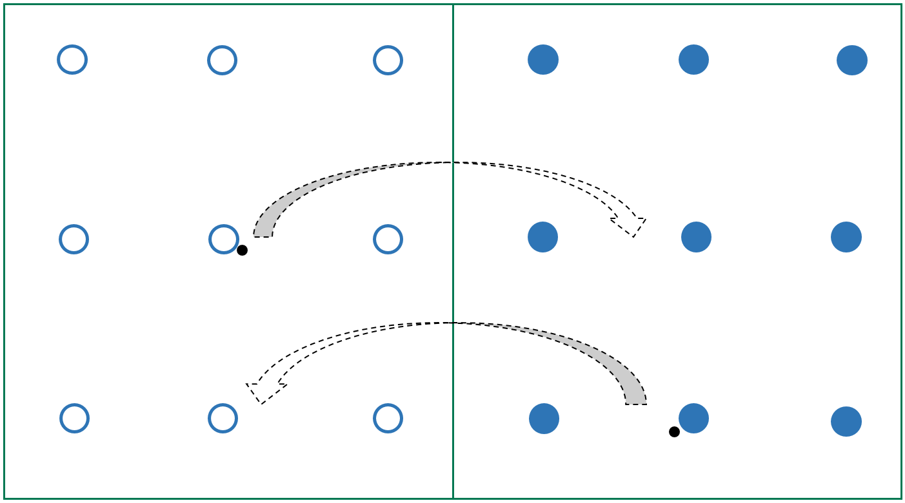
Diagram 21 – drop kick tennis

Activity 1 – team keep ball
- Split the large grid into two or four smaller grids.
- Separate students into four – six groups; one ball per grid.
  - Groups in possession of the ball pass the ball between themselves in an attempt to complete a set number of passes – on successful completion of the set number of passes, that group gets a point.
  - Groups without the ball work together to intercept or force a misplaced pass outside the grid – if this occurs, the ball is turned over (Diagram 22).
- Differentiation – change the number of passes required, size of the grid, number of players on each team.
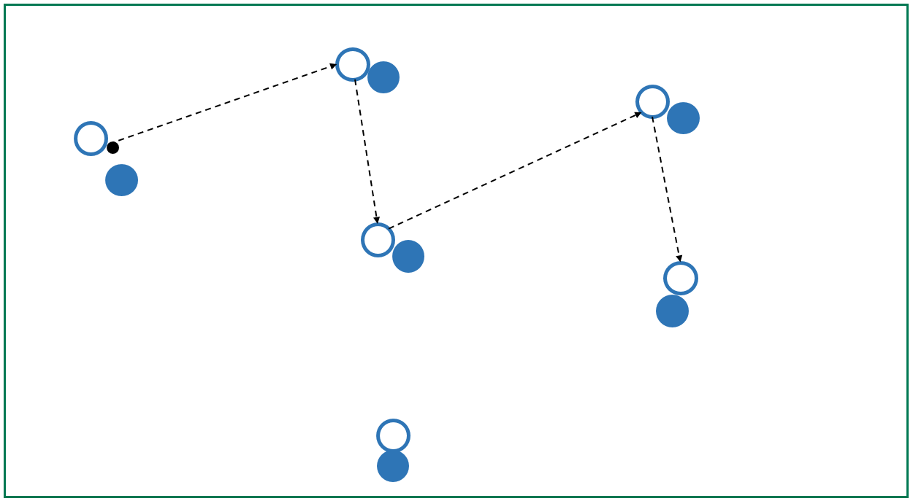
Diagram 22 – team keep ball

Activity 3 – end-zone goal
- Adjust grids so they now include four goals, two at each end of the grid (Diagram 23).
- Explain activity to students:
  - The groups in possession of the ball pass the ball between themselves in an attempt to complete a predetermined number of passes.
  - On successful completion of the required number of passes, that team can score a goal in any of the four goals to achieve a point.
  - The team (members) without the ball work together to intercept or force a misplaced pass outside the grid – if this occurs, the ball is turned over.
- Differentiation – change the number of passes required, size of the grid, number of ball touches the students are allowed when in possession of the ball, number of players on each team, size of the goals.
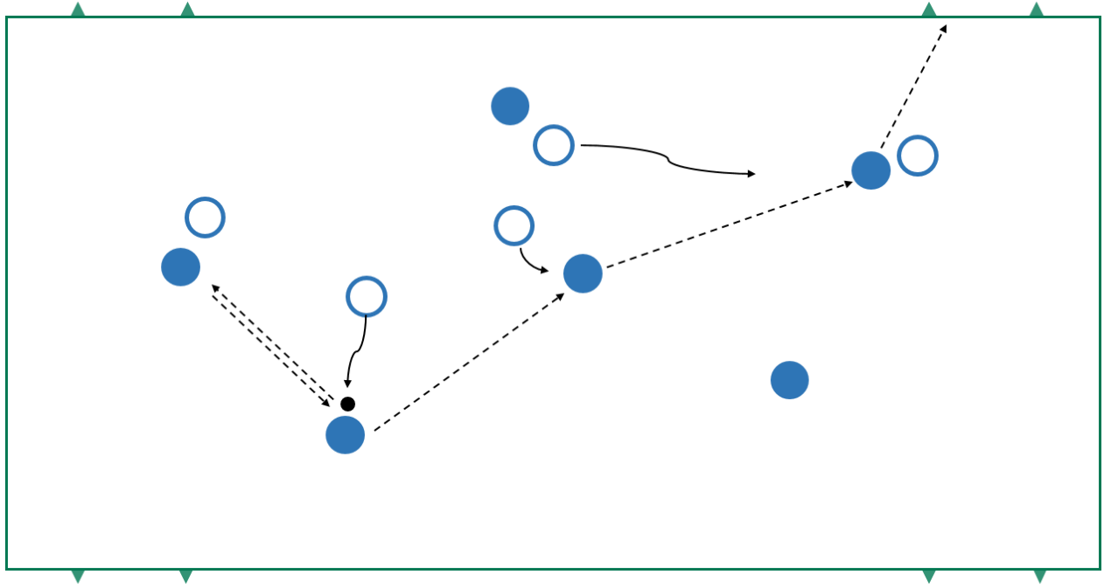
Diagram 23 – end-zone goal

Warm-up – bounce and solo
- Set up a large grid (Diagram 24).
- Tell students to get a soccer ball each and stand on one side.
  - The students move at their own pace across the length of the grid.
  - Every four paces, the students alternate between soloing and bouncing the ball.
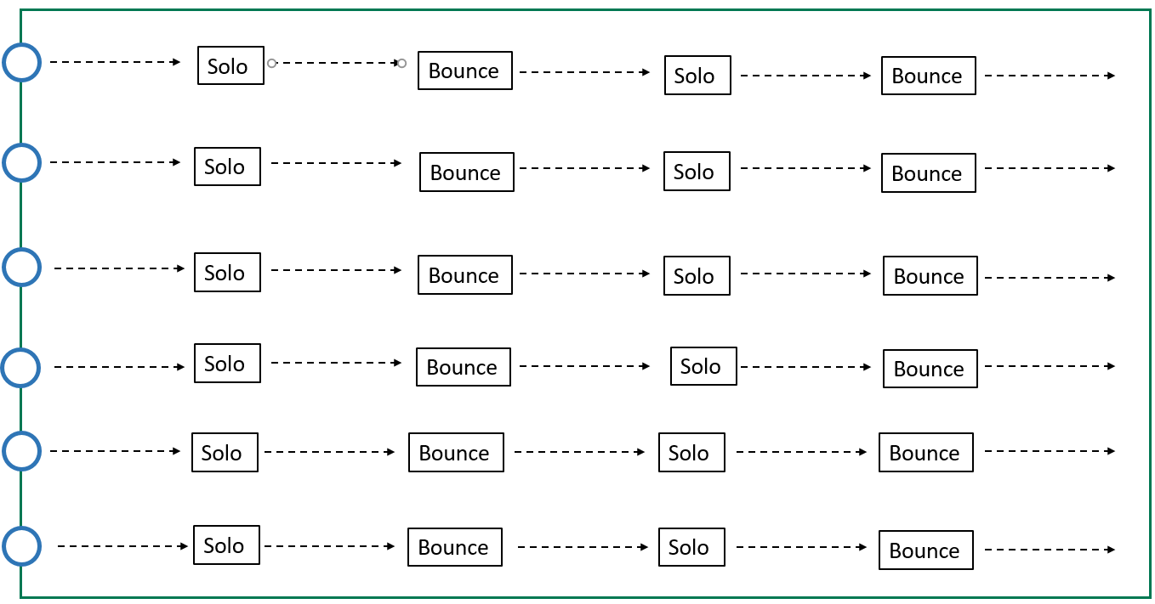
  - Repeat multiple times.
Diagram 24 – bounce and solo

Activity 1 – straight line drop-kick and follow
- Group students into groups of seven with one ball between them.
  - Four students stand on one side of the grid with the soccer ball. The other three students stand on the opposite side, facing them.
  - The students drop-kick the ball, follow it and join the back of the opposite group
(Diagram 25).
- Differentiation – the receiving student marks the ball then kicks it over the student on the mark, follows and stands on the mark. Increase or decrease distances between students.
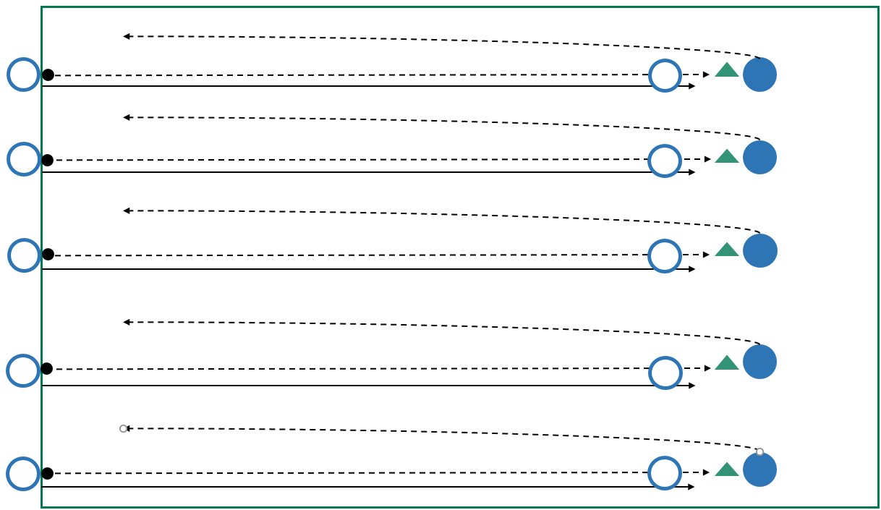
Diagram 25 – straight line drop kick and follow

Activity 2 – summative assessment – game performance task
Assessment support notes
- Teacher forms students into two teams of seven.
- Goals are set up with markers two metres apart, working in one half of the field.
- Students participate in a small‐sided Gaelic football game (Diagram 26).
- Part B: Summative assessment checklist – Teacher assessment.
Rules
- If the students carry the ball by hand, then every four steps the ball must be either bounced or soloed.
  - Note: solo – the player drops the ball onto their foot and kicks it back into their hand.
- Students may not bounce the ball twice in a row.
- A mark is paid if the ball is cleanly caught, having been kicked 10 metres.
- Students are allowed to use soccer skills to dribble and kick the ball from the ground.
- Players may contest for the ball by playing it with the hand, or by shoulder charging an opponent side-to-side, or soccer tackle if the ball is on the ground.
- If the ball is kicked out of the playing area, the team that did not touch it last drop kicks the ball in to restart the game.
Scoring
To score, the ball must be kicked between the markers.
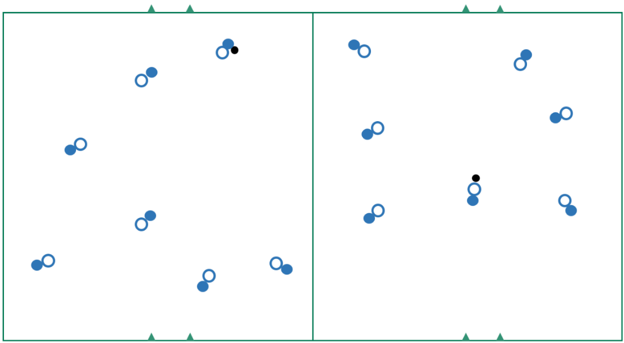
Diagram 26 – game performance

Appendix B
Assessment task 1
Interpersonal skills

Task details
Title Interpersonal skills assessment checklist
Description Students will be assessed on their ability to utilise modification of rules
Type of assessment Formative and summative
Part A: Self-reflection and peer evaluation (to support teacher’s judgement – formative)
Part B: Teacher assessment (summative)
Purpose of assessment To assess student ability to utilise modification of rules to allow for fair play, safety and inclusion of all participants, and interpret verbal, physical and situational cues to identify and appropriately respond to the feelings and motives of others when working in a team or group.
Assessment strategy Performance
Evidence to be collected Checklist
Suggested time Part A: Weeks 4 and 8
Part B: Week 9

Content description
Movement and physical activity
Interpersonal skills
- Modification of rules, equipment or scoring systems to allow for fair play, safety and inclusion of all participants
- Verbal, physical and situational cues to identify and appropriately respond to the feelings and motives of others when working in a team or group

Task preparation
Prior learning
Students have participated in a 10-week kicking lesson sequence, focusing on the skill of kicking in a variety of contexts, such as Soccer, Gaelic football and Australian Rules football.

Assessment task
Assessment conditions
In-class assessment
Differentiation
Teachers should differentiate their teaching and assessment to meet the specific learning needs of their students, based on their readiness to learn and their need to be challenged. Where appropriate, teachers may scaffold or extend the scope of the assessment tasks.

Resources
- Soccer balls
- Markers
- Sashes or bibs, to differentiate teams
- Student reflection and peer evaluation task sheet
- Filming device (if recording evidence)

Instructions to teachers
Within the lesson sequence students should be provided with opportunities to demonstrate their ability to modify rules in an invasion game context to allow for fair play, safety and inclusion of all participants, and use cues to identify and appropriately respond to others when work in a team or group. This can be achieved through active management of teammates and making sure each player operates fairly and ethically, and abides by game rules, maintaining and promoting the integrity of the sport.
Formative assessment
This teaching and learning sequence encourages ongoing formative assessment. Students will be formatively assessed throughout this lesson sequence on their progress and development, and offered feedback to assist with their growth. This is essential for learning. Interpersonal skills require time to develop and be effective in assisting students to establish roles, routines and responsibilities within their teams, and foster understandings and links in a sporting context. Monitoring the students using formative assessments (checklists, anecdotal notetaking) will provide the teacher with additional evidence on which to base their final assessment mark.
During the lesson sequence, the teacher will use a formative assessment process through observing:
- rule modification in invasion games
- students’ ability to allow for fair play, safety and inclusion of all participants
- students’ ability to identify and appropriately respond to others in a team or group
- students’ verbal, physical and situational cues
Students engage in invasion game activities throughout the sequence.
- Lessons 1–5 – Soccer
- Lessons 7–11 – Modified Gaelic football
Students complete Part A: Student checklist – Self-reflection and peer evaluation (Appendix B).
- Lesson 4 and Lesson 8
Students reflect on their skills of responding to others, fair play, safety and inclusion of all participants, and understanding and implementation of modified rules of the game.
The reflections and evaluations are not instances of students self-assessing. The purpose of the student checklist is to allow the teacher to collect support for their judgement, as appropriate.
Students complete a checklist to reflect on their own and peers’ personal growth within a team environment. Students are required to make judgements on:
- responding to others
- fair play, safety and inclusion of all participants
- modified rules of the game.
Summative assessment
The summative assessment gives students the opportunity to demonstrate all the qualities they have acquired in a holistic approach throughout this gameplay sequence.
Part B: Summative assessment checklist – Teacher assessment (Week 9)
Students will be assessed on:
- Interpersonal skills (actions/skills to support physical activity).
Students will be assessed according to the marking of a summative assessment checklist and marking key provided. Use this checklist to create a holistic judgment regarding the students’ ability to collaborate and cooperate effectively in teams throughout the gameplay program.
Students will be awarded a mark out of 5 for each area based on their performance, in accordance with the checklist.

Marking observations
This table will assist in making a holistic judgement regarding performance, in the three areas from Interpersonal skills content.
 | Intrinsic qualities | Extrinsic performance
Responding to others | - empathy  - active listening  - adaptability  - emotional intelligence  - patience | - clear communication  - positive reinforcement  - conflict resolution  - team building  - flexibility  - promoting inclusion
Fair play, safety inclusion of all participants | - honesty  - responsibility  - integrity  - equity  - respect  - attitude and demeanour | - establishment of clear rules and guidelines  - respects self  - respects others and their rights  - provides accurate feedback  - consistency  - credible  - follows rules  - respects opposition  - congratulates others
Modified rules of the game | - knowledge of rules  - application to games  - application to situation | - understands rules

Task 1 – Interpersonal skills (gameplay) assessment
Demonstration of skills in both developmental and competitive situations will be assessed, taking into account the combination of three elements of Responding to others; Fair play, safety and inclusion of all participants; Modified rules of the game.
Mark | Responding to others | Fair play, safety and inclusion of all participants | Modified rules of the game
5 | Consistently utilises verbal, physical and situational cues to select and justify appropriate responses to the feelings and motives of others, to an outstanding level to achieve required outcomes in a team or group | Consistently displays outstanding fair play, safety and inclusion of all participants, making effective decisions and choices appropriate to the situation to achieve required outcomes | Consistently displays outstanding application of modifying rules of the game to achieve required outcomes
4 | Utilises verbal, physical and situational cues to select and justify appropriate responses to the feelings and motives of others, to a high level to achieve required outcomes in a team or group | Demonstrates a high level of fair play, safety and inclusion of all participants, often making decisions appropriate for the situation to have a high degree of success in achieving the required outcomes | Demonstrates a high level of applied engagement with the modified rules of the game to achieve required outcomes
3 | Competently utilises verbal, physical and situational cues to select and justify appropriate responses to the feelings and motives of others, to achieve satisfactory outcomes | Competently demonstrates fair play, safety and inclusion of all participants, and selects and uses appropriate decisions for the situation, achieving satisfactory outcomes | Competently demonstrates the modified rules of the game achieving satisfactory outcomes
2 | Utilises verbal, physical or situational cues to select or justify responses to the feelings and motives of others, to a basic level to occasionally achieving outcomes | Demonstrates a basic level of fair play, safety and inclusion of all participants, and is indecisive in situations, occasionally achieving outcomes | Demonstrates a basic level of the modified rules of the game, occasionally achieving outcomes
1 | Utilises verbal, physical or situational cues to select or justify responses to the feelings and motives of others, to a limited level with a low degree of success in occasionally achieving outcomes | Demonstrates a limited level of fair play, safety and inclusion of all participants, and is often indecisive with a low degree of success in occasionally achieving outcomes | Demonstrates a limited level of the modified rules of the game and selects, with a low degree of success, occasionally achieving the outcomes

Part A: Student checklist – self-reflection and peer evaluation
This task is designed to measure your own and your peers’ level of personal growth throughout the lesson sequence. Indicate your judgement on the table.
Interpersonal skills qualities
Name of student:
Self-evaluation/ reflection | Consistently | Often | Sometimes | Seldom | Limited
Responding to others
Fair play, safety and inclusion of all participants
Modified rules of the game
Name of peer:
Peer evaluation | Consistently | Often | Sometimes | Seldom | Limited
Responding to others
Fair play, safety and inclusion of all participants
Modified rules of the game

Part B: Teacher checklist – summative assessment
This task is designed to measure a student’s personal growth throughout the lesson sequence. Utilise formative assessment feedback from students as a support for your judgement, as appropriate.
Indicate on the table the position of your judgement.
Interpersonal skills – Part B
 | Consistently 5 | Often  4 | Sometimes  3 | Seldom  2 | Limited  1
Responding to others
Fair play, safety and inclusion of all participants
Modified rules of the game
Observation notes
Total |  |  |  |  |  | /15

Appendix C
Assessment task 2
Soccer and Gaelic football

Task details
Title Assessment of strategic and tactical skills within a gameplay kicking context
Description Students will participate within a gameplay kicking activity. The practical assessments will provide students with opportunities to demonstrate individual kicking skills related to game performance. The assessment activities allow students of varying abilities, to demonstrate individual kicking skills in different competitive contexts
Type of assessment Summative
Purpose of assessment To assess student achievement in a variety of skills (summative), at the conclusion of the kicking lesson sequence
Assessment strategy Performance
Evidence to be collected Check list/video footage
Suggested time Two lessons:
Week 6: Soccer context assessment
Week 11: Gaelic football context assessment

Content descriptions
Movement skills
- Movement skills and sequences within different physical activity contexts with a focus on:
  - increased efficiency in skill performance
  - control of balance and stability
- Selection of strategic skills and tactical skills in the manipulation of effort, space, time, objects and people in a variety of movement contexts

Task preparation
Prior learning
Students have participated in the relevant lessons and have been instructed in the individual skills, game tactics and rules, to effectively compete in kicking invasion games.

Assessment task
Assessment conditions
- In-class assessment
- Students can be grouped according to ability, or maintain mixed ability across the groups
Differentiation
Teachers should differentiate their teaching and assessment to meet the specific learning needs of their students, based on their readiness to learn and their need to be challenged. Where appropriate, teachers may scaffold or extend the scope of the assessment tasks.

Resources
- Performance assessment support material – Soccer and Gaelic football
- Markers (cones)
- Soccer balls
- Set of bibs to differentiate the two teams
- Soccer field

Instructions for teachers
Throughout this lesson sequence, students will be assessed on a lesson-by-lesson basis. Formative assessment provides the teacher with additional evidence for their final assessment mark and avoids the requirement for a set assessment day.
The purpose of the summative assessment is to finalise the formative assessment, giving students the opportunity to demonstrate the skills and knowledge they have acquired during this
lesson sequence.
Task details
Description of task
Students learn skills to participate in a variety of invasion games with a kicking context. This will be followed by the assessment task – participation in a modified game – in which students will be provided with opportunities to demonstrate skills related to game performance.
Lesson 5 – Soccer
Students participate in a 5v5 soccer game, using a quarter of a full pitch size. Students are assessed on skill proficiency, selection and application of skills and tactical application in both offense and defence. The suggested total time for summative assessment is up to 20 minutes (allowing for students’ level of fitness). Groups are to be rotated, or multiple groups work concurrently.
- Teacher forms teams of 5 students.
- Teams can be allocated according to student ability (within the class), or representative of a mixture of abilities.
- Students can stay in the same teams for the duration of the assessment; however, flexibility to move students to different teams will provide opportunities for students to experience a range of situations.
- Games will run for a set time (according to fitness and ability levels), with multiple pitches running concurrently.
- Teacher rotates teams around (allowing for students’ level of fitness).
Students will be assessed on:
- proficiency of skills
- selection and application of skills in the game context
- offensive tactical application
- defensive tactical application – creating, using and defending space.

Lesson 10 – Gaelic football
Students participate in a 7v7, modified Gaelic football game, in which they are assessed on skill proficiency, selection and application of skills, and tactical application in both offense and defence. The suggested pitch size is half a soccer pitch, and the total time for summative assessment is up to 20 minutes (allowing for students’ level of fitness). Groups are to be rotated, or multiple groups work concurrently.
- The teacher forms students into teams of seven.
- The teams can be allocated according to student ability (within the class), or representative of a mixture of abilities.
- The students can stay in the same teams for the duration of the assessment; however, flexibility to move students to different teams will provide opportunities for students to experience a range of situations.
- The games will run for a set time (according to fitness and ability levels), with multiple pitches running concurrently.
- The teacher rotates teams around (allowing for students’ level of fitness).
Students will be assessed on:
- proficiency of skills
- selection and application of skills in the game context
- offensive tactical application
- defensive tactical application – creating, using and defending space.
Assessment notes
For both parts of the practical assessment, evidence can be collated through video recording to review, or an observation schedule can be implemented.
Students will be assessed according to the marking observation table and marking key provided. Teachers will use this table to make a holistic judgment regarding student proficiency, selection and application of skills and tactical application in both offense and defence contexts in a game situation.
Students will be awarded a mark out of five for each area based on their performance, in accordance with the observation table.

Marking observations
Use this table to assist in making a holistic judgement regarding performance in each of the four areas.
Proficiency | Selection and application of skills | Tactical application | Tactical application
- Execution  - consistency  - control  - fluency  - precision  - Efficient sequencing of body parts during kicking | - Selection of, and transfer of, tactics between movement contexts and settings  - Examples of decisions to be made could include choice of kick to use at appropriate time | - Defence  - regains possession  - anticipates ball movement and moves to defensive position  - reads the play to prevent scoring opportunities  - appropriate marking of an opponent who may, or may not, have the ball  - transitional play shows attacking flair in turnovers  - communicates with teammates | - Offence  - maintains possession  - leads to open space to create a passing option for a team‐mate or draw defenders away  - creates scoring opportunities  - creates options by moving to areas such as behind a defender; passing to team‐mate in open position; supporting team‐mate with the ball  - transitional play – moves to a defensive position when possession is lost  - communicates with teammates

Marking key
Demonstration of skills in competitive situations will be assessed, taking into account the combination of four elements of an action; for example, consistency, precision, fluency, control. Game pressure, pace, skill and intensity of opponent and teammates, playing area, environmental conditions etcetera may affect performance and should be considered when marking. This marking key can be used in conjunction with Performance assessment support material – Australian Rules football and soccer, which outlines the observation points for the skills in the specific assessment context.
These documents can be found on the Authority website:
https://k10outline.scsa.wa.edu.au/home/assessment/assessment-support-materials
Description | Marks
Proficiency
Consistently performs skills with efficiency, precision and fluency  Consistently controls the flight and delivery of the ball, achieving the desired outcome | 5
Performs skills with a high degree of precision and fluency  Demonstrates a high level of control of the delivery and flight of the ball when aiming for a target, with a high degree of success in achieving the desired outcome | 4
Performs most skills with precision and fluency  Controls the delivery and flight of the ball when aiming for a target most of the time, mostly achieving the desired outcome | 3
Performs some skills with fluency and precision  Controls the delivery and flight of the ball some of the time when aiming for a target, with some degree of success in achieving the desired outcome | 2
Performs few skills and demonstrates limited fluency  Demonstrates limited control of the delivery and flight of the ball when aiming for a target, with a low degree of success in achieving the desired outcome | 1
Subtotal | /5
Selection and application of skills
Consistently makes the correct decision and selects a variety of skills that range from simple to complex and are appropriate to the situation, achieving the desired outcome | 5
Selects a broad range of simple and complex skills that are mostly appropriate for the situation, with a high degree of success in achieving the desired outcome | 4
Selects and uses mainly simple skills that are mostly appropriate for the situation, usually achieving the desired outcome | 3
Uses the appropriate skill in some situations, giving preference to more familiar and less complex skills | 2
Performs a limited range of simple skills regardless of the situation, with a low degree of success in achieving the desired outcome | 1
Subtotal | /5
Offence
Performs required skills appropriate to the competitive situation to an exceptional level, demonstrating creativity, deception and anticipation while maintaining intensity under game-like pressure | 5
Performs required skills appropriate to the competitive situation to a high level with some consistency, usually demonstrating creativity, deception and anticipation, while maintaining intensity under game-like pressure on most occasions | 4
Often performs required skills appropriate to the competitive situation, at times demonstrating creativity, deception and anticipation at a reduced intensity | 3
Sometimes performs required skills appropriate to the competitive situation, occasionally demonstrating a low degree of creativity, deception or anticipation at a low intensity | 2
At times performs required skills appropriate to the competitive situation, with little or no creativity, deception or anticipation at a minimal intensity | 1
Subtotal | /5
Tactical application – defence
Performs required skills appropriate to the competitive situation to an exceptional level, demonstrating creativity, deception and anticipation while maintaining intensity under game-like pressure | 5
Performs required skills appropriate to the competitive situation to a high level with some consistency, usually demonstrating creativity, deception and anticipation, while maintaining intensity under game-like pressure on most occasions | 4
Often performs required skills appropriate to the competitive situation, at times demonstrating creativity, deception and anticipation at a reduced intensity | 3
Sometimes performs required skills appropriate to the competitive situation, occasionally demonstrating a low degree of creativity, deception or anticipation at a low intensity | 2
At times performs required skills appropriate to the competitive situation, with little or no creativity, deception or anticipation at a minimal intensity | 1
Subtotal | /5
Total | /20



