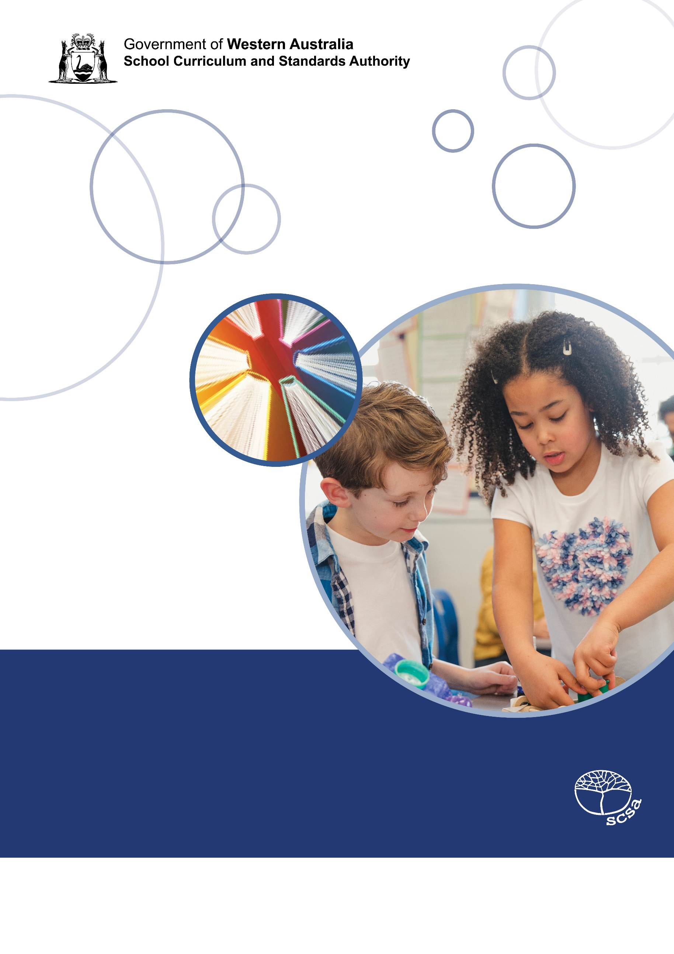
Technologies: Design and Technologies
Teaching learning and assessment exemplar
Year 3
Food and fibre production; Food specialisations

Acknowledgement of Country
Kaya. The School Curriculum and Standards Authority (the Authority) acknowledges that our offices are on Whadjuk Noongar boodjar and that we deliver our services on the country of many traditional custodians and language groups throughout Western Australia. The Authority acknowledges the traditional custodians throughout Western Australia and their continuing connection to land, waters and community. We offer our respect to Elders past and present.
Background
This teaching, learning and assessment exemplar (the exemplar) has been developed by the School Curriculum and Standards Authority (the Authority) as part of the School Education Act Employees (Teachers and Administrators) General Agreement 2017 (Clause 61.1–61.3).
Copyright
© School Curriculum and Standards Authority, 2026
This document – apart from any third-party copyright material contained in it – may be freely copied, or communicated on an intranet, for non-commercial purposes in educational institutions, provided that the School Curriculum and Standards Authority (the Authority) is acknowledged as the copyright owner, and that the Authority’s moral rights are not infringed.
Copying or communication for any other purpose can be done only within the terms of the Copyright Act 1968 or with prior written permission of the Authority. Copying or communication of any third-party copyright material can be done only within the terms of the Copyright Act 1968 or with permission of the copyright owners.
Any content in this document that has been derived from the Australian Curriculum may be used under the terms of the Creative Commons Attribution 4.0 International licence.
Disclaimer
Any resources such as texts, websites and so on that may be referred to in this document are provided as examples of resources that teachers can use to support their learning programs. Their inclusion does not imply that they are mandatory or that they are the only resources relevant to the course. Teachers must exercise their professional judgement as to the appropriateness of any they may wish to use.
SolStock. (2018). [Stock photo ID:1007225890]. Retrieved August, 2021, from https://www.istockphoto.com/
Cover image adapted from: blackred. (2020). [Stock photograph ID: 1199586270]. Retrieved July, 2021, from https://www.istockphoto.com/ .
Contents
The Western Australian Curriculum 1
The Technologies curriculum 1
This exemplar 2
Catering for diversity 2
Using this exemplar 3
Links to electronic resources 3
Best practice 4
Teaching and learning 4
Assessing 4
Reflecting 4
Year level description 5
Achievement standard 6
Term 1 7
Term 2 21
Term 3 33
Term 4 49
Appendix A 63
Appendix B 81
Appendix C 85
Acknowledgements 94

The Western Australian Curriculum
The Western Australian Curriculum and Assessment Outline (the Outline – https://k10outline.scsa.wa.edu.au/) sets out the mandated curriculum, guiding principles for teaching, learning and assessment, and support for teachers in their assessment and reporting of student achievement. The Outline recognises that all students in Australian schools, or international schools implementing the Western Australian Curriculum, are entitled to be given access to the eight learning areas described in the Alice Springs (Mparntwe) Education Declaration, December 2019.

The Technologies curriculum
The mandated curriculum is presented in the year level syllabus documents.
The Technologies curriculum delivers a sequential and age-appropriate progression of learning with the following key elements:
- a year level description that provides an overview of the context for teaching and learning in the year
- a series of content descriptions, populated through strands and sub-strands, that sets out the knowledge, understanding and skills that teachers are expected to teach and students are expected to learn
- an achievement standard that describes an expected level that the majority of students are achieving by the end of a given year of schooling. An achievement standard describes the quality of learning (e.g. the depth of conceptual understanding and the sophistication of skills) that would indicate the student is well placed to commence the learning required in the next year.

This exemplar
This Technologies exemplar articulates the content in the Outline and approaches to teaching, learning and assessment reflective of the Principles of Teaching, Learning and Assessment. This exemplar presents planning for eight weeks of teaching and learning for each of the four terms, with a time allocation of one hour per week.

Catering for diversity
This exemplar provides a suggested approach for the delivery of the curriculum and reflects the rationale, aims and content structure of the learning area. When planning the learning experiences, consideration has been given to ensuring that they are inclusive and can be used in, or adapted for, individual circumstances. It is the classroom teacher who is best placed to consider and respond to (accommodate) the diversity of their students. Reflecting on the learning experiences offered in this exemplar will enable teachers to make appropriate adjustments (where applicable) to better cater for students’ gender, personal interests, achievement levels, socio-economic, cultural and language backgrounds, experiences and local area contexts.

Using this exemplar
This teaching, learning and assessment exemplar provides suggestions to support the delivery of the mandated curriculum content. The exemplar provides:
- a teaching and learning sequence
- the mandated curriculum content to be taught at each point of the teaching and learning sequence, suggested resources, sample assessment tasks and marking keys
- the number of lessons to deliver the teaching and learning experiences
- learning intentions and support notes that may provide focus questions and additional information and/or examples to assist with the interpretation of curriculum content
- support notes to assist teachers to unpack the content and support teaching and learning experiences
- teaching and learning experiences that outline the structure of the lesson. These explicitly state each activity that the lesson will progress through and the key focus area for that activity.

Links to electronic resources
This sequence of lessons may utilise electronic web-based resources, such as videos and image galleries. Teachers should be present while an electronic resource is in use and close links immediately after a resource, such as a video, has played to prevent default ‘auto play’ of additional videos. Where resources are referred for home study, they should be uploaded through Connect, or an equivalent system, that filters advertising content.

Best practice

Teaching and learning
The teaching and learning opportunities offered in this exemplar are not exhaustive. Thus, teachers are encouraged to make professional decisions about which learning experiences, and the sequence in which they are delivered, are best suited to their classroom context, taking into account the availability of resources and student ability.
This sample may prove a useful starting point for amplifying creativity in the classroom, while presenting the embedded expectations of the Western Australian Curriculum: Technologies.
Teachers may find opportunities to incorporate the General Capabilities and the Cross-curriculum Priorities into the teaching and learning program.
Ways of teaching – teachers can locate additional information on the Ways of teaching from the School Curriculum and Standards Authority (the Authority) website https://k10outline.scsa.wa.edu.au/home/wa-curriculum/learning-areas/technologies/design-and-technologies/p-10-design-and-technologies-teaching/design-and-technologies-ways-of-teaching.

Assessing
Assessment, both formative and summative, is an integral part of teaching and learning. Assessment should arise naturally out of the learning experiences provided to students. In addition, assessment should provide regular opportunities for teachers to reflect on student achievement and progress. As part of the support it provides for teachers, this exemplar includes suggested assessment points. It is the teacher’s role to consider the contexts of their classroom and students, the range of assessments required, and the sampling of content descriptions selected to allow their students the opportunity to demonstrate achievement in relation to the year level achievement standard. Teachers are best placed to make decisions about whether the suggested assessment/s are used as formative or summative assessment and/or for moderation purposes.
Ways of assessing – a range of assessment strategies that can enable teachers to understand where students are in their learning is available on the Authority website https://k10outline.scsa.wa.edu.au/home/teaching/curriculum-browser/technologies/technologies-overview/ways-of-assessing.

Reflecting
Reflective practice involves a cyclic process during which teachers continually review the effects of their teaching and make appropriate adjustments to their planning. The cycle involves planning, teaching, observing, reflecting and replanning.
This exemplar supports reflective practice and provides flexibility for teachers in their planning. The exemplar shows how content can be combined and revisited throughout the year. Teachers will choose to expand or contract the amount of time spent on developing the required understandings and skills according to their reflective processes and professional judgements about their students’ evolving learning needs.

Year level description
In the middle to late childhood phase of schooling, students develop a sense of self, their world expands, and they begin to see themselves as members of larger communities. Learning experiences emphasise and lead to an appreciation of both the commonality and diversity of human experience and concerns.
Design and Technologies builds on concepts previously acquired and students continue to develop understanding in design thinking skills, such as products to assist people with limited mobility, hearing or sight, and outlining procedures to achieve solutions.
In Year 3, students have opportunities to learn about technologies in society and to create solutions in at least one of the following Design and Technologies contexts: Engineering principles and systems, Food and fibre production, Food specialisations, and Materials and technologies specialisations. Students are provided with opportunities to manage, develop ideas, design and make products for individual and/or local community needs.
Students apply design thinking skills to generate multiple ideas for their designed solutions. They learn to define problems using project management skills. Students experiment with appropriate work protocols and consider ways to improve, modify or adapt for different situations, including safety. They use given criteria to evaluate diagrams, technologies and the components used for the designed solution.

Achievement standard
By the end of the year:
Students explore and recognise roles people in Design and Technologies occupations have in the local community. They explore ways technologies are designed for solutions and used to create products, services or environments to meet individual or local community needs. In Engineering principles and systems, students observe and recognise ways forces and the properties of materials affect the behaviour of objects. In Food and fibre production, students recognise food and fibre are produced to meet food and clothing needs. In Food specialisations, students select food to nourish the body for energy to move and support growth. In Materials and technologies specialisations, students select and safely use suitable materials, appropriate technologies and components to create a product to achieve a designed solution.
In the Design and Technologies contexts, students develop a sequence of steps to achieve a designed solution. They define features of a design brief and communicate ideas using labelled drawings and technical terms. Students select and safely use appropriate technologies and components to develop a solution. They use given criteria to evaluate diagrams, technologies and components used for the designed solution. Students follow a plan, communicate sequenced steps to manage and create a product, service or environment for an individual or local community need.



Term 1
Weeks 1-8: Food and fibre production

Term 1 Week 1: Farm to fridge
Western Australian Curriculum content | Teaching and learning intentions | Learning experiences
Food and fibre production  Food and fibre produced to meet food and clothing needs  Technologies and society  Role of people in design and technologies occupations in the local community | Learning intention  Understand the role of different people in the production of milk.  Focus questions  - How does milk get from the farm to the fridge?  - What equipment is used in the supply chain of milk?  - What jobs/occupations are involved in the production and supply chain of milk?  - What is the role of the farmer? Vet? Quality control? Truck driver?  - What is automation and what types of equipment are automated?  Support notes  This lesson is an introduction to the equipment and occupations used in the milk supply chain process. The term ‘supply chain’ refers to the process of getting milk from the cow, through to preparing the milk for sale or to use in other milk-based products.  When identifying the equipment used in the milk supply chain, include automatic milking systems, refrigerated transport, processing factories for pasteurisation, containers and refrigerated transport to stores.  The first video listed in Appendix A.1, explicitly refers to some occupations: dairy farmer, nutritionist, vet and quality control. Other roles may be highlighted using the focus questions. Occupations including dairy farmers, nutritionists and vets are directly involved in ensuring the cows produce milk.  Week 2 will examine historical milk supply chains and the equipment and jobs involved in the process, e.g. milk production.  Resources  Suggested video links used in the learning experiences. (Appendix A.1)  Suggested assessment points  Use the T-chart responses and drawings to gauge students’ understanding of the roles of different individuals in the milk production process. | Introduction  Use the first focus question to determine students’ prior knowledge about the ‘farm-to-fridge’ process for milk. List student responses to refer to at the end of the lesson.  Watch a short video on the current process of farm-to-fridge and highlight the process and occupations within the supply chain. https://www.youtube.com/watch?v=0XSoTEcD_vQ&t=48s  Learning activity  Model developing a T-chart using the headings Equipment and Occupations. In groups, students create their own T-chart using the same headings as the modelled chart.  Using information from the video, as well as additional videos if required, students list the equipment used in the supply chain from the farm to the supermarket, including the occupations.  Students create a drawing showing the process of milk production from cow to fridge.  Conclusion  Use the focus questions to clarify students’ understanding of the jobs/occupations involved in the milk production and supply chain.

Term 1 Week 2: Milk production now and in the past
Western Australian Curriculum content | Teaching and learning intentions | Learning experiences
Food and fibre production  Food and fibre produced to meet food and clothing needs  Technologies and society  Role of people in design and technologies occupations in the local community | Learning intention  Understand the similarities and differences between the milk supply chain now and in the past.  Focus questions  - What might have been different about the equipment that was used in milk production 60 or 150 years ago?  - What is the same about the equipment used in the past and equipment used now?  - What jobs have changed in the milk supply chain?  Support notes  Discuss the equipment and roles of people in the past: cows were milked by hand or less efficient milking technologies; there were smaller storage containers on the farm; containers were metal/glass; there was less automation, so more people were required to work in milk processing. Discuss the definition of automation with students. Explain that automation refers to the use of technology to perform tasks with minimal human involvement to improve efficiency and accuracy.  Suggested assessment points  Use the completed Venn diagram to determine students’ ability to identify the equipment and jobs in current and past milk supply chains.  Resources  Suggested video links (Appendix A.1). | Introduction  Refer to the T-charts from the previous learning experience to review the equipment and occupations involved in the modern milk supply chain.  Use the first focus question to determine students’ understanding of how equipment may have changed over time.  Watch a video on the milk supply chain from the past. Highlight equipment and occupations.  Use the focus questions to guide a discussion about the key differences and similarities between equipment and occupations in the current milk supply chain and a milk supply chain from the past.  During the discussion, model using a Venn diagram to highlight similarities and differences.  Learning activity  In groups, students complete a Venn diagram showing the differences and similarities between the role of people in the milk production and supply chain jobs from the past and present. Re-watch the video as required.  Conclusion  Invite students to share the key differences and similarities found (Appendix A.2).

Term 1 Week 3: Milk to ice cream
Western Australian Curriculum content | Teaching and learning intentions | Learning experiences
Food and fibre production  Food and fibre produced to meet food and clothing needs  Technologies and society  Technologies are designed and used in products, services or environments to meet individual needs  Designing  Design solutions created with labelled drawings, use of technical terms and/or a sequence of steps | Learning intention  Understand how milk is used to produce ice cream  Focus questions  - What foods are produced from milk?  - What do you know about the production of ice cream?  - How is milk used to make ice cream?  - Why are there different sized containers of ice cream produced?  Support notes  Week 3 introduces students to the modern process of manufacturing ice cream.  Using a large sheet of paper, model a flow chart for the milk supply chain to show the main steps of milking, transportation to the factory, processing (pasteurisation), packaging and transportation to the store. Use a picture with a label for each step. This will be used for review in Week 4.  This lesson could link with the Digital Technologies content related to the use of flow charts.  Different types of ice cream are produced to meet community needs. Larger containers are produced to go directly to ice cream stores. Smaller sized packaging is transported to grocery stores for household consumption. Individual sized ice creams are also produced but these are not shown in the suggested video links.  Highlight the production of single serve ice cream links to the design task of making ice cream.  Suggested assessment points  Use the KWL charts to inform future planning.  Resources  Suggested videos for the milk supply chain (Term 1, Week 1) and videos on ice cream production (Term 1, Week 3) (Appendix A.1). | Introduction  Discuss what students now know about the modern milk supply chain process.  Model developing a flow chart to highlight the key steps in the milk supply chain process.  Ask the first focus question and list student responses as a brainstorm.  Ask the second focus question and invite five or six responses from the class.  Learning activity  Individually, students complete the K (What I already know) and W (What I want to know) sections in a KWL chart about milk production and foods produced from milk.  Conclusion  Watch a short video on how ice cream is made. (Appendix A.1)  Use the focus questions to guide discussion about the process, including equipment used, and the types of ice cream produced to meet community need.  Refer to the KWL charts to identify if ‘W’ section has been covered from the viewed video.

Term 1 Week 4: Ice cream flow charts
Western Australian Curriculum content | Teaching and learning intentions | Learning experiences
Food and fibre production  Food and fibre produced to meet food and clothing needs  Investigating and defining  Define ideas and design opportunities for individual and/or local needs  Designing  Design solutions created with labelled drawings, use of technical terms and/or a sequence of steps | Learning intention  Use a flow chart to explain the steps of ice cream production.  Focus questions  - How is ice cream made from milk?  - What equipment is used to produce ice cream?  Support notes  The main steps in ice cream production are:  - mixing the base ingredients including milk, pasteurisation and/or homogenisation (heating the milk to kill bacteria, then evenly distributing the fat in the milk to make it smooth)  - cooling the mixture  - adding flavours  - packaging the ice cream  - freezing the ice cream  - transporting to the store.  Milk used in ice cream that comes from cows follows a similar process as milk from other animals, such as goats/sheep/camels; however, the milk production process is different in nut-based ‘mylk’.  The web links outline the steps in greater detail and are provided for teacher information only (Appendix A.1).  Provide students essential information, including the equipment used in the production process.  Resources  Suggested video links (Appendix A.1). | Introduction  Rewatch a brief video on the production of ice cream. Highlight and discuss the equipment and main steps used in producing ice cream from milk.  Review the milk supply chain flow chart developed in Week 3.  Learning activity  Draw a simple flow chart to demonstrate the main steps in making ice cream. Students draw pictures with a label for each step.  Conclusion  Share some of the flow charts created to explain the production process.

Term 1 Week 5: Power free ice cream
Western Australian Curriculum content | Teaching and learning intentions | Learning experiences
Food and fibre production  Food and fibre produced to meet food and clothing needs  Technologies and society  Technologies are designed and used in products, services or environments to meet individual needs  Designing  Design solutions created with labelled drawings, use of technical terms and/or a sequence of steps | Learning intention  Understand the design steps involved in making ice cream without the use of electricity.  Focus questions  - How could ice cream be made without electricity?  - Why would you only make a small quantity of ice cream when making ice cream without electricity?  Support notes  Ice cream has been made in various forms for over a thousand years by mixing ice with sweet ingredients such as honey. Until the 1800s, ice cream was a luxury for the wealthy because ice was difficult to obtain. Before electricity, ice was cut from frozen lakes and shipped to Australia until the 1860s, when James Harrison invented a mechanical ice-making machine (Appendix A.1).  This lesson introduces the design task: making an individual serve of ice cream without using electricity.  Design criteria could include:  - equipment used to produce ice cream without electricity (e.g. zip-lock bags, ice, salt)  - ability to freeze the mixture effectively  - taste and presentation (if designing for a particular audience: ‘luxury’ ice cream for the wealthy).  Prepare materials and ingredients for Week 6 for the design task (Appendix A.3).  Suggested assessment points  Use the annotated diagram of design plan for making the ice cream to assess students’ understanding of the design process. | Introduction  Review how ice cream is produced using modern equipment, referring to the flow charts from Week 4.  Organise students in small groups and ask the focus questions. In groups, students brainstorm how ice and ice cream could be produced without electricity.  Each group assigns a manager/note-taker to share responses with the class.  Learning activity  Provide a brief history of ice cream making (support notes).  Discuss how modern technology has improved efficiency and allowed for mass production.  Outline the design task of making individual servings of ice cream without using electricity and introduce the design criteria.  As a class, identify and agree on three criteria that are important for completing the task (see support notes for suggestions). Have the criteria displayed for students to reference in the next learning experience.  Provide the recipe for power-free ice cream. Students draw and label a diagram showing how they will make the ice cream, including materials, steps and notes on how the process works to freeze the mixture.  Conclusion  Students reflect on their designs:  - What materials are essential?  - Why is sequencing important in this process?

Term 1 Week 6: Making the ice cream
Western Australian Curriculum content | Teaching and learning intentions | Learning experiences
Food and fibre production  Food and fibre produced to meet food and clothing needs  Project management  Communicate ideas and follow a plan with consideration of time management, to develop a solution  Producing and implementing  Use appropriate technologies and components with given equipment and follow agreed protocols to produce a designed solution | Learning intention  Follow a design task and make ice cream without electricity.  Focus questions  - What is required in your design task, ’making ice cream without electricity’?  - What safety risks should be considered in making ice cream without a freezer?  - What steps are required to reduce the safety risks as identified in the video?  Support notes  The plastic resealable bags used in making ice cream would be considered new equipment. The use of ice and salt to freeze the cream/milk mixture are old equipment/technologies.  The design task is to produce ice cream without electricity or a freezer. The safety risks include getting very cold hands in handling the ice. The suggested videos show the presenter using a towel to cover the bag with ice in it when shaking/kneading the ice cream mixture so they don’t get cold hands. It is important to discuss safety protocols to avoid these risks with the students.  Students will be annotating photos in Week 7.  Resources  Suggested videos on making ice cream without a freezer (Appendix A.1).  Suggested assessment points  Observe students’ use of safety materials when making the ice cream. Additionally, observe students’ ability to project manage the design task of making ice cream when working with frozen ingredients. | Introduction  Watch a video on the production of ice cream without a freezer or electricity (Appendix A.1). Discuss modern equipment/technologies versus old equipment used in the video. Use the focus questions to guide a brief discussion.  Display and review the design task and design criteria from Week 5. Discuss the steps required to set up the ice cream making, encouraging students to reflect on the annotated drawings from the previous week.  Ensure students are aware of the identified project management skills:  - time management, to complete each component of the task  - how to share the roles among group members  - how to manage the space  - safe movement around the class.  Learning activity  With teacher guidance, students make individual servings of ice cream without electricity or a freezer.  Take photos of each main step in the production process.  If visual appeal is one of the design criteria, serve and decorate the ice cream.  Conclusion  Students sample their ice cream and discuss the success of their final product against the design criteria, determined in Week 5.

Term 1 Weeks 7–8: Design evaluation
Western Australian Curriculum content | Teaching and learning intentions | Learning experiences
Food and fibre production  Food and fibre produced to meet food and clothing needs  Designing  Design solutions created with labelled drawings, use of technical terms and/or a sequence of steps  Producing and implementing  Use appropriate technologies and components with given equipment and follow agreed protocols to produce a designed solution  Evaluating  Use given criteria to evaluate diagrams, technologies and the components used for the designed solution | Learning intention  Reflect on the design task’s success and challenges in making ice cream without electricity.  Focus questions  - What was your design task?  - What old equipment and components were used in making ice cream?  - What new equipment was used in making ice cream?  - What food was your ice cream made from?  - How was your ice cream made?  - What safety steps did you take?  Support notes  This lesson is about consolidating student understanding and having students reflect on the success of their task using the design criteria.  Use the focus questions to guide discussion: The plastic resealable bags used in making ice cream would be considered new equipment/technology. Using ice and salt to freeze the cream/milk mix is old equipment/technology.  Suggested assessment points  Use the evaluation video and order of photos to determine students’ understanding of the design task and their ability to effectively evaluate their success in completing the task. | Introduction  Review the design task and design criteria. Use the focus questions to guide a discussion.  Use one of the photos from Week 6 to model labelling equipment/components and materials as well as safety precautions used in producing ice cream.  Learning activity  Students use photos to label equipment/technologies and safety precautions.  Students order photos from the beginning to the end of the design task, and label the steps as captions on the photos.  Discuss with students the design criteria, and how they might reflect on their successes and challenges.  Students evaluate their ice cream against the identified design criteria. This could be achieved with students creating a reflective video that includes the images, and has students reflecting on their successes and challenges that occurred.  Learning  Students create their evaluation video.  Conclusion  If time permits, students share their evaluations in groups.

Term 2
Weeks 1–8: Food and fibre production

Term 2 Week 1: Multicultural food technologies Part 1
Western Australian Curriculum content | Teaching and learning intentions | Learning experiences
Food and fibre production  Food and fibre produced to meet food and clothing needs  Technologies and society  Technologies are designed and used in products, services or environments to meet individual needs | Learning intention  Identify the variety of technologies that have been used to make food from different cultures.  Focus questions  - What are some of your favourite meals?  - Which country did your favourite meal originate from?  - What cooking tools or methods are used to prepare food at home?  Support notes  Consider the background of students when:  - selecting a picture book to engage students  - selecting multicultural cooking equipment or techniques.  There is the opportunity to examine traditional cooking methods and equipment of Aboriginal and Torres Strait Islander people.  Common dishes and technologies differ between countries, although methods and equipment may be adapted and used across cultures. Traditional food and serving dishes are made using foods local to an area as well as accessible equipment.  Resources  Suggested list of picture books about multicultural food (Appendix A.4). | Introduction  Read a picture book about multicultural food to engage students. Identify any equipment components and/or technologies used in the cooking or serving process in the book.  Organise students into groups of four to six.  Learning activity  In groups, students discuss and create a list of their favourite meals as well as the country of origin.  Each group shares a favourite meal and country of origin with the class and explains why it is their favourite meal.  Conclusion  Referring to the picture book if needed, discuss how different countries can use different equipment and methods to prepare and cook food.  If time permits, encourage students to develop reasons why different countries have different ways to produce meals or use different foods.

Term 2 Week 2: Multicultural food technologies Part 2
Western Australian Curriculum content | Teaching and learning intentions | Learning experiences
Food and fibre production  Food and fibre produced to meet food and clothing needs  Technologies and society  Technologies are designed and used in products, services or environments to meet individual needs | Learning intention  Understand how and why various food preparation technologies are used in different cultures.  Focus questions  - Which cooking methods/tools are similar to those used in your home?  - Which cooking methods/tools are different to those used in your home?  Support notes  Set up learning stations, each with an image and information about different cooking/serving equipment used around the world (Appendix A.6).  An envoy is when one student in each group is chosen to be the expert and then rotates through the groups sharing their information. When the envoy returns to their original group, their group shares what they have learned about various types of multicultural cooking.  Resources  Prepare six information sheets on multicultural methods/equipment (Appendix A.6).  Multicultural cooking technologies and equipment (Appendix A.5). | Teaching  Re-read a picture book about multicultural dishes if required.  Explain that each group will become an expert on one multicultural cooking method or equipment/technologies used. Model the completion of one row on the table (Appendix A.5) for a cooking method or piece of equipment. Allocate each group to a learning station.  Learning  In groups, students complete the first row of the table at their learning station.  Use a cooperative learning strategy, such as a jigsaw or envoy, for each group/pair or individual student to share what they have learned with other students.  Students complete the table as they learn about another four multicultural cooking methods or cooking tools.  Conclusion  As a class, reflect on differences and similarities between the multicultural cooking methods and technologies explored and how they are designed and used.

Term 2 Weeks 3–4: Natural fibres
Western Australian Curriculum content | Teaching and learning intentions | Learning experiences
Food and fibre production  Food and fibre produced to meet food and clothing needs  Technologies and society  Technologies are designed and used in products, services or environments to meet individual needs  Investigating and defining  Define ideas and design opportunities for individual and/or local needs  Evaluating  Use given criteria to evaluate diagrams, technologies and the components used for the designed solution | Learning intention  Understand what products are made from natural fibres.  Focus questions  - What is a fibre?  - What is an original fibre source?  - What are natural fibres?  - What is the difference between natural and manufactured fibres?  - Are fibres plant-based or animal-based?  Support notes  Fibres are a natural or manufactured material which are designed and made into other products.  Natural fibre sources include sheep (wool fibre), cows (leather), trees (wood/paper), cotton plants, rubber trees (natural rubber latex), chickens (feathers), silkworms (silk).  To identify whether the original fibre source is animal- or plant-based, include products that use different fibres in their production. For example, ‘rubber’ erasers, cotton T-shirt, woollen scarf/beanie, paper, leather bag and baskets. Alternatively, make a slide show with images of different products.  Manufactured fibres are not sourced directly from plants, rather they are created by humans using a chemical process. Some examples of manufactured fibres are polyester, viscose and acrylic, all of which are commonly found in clothing. Check the labels on a variety of clothing items.  Before conducting research, discuss with students the protocols for internet safety and using specific key search terms. Students may find that fibres, such as wool, can come from different sources; for example, sheep and alpacas. Some possible search engines may be Brittanica Kids, Kiddle or KidzSearch.  Leather has not been included for independent student research due to the nature of some of the information and images found online. Ensure teacher research is completed prior to the lesson.  Resources  Suggested table for the Fibre fact shuffle (Appendix A.7). | Introduction  Use the first two focus questions to guide a discussion and check students’ understanding of fibres.  Ask the remaining focus questions and list student responses. Clarify any misconceptions about where fibres come from. For example, natural fibres, such as cotton come from plants, while synthetic fibres, such as polyester are manufactured and cannot be farmed.  Watch Australian Cotton, from Seed to Sock (Cotton Australia) https://www.youtube.com/watch?v=t6plTYrBth4&t=14s and discuss how cotton is only one product which is farmed and used to make products. Briefly discuss the difference between natural and manufactured fibres.  Display a range of products made from fibres and ask students ‘Are these products made from natural or manufactured fibres?’. Criteria could include feel, colour or strength.  Learning activity  Students physically move to either the left or right of the class (under classification headings) if they believe the product was made from plant materials (left side of the classroom) or animal (right side of the classroom).  Ask the question, ‘Where does leather come from?’ and ‘What products can be made out of leather?’ List student responses in a brainstorm.  Allocate students into pairs or small groups. Assign each group a natural fibre: natural rubber latex, cotton, wool, wood or silk.  Each group researches the source of their natural fibre and creates a brainstorm showing the products each fibre can be made into.  Conclusion  Use a cooperative learning strategy for pairs or small groups to share their brainstorm.

Term 2 Weeks 5–6: Wool weaving
Western Australian Curriculum content | Teaching and learning intentions | Learning experiences
Food and fibre production  Food and fibre produced to meet food and clothing needs  Technologies and society  Role of people in design and technologies occupations in the local community  Technologies are designed and used in products, services or environments to meet individual needs  Investigating and defining  Define ideas and design opportunities for individual and/or local needs | Learning intention  Understand the differences between traditional weaving and wool production and identify the technologies and processes used.  Focus questions  - What is the source of these fibres?  - Are the fibres used in weaving and wool production natural or manufactured?  - What are the similarities between traditional weaving and wool processing?  Support notes  For the Fibre fact shuffle, students link images of a fibre product, such as a straw basket or woollen jumper to the image of the fibre source, such as wheat or sheep.  The summary notes students take during the videos should include:  - identifying the fibre  - the equipment used  - the process  - whether the process is traditional or modern  - differences, such as weaving being handmade and wool processing requiring machinery.  Resources  Appendix A:  - sample table for the Fibre fact shuffle  - suggested video links on traditional weaving  - suggested video links on how wool is made  - suggested video links for wool weaving.  Wool/blend of wool and synthetic yarn  Twigs and small sticks found outside | Introduction  Display an image or product made from natural fibres as well as a range of images of original fibre sources, such as sheep, cows, trees, cotton plant.  Model completing a Fibre fact shuffle and discuss what the fibre product is, where the fibre came from, whether it is a plant or animal fibre and the name of the fibre.  Learning activity  Using five images of fibre products, students work in pairs to complete a Fibre fact shuffle.  Use a cooperative learning strategy for students to share facts in a small group. As a class, watch a short video on traditional weaving. See Appendix A.4 for a suggested weaving video from the Noongar people of Perth.  https://www.youtube.com/watch?v=EqlfEGR9ReU  Identify the fibre, the equipment used to weave and the construction process.  As a class, watch a short, age-appropriate video on how wool is made (Appendix A.4).  https://www.youtube.com/watch?v=PuPSZY2PHfQ  Identify the fibre, fibre source and equipment used during the production process.  Expose the students to ways that they can begin making weaves of their own. Start with basic weaving using their hands and sticks located outside the classroom.  See https://gabriellavolpe.com/day-12-yarn-play-for-the-child-with-special-needs/#close for potential ideas in beginning wool weaving.  Students experiment with different ways that they can weave using their hands and simple tools, such as sticks.  Conclusion  Invite students to share their ideas on how wool weaving can be used to make various products and for different purposes.

Term 2 Week 7
Western Australian Curriculum content | Teaching and learning intentions | Learning experiences
Food and fibre production  Food and fibre produced to meet food and clothing needs  Technologies and society  Role of people in design and technologies occupations in the local community  Technologies are designed and used in products, services or environments to meet individual needs  Project management  Communicate ideas and follow a plan with consideration of time management, to develop a solution  Investigating and defining  Define ideas and design opportunities for individual and/or local needs  Designing  Design solutions created with labelled drawings, use of technical terms and/or a sequence of steps  Producing and implementing  Use appropriate technologies and components with given equipment and follow agreed protocols to produce a designed solution | Learning intention  To use a wool/wool blend fibre (yarn) to design and create a woven product for a purpose.  Focus questions  - What type of fibre will be used in the weave?  - What product will be woven?  Suggested assessment points  See Assessment task 1 (Appendix B). | Introduction  Allow students time to reflect on their beginning weaves from the previous session. Discuss with students what they discovered about using wool/wool blend yarn when feeling how it moved through their hands.  Discuss how weaving could be used today to create products. Brainstorm ideas for products they could create by hand weaving.  See Appendix A.4 for links that offer suggestions for hand and finger weaving activities designed for children. Show videos/images/models of different ways that wool/yarn can be woven into various styles and patterns for different purposes.  Learning activity  Students work in small groups to generate ideas for how and what to weave. Provide wool/yarn for the students to experiment with during this ideation process.  Explain to students that they will be designing, creating and developing an instructional video/photo book/hand-drawn booklet (depending on resources available) to showcase the process undertaken in the weave.  Students design a woven product using wool or yarn, drawing and labelling the technologies required to create the product.  Students create their weave, taking photos/videos/drawing pictures along the way to collate into an instructional document.  Conclusion  Students share their woven products and discuss any challenges that occurred during the process.

Term 2 Week 8
Western Australian Curriculum content | Teaching and learning intentions | Learning experiences
Food and fibre production  Food and fibre produced to meet food and clothing needs  Technologies and society  Role of people in design and technologies occupations in the local community  Technologies are designed and used in products, services or environments to meet individual needs  Project management  Communicate ideas and follow a plan with consideration of time management, to develop a solution  Investigating and defining  Define ideas and design opportunities for individual and/or local needs  Designing  Design solutions created with labelled drawings, use of technical terms and/or a sequence of steps  Producing and implementing  Use appropriate technologies and components with given equipment and follow agreed protocols to produce a designed solution | Learning intention  To use a wool/wool blend fibre (yarn) to design and create a woven product for a purpose.  Focus questions  - What type of fibre will be used in the weave?  - What product will be woven?  Suggested assessment points  See Assessment task 1 (Appendix B ) for instructions and resources. | Introduction  Allow students time to reflect on their beginning weaves from the previous week. Discuss with students what they discovered about using wool/wool blend yarn when feeling how it moved through their hands.  Discuss how weaving could be used today to create products. Brainstorm ideas for products they could create by hand weaving.  See Appendix A.4 for links that offer suggestions for hand and finger weaving activities designed for children. Show videos/images/models of different ways that wool/yarn can be woven into various styles and patterns for different purposes.  Learning activity  Students work in small groups to generate ideas for how and what to weave. Provide wool/yarn for the students to experiment with during this ideation process.  Explain to students that they will be designing, creating and developing an instructional video/photo book/hand-drawn booklet (depending on resources available) to showcase the process undertaken in the weave.  Students design a woven product using wool or yarn, drawing and labelling the technologies required to create the product.  Students create their weave, taking photos/videos/drawing pictures along the way to collate into an instructional document.  Conclusion  Students share their woven products and discuss any challenges that occurred during the process.

Term 3
Weeks 1–8: Food specialisations

Term 3 Week 1: Food safety and hygiene
Western Australian Curriculum content | Teaching and learning intentions | Learning experiences
Food specialisations  Food selected to nourish the body, for energy to move and support growth  Technologies and society  Technologies are designed and used in products, services or environments to meet individual needs | Learning intention  Understand the importance of food safety and hygiene measures when preparing food for others.  Focus questions  - What is food safety and hygiene?  - How might cooking for others differ from cooking for yourself at home?  - What items in a kitchen are important for food safety and hygiene?  - How might you ensure you are preparing a meal safely?  Support notes  Consider examples of different kitchens, including commercial kitchens and the set-ups available in the school.  Suggested assessment point  Use the kitchen mark-up images and the recipe explanation to check how far each student has progressed in their understanding of the essential requirements of food safety. | Introduction  Explain to students that the focus this term will be Food specialisations. As a part of the learning experiences, the class will be preparing food, sampling different types of food, and reflecting on how food gives our body nourishment and energy so we can move and grow. It is important to start with the essentials of food hygiene and preparation, to prepare food for yourself and others and following food safety guidelines.  Ask students to determine a definition for the word ‘hygiene’. Brainstorm common words, tips and reasons for food hygiene, including things like wearing gloves.  Watch a BTN clip about food safety: https://www.youtube.com/watch?v=j38gvrfxGd4  See Appendix A.8 for full details of this resource.  Discuss the importance of separating raw food, such as meat, and other foods, the chilling of food, and the different items that are set up in a kitchen to ensure food is prepared safely.  Discuss the various appliances available for food preparation and when they are used, dependent on the type of food prepared. Identify which appliances might be used or available.  Learning activity  Students separate into pairs or small groups and, using an image of a kitchen (within the school, from a magazine or the internet), label/mark up the different safety considerations and various appliances they can identify.  Use a recipe for a food the students would be familiar with; for example, pancakes, meatballs, pasta. Read the recipe as a class and discuss what considerations would need to be taken when preparing this food for others to enjoy.  Return to the original pairs/small groups and assign each group a recipe (or encourage them to choose a familiar recipe from a site, such as the ABC kids recipe book)  https://www.abc.net.au/abckids/abc-kids-recipe-book/12135084.  See Appendix A.8 for full details of this resource.  Conclusion  Each pair/group to go through the recipe and add in steps to explain to someone who has not cooked in a kitchen before, all of the important hygiene and safety considerations they need to have when preparing this meal.

Term 3 Week 2: Canteen visit
Western Australian Curriculum content | Teaching and learning intentions | Learning experiences
Food specialisations  Food selected to nourish the body, for energy to move and support growth  Technologies and society  Role of people in design and technologies occupations in the local community | Learning intention  Understand the role of the canteen manager and how the school canteen is set up to prepare food.  Focus questions  - How is the canteen set up to prepare food for the school?  - What different equipment/tools can you notice in the school canteen that are not available at home?  Support notes  Explore various kitchen-related experiences that could happen in the school environment. This lesson refers to a canteen visit; however, depending on the school, this may not be available. Other options could also include food technologies kitchens in a linked secondary school or the staffroom kitchen.  If there are no physical options for exposure to a kitchen for the students, consider using photos of other school canteens or online tools where various kitchen images are available, such as the IKEA website, to explore elements of a kitchen. It may also be helpful to visit local restaurants and have a range of menus from restaurants in the area, should a canteen menu not exist. | Introduction  Reflect on the hygiene considerations from the previous lesson and ask students if they have made any changes in the way they help with food preparation at home. Discuss the various people in the community who work in food-related occupations and lead the students to identify the canteen manager or volunteer parents at the school who work in the canteen. If no canteen exists, students could discuss the different restaurants and cafes where people prepare food.  Learning activity  Visit the canteen and conduct a ‘food preparation hunt’. Students take photos/clipboards to take notes of the way the canteen is set up. Students note the different equipment that they don’t have at home, i.e. industrial-sized ovens, large sandwich press, walk-in fridge/freezer, organisation of food with meat placed at the bottom and date labels to identify when things expire, and aprons, gloves, hairnets. If it is not possible to visit a canteen, students use a kitchen design website, such as IKEA. Students explore and design a kitchen, screenshotting images from the kitchen section of the website, or alternatively printing and pasting pictures from kitchen stores and labelling what they would include in a kitchen to be ready for food preparation. Return to the classroom with a copy/photo of the canteen menu. How does the canteen cater for a variety of food preferences and dietary requirements?  If no canteen menu is available, students can use a kids menu or regular menu from a local restaurant, and discuss how the menu caters to different food preferences and dietary requirements.  Students work in small groups to reflect on the photos they took during the canteen visit and the menu.  Conclusion  Ask students to suggest ways the canteen could improve the layout of the equipment/technologies or missed opportunities on the menu. If applicable, students could write suggestions to deliver to the canteen manager to add to their school canteen se-tup. If students used a website to search for kitchen items, they could take some time sharing their ideal kitchen set-up in small groups.

Term 3 Week 3: Fermented foods
Western Australian Curriculum content | Teaching and learning intentions | Learning experiences
Food specialisations  Food selected to nourish the body, for energy to move and support growth  Technologies and society  Technologies are designed and used in products, services or environments to meet individual needs  Project management  Communicate ideas and follow a plan with consideration of time management, to develop a solution | Learning intention  Understand the benefits and unique flavours of fermented foods.  Focus questions  - What is fermentation?  - Why are fermented foods a positive addition to a varied diet?  - What different taste sensations do you experience when eating fermented foods?  Support notes  This lesson involves setting up a taste journal, which will be ongoing throughout this term and the next. Teachers are best placed to determine the appropriate format, based on the context of the classroom. See Appendix A.9 for an example of how to set up a taste journal.  Preparation will involve purchasing fermented foods for students to sample. Inform parents/caregivers prior to the lesson about the foods that will be sampled, to ensure there are no known allergies and to ensure cultural appropriateness.  Some examples of fermented foods with a variety of flavours and textures and are readily available in supermarkets include:  - miso (add hot water to paste to create soup)  - kefir  - kimchi  - pickled cucumber/other pickled vegetables  - sauerkraut  - aged cheese (e.g. parmesan)  - apple cider vinegar  - tempeh  - soy sauce  - sourdough bread  - olives.  Be conscious not to overwhelm students with too many flavours. It may be prudent to group fermented flavours together for students to taste. Possible ways to group the fermented flavours could be:  - all pickled vegetable varieties (root vegetables and pickled cucumbers)  - soy sauce, tempeh, kimchi and miso (Asian food accompaniments)  - different vinegars (balsamic, rice, apple cider)  - different fermented cheeses (cheddar, Swiss, parmesan).  Yoghurt is also a fermented food; however, the following lessons will feature yogurt heavily, so do not use this in the initial fermentation lesson.  Consider presenting the students with some items before the fermentation process or when unfermented, to compare the flavour, texture and colour.  For example:  - cucumbers versus pickles  - fresh vegetables (carrot, radish beetroot, turnip and other root vegetables) versus pickled root vegetables  - yeast-made bread versus sourdough bread  - cabbage versus sauerkraut  - fresh cheese (mozzarella, cottage, cream) versus fermented cheese (parmesan, cheddar).  Suggested assessment points  Use the students’ descriptions in their taste journals as an indication of their ability to discern and describe differing food flavour sensations. | Introduction  Discuss with students the different types of foods they like to eat that help nourish their body. Introduce the word fermentation and ask the students if anyone knows what it means or know any examples of fermented foods.  Watch the Gardening Australia (ABC) video on fermented fruit and vegetables as an introduction to the fermenting process and why fermented foods help nourish your body.  https://www.youtube.com/watch?v=YM__U0Iosx0.  See Appendix A.8 for full details of this resource.  Brainstorm the different fermented foods students may know. Prompt if students are not familiar with fermenting by presenting the variety of fermented foods that are provided to sample, along with suggestions of other examples that they may be aware of.  Discuss with students the benefits of eating fermented foods in a varied diet, using the following resources:  - https://www.ruthfellowes.com.au/introducing-fermented-foods-kids/  - https://healthykidsnaturally.com.au/fermented-foods-to-boost-your-families-health/  See Appendix A.8 for full details of these resources.  Explain to students that this learning experience will involve sampling fermented foods and recording experiences in a taste journal (Appendix A.9). The focus will be on noting the sensations they experience when sampling each food. Reflect on the five senses, displaying them on a shared classroom board as a reminder during the tasting session.  Learning activity  Students set up their taste journal, ensuring they have space to record reactions from their five senses.  Remind students of the expectations around food safety and preparation. Ensure all students wash hands and use correct processes when sampling the food, disposing of rubbish appropriately. Students work in small groups to sample different fermented foods, adding reflections into their ongoing taste journal.  One student from each group is assigned the role of reporter and will feed back the group’s observations.  Encourage an attitude of trying new foods, without judgement of others’ taste preferences. Discuss with students the sensible way to sample the foods. For example, vinegars are not to be drunk like water, but sipped or used as a dressing, and fermented foods, such as pickles often have a strong flavour so are eaten in small servings, or with accompaniments like cheese and crackers. Ensure each student has access to water for a sip after each tasting.  Ask students to reflect as a group on which foods were their favourites, similarities between the fermented foods or flavour experiences that surprised them.  Conclusion  The reporter from each group explains what was noticed by the group with the whole class. Discuss the different vocabulary used to explain the sensations experienced when sampling the food. Discuss how these foods might become a part of their diet at home.

Term 3 Week 4: Making yoghurt
Western Australian Curriculum content | Teaching and learning intentions | Learning experiences
Food specialisations  Food selected to nourish the body, for energy to move and support growth  Technologies and society  Technologies are designed and used in products, services or environments to meet individual needs | Learning intention  Understand how technologies are used to create a variety of different types of yoghurts  Focus questions  - How is yoghurt made?  - What are the different types of yoghurt available?  Support notes  The next series of lessons focuses on making and sampling yoghurt. If there are students in the class with dairy allergies, there are a range of dairy-free yoghurts that can be made and sampled.  Background information on the history of yoghurt  https://bcdairy.ca/food-for-thought-a-short-history-of-yogurt/  Suggested assessment points  Observations of students’ abilities to follow a simple recipe and use hygiene measures. | Introduction  Reflect on the fermentation sampling from the previous learning experience.  Explain that they will be exploring a different type of fermented food, yoghurt, in this learning experience.  Investigate how technologies are used in food product creation to meet individual needs. Yoghurt originally was one simple recipe, but now there are a wide range of yoghurts available, depending on people’s taste preferences and/or dietary requirements.  As a class, brainstorm the variety of yoghurts that are available on the market. Visit a supermarket website as a class and search yoghurt to add any ideas that were possibly missed. Ideas could include:  - different serving sizes and packaging for different purposes  - pouch yoghurt  - yoghurt with toppings  - flavoured yoghurt  - dairy alternatives, such as soy, coconut, almond  - sugar-free marketed yoghurt  - high-protein yoghurt.  When listing the options, discuss which people might these products be marketed to; for example, pouches for babies and young children, protein for growing teenagers or adults who exercise.  Explore how plain yoghurt is made  https://www.natgeokids.com/uk/kids-club/cool-kids/general-kids-club/how-to-make-homemade-yogurt/.  Learning activity  Students work in small groups to follow a yoghurt recipe from scratch. Use a simple recipe, such as the one above.  Revise the essential hygiene measures when preparing food and separate students into small groups to create their batch of yoghurt. Leave the yoghurt to ferment overnight or the required length of time specified in the recipe. Ensure groups’ yoghurts are labelled and stored appropriately during the fermenting process.  Conclusion  Reflect with students on the key ingredients used to make this type of yoghurt and emphasise that knowing what ingredients are in the food product is best for our health.

Term 3 Week 5: Sampling yoghurt
Western Australian Curriculum content | Teaching and learning intentions | Learning experiences
Food specialisations  Food selected to nourish the body, for energy to move and support growth  Investigating and defining  Define ideas and design opportunities for individual and/or local needs | Learning intention  Understand how different types of yoghurt provide nourishment to our bodies/  Focus questions  - What flavours are available in different types of yoghurt?  - Is yoghurt nourishing for our bodies? Why?  Support notes  Different types of yoghurt suggestions for sampling:  - Greek yoghurt  - kefir  - coconut yoghurt  - labne  - flavoured yoghurt (e.g. strawberry, vanilla, honey)  - yoghurt with granola or chocolate chips.  Suggested assessment points  Use the reflections from the students’ taste journals to observe their progress in understanding differing flavours when adding toppings to plain yoghurt. | Introduction  Investigation: Yoghurt  Is yoghurt a good choice for our growing bodies? Discuss this with the students, using the following stimuli:  Where does milk come from?  https://www.abc.net.au/education/for-the-juniors-milk-from-the-dairy-to-the-shop/13500334  How is yoghurt made?  https://www.dairydiscoveryzone.com/farm-table  The Australian Guide to Healthy Eating shows dairy as a positive part of a varied diet:  https://www.eatforhealth.gov.au/guidelines/australian-guide-healthy-eating  Reflect on the different types of yoghurts available from the previous lesson. Identify one yoghurt that would be a good choice to support the energy needs of growing bodies. Discuss reasons why this is a good choice. Mention good gut health bacteria in yoghurt, and why it needs to culture over time and cannot be eaten immediately.  Learning activity  Students sample various types of yoghurt available. Begin with homemade yoghurt, and progress through the various samples of flavoured yoghurt. Students use their taste journal to record their thoughts and reactions when sampling each type of yoghurt.  Conclusion  Discuss the benefits of each type of yoghurt. What are the ingredients included in each one? Are there any that may be more or less nourishing? Encourage sharing of their taste journals, and which flavours they preferred. Identify which yoghurt:  - will provide the most energy?  - would be a good dessert?  - would be suitable for breakfast/smoothie/snack?

Term 3 Week 6: Yoghurt bark recipe
Western Australian Curriculum content | Teaching and learning intentions | Learning experiences
Project management  Communicate ideas and follow a plan with consideration of time management, to develop a solution  Investigating and defining  Define ideas and design opportunities for individual and/or local needs  Designing  Design solutions created with labelled drawings, use of technical terms and/or a sequence of steps | Learning intention  Design a yoghurt bark recipe, to suit a chosen audience.  Focus questions  - Who is the person chosen to receive your yoghurt bark?  - What ingredients included for a recipe design of yoghurt bark?  Support notes  Modelling a recipe will help students visualise the steps needed to include in the design of their yoghurt bark recipe and to consider why they are choosing toppings for their chosen individual.  Summative assessment  Use Appendix C for information about a sample summative assessment.  Students will follow a recipe, use basic hygiene procedures and create their own recipe for yoghurt bark, evaluating it upon completion. | Teaching  Discuss with students the yoghurt bark design task (Appendix C). They select someone (sibling, parent, friend, neighbour) who they would like to make a yoghurt bark recipe for, considering this person’s individual needs and likes. The yoghurt bark will be gifted to the person chosen.  Review how to read a recipe. Show an example of a recipe for yoghurt bark with toppings:  https://feelgoodfoodie.net/recipe/frozen-yogurt-bark/#wprm-recipe-container-40676  https://boobtofood.com/2023-5-4-yoghurt-bark-2/.  Demonstrate how to make one of the recipes. Ask students to consider the possible alternatives to meet the needs of their selected person. This may be based on age, preference for sweet or savoury, or the inclusion of toppings.  Explain to the students that upon completing their yoghurt bark recipe they will be evaluating it based on set criteria. Predetermine the criteria or negotiate this with the students. Criteria should include ideas related to food preferences and design thinking principles. Use three criteria for students to focus on in their design, phrasing them as success criteria.  For example:  - I can create a recipe using ingredients that considers what others may like.  - I can draw a picture and label my yoghurt bark design.  - I can use the ingredients and materials safely to successfully make yoghurt bark.  Learning activity  Students use the design to plan a recipe for yoghurt bark. Students sketch and label the features of their yoghurt bark, recording step by step how to create their recipe. Students justify why they chose alternatives chosen for the intended recipient.  Conclusion  Discuss the logistics of the next session, ensuring students are adequately prepared and have considered all ingredients and equipment that will be required to make the yoghurt bark recipe.

Term 3 Week 7: Making the yoghurt bark
Western Australian Curriculum content | Teaching and learning intentions | Learning experiences
Project management  Communicate ideas and follow a plan with consideration of time management, to develop a solution  Producing and implementing  Use appropriate technologies and components with given equipment and follow agreed protocols to produce a designed solution | Learning intention  Create successful yoghurt bark by following a recipe  Focus questions  - What protocols are needed to produce the yoghurt bark?  - What equipment is needed when creating the yoghurt bark?  Support notes  Consider the set-up of this lesson. Ensure there is a space organised for the students to create their recipes. Consider having buffet-style stations with ingredients set up for students to approach in small groups. It is important to note that the yoghurt may take up to three hours to set in the freezer, depending on the thickness and toppings added.  Suggested assessment points  Refer to Appendix C for information on this summative assessment. | Introduction  Review the sample recipes from the previous learning experience and ask students to review their design plans and recipe for the yoghurt bark. Remind students of food safety and hygiene procedures for the lesson, setting up various stations around the room for recipe creation and a process for freezing the yogurt when complete.  Explore with students the various methods for preparing their toppings. For example, do they need to chop/crush any items? How will they break their yoghurt bark? Are they wanting uniform shapes in the bark or a random approach?  Learning  Students work to create their yoghurt bark recipes. Assist students with chopping of toppings and ensure space is organised so students can follow the recipe accurately and safely.  Conclusion  It is intended that the yoghurt bark will be sampled or given out at the next session for evaluation.

Term 3 Week 8: Evaluation
Western Australian Curriculum content | Teaching and learning intentions | Learning experiences
Food specialisations  Food selected to nourish the body, for energy to move and support growth  Evaluating  Use given criteria to evaluate diagrams, technologies and the components used for the designed solution | Learning intention  Evaluate the success of their recipe for yoghurt bark.  Focus questions  - Could the recipe and plan be followed accurately?  - What did you like or dislike about the results?  - What would you change if you were to make yoghurt bark again?  Support notes  Hand out the yoghurt bark at the end of the day to reduce the likelihood of it melting on the trip home. Consider using small disposable freezer bags to distribute the yoghurt bark as gifts.  Suggested assessment points  Use Appendix C for a summative assessment. Students will evaluate the success of the planned recipe for yoghurt bark, evaluating it upon completion. Depending on the skill level of the students, the evaluation could take place as a video reflection, to allow them to express their ideas fully. | Introduction  Discuss with the students their yoghurt bark creation from the previous lesson and hand out the now frozen bark.  Explain to students that the final session will involve an evaluation of their yoghurt bark. Discuss what the word evaluate means.  Learning activity  Allow students time to sample their yoghurt bark and package some ready to give to their intended gift recipient, if not already done. Students should record the flavours in their taste journal.  Using the suggested format from Assessment task 2 (Appendix C), students record an evaluation of their final product.  Conclusion  If time and resources permit, allow students to sample each other’s yoghurt bark, providing possible suggestions for how they might have changed their recipe, and how to sample the yoghurt bark hygienically.

Term 4
Weeks 1–8: Food specialisations

Term 4 Week 1: Wonderful water
Western Australian Curriculum content | Teaching and learning intentions | Learning experiences
Food specialisations  Food selected to nourish the body, for energy to move and support growth  Project management  Communicate ideas and follow a plan with consideration of time management, to develop a solution  Designing  Design solutions created with labelled drawings, use of technical terms and/or a sequence of steps | Learning intention  Understand the importance of water in hydrating our body for energy and general health.  Focus questions  - Why is water important for our bodies?  - How might we measure our daily water consumption?  Suggested assessment point  Advertising campaigns developed as a formative assessment to assess students’ understanding of the role of water in keeping our bodies hydrated. | Introduction  Discuss with students the importance of water for our health. Explain how the body is made up of 60% water and discuss why staying hydrated is important.  Use the facts from the following website to generate discussion and conduct the quiz as a class to gauge students’ current level of understanding:  https://www.bbc.co.uk/bitesize/articles/zj8nxbk#zp7k8hv.  Discuss what happens when we don’t drink enough water.  Identify fruit and vegetables that have high water content as an additional way to help stay hydrated.  Learning activity  Students work in pairs/small groups to brainstorm strategies to increase daily water consumption. Students create an advertisement to convince fellow students of the importance of drinking water. This could be in the form of a poster, short video or similar. Consider time when offering options to the students, as a poster and video may take different amounts of time depending on resources available, time left in the lesson and students’ skills.  Conclusion  Students share advertisements with the class and provide feedback to each other on the ways the advertisements encourage hydration. Did it encourage them to think about drinking water in a different way?

Term 4 Week 2: Fruit and vegetable snack
Western Australian Curriculum content | Teaching and learning intentions | Learning experiences
Food specialisations  Food selected to nourish the body, for energy to move and support growth  Investigating and defining  Define ideas and design opportunities for individual and/or local needs  Designing  Design solutions created with labelled drawings, use of technical terms and/or a sequence of steps | Learning intention  Understand that fruit, vegetables and water provide our bodies with nourishment, energy and support growth.  Focus questions  - What snacks might provide the body with nourishment throughout the day?  - Why are fruits and vegetables important to eat?  Support notes  Crunch&Sip is a program in Western Australia aimed at encouraging primary school-aged children to eat fruit and vegetables, and drink water during class time. It is backed by research and information from the Cancer Council and aims to increase knowledge of nutrition for students and teachers in Western Australia.  This program may already be in place at your school or alternatively could be a helpful resource when discussing fruit and vegetable snacks to eat throughout the day to provide nourishment for the body.  For more information, visit  https://www.crunchandsip.com.au/  For alternative classroom activities to encourage engagement with the Crunch&Sip program, visit  https://www.crunchandsip.com.au/schools.  See Appendix A.10 – Resources for full details of this resource.  Suggested assessment points  Use the students’ pictures and annotations to assess students’ understanding of what foods may contribute to a nourishing diet for general health and to support growth. | Introduction  Reflect on the importance of water and extend from the sip to the crunch. Why are fruit and vegetables important to eat? Why would a variety of fruit and vegetables help our bodies to grow?  Display a sample snack for during the day, such as a fruit and/or vegetable snack, and discuss with students why these might be a nourishing snack, and how these items provide your body with energy and support growth.  Learning activity  Students draw a picture of an ideal snack to eat during the day, labelling the fruit and vegetables that would provide nourishment. Encourage students to select a variety of foods, as different fruit and vegetables provide the body with different vitamins and minerals.  Conclusion  Display the snack images around the classroom, encouraging students to see the variety of different foods that students enjoy eating.

Term 4 Week 3
Western Australian Curriculum content | Teaching and learning intentions | Learning experiences
Food specialisations  Food selected to nourish the body, for energy to move and support growth  Evaluating  Use given criteria to evaluate diagrams, technologies and the components used for the designed solution | Learning intention  For students to explore the benefits of a variety of fruits and vegetables for nourishing the human body.  Focus questions  - What are some fruits and vegetables you have never tried before?  - Why might it be important to eat a variety of fruit and vegetables?  - How might you improve your ideal fruit and vegetable snack?  Support notes  This lesson involves students discussing different fruit and vegetables. If appropriate in your setting, you may wish to bring in some different fruit and vegetables that the students may not have seen or sampled before, to encourage eating a variety of foods, and thereby increasing the vitamins and minerals that nourish their bodies. If this is not possible, prepare a series of images of different fruit and vegetables that the students did not mention in their fruit and vegetable snack posters from the previous lesson.  Suggested assessment points  Note the students’ additions to their posters and the annotations that explain why an increased variety of fruit and vegetables is beneficial. | Introduction  Reflect on the previous lesson where students created their ideal fruit and vegetable snack for the day. Discuss with students what foods they chose and why. Display images of (or bring in for sampling) different fruit and vegetables that students may not have seen before. Explain to students why a variety of fruit and vegetables is beneficial for our bodies.  Students examine their fruit and vegetable poster from the previous learning experience. Students evaluate what they have created. Did they include both fruit and vegetables? What might they add to it to increase the variety of fruit and vegetables on offer? Encourage students to add other fruit and vegetables to their posters, as well as annotations explaining how eating a wide variety of fruit and vegetables is beneficial for the body.  Conclusion  What changes did they make to improve overall nutrition and hydration opportunities?

Term 4 Week 4: Mindful eating
Western Australian Curriculum content | Teaching and learning intentions | Learning experiences
Food specialisations  Food selected to nourish the body, for energy to move and support growth | Learning intention  Understand how ‘mindful’ eating can help to nourish the human body effectively.  Focus questions  - What is mindful eating?  - How does eating mindfully effectively nourish the human body?  - What senses are you aware of when eating?  Support notes  This lesson requires some pre-preparation in purchasing simple snacks for the students to eat. It may be helpful to select foods that nourish in different ways, to allow for different sensations when sampling. For example, a small lolly may taste good and provide a quick release of sugar but will leave you wanting more. A raw vegetable like cucumber may provide hydration and refresh your body. A bread roll may fill a hungry stomach.  Suggested assessment points  Note the students’ ability to explain how different foods felt when eating them. Did they explain or explore a variety of nourishing foods? | Introduction  Discuss with students the concept of ‘mindful eating’.  https://www.oac.edu.au/news-views/benefits-of-mindful-eating/  Explain that, at times, eating may feel rushed or people become distracted, such as when eating while watching TV, and not realising how much/little has been eaten and how full/hungry a person feels.  Explain to students that they will be sampling food and attempting to eat mindfully, observing the sensations they experience when tasting. Discuss with students using their senses when sampling foods and encourage an open attitude to different peoples’ likes and dislikes. Every person is entitled to their own personal preferences when sampling food.  Learning activity  Remind students of food safety and hygiene procedures. Students use their taste journal to sample a variety of different foods they would usually eat. Students examine the physical properties of the food before tasting it, taking note of the appearance, colour, smell, etc. Students take a small bite of the food item and analyse the flavours and various sensations when eating, chewing slowly and mindfully. Students make note of how they feel after savouring the food, considering what that food did to nourish their body.  Conclusion  Reflect with the students on what they noticed during their mindful eating. Discuss with students if they noticed a difference to their previous descriptions from other food samples, using different sensory experiences in a wide range of available foods. Help students to understand why certain foods provide different nutrition, such as the difference between processed foods and vegetables.

Term 4 Week 5: Shared meals
Western Australian Curriculum content | Teaching and learning intentions | Learning experiences
Food specialisations  Food selected to nourish the body, for energy to move and support growth | Learning intention  Understand how connection with others when eating can help our bodies feel nourished.  Focus questions  - Why does connection when eating matter?  - What can we do to help us connect with our family or friends and food when eating meals?  - How might connecting with others help you to feel properly nourished after a meal?  - How are our five senses used when eating a meal?  Support notes  Prepare the learning environment to feel like a restaurant. Use the staffroom, a meeting room, or a classroom that is set up with tables for meals for students to feel as though this is a special experience.  This lesson involves the teacher preparing a meal to share with the students. Students could have a choice of one to three options to select for their meal, as if they are in a real restaurant. Alternatively, provide students with a basic meal, such as roast chicken, bread roll and salad, where there is a balance of protein, carbohydrates and vegetables, as a complete meal.  Suggested assessment points  Note students’ reflections at the conclusion of the restaurant experience. Did they feel as though eating in a setting that focused on selecting foods and connecting with their peers helped them to appreciate what was going into their body? | Introduction  Reflect on the previous session about mindful eating.  Explain to students that the learning experience will focus on using our five senses and connection with others when eating. Discuss why this might be an important part of mealtime.  Students will be eating a meal with the class in a restaurant setting. The focus will be on the conversation students have during the meal, and the use of their five senses when eating. Brainstorm what would help them to feel connected to each other and thereby connected to the meal experience. Recall the five senses and how savouring food when eating can allow your body to feel more nourished.  Set up a shared meal and ask students to consider: How did they feel while eating? What made it more enjoyable when taking the time to savour and enjoy their food? Did they find they noticed when they were full/hungry more readily? Did eating in a restaurant setting where the focus was on talking about food help them to eat slowly and appreciate the nourishment from their food, instead of rushing out to play?  Learning activity  Students move in to the restaurant area, participating in eating their meal and discussing the various sensory experiences they are having in this type of setting.  Conclusion  At the conclusion of this experience, reflect with students the similarities and differences from when they usually eat. Did they feel that this experience allowed them to appreciate their food more? How might this sensory experience add to the way food provides nourishment? Are they more likely to try different foods when eating in a mindful manner, and connecting with their peers?

Term 4 Week 6: Wholegrains
Western Australian Curriculum content | Teaching and learning intentions | Learning experiences
Food specialisations  Food selected to nourish the body, for energy to move and support growth  Project management  Communicate ideas and follow a plan with consideration of time management, to develop a solution  Investigating and defining  Define ideas and design opportunities for individual and/or local needs  Designing  Design solutions created with labelled drawings, use of technical terms and/or a sequence of steps | Learning intention  Understand how wholegrain food is important for nourishing the body to grow.  Focus questions  - Why are wholegrains an important part of a varied diet?  - What recipes include wholegrains?  Support notes  Background information on why wholegrains are important for children’s bodies:  https://www.glnc.org.au/whole-grains-for-kids-health/#:~:text=It%20is%20crucial%20for%20school,chronic%20disease%20such%20as%20Cardiovascular  https://www.eatforhealth.gov.au/food-essentials/five-food-groups/grain-cereal-foods-mostly-wholegrain-and-or-high-cereal-fibre  Suggested assessment points  Use the wholegrain infographic as an assessment for their understanding of the importance of wholegrains in a person’s diet. | Introduction  Explain to students that the focus for the next three learning experiences is the benefit of eating wholegrain foods. Define the word wholegrain and brainstorm a list of wholegrain foods.  Explore the role of wholegrains in nourishing the body and providing us with the energy we need to move. Investigate why growing bodies need wholegrains to support growth. Watch the video summarising what wholegrains are and why they are important for nourishing our bodies to grow:  https://www.youtube.com/watch?v=smzoQVPlWHw.  Learning activity  Individually, in pairs or in groups, students design an infographic to explain what wholegrains are, labelling the various items and detailing the nutritional benefits of wholegrains.  Conclusion  As a class, read through selected recipes for wholegrain savoury muffins (see Appendix A.10 for suggestions). Discuss what ingredients make them wholegrain and take a vote on which recipe to produce in the following learning experience. Work with students to develop the criteria for reviewing the muffin. As a class, agree on three criteria that will help determine the making of a successful muffin. Phrase these as success criteria.  For example:  - I followed the ingredients and method in the savoury muffin recipe.  - I worked collaboratively with my group to produce a savoury muffin.  - I can explain why this muffin nourishes the body.

Term 4 Week 7: Wholegrain muffins
Western Australian Curriculum content | Teaching and learning intentions | Learning experiences
Food specialisations  Food selected to nourish the body, for energy to move and support growth  Project management  Communicate ideas and follow a plan with consideration of time management, to develop a solution  Producing and implementing  Use appropriate technologies and components with given equipment and follow agreed protocols to produce a designed solution | Learning intention  Use a recipe to create a wholegrain savoury muffin.  Focus questions  - What skills are required to make this muffin?  - How might we work as a group to complete the baking of this muffin?  Support notes  Place various ingredients in stations around the room, so that students may work in small groups to assemble the parts of the muffin, and all be a part of the process. If appropriate, consider asking caregivers to come in and assist with the preparation. Using additional supervisors for one or two of the small group stations will make managing the task easier.  Suggested assessment points  Observe the students’ project management skills in this task. Note the students’ ability to follow explained protocols for food handling to prepare and produce savoury muffins. | Teaching  Review the recipe chosen in the previous lesson for creating a savoury muffin. Remind students of food safety and hygiene when creating a recipe to share with others.  Discuss the preparation required and the tools needed to prepare different foods specific to the recipe, such as chopping, dicing, combining ingredients, sifting flour.  Reflect on and display the criteria that was agreed on in the previous learning experience for the evaluation of the savoury muffin.  Learning  Set up stations for various parts of the recipe for the different steps required in making the muffins.  Focus on the project management skills required during the lesson. Consider the role each person has and how the group can work together.  Conclusion  Provide the students an opportunity to reflect on the muffin making process, considering the aspects that worked well and ideas for future improvement.

Term 4 Week 8: Muffin evaluation
Western Australian Curriculum content | Teaching and learning intentions | Learning experiences
Food specialisations  Food selected to nourish the body, for energy to move and support growth  Evaluating  Use given criteria to evaluate diagrams, technologies and the components used for the designed solution | Learning intention  To reflect on the success of the nourishing savoury muffin.  Focus questions  - How successful was your group in producing a nourishing savoury muffin?  - What might your group do differently if the class were to make the recipe again?  - Why was this recipe considered nourishing to assist your body with energy to move and support growth?  Suggested assessment point  Evaluation of savoury muffin for appearance, flavour, texture and the process of cooking. | Introduction  Discuss with the students the savoury muffins baked in the previous session. Reflect on the criteria previously established. As the chefs, students evaluate the savoury muffins compared to the criteria and explain why the savoury muffin would be suitable before a high-energy activity, to help provide nourishment.  Learning activity  Students create an evaluation video, to reflect on each criterion, project management skills, and how the final product worked as an example of a nutritious food.  If video creation is not an option, students may create a short role-play in an interview style, where the students take on the roles of chef and food critic reflecting on the success of the savoury muffin. This could be performed for the class.  Conclusion  Reiterate the focus questions as a whole class. What answers to the criteria came out from their evaluation task?



Appendix A
Resources

Appendix A.1
Term 1: Food and fibre production
Week | Resource | Link/information
1 and 3 | Clip showing current milk supply chain | - Dairy MAX, How milk gets from farm to fridge [Video]. YouTube. https://www.youtube.com/watch?v=0XSoTEcD_vQ&t=48s
1 and 3 | Animated clip showing current milk supply chain. US site. | - The Story of Milk: Where does milk come from? Indy with Kids [Video] YouTube.  https://www.youtube.com/watch?v=p-gvwJWuHMg
2 | 1950s black and white educational film about milk production. | - PeriscopeFilm 1950’s Milk Documentary ‘Milk for the City’ Dairy Industry/Milk Men 65284 [Video]. YouTube. https://www.youtube.com/watch?v=qgj1yOHCK70  Begin the clip at 1:50.
2 | Clip follows the production of milk from pasture through to delivery. It shows the milk supply chain in 1960. | - NSW State Archives ‘Our Daily Milk – The story of your milk supply (1960)’ [Video]. YouTube.  https://www.youtube.com/watch?v=7yuHfEVLOV4  The clip is 31:05 minutes long. Supply chain begins at 8:40.
2 | Short clip (without audio) showing milking, delivery, processing and delivery in 1947. | - HuntleyFilmArchives, Milk delivery, 1947. Archive film 92719 [Video]. YouTube.  https://www.youtube.com/watch?v=d1ogq070-tc
2 | Short clip showing milking by hand to represent milking in the 19th century | - Living History Farms, Milking at the 1850 Farm [Video]. YouTube.  https://www.youtube.com/watch?v=FTk-FdlOUJY
2 | Website outlining history of milk production | - Living History Farms Livestock Dairy (2021)  https://www.lhf.org/learning-fields/livestock/dairy/
3 and 4 | Short video showing how ice cream gets from an English farm to the shops. | - The Kid Should See This™, TKSST ™ How is ice cream made?  (2011–2021)  https://thekidshouldseethis.com/post/how-is-ice-cream-made  Watch from 2–minute point.
3 and 4 | Short clip showing how Ben & Jerry’s ice cream is made. | - Refinery29, How Ben and Jerry’s Ice Cream Is Made | How Stuff Is Made | Refinery 29 [Video]. YouTube.  https://www.youtube.com/watch?v=i6ij3EKKSyM
3 and 4 | Short clip showing how ice cream is made. | - Scholastic, Learn How Ice Cream is Made with Scholastic News [Video]. YouTube. https://www.youtube.com/watch?v=2egyyEOYg5w  Start clip from 1minute 30.
3 and 4 | Website with teacher information about the production of ice cream. | - Advameg, Inc, How Products are Made Ice Cream (2021) http://www.madehow.com/Volume-3/Ice-Cream.html
3 and 4 | Website with teacher reference information about the history of ice harvesting / production. | - Australian Food Timeline , 1839 First Ice in Sydney, (ND) https://australianfoodtimeline.com.au/ice-trade-sydney/
3 and 4 | Website with teacher reference information about James Harrison, the inventor of the first mechanical refrigerator. | - Dynamic Refrigeration Solutions, James Harrison, Australia, and the World’s First Patented Refrigerator. https://dynamicrefrigeration.com.au/blog/james-harrison-ice-machine/
6 | Short clip demonstrating making ice cream without a freezer. | - Tasty Recipe Hut, No need to wait 8 hours! Make your ice cream without fridge in 5 minutes [Video]. YouTube. https://www.youtube.com/watch?v=VDnSyphOUCc
6 | Short clip demonstrating making ice cream without a freezer in five minutes. | - Emma’s Goodies, 5 minute INSTANT NO FREEZER Ice Cream! No waiting! Easy Vanilla & Chocolate Ice Cream Recipe [Video]. YouTube.  https://www.youtube.com/watch?v=2slG1FM0tn8

Appendix A.2
Milk production comparison
Current technology/equipment | Past technology/equipment

Appendix A.3
Term 1 Week 5: Making ice cream without electricity
The recipe was inspired by the following recipes:
Tasty Recipe Hut, No need to wait 8 hours! Make your ice cream without fridge in 5 minutes (2019, 10 May) [Video]. YouTube. https://www.youtube.com/watch?v=VDnSyphOUCc
Emma’s Goodies, 5 minute INSTANT NO FREEZER Ice Cream! No waiting! Easy Vanilla & Chocolate Ice Cream Recipe (2020, 13 June) [Video]. YouTube.
https://www.youtube.com/watch?v=2slG1FM0tn8
Ingredients and materials per student (makes one cup of ice cream)
1 x sandwich-size zip-lock bag
1 x medium to large zip-lock bag
3 to 4 cups of ice
½ cup of salt
½ cup full cream milk
½ cup cream
1 tablespoon sugar
¼ teaspoon vanilla extract
Small towel or gloves or oven mitt
1 cup and spoon for eating
Decorations if required; for example, 100s and 1000s, berries
Note: the teacher should consider the dietary requirements of their students before undertaking the task.
Method
- Put the milk, cream, sugar and vanilla extract into the sandwich-size zip-lock bag. Mix and seal the bag, making sure no air is left inside the bag.
- Put the ice and salt in the medium to large zip-lock bag. Place the sandwich-size zip-lock bag with the ice cream mixture inside the salt and ice bag and seal the larger bag, making sure no air is left inside the bag.
- Use the gloves, small towel or oven mitt to shake and gently knead the ice bag, moving the ice and salt mixture around the smaller bag with the ice cream mixture.
- Check the ice cream mixture after five minutes. If not firm, seal the bags again and shake or knead for another five or 10 minutes. Make sure the ice and salt mixture doesn’t go into the ice cream mixture bag.
- Once the ice cream mixture is firm, spoon it into a cup. Make sure none of the ice and salt mixture goes into the ice cream, including the residue left on the outside of the sandwich-size zip-lock bag.

Appendix A.4
Term 2: Food and fibre production
Week | Resource | Link/information
1 | Hot, Hot Roti for Dada-ji | - Zia, J. & Min, K. (2011). Hot, Hot Roti for Dada-ji. New York, Lee & Low Books.
1 | Dim Sum for Everyone | - Lin, G. (2014). Dim Sum for Everyone. New York. Alfred A. Knopf.
1 | Cora Cooks Pancit | - Gilmore, D.L, & Valiant, K. (2017). Cora Cooks Pancit. New York, Shen’s Books.
1 | Bee-bim Bop | - Park, L S. (2005). Bee-bim Bop. Clarion Books.
1 | Rice and Rocks | - Richards, S L, Sullivan, M K. (2017). Rice and Rocks. Minneapolis, MN. Wise Ink Creative Publishing.
1 | Everybody Cooks Rice | - Dooley, N, Thornton, P. (1991). Everybody Cooks Rice. New York, Scholastic Inc.
1 | Short clip of Rhonda Brim sharing the process of basket weaving (dillybags) | - Simpson Marketing, Traditional Basket Weaving with Rhonda Brim (2103, 28 May) [Video]. YouTube. https://www.youtube.com/watch?v=L9SLmcKYeiQ.
3 and 4 | Explanation of how cotton is harvested | - CottonAustralia. (2016). Australian Cotton – From Seed to Sock. https://www.youtube.com/watch?v=t6plTYrBth4&t=14s
5 and 6 | Video from Noongar people of Perth about weaving with reeds. | - SeaWeekAustralia (2024). Noongar Reed Weaving. https://www.youtube.com/watch?v=EqlfEGR9ReU
5 and 6 | Video of wool production. | - George the Farmer (2021). Wool from sheep with George the farmer.  https://www.youtube.com/watch?v=PuPSZY2PHfQ
5 and 6 | Wool weaving ideas | - Volpe, G. (2025). Day 12: Yarn play. https://gabriellavolpe.com/day-12-yarn-play-for-the-child-with-special-needs/#close  - The Craft Train (2017). Finger knitting for kids. https://thecrafttrain.com/finger-knitting-for-kids/

Appendix A.5
Term 2 Week 2: Multicultural cooking technologies and equipment
Cooking method or equipment | Where it is used | What food it is used to cook | How it is used

Appendix A.6
Hangi
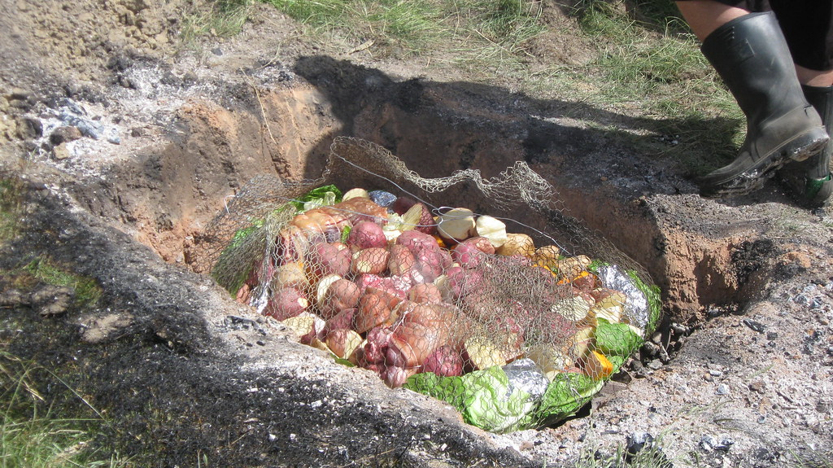
Image: Stewart, S. M., 2010
Figure 1: A Hangi used by Maori people
A hangi is an earth oven used by Maori people in New Zealand. It is a pit dug into the ground. Hot stones from a fire beside the hangi are placed at the bottom of the pit. Baskets of food are put on top of the hot stones and covered with a wet cloth and dirt. The steam from the wet cloth and hot rocks creates steam to cook the food. Hangis are traditionally used to cook food, such as fish and sweet potato, but today other varieties of meat and vegetables are cooked in hangis. The food is cooked for approximately three to four hours inside the hangi.

Steaming in banana leaves
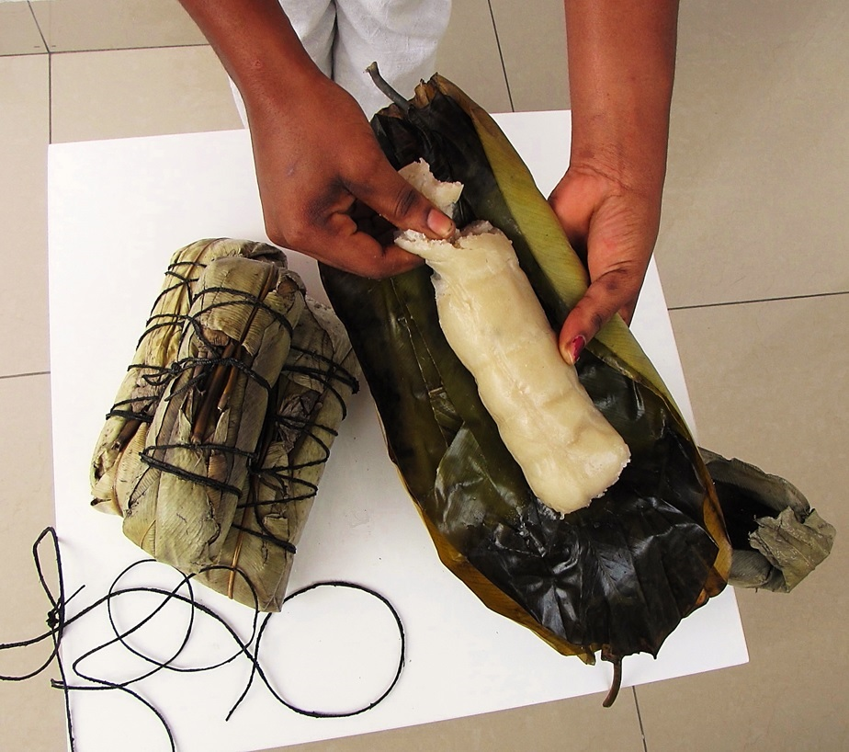
Image: Naliaka, T. K., (2015)
Figure 2: Banana leaves are used for both cooking and serving food
In many places across the world, such as the Pacific islands, North Africa, inner Laos, and south, east and west India, banana leaves are used to cook and serve food, with the leaf being used as a plate. Foods such as rice, vegetables and fish are wrapped in banana leaves and steamed.

Baking in bamboo
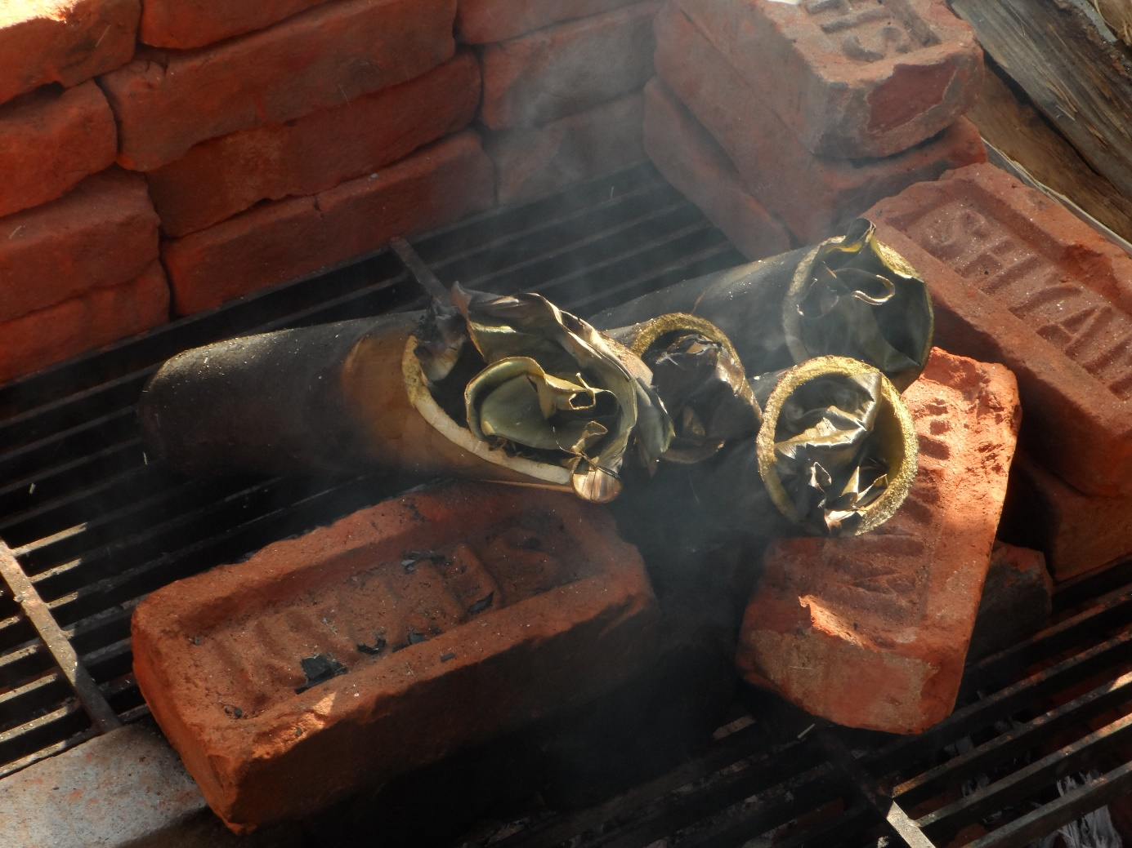
Image: Bolt, S., (2014)
Figure 3: Bamboo is used to cook food in Thailand
In Thailand, food is often cooked using natural materials, such as bamboo. The bamboo is stuffed with food, such as rice and the end is sealed with a banana leaf. The bamboo sticks are cooked on hot coals.
Wok
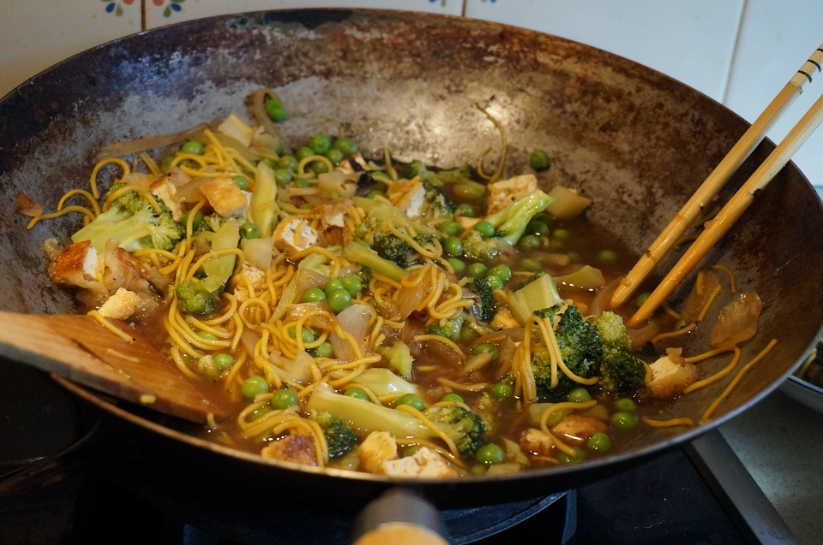
Image: Corbey, D., (2015)
Figure 4: Woks are used all over the world
Woks were originally used in China before being used across Asia. Today woks are used all over the world. The shape of the wok, with a round bottom, lets heat spread all over the wok. Woks are used to cook a wide range of meals including stir-fry, stew and soup.

Tagines
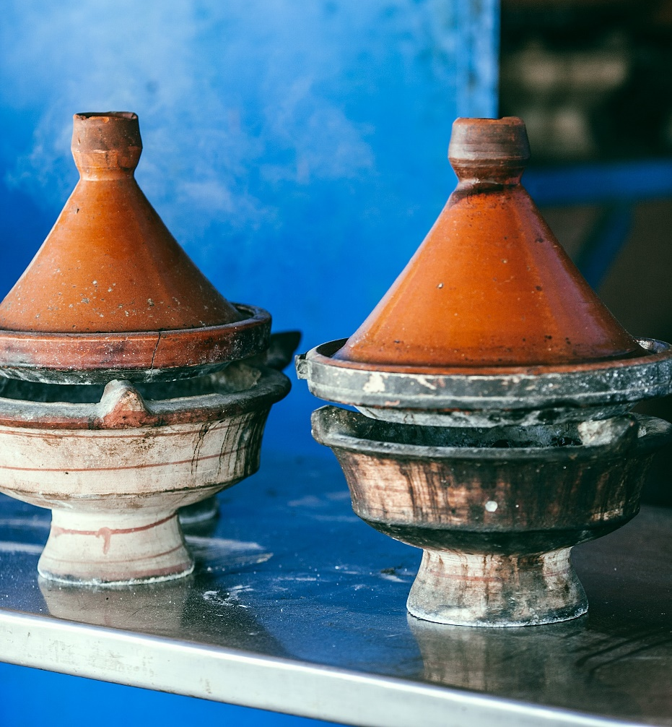
Image: Orlova, M., (2020)
Figure 5: A North African tagine
Tagines were originally used in North Africa to cook food on a fire. They are now widely used in Moroccan cooking for stews with meat. The tagine is a clay dish which has two parts: a cone-shaped lid, which sits on top, and the base.

Spider (bamboo) skimmer
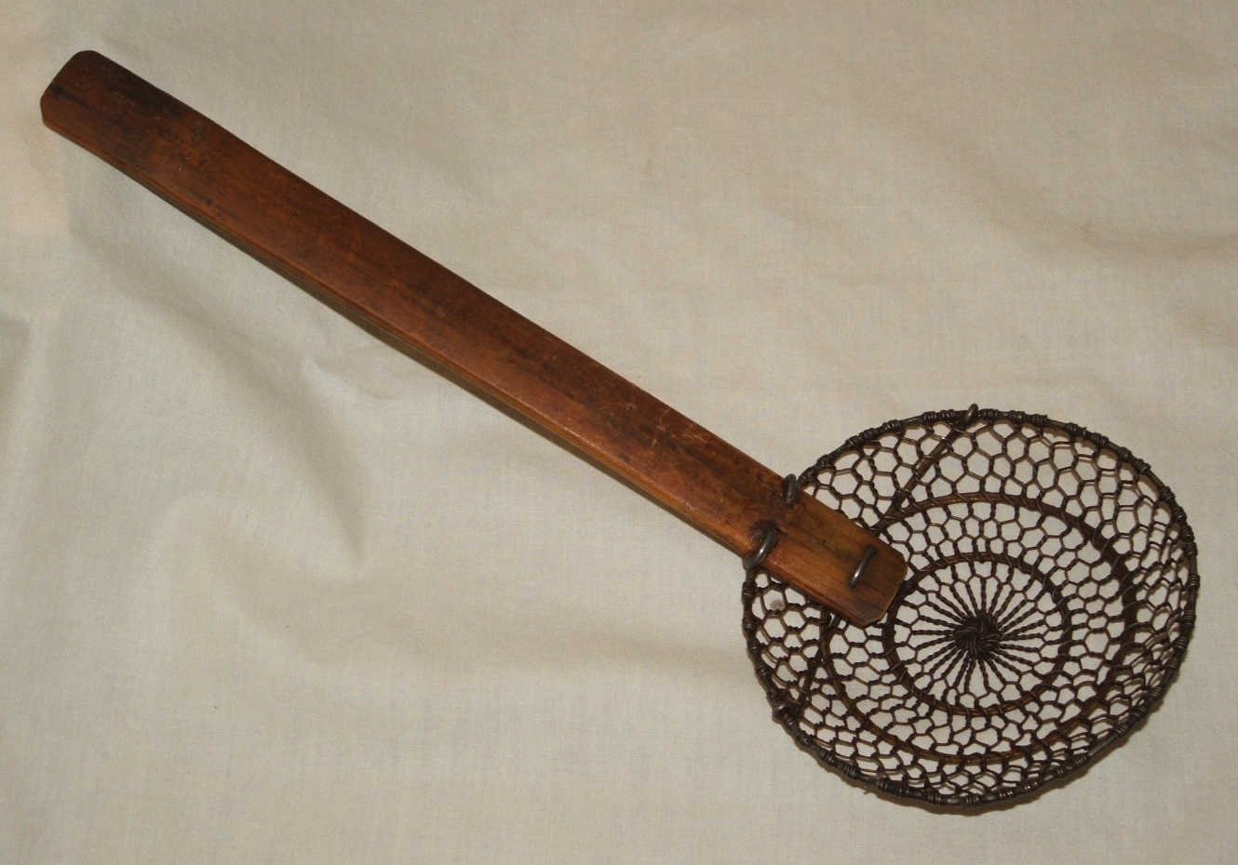
Image: Lane, G., (2008)
Figure 6: Skimmers are used in Asian cooking
A bamboo skimmer is also known as a spider skimmer in Asian cooking. It has a long handle and a fine mesh basket at one end. A spider skimmer is used to remove hot food from liquids or for removing foam from broths.

Appendix A.7
Term 2 Weeks 3–4: Fibre fact shuffle
Fibre product | Where the fibre came from | Plant/animal fibre | Name of fibre, e.g. wool, straw, silk, wood pulp

Appendix A.8
Term 3: Food specialisations
Week | Resource | Link/information
1 | BTN Food safety episode | - Behind the News (2020). Food Safety Week – Behind the News. https://www.youtube.com/watch?v=j38gvrfxGd4
1 | ABC Kids Food Recipe Book | - ABC (2025). Recipe Book. https://www.abc.net.au/abckids/abc-kids-recipe-book/12135084
3 | Gardening Australia fermenting vegetables episode | - Gardening Australia (2020). Fermenting vegetables is good for you and cuts down on food waste – Gardening Australia. https://www.youtube.com/watch?v=YM__U0Iosx0
3 | Introducing kids to fermented foods blog | - Fellows, R. (2025). Introducing fermented foods to kids. https://www.ruthfellowes.com.au/introducing-fermented-foods-kids/
3 | Blog on benefits of fermented foods | - Healthy Kids Naturally (n.d.) Fermented foods to boost your family's health.  https://healthykidsnaturally.com.au/fermented-foods-to-boost-your-families-health/
4 | History of yoghurt blog | - BC Dairy (2022). Food for thought – a short history of yoghurt. https://bcdairy.ca/food-for-thought-a-short-history-of-yogurt/
4 | Simple homemade yoghurt recipe | - National Geographic Kids (n.d.) How to make homemade yoghurt. https://www.natgeokids.com/uk/kids-club/cool-kids/general-kids-club/how-to-make-homemade-yogurt/
5 | Milk from the dairy to the shop | - ABC Education (2022). For the Juniors: Milk from the dairy to the shop.  https://www.abc.net.au/education/for-the-juniors-milk-from-the-dairy-to-the-shop/13500334
5 | Description of how milk is produced | - Dairy Max (2025). Cows turn plants into milk. https://www.dairydiscoveryzone.com/farm-table
5 | A positive representation of a varied diet | - eatforhealth.gov.au Australian Guide to Healthy Eating https://www.eatforhealth.gov.au/guidelines/australian-guide-healthy-eating
6 | Recipe for yoghurt bark | - Jawad, Y (2021). Frozen yoghurt bark. https://feelgoodfoodie.net/recipe/frozen-yogurt-bark/#wprm-recipe-container-40676
6 | Recipe for yoghurt bark | - Boob to food (n.d.). Yoghurt bark.  https://boobtofood.com/2023-5-4-yoghurt-bark-2/

Appendix A.9
Term 3 Week 3: Suggested layout for My taste journal
What did I ...
See Feel Smell Taste Hear
... when I sampled this food?
Food item | Reaction | One word explaining your reaction: Why?

Appendix A.10
Term 4: Food specialisations
Week | Resource | Link/information
1 | BBC Bitesize information about why water is important | - BBC (2025). Why do we need to drink water? https://www.bbc.co.uk/bitesize/articles/zj8nxbk#z48bg7h
2 | Crunch&Sip Program | - Cancer Council Western Australia (2025). Crunch & Sip.  https://www.crunchandsip.com.au/
4 | Mindful eating | - Only About Children (2025). Benefits of Mindful Eating.  https://www.oac.edu.au/news-views/benefits-of-mindful-eating/
6 | Wholegrains for kids | - Grains and Legumes Nutrition Council (2025). Whole grains for kids’ health. https://www.glnc.org.au/resource/whole-grains-for-kids-health/#:~:text=It%20is%20crucial%20for%20school,chronic%20disease%20such%20as%20Cardiovascular
6 | Wholegrains and cereals | - Australian Government (n.d.). Grain (cereal) foods, mostly wholegrain and/or high cereal fibre varieties. https://www.eatforhealth.gov.au/food-essentials/five-food-groups/grain-cereal-foods-mostly-wholegrain-and-or-high-cereal-fibre
6 | Wholegrains | - Ed Said (2016). Ed Said | EdVentures in Healthy Eating – Whole Grains | MPB https://www.youtube.com/watch?v=smzoQVPlWHw
6 | Carrot and oat mini muffins | - Raising Children Network Australia (2025). Carrot and oat mini muffins. https://raisingchildren.net.au/toddlers/nutrition-fitness/food-recipes/mini-muffins
6 | Savoury muffins | - Health and Wellbeing Queensland (2020). Savoury Muffins.  https://hw.qld.gov.au/blog/boost-your-recipes/savoury-muffins/

Appendix B
Assessment task 1
Weave it together

Task details
Title Weave it together
Description In small groups or pairs, students create a woven item using wool or a wool blend yarn. They create an instructional document (video/photos/drawings) explaining how their weave was created
Type of assessment Summative
Ways of assessing Design and process document, in video/photo or hand drawn form
Suggested time 2 x 60-minute lessons
Differentiation Teachers should differentiate their teaching and assessment to meet the specific learning needs of students, based on their level of readiness to learn and to be challenged. Where appropriate, teachers may either scaffold or extend the scope of the assessment tasks.

Content descriptions
Food and fibre production
Food and fibre produced to meet food and clothing needs
Design thinking skills
Project management
Communicate ideas and follow a plan with consideration of time management, to develop a solution
Investigating and defining
Define ideas and design opportunities for individual and/or local needs
Designing
Design solutions created with labelled drawings, use of technical terms and/or a sequence of steps
Producing and implementing
Use appropriate technologies and components with given equipment and follow agreed protocols to produce a designed solution

Resources
- Wool/wool blend yarn
- Found sticks
- Design task prompts for instructional document

Instructions for teacher
Allow students time to reflect on their beginning weaves from learning experiences. Discuss with students what they discovered about using wool/wool blend yarn when feeling how it moved in their hands.
Discuss how weaving could be used to create products. Brainstorm ideas for products they could create by hand weaving.
See Appendix A.2 for links that offer suggestions for age-appropriate hand and finger weaving activities. Show videos/images/model examples of different ways that wool/yarn can be woven into various styles and patterns for different purposes.
Explain to students that they will be designing, creating and developing an instructional video/photo book/hand drawn booklet (depending on resources available) to showcase the process undertaken in the weave.

Instructions for students
Students work in small groups to generate ideas for what they will weave and how they will weave it. Provide wool or yarn for the students to experiment with during this ideation process.
Students design a woven product using wool or yarn, drawing and labelling the technologies required to create the product.
Students create their weave, taking photos/videos/drawing pictures along the way to collate into an instructional design document.
Students share their woven products and discuss any challenges that occurred during the process.

Marking key
Description | Marks
Investigating and defining
Defines the product idea and explains clearly and in detail why it is a helpful/interesting item to create out of wool/yarn. | 3
Gives a basic definition of the product including a simple reason why it might be helpful/interesting to weave. | 2
Defines the product idea but gives no explanation as to why it was chosen. | 1
Subtotal | /3
Designing
Creates logical, sequenced steps with an annotated diagram to make a wool/yarn weave | 3
Creates sequenced steps with an annotated diagram missing some labels to make a wool/yarn weave | 2
Creates incomplete steps and an unclear diagram to make a wool/yarn weave and/or steps are not sequential | 1
Subtotal | /3
Producing and implementing
Selects and safely uses appropriate technologies to produce a weave using design ideas, following agreed protocols. | 2
Uses given equipment to produce a weave but needs instruction on safety and/or protocols for use. | 1
Subtotal | /2
Total | /8

Appendix C
Assessment task 2
Food specialisations: Yoghurt bark recipe

Task details
Title Yoghurt bark recipe
Description Students draw, annotate and describe the steps to create their own recipe for yoghurt bark.
Type of assessment Summative
Ways of assessing Labelled drawing
Step-by-step recipe instructions
Evaluation of yoghurt bark
Suggested time 3 x 60-minute lessons
Differentiation Teachers should differentiate their teaching and assessment to meet the specific learning needs of their students, based on their level of readiness to learn and their need to be challenged. Where appropriate, teachers may either scaffold or extend the scope of the assessment tasks.

Content descriptions
Food specialisations
Food selected to nourish the body, for energy to move and support growth
Design thinking skills
Project management
Communicate ideas and follow a plan with consideration of time management, to develop a solution
Investigating and defining
Define ideas and design opportunities for individual and/or local needs
Designing
Design solutions created with labelled drawings, use of technical terms and/or a sequence of steps
Producing and implementing
Use appropriate technologies and components with given equipment and follow agreed protocols to produce a designed solution
Evaluating
Use given criteria to evaluate diagrams, technologies and the components used for the designed solution

Task preparation
Prior learning
Students understand and have practised the principles of food safety and hygiene.
Students have explored fermentation in yoghurt and understand why yoghurt is a nourishing food choice for peoples’ bodies.

Resources
- Natural yoghurt
- Spoons for dishing out toppings
- Toppings as required based on student requests
- Trays for setting yoghurt
- Baking paper to line trays
- Freezer
- Wooden knives, bowls and chopping boards as required for toppings
- Recipe and evaluation template

Instructions for teacher
Discuss with students the design task, ‘Yoghurt Bark Recipe’. They are to select someone (sibling, parent, friend, neighbour) who they would like to make a yoghurt bark recipe for, considering the person’s individual needs and likes. The yoghurt bark will be gifted to the chosen person.
Review how to read a recipe. Show an example of a recipe for yoghurt bark, with toppings; for example:
https://feelgoodfoodie.net/recipe/frozen-yogurt-bark/#wprm-recipe-container-40676
https://boobtofood.com/2023-5-4-yoghurt-bark-2/
Demonstrate how to make one of the recipes. Ask students to consider the possible alternatives to meet the needs of their selected person. This may be based on age, preference for sweet or savoury, or the inclusion of toppings.
Explain to the students that upon completing their yoghurt bark recipe they will be evaluating it based on set criteria. Predetermine the criteria or negotiate this with the students. Criteria should include ideas around food preferences and design thinking principles.
Use three criteria for students to focus on in their design, phrasing them as success criteria.
For example:
- I can create a recipe using ingredients that considers what others may like
- I can draw a picture and label my yoghurt bark design
- I can use the ingredients and materials safely to successfully make yoghurt bark.
Explore with students the various methods for preparing their toppings. For example, do they need to chop/crush any items? How will they break their yoghurt bark? Are they wanting uniform shapes in the bark or a random approach?
Explain to students that the final session will involve an evaluation of their yoghurt bark. Discuss what the word evaluate means.

Instructions for students
Students use the design template to plan a recipe for yoghurt bark. Students sketch and label the features of their yoghurt bark, recording step by step how to create their recipe. Students justify why they chose alternatives chosen for the intended recipient.
Students work to create their yoghurt bark recipes. Assist students with chopping of toppings and ensure space is organised so students can follow the recipe accurately and safely.
Allow students time to sample their yoghurt bark and package some ready to gift to their intended gift recipient, if not already done. Students should record the flavours in their taste journal.

Yoghurt bark recipe template
Design sheet
Design yoghurt bark. Include the following information:
- a labelled drawing
- a list of chosen ingredients
- a list of equipment needed.
Drawing/sketch:

Ingredients | Equipment

Recipe
Explain step by step the process to create yoghurt bark recipe:

Evaluate using the following criteria
After students have taste tested their recipes, they are to evaluate their success based on the criteria established during lesson 6. Alter these criteria as necessary based on class feedback and discussion. It is not necessary to choose all of these, just those selected as a class.
Food specialisations | Producing and implementing | Investigating and defining
Describe the flavours in the yoghurt bark. | Outline the steps in the recipe. | Explain how the yoghurt bark was designed for your chosen individual.
Describe what flavours worked well together/did not work in the yoghurt bark. | List changes would you make to the recipe if you were to make it again. | Discuss - did your chosen individual like/dislike the yoghurt bark? Why/why not?
List any toppings you wish you had considered. Explain why. | Explain why you would make these changes. | Identify what you could have done to improve this recipe for your chosen individual.

Description | Marks
Designing
Detailed, labelled diagram of their yoghurt bark, with all possible ingredients and equipment needed included. | 3
Simple diagram of their yoghurt bark with some labels and some ingredients and equipment. | 2
Diagram drawn, but no labels or appropriate ingredients/equipment needed. | 1
Subtotal | /3
Producing and implementing
Explains in detail the steps required to create yoghurt bark, explaining hygiene tips as well as food preparation skills. | 3
Describes the steps required to make yoghurt bark, with some mention of hygiene tips or food preparation skills. | 2
Lists the steps for pouring the yoghurt and adding toppings, without any additional details specific to their recipe. | 1
Subtotal | /3
Evaluating
Lists additional flavours suitable for the design, identifies improvements and explains why these changes would improve the product. | 3
Evaluates the selected flavours based on feedback from the selected person and lists some changes to the design. | 2
Describes the flavours used. | 1
Subtotal | /3
Total | /9

Acknowledgements
Appendix A.6
Hangi Stewart, S. M. (2010). EDC Hangi 2010 [Photograph]. Retrieved December, 2025, from https://flic.kr/p/92rDg8
Used under a Creative Commons Attribution 2.0 Generic licence.
Steaming in Banana Leaves Naliaka, T. K. (2015). Cassava Bread - Cassava Cooked in Leaf Wrap (Kwanga, Chikwangue) [Photograph]. Retrieved December, 2025, from https://commons.wikimedia.org/w/index.php?curid=43349736
Used under a Creative Commons Attribution-ShareAlike 4.0 International licence.
Baking in Bamboo Bolt, S. (2014). Putek huu [Photograph]. Retrieved January, 2026, from https://commons.wikimedia.org/w/index.php?curid=40991268
Used under a Creative Commons Attribution-ShareAlike 4.0 International licence.
Wok Corbey, D. (2015). [Photograph of a noodle and vegetable stir fry in a wok with chopsticks and spoon]. Retrieved January, 2026, from https://pixabay.com/photos/wok-stir-fry-vegetables-chinese-963754/
Tagines Orlova, M. (2020). [Photograph of tagines]. Retrieved January, 2026, from https://www.pexels.com/photo/similar-tagines-on-metal-table-in-daylight-4917090/
Spider (Bamboo) Skimmer Lane, G. (2008). Spider (Cooking) [Photograph]. Retrieved January, 2026, from https://commons.wikimedia.org/w/index.php?curid=4613673
Used under a Creative Commons Attribution-Share Alike 3.0 Unported licence.

