
Mathematics: Number and algebra; Measurement and geometry
Teaching, learning and assessment exemplar
Year 9
Coordinate geometry and Pythagoras

Acknowledgement of Country
Kaya. The School Curriculum and Standards Authority (the Authority) acknowledges that our offices are on Whadjuk Noongar boodjar and that we deliver our services on the country of many traditional custodians and language groups throughout Western Australia. The Authority acknowledges the traditional custodians throughout Western Australia and their continuing connection to land, waters and community. We offer our respect to Elders past and present.
Background
This teaching, learning and assessment exemplar (the exemplar) has been developed by the School Curriculum and Standards Authority (the Authority) as part of the School Education Act Employees (Teachers and Administrators) General Agreement 2017 (Clause 61.1–61.3).
Copyright
© School Curriculum and Standards Authority, 2025
This document – apart from any third-party copyright material contained in it – may be freely copied, or communicated on an intranet, for non-commercial purposes in educational institutions, provided that the School Curriculum and Standards Authority (the Authority) is acknowledged as the copyright owner, and that the Authority’s moral rights are not infringed.
Copying or communication for any other purpose can be done only within the terms of the Copyright Act 1968 or with prior written permission of the Authority. Copying or communication of any third-party copyright material can be done only within the terms of the Copyright Act 1968 or with permission of the copyright owners.
Any content in this document that has been derived from the Australian Curriculum may be used under the terms of the Creative Commons Attribution 4.0 International licence.
Disclaimer
Any resources such as texts, websites and so on that may be referred to in this document are provided as examples of resources that teachers can use to support their learning programs. Their inclusion does not imply that they are mandatory or that they are the only resources relevant to the course. Teachers must exercise their professional judgement as to the appropriateness of any they may wish to use.
This resource utilises electronic web-based resources, such as videos and image galleries. Teachers should be present while an electronic resource is in use and close links immediately after a resource, such as a video has played to prevent default ‘auto play’ of additional videos. Where resources are referred for home study, they should be uploaded through Connect, or an equivalent system, that filters advertising content.

Contents
The Western Australian Curriculum 1
The Mathematics curriculum 1
This exemplar 2
Catering for diversity 2
Using this exemplar 3
Links to electronic resources 3
Best practice 4
Teaching and learning 4
Assessing 4
Reflecting 4
Coordinate geometry and Pythagoras 5
Year level description 6
Achievement standard 7
Lessons 1–13 9
Appendix A 33
Appendix B 65
Appendix C 83
Acknowledgements 101

The Western Australian Curriculum
The Western Australian Curriculum and Assessment Outline (the Outline – https://k10outline.scsa.wa.edu.au/) sets out the mandated curriculum, guiding principles for teaching, learning and assessment, and support for teachers in their assessment and reporting of student achievement. The Outline recognises that all students in Australian schools, or international schools implementing the Western Australian Curriculum, are entitled to be given access to the eight learning areas described in the Alice Springs (Mparntwe) Education Declaration, December 2019.

The Mathematics curriculum
The mandated curriculum is presented in the year level syllabus documents.
The Mathematics curriculum delivers a sequential and age-appropriate progression of learning with the following key elements:
- a year level description that provides an overview of the context for teaching and learning in the year
- a series of content descriptions, populated through strands and sub-strands, that sets out the knowledge, understanding and skills that teachers are expected to teach and students are expected to learn
- an achievement standard that describes an expected level that the majority of students are achieving by the end of a given year of schooling. An achievement standard describes the quality of learning (e.g. the depth of conceptual understanding and the sophistication of skills) that would indicate the student is well placed to commence the learning required in the next year.

This exemplar
This Mathematics exemplar articulates the content in the Outline and approaches to teaching, learning and assessment reflective of the Principles of Teaching, Learning and Assessment. This exemplar demonstrates a sequence of teaching and learning, including suggested assessment points, for 13 lessons.

Catering for diversity
This exemplar provides a suggested approach for the delivery of the curriculum and reflects the rationale, aims and content structure of the learning area. When planning the learning experiences, consideration has been given to ensuring that they are inclusive and can be used in, or adapted for, individual circumstances. It is the classroom teacher who is best placed to consider and respond to (accommodate) the diversity of their students. Reflecting on the learning experiences offered in this exemplar will enable teachers to make appropriate adjustments (where applicable) to better cater for students’ gender, personal interests, achievement levels, socio-economic, cultural and language backgrounds, experiences and local area contexts.

Using this exemplar
This teaching, learning and assessment exemplar provides suggestions to support the delivery of the mandated curriculum content. The exemplar provides:
- a teaching and learning sequence
- the mandated curriculum content to be taught at each point of the teaching and learning sequence, suggested resources, sample assessment tasks and marking keys
- the number of lessons to deliver the teaching and learning experiences
- learning intentions and support notes that may provide focus questions and additional information and/or examples to assist with the interpretation of curriculum content
- support notes to assist teachers to unpack the content and support teaching and learning experiences
- teaching and learning experiences that outline the structure of the lesson. These explicitly state each activity that the lesson will progress through and the key focus area for that activity.

Links to electronic resources
This sequence of lessons may utilise electronic web-based resources, such as videos and image galleries. Teachers should be present while an electronic resource is in use and close links immediately after a resource, such as a video, has played to prevent default ‘auto play’ of additional videos. Where resources are referred for home study, they should be uploaded through Connect, or an equivalent system, that filters advertising content.

Best practice

Teaching and learning
The teaching and learning opportunities offered in this exemplar are not exhaustive. Thus, teachers are encouraged to make professional decisions about which learning experiences, and the sequence in which they are delivered, are best suited to their classroom context, taking into account the availability of resources and student ability.
This sample may prove a useful starting point for amplifying creativity in the classroom, while presenting the embedded expectations of the Western Australian Curriculum: Mathematics.
Teachers may find opportunities to incorporate the General Capabilities and the Cross-curriculum Priorities into the teaching and learning program.
Ways of teaching – teachers can locate additional information on the Ways of teaching on the School Curriculum and Standards Authority (the Authority) website
https://k10outline.scsa.wa.edu.au/home/wa-curriculum/learning-areas/mathematics/overview/mathematics-ways-of-teaching.

Assessing
Assessment, both formative and summative, is an integral part of teaching and learning. Assessment should arise naturally out of the learning experiences provided to students. In addition, assessment should provide regular opportunities for teachers to reflect on student achievement and progress. As part of the support it provides for teachers, this exemplar includes suggested assessment points. It is the teacher’s role to consider the contexts of their classroom and students, the range of assessments required, and the sampling of content descriptions selected to allow their students the opportunity to demonstrate achievement in relation to the year level achievement standard. Teachers are best placed to make decisions about whether the suggested assessment/s are used as formative or summative assessment and/or for moderation purposes.
Ways of assessing – a range of assessment strategies that can enable teachers to understand where students are in their learning is available on the Authority website
https://k10outline.scsa.wa.edu.au/home/wa-curriculum/learning-areas/mathematics/overview/mathematics-ways-of-assessing.

Reflecting
Reflective practice involves a cyclic process during which teachers continually review the effects of their teaching and make appropriate adjustments to their planning. The cycle involves planning, teaching, observing, reflecting and replanning.
This exemplar supports reflective practice and provides flexibility for teachers in their planning. The exemplar shows how content can be combined and revisited throughout the year. Teachers will choose to expand or contract the amount of time spent on developing the required understandings and skills according to their reflective processes and professional judgements about their students’ evolving learning needs.

Coordinate geometry and Pythagoras
This exemplar addresses aspects of the Year 9 Mathematics content identified below.

Number and algebra
Linear and non-linear patterns and relationships
- Use the Cartesian plane to explore finding the distance, gradient and midpoint between two points
- Develop and use the algebraic formulas for finding the distance, midpoint and gradient between two points (Year 9 optional)

Measurement and geometry
Two-dimensional space and structures
- Use Pythagoras’ theorem to determine the perimeter and area of shapes involving right-angled triangles, in both exact and decimal approximation form. Investigate and apply the converse of Pythagoras’ theorem to establish whether a triangle is right-angled

Year level description
In the middle adolescence phase of schooling, teaching and learning programs encourage students to develop an open and questioning view of themselves as active participants in their society and the world.
Mathematics provides opportunities for students to engage in a range of approaches to learning through the proficiencies of understanding, fluency, problem-solving and reasoning. These reinforce the significance of working mathematically with the content and describe how the content is explored or developed. Students draw on the behaviours of the proficiencies when selecting and using year level content to apply the complete modelling process, leading to an increased understanding of the complexity of the natural environment, society and technology.
In Year 9, students explore and investigate to understand, calculate flexibly and efficiently, and model with real numbers, writing solutions in exact or approximated form. They engage with financial mathematics by calculating simple interest and exploring ways in which people earn money. They work flexibly, both algebraically and graphically with linear equations, developing an understanding of gradient.
Students explain and determine perimeter and area of composite figures. They apply Pythagoras’ theorem to solve perimeter and area problems. Through construction, drawing and geometric reasoning, students establish conditions for congruent triangles, explore properties of similar figures and develop the trigonometric ratios. Students extend their use of formula to include volume, capacity and surface area of right prisms and cylinders.
Students connect probability and statistics by collecting data from experiments and simulations related to two-stage chance experiments, both with and without replacement. They analyse comparative graphs in context using statistical language and critically analyse statistical processes and claims made in the media that relate to data sampling.
Note: the optional content in Year 9 is intended to build and extend students’ year level knowledge according to areas of interest, understanding of content and preparation for subsequent study. The content descriptions are optional. Teachers may choose from optional content according to the needs of the student/s.

Achievement standard
By the end of the year:
Students demonstrate the behaviours of the proficiencies of understanding, fluency, problem-solving and reasoning in conjunction with year level content in routine situations. As part of this, they select from and use year level content along with the modelling process, in which they analyse the situation mathematically, represent the problem and interpret and communicate their findings, to solve straightforward, real-world problems in familiar contexts across all strands.
Students compare and order real numbers, including those expressed in scientific notation. They demonstrate flexible and efficient strategies to carry out the four operations with real numbers, expressing solutions in exact or approximated form. They express real numbers in scientific notation. Students apply the index laws to variable bases with positive-integer and zero indices, expand and factorise expressions with an algebraic factor and expand binomial products. Students solve linear equations involving brackets. They use the Cartesian plane to find the distance between two points and the gradient and midpoint of a line segment. They graph straight lines using the gradient and
y-intercept, and identify and represent direct proportion algebraically and graphically. Students solve simple quadratic equations algebraically and use tables of values to graph the function. They determine interest using the simple interest formula and perform calculations that relate to earning income.
Students determine the perimeter and area of composite shapes, including those involving right-angled triangles. They use triangle and angle properties to show reasoning as to why triangles are congruent and find unknown sides and angles. They use properties of similar figures and scale to determine real-life lengths from scale drawings and apply a trigonometric ratio to find unknown sides and angles in right-angled triangles. Students apply formulas to determine the volume, capacity and surface area of right prisms and cylinders.
Students construct sample spaces, assign probabilities and conduct experiments and simulations for two-stage events, both with and without replacement, and identify variation in estimated probabilities. They describe data represented in tables using statistical measures and relative frequencies to make inferences. They compare back-to-back stem-and-leaf plots and comparative histograms using shape and spread. Students describe different sampling methods and make critical comments on statistics relating to data sampling in the media.



Lessons 1–13
Coordinate geometry and Pythagoras

Lesson 1: Cartesian coordinates
The Western Australian Curriculum content addressed in this lesson is below.

Measurement and geometry

Two-dimensional space and structures
- Plot coordinates on the Cartesian plane and explore, visualise, predict and determine image coordinates after translation or reflection across the axes, or rotation about the origin [Year 7]

Learning intentions
- Revision of the Cartesian plane:
  - Plot coordinates on a Cartesian plane.
  - Write coordinates for a point on a Cartesian plane.
  - Identify the four quadrants.

Focus questions
- Where might we use coordinates in everyday life?
- What strategy do you use to remember which axis each coordinate relates to?
- Why are the origin and the axis intercepts not considered to be part of a quadrant?
- Which two quadrants have positive $x$-coordinates?
- Which two quadrants have negative $x$-coordinates?

Teaching and learning experiences

Starter
- Use an activity such as Cartesian coordinate figures (Appendix A). Students place figures of different shapes and sizes on a Cartesian plane that runs from −6 to 6 on the x- and y-axis. Students play in pairs, picking coordinates to try to guess (‘hit’) the location of each shape. This can be modified to support students who are not strong with negative numbers by including either all coordinates in the first quadrant or by using only the first quadrant and either the second or fourth quadrant.
Suggested learning experiences
- Define the parts of the Cartesian plane and its coordinates system. Focus on the axes, the quadrants and what each part of the coordinate pair represents. Remind students that these are pairs that are linked together, so they will always need to have a set of brackets around them, with the comma separating them from each other i.e. ($x, y$).
- Write a pair of coordinates on the board. Students use a small whiteboard or tablet to show 1, 2, 3 or 4 to represent the quadrant in which the coordinates are located. Use coordinates, such as $(0, 0), (0, 4)$and$\left(5, 0\right),$ to invite critical thinking about which quadrant coordinates on the axes are in (the definition states these coordinates are not in any quadrant).
- Display a Cartesian plane using the whiteboard or projector, and ask students to come up in groups of five to place a sticker on a given coordinate. Students write the coordinate of their sticker on the whiteboard, checking and recording their understanding as they go. Use this as a formative assessment opportunity to determine the class’s understanding of plotting Cartesian coordinates.
- Label up to 26 coordinates (A through to Z) on the same Cartesian plane as in above, starting in the first quadrant and working in an anticlockwise direction. Students write each of the coordinates in their workbooks. Ask each student to share an answer they are confident with, allowing them to pass if they aren’t confident with their answers.
- If students have demonstrated a collective competency in the warm-up and diagnostic activities, proceed to drawing a picture using Cartesian coordinates. Find a suitable online resource.

Lesson 2: Introduction to midpoint
The Western Australian Curriculum content addressed in this lesson is below.

Number and algebra

Linear and non-linear patterns and relationships
- Use the Cartesian plane to explore finding the distance, gradient and midpoint between two points
- Develop and use the algebraic formulas for finding the distance, midpoint and gradient between two points (Year 9 optional – extension opportunity)

Learning intentions
- Determine the horizontal and vertical midpoints and use these to determine the midpoint of a line segment.
- Relate the midpoint of two coordinates to mean.

Focus questions
- What are we doing mathematically when we determine the middle of two things?
- How far is the midpoint from each end of the line?
- Is the midpoint of a line segment always between the two points?

Teaching and learning experiences

Starter
- Provide students with small datasets to calculate the means.

Suggested learning experiences
- Provide students with pairs of objects; for example, two sticks of different lengths, two bags of sand with different masses, two shoes of different sizes. Each pair should be the same object of different measurements; for example, two cups of water, one having 100 mL and the other 160 mL. Ask students to work out the value of a third object (using the same units) which is exactly in the middle of the two provided. If possible, provide scales, tape measures, rulers and beakers, allowing students to actively measure the objects. Students create a table in their workbooks that has one column for each object, one column for the total of the two objects and one column for the middle object.
- Print four or five number lines for each student, with each number line spanning from –10 to 10. Provide students with two even counting numbers. Model the process of folding the number line to make the points meet. Ask students what the location of the fold represents. Practise this method using a combination of positive odd and even pairs, pairs of negative numbers, pairs that cross 0 and even pairs which are non-integers. Question students about how they could determine the value of the halfway point without folding the paper every time. Prompt them to move towards the idea of adding the numbers up and dividing the total by two.
- Pick two students in the class at random. Have them stand up and ask a third student to move around to try and stand in the middle of both students. Ask the rest of the class to comment on the accuracy of this prediction and then instruct the student in the middle where to move to improve the accuracy, if required. Practise this a few times, with students in different orientations within the room.
- Provide students with a Cartesian plane that has a series of Cartesian coordinates plotted and labelled from A to S (Appendix A). Students visually locate the midpoint of at least 10 sets of coordinates, filling out a retrieval chart as they go. Students develop a way to identify the midpoint by using the halfway points of the vertical and horizontal units. Some students may describe their method of finding the midpoint as averaging the coordinates of the end points. It is intended that they will explore and develop a method as they work.
- Consolidate learning through an appropriate learning activity. For example: Students work in pairs to create coordinates using a deck of cards. This could be easily modelled with the black cards being positive coordinates and the red cards being negative coordinates. Each student creates a set of coordinates using two cards, then both calculate the midpoint between the cards. Students show working in their workbook.
- Pose a problem to be solved as an exit ticket. If students have demonstrated their understanding, problems could focus on determining an end point when the midpoint and the other end point are known; otherwise, focus problems on a calculation of the midpoint.

Extension opportunities
- Students determine the coordinates that split a line segment into three or four even parts.
- Students determine the end point when given the midpoint and the other end point (same as the exit ticket).
- Students determine the coordinates of the end point when given the other end point and a quarter point. Extend this to include other simple fraction points.
- Year 9 optional content: Develop and use the algebraic formulas for finding the distance, midpoint and gradient between two points. Students could be guided into formalising their findings from the activity in Appendix A to the general midpoint formula $\left(\frac{x_{1}+ x_{2}}{2},\frac{y_{1}+{ y}_{2}}{2} \right)$.

Lesson 3: Application of midpoint
The Western Australian Curriculum content addressed in this lesson is below.

Number and algebra

Linear and non-linear patterns and relationships
- Use the Cartesian plane to explore finding the distance, gradient and midpoint between two points
- Develop and use the algebraic formulas for finding the distance, midpoint and gradient between two points (Year 9 optional – extension opportunity)

Learning intentions
- Consolidate and apply working with midpoints.

Focus questions
- Was it accurate? Did the terrain change the actual ‘middle’ in walking terms? Why didn’t the exact midpoint work in practice?

Teaching and learning experiences

Starter
- Provide students with a range of midpoint questions related to the previous lesson. Ask students to choose the level of difficulty they wish to answer.

Suggested learning experiences
- Provide students with a school map showing marked locations and allocate different coordinate locations to each student. Students then pair up and map the midpoint for a physical meeting point between their two positions on the school grounds. They then check their answer by walking from their individual end point to the mapped midpoint. Students attempt to arrive at the same place (proposed midpoint) at the same time. Use the focus questions as a class discussion after the activity.

Resources
- school map (with a coordinate grid overlay e.g. 1 cm = 5 m)
- rulers, pencils, clipboards, paper
- chalk or cones for marking locations
- tape measures or trundle wheels (optional for ground checks)
Extension opportunities
Year 9 optional content: Develop and use the algebraic formulas for finding the distance, midpoint and gradient between two points
For the mapping exercise, provide students with an ‘obstacle map’ and ask them to propose a meeting location that minimises total walking distance. This could serve as the basis for a mathematical modelling task.

Lesson 4: Introduction to distance between two points
The Western Australian Curriculum content addressed in this lesson is below.

Number and algebra

Linear and non-linear patterns and relationships
- Use the Cartesian plane to explore finding the distance, gradient and midpoint between two points
- Develop and use the algebraic formulas for finding the distance, midpoint and gradient between two points (Year 9 optional – extension opportunity)

Learning intentions
- Determine the length of a line segment by measuring and inspecting.

Focus questions
- How does the length of a triangle’s sides affect its interior angles?
- Is it the same for all right-angled triangles?
- Which method of travel covers less distance: a straight line ‘as the crow flies’, or taking the streets?

Teaching and learning experiences
Starter
- Warm up with mental maths questions related to squares and square roots.

Suggested learning experiences
- Locate an appropriate map of either the Perth CBD or a district relevant to your school context.
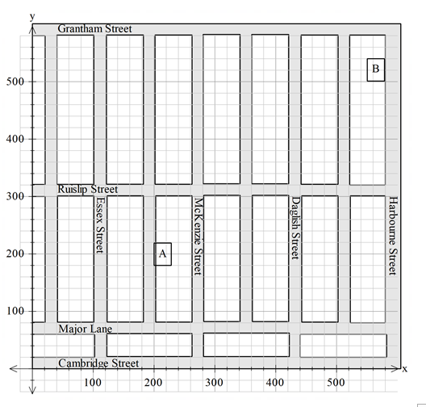
- Ensure the map includes only vertical and horizontal streets. Place a Cartesian plane over the map so that the map occurs in the first quadrant only. An example is shown below.
Using this example, discuss the logistics of getting from one location to another. Ask students to estimate the distance travelled between point A and point B if they could only travel along the streets. Then ask students to estimate what they think the distance would be if they could travel directly between the two points (i.e. ‘as the crow flies’). Students will then use an appropriate method to measure (either scale or another method, such as using a ruler) the distance between the two points in both instances and compare.
Note: scale is not formally taught or assessed in this exemplar; however, this provides a good opportunity to adjust the sequence and add an activity involving scale, as appropriate to the class/students.
- Use a tool such as GeoBoard for students to practise comparing the distances between two points using the horizontal and vertical distances and the straight-line measure. This will be easier to measure physically using a grid system or even on a blank page – as long as the students are able to create a right-angled triangle.
The Math Learning Centre – Geoboard
https://apps.mathlearningcenter.org/geoboard/
- Give students a 6 × 6 dotted grid and ask them to draw squares with as many different areas as possible. Go through the five which align to the grid (1 cm², 4 cm², 9 cm², 16 cm², 25 cm², 36 cm²) as a class. Ask if there are any more squares that are possible. This should lead to students using angled squares, such as shown in the diagram below. Help students determine the area of these squares, by splitting them into component squares and triangles.
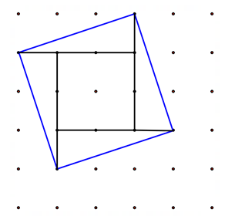
The example below shows a square made up of line segments which have a vertical distance of one unit and a horizontal distance of three units (or the opposite). The area of this square is determined by looking at the individual shapes (four triangles and the square). Ask students to determine the length of the side of the square using the formula $A=l^{2} or l=\sqrt{A}$.

- Model determining the distance between two points. Students first measure the distance to two decimal places by using a set of Cartesian coordinates. They then compare this to the square root of the area of the square this line segment forms and comment on the accuracy of both methods.
Provide opportunities for consolidation as required.

Extension opportunities
Year 9 optional content: Develop and use the algebraic formulas for finding the distance, midpoint and gradient between two points
The development of the formal distance formula is an extension of Pythagoras’ theorem. Depending on the students in the class, and if students have prior knowledge (Year 8) of Pythagoras’ theorem, the development of the distance formula could be explored and formalised. For those students who do not have prior knowledge of Pythagoras’ theorem, it is suggested that they are exposed to Pythagoras’ theorem first (Lesson 5).

Lesson 5: Review of Pythagoras’ theorem
[Note: this lesson can be used if Pythagoras theorem has not previously been studied in Year 8 or as a review lesson.]
The Western Australian Curriculum content addressed in this lesson is below.

Measurement and geometry

Two-dimensional space and structures
- Investigate in order to establish, define and use Pythagoras’ theorem to determine the length of an unknown side in a right-angled triangle [Year 8]

Number and algebra

Linear and non-linear patterns and relationships
- Use the Cartesian plane to explore finding the distance, gradient and midpoint between two points

Learning intentions
- Develop understanding of Pythagoras’ theorem through investigation and experimentation with shapes and measurements.
- State Pythagoras’ theorem.
- Use Pythagoras’ theorem to determine the length of the hypotenuse and of a shorter side.

Focus questions
- Is it possible to use negative numbers for the side lengths? What happens to them in the formula?
- Are there any cases where the side lengths are longer than the hypotenuse?
- Are there any right-angled triangles that are made up of whole number side lengths only?
- What is the difference in the operations required to find the hypotenuse compared to finding a short side, when using Pythagoras’ theorem in a right-angled triangle?
- What can you say about a triangle where the Pythagorean theorem is true?

Teaching and learning experiences

Starter
- Warm up with square and square root practice questions.

Suggested learning experiences
- Provide students with the template in Appendix A. Students cut out the triangle templates and put them back together to make a complete square. This should lead to students making one of the shapes below.
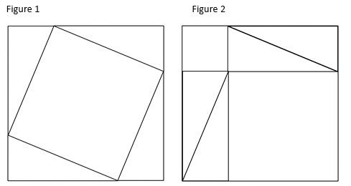
If appropriate, create a template to reflect both options and have adjacent students work on different templates. This can be modelled to students electronically using an applet, such as: Interactive Maths – Pythagoras Proof
https://www.interactive-maths.com/pythagoras-proof-ggb.html.
Ask questions, such as:
  - What do you notice about the area of the two squares your pair made?
  - What features of the squares are the same?
  - What features are different? (think about size, orientation or position)
  - How does the area of the larger square within Figure 1 compare to the area of the two smaller squares within Figure 2?
  - Where do the right-angled triangles appear in this construction?
  - How are the sides of the squares related to the sides of the right-angled triangles?
  - How can you describe the relationship between the side lengths of the triangles and the areas of the squares?
- Show the relationship between the area of the squares on the side lengths using a website, such as:
Interactive Maths – Pythagoras Theorem
https://www.interactive-maths.com/pythagoras-theorem-ggb.html.
This can be used to prompt students to think about what the formula for Pythagoras’ theorem might be.
- Provide students with a range of right-angled triangles (Appendix A). Students record side length measurements in the table provided. Encourage students to look for patterns or connections between the squared sides. Students may communicate that the sum of the squares of the two shorter sides equals the square of the longest side.
Introduce the relationship $a^{2}+b^{2}=c^{2}$. Demonstrate with labelled triangle examples how to determine the length of the hypotenuse and the shorter sides. Provide students with guided practice to solve problems involving missing side lengths in right-angled triangles.
- Provide students a series of three side lengths. Ask students whether the side lengths would create a right-angled triangle. Ask questions that prompt students to conclude that if Pythagoras’ theorem works, then the triangle is right-angled.
- Provide opportunities for consolidation. For example, you could explore Pythagoras’ theorem with cards: Remove the picture cards from a deck of cards. In pairs, students draw one card each from the deck. Students draw and label a triangle, using their cards as the shorter side lengths. They then determine the length of the hypotenuse. This can be extended to include two cards per side length, which could represent a two-digit number or a decimal number. Students can also choose to use the greater value card as the hypotenuse and work out the length of a smaller side.
- Use an exit ticket where students select the hardest problem they think they can solve out of the following:
  - What is the relationship between the sides in a right-angled triangle?
  - Which side of a right-angled triangle is always the longest?
  - The shorter two sides of a triangle are 3 cm and 4 cm. What is the length of the hypotenuse?
  - Sketch and label a right-angled triangle. Write down reasons why your triangle is a right-angled triangle.
Formative assessment
This lesson has multiple opportunities for the teacher to ask key questions and observe to gauge student understanding.
Extension opportunities
- Students create a repeating pattern that models Pythagoras’ theorem, which is known as Pythagorean tiling. Provide students with graph paper and see what patterns they can create to model Pythagoras’ theorem, such as the pattern shown below.
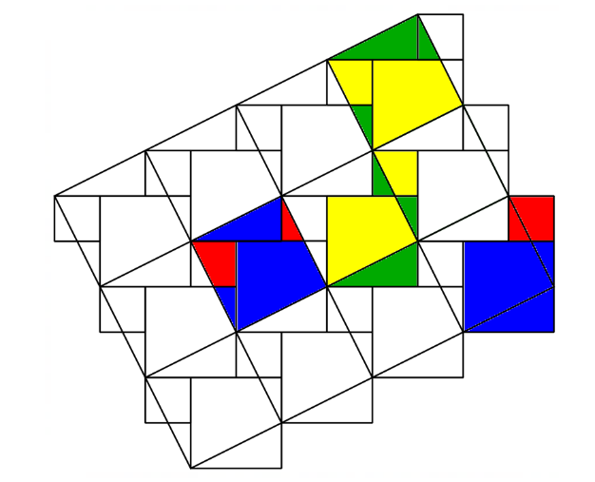

- Students construct a Pythagorean tree. This involves starting with the basic visual representation of Pythagoras’ theorem. Each of the squares on the smaller sides are then used to represent the square of the hypotenuse of a smaller triangle as shown below. Students repeat the pattern and continue to make a Pythagorean tree. Challenge them to determine the dimensions of each shape and the total area of the tree after adding each iteration.
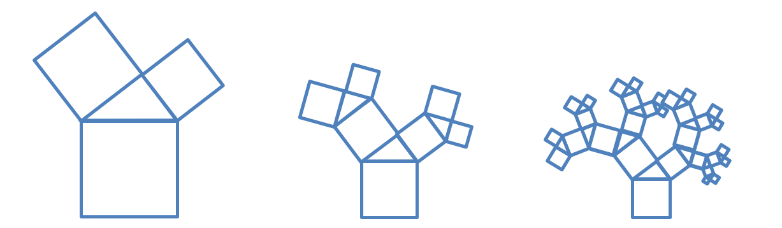

Lessons 6–7: Applications of Pythagoras’ theorem
The Western Australian Curriculum content addressed in these lessons is below.

Measurement and geometry

Two-dimensional space and structures
- Use Pythagoras’ theorem to determine the perimeter and area of shapes involving right-angled triangles, in both exact and decimal approximation form. Investigate and apply the converse of Pythagoras’ theorem to establish whether a triangle is right-angled
- Explore and apply Pythagoras’ theorem and trigonometry to simple situations involving right-angled triangles in three-dimensional contexts projected to two dimensions (Year 9 optional – extension opportunity)

Learning intentions
- Use Pythagoras’ theorem to determine the perimeter and area of composite shapes involving triangles.
- Draw and label a diagram from a worded problem involving right-angled triangles.
- Extract information from an authentic context and represent it as a diagram.

Focus questions
- Where might you see Pythagoras’ theorem used in everyday life?
- Computer monitors are measured by the length of their hypotenuse. If we know a computer monitor is 60 cm, why don’t we know the exact dimensions of the screen’s height and width?

Teaching and learning experiences

Starter
- Warm up with guided practice of using Pythagoras’ theorem to find the hypotenuse and/or the short side of a triangle.

Suggested learning experiences
- Present students with composite shapes that require the application of Pythagoras’ theorem to calculate their perimeter and area. See some examples below.

Example 1: Determine (in exact and approximate units) the height, area and perimeter of a right-angled triangle with base length of 12 cm and hypotenuse of 16 cm.

Example 2: Example 3:
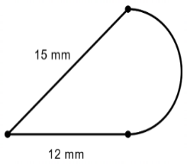
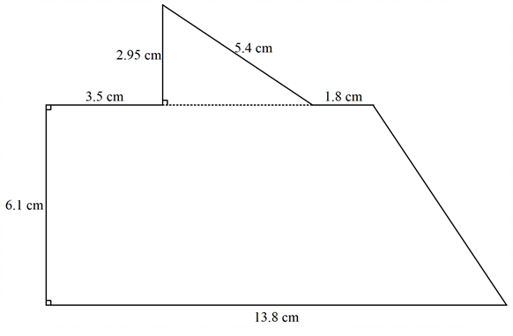

Use a collaborative activity, such as think-pair-share, to explore and discuss strategies for calculating the perimeter and area of these shapes in both exact and decimal approximation form.
- Relate Pythagoras’ theorem back to the lesson on finding the distance between two points on a Cartesian plane. This can be done by creating a right-angled triangle on a Cartesian plane with the vertical and horizontal units between two plotted points. Apply Pythagoras’ theorem to determine the distance between the two points.
- Question students about where Pythagoras’ theorem could be seen or used in everyday life. Choose an appropriate response and use this to build a question/s. Some everyday uses include:
  - in the construction of roofs and housing
  - determining total distance walked or component parts of a walk, by looking at compass direction movements
  - determining the length of a ladder required to reach a window
  - finding the shortest distance between two points.
- Look at the case of side lengths 3, 4 and 5 making a right-angled triangle. Ask students to research other whole-number right-angled triangles. Test multiples of these, such as 6, 8, 10 or even 0.3, 0.4 and 0.5. Ask students to write their own unique Pythagorean triad. Create a word wall of these.
- Reflect on the learning needs of the students in the class and choose an appropriate resource to practise using Pythagoras’ theorem in real-world situations.
- If time is available, use a resource, such as reSolve’s three-lesson sequence Lunch Lap, to enrich and extend students. Adjust the lesson sequence to suit the interest and level of your students. This lesson sequence could be adjusted to suit a modelling task.
reSolve – Geometry: Lunch Lap
https://resolve.edu.au/geometry-lunch-lap-trial
- Use an exit ticket where students create their own question. The range of questions could be used as a formative assessment to ascertain students’ level of understanding.
Extension opportunities
Year 9 optional: Explore and apply Pythagoras’ theorem and trigonometry to simple situations involving right-angled triangles in three-dimensional contexts projected to two dimensions

Lesson 8: Formative assessment
The Western Australian Curriculum content addressed in this lesson is below.

Number and algebra

Linear and non-linear patterns and relationships
- Use the Cartesian plane to explore finding the distance, gradient and midpoint between two points

Measurement and geometry

Two-dimensional space and structures
- Use Pythagoras’ theorem to determine the perimeter and area of shapes involving right-angled triangles, in both exact and decimal approximation form. Investigate and apply the converse of Pythagoras’ theorem to establish whether a triangle is right-angled

Learning intentions
- Identify progress in the topic by conducting formative assessment and reflecting upon students’ own learning.

Teaching and learning experiences

Sequence
- The formative assessment task is in Appendix B.

Lesson 9: Gradient of a line segment
The Western Australian Curriculum content addressed in this lesson is below.

Number and algebra

Linear and non-linear patterns and relationships
- Use the Cartesian plane to explore finding the distance, gradient and midpoint between two points

Learning intentions
- Determine the vertical and horizontal lengths of a line segment.
- Use the horizontal and vertical lengths of a line segment to calculate the gradient of a line.
- Identify if a gradient is positive or negative by inspection.
- Identify if the magnitude of a gradient is greater than or less than one by inspection.
- Calculate the gradient of a line segment between two points on the Cartesian plane.

Focus questions
- If there is a ski lift and a ski run on exactly the same slope, what is the same and what is different about the travel occurring? Which is going up (positive) and which is going down (negative)?
- What is the slope of a flat surface?
- What is the slope of a vertical surface?
- If the vertical length of a slope is halved, what is the impact on the gradient of the slope?
- If the vertical length of a slope is doubled, what is the impact on the gradient of the slope?

Teaching and learning experiences

Suggested learning experiences
- Discuss slope and introduce the word gradient and associated terms. Play a round of Simon says using gradients. Students make the gradient of a straight line using their arms as either positive, negative, zero or undefined (or infinite).
- Students work through Appendix A on ski resorts, applying their knowledge of the Cartesian plane and coordinate geometry to determine the gradient of slopes. This is a group activity, where students will first rank the ski slopes from the easiest to the most difficult. After this, they calculate the gradient of the slopes, given pairs of Cartesian coordinates. Finally, they create their own map of ski runs for an imaginary resort.
- Note: this activity may require more than one lesson for students to fully develop their understanding. The teacher determines the time required to deliver the sequence of teaching and learning in Appendix A.

Lesson 10: Distance between two points
The Western Australian Curriculum content addressed in this lesson is below.

Number and algebra

Linear and non-linear patterns and relationships
- Use the Cartesian plane to explore finding the distance, gradient and midpoint between two points
- Develop and use the algebraic formulas for finding the distance, midpoint and gradient between two points (Year 9 optional – extension opportunity)

Measurement and geometry

Two-dimensional space and structures
- Use Pythagoras’ theorem to determine the perimeter and area of shapes involving right-angled triangles, in both exact and decimal approximation form. Investigate and apply the converse of Pythagoras’ theorem to establish whether a triangle is right-angled

Learning intentions
- Determine the distance between two points.
- Use a scale factor to use coordinates on a map to apply to measurements in real life.

Focus questions
- How does the distance between two points on the Cartesian plane relate to Pythagoras’ theorem?
- How can we use Pythagoras’ theorem to calculate this distance?

Teaching and learning experiences

Suggested learning experiences
- Warm up by determining the gradient of line segments on a Cartesian plane.
- Review Pythagoras’ theorem with two drawn triangles and a worded problem which includes decimals.
- Display a map of Australia overlaid onto a Cartesian plane (Appendix A). Students determine the coordinates of each capital city.
- As a class, look at the coordinates of Perth $(-32, -12.5)$ and Melbourne $(20, -24.5).$ At this stage, students should be able to connect these cities by a straight line and then draw the horizontal and vertical distances to create a right-angled triangle. Support them as needed. Ask students how they can calculate the horizontal and vertical distances using the coordinates of the cities.
- Students use Pythagoras’ theorem to determine the distance between Perth and Melbourne (53.37 units). They then check online the distance between these two cities (2727 km). Ask why these two numbers are different. Students should recognise that there is a scale factor required to determine the exact answer. On this map, one unit represents 50 km. Multiply the number of units by 50 to get the actual distance from this map (2668.33 km). Scaffold as needed.
- Students calculate what the percentage difference is (difference between the measured distance and the actual distance, divided by the actual distance). Discuss why there might be a difference in the values and where this error could come from. Potential sources of errors may include the assumption that the cities were exactly on those coordinates, the coordinates may have been rounded, the map scale is not exact or the triangle may not have been drawn exactly.
- Students calculate the distance between each city and record their answers in the table from Appendix A.
Extension opportunities
Year 9 optional content: Develop and use the algebraic formulas for finding the distance, midpoint and gradient between two points
- Choose two cities from the map, such as Darwin $(-4, 37.5)$ and Brisbane $(37.5, -2).$ Ask if there is a way we can go straight from the coordinates of each location to the distance between them in one calculator operation. Students write down step by step what they would do, then try to recreate this as one singular calculation.
- Introduce the distance formula, $d=\sqrt{{\left(x_{2}-x_{1}\right)}^{2}+{\left(y_{2}-y_{1}\right)}^{2}}$, and have students apply this to their calculations for Perth to Melbourne and Darwin to Brisbane. Ask students if the order of the points matters. Follow this up by asking what happens to negative numbers when they are squared. Remind them of the importance of ensuring that the coordinates are represented as $\left(x_{1}, { y}_{1}\right)$ and $(x_{2}, { y}_{2})$.
- Play students a video showing how midpoint and gradient are used to construct naturally occurring patterns, such as the spots on a giraffe, the patterns bubbles make when they combine and the cracks that appear in mud. Animators from Pixar® talk about how they use this technique in this video:
Khan Academy – Voronoi Partition
https://www.khanacademy.org/computing/pixar/pattern/dino/v/patterns2_new.
- This idea can be consolidated using a game, such as that found on GitHub:
Frederik Brasz – Voronoi diagram area game
http://cfbrasz.github.io/VoronoiColoring.html.

Lesson 11: Bringing it all together
The Western Australian Curriculum content addressed in this lesson is below.

Number and algebra

Linear and non-linear patterns and relationships
- Use the Cartesian plane to explore finding the distance, gradient and midpoint between two points

Measurement and geometry

Two-dimensional space and structures
- Use Pythagoras’ theorem to determine the perimeter and area of shapes involving right-angled triangles, in both exact and decimal approximation form. Investigate and apply the converse of Pythagoras’ theorem to establish whether a triangle is right-angled

Learning intentions
- Identify applications of Pythagoras’ theorem in real-life contexts.
- Use Pythagoras’ theorem, distance, midpoint and gradient in conjunction in a single context.

Focus questions
- What are the possible errors that someone could make when calculating the distance, midpoint or gradient of a line segment?
- How could you check to see whether someone had made one of these errors?

Teaching and learning experiences

Suggested learning experiences
- Set the following problem for students:
A local dressage club uses ropes of a known length to set up the 60 m by 20 m rectangular arena used. The club has ropes which are 12 m, 15 m, 20 m, 60 m, 80 m and 100 m. Explain how the club can use these ropes to set up the arena without measuring anything, making sure the angles of the arena are exactly 90 degrees.
For showjumping, the arena will either be 60 m by 40 m or 60 m by 100 m. What ropes would they need as a minimum to set up either of these two arenas?
- Provide each student with a copy of the template in Appendix A. Students take turns adding two points to the template, calculating the gradient, distance and midpoint for each line segment.
- Students create their own triangle problems to be swapped with a partner. These may include finding an unknown length on the hypotenuse or an unknown length on a short side. Encourage students to write a worded problem to be solved using Pythagoras’ theorem. Students should be asked to write the solutions of their problems so they can mark their partner’s solution.
- In preparation for the upcoming revision lesson, students complete an exit ticket by ranking the skills they have learned from those they feel most confident using to the least confident. This can be done through an online survey or on sticky notes, using the table template below. Use this opportunity to identify the common concerns of students, to direct the focus of the revision lesson.
Topic | Rank  (1 = most confident)
Midpoint
Distance between points
Gradient
Pythagoras

Notes:

Lesson 12: Review for summative assessment
The Western Australian Curriculum content addressed in this lesson is below.

Number and algebra

Linear and non-linear patterns and relationships
- Use the Cartesian plane to explore finding the distance, gradient and midpoint between two points

Measurement and geometry
Two-dimensional space and structures
- Use Pythagoras’ theorem to determine the perimeter and area of shapes involving right-angled triangles, in both exact and decimal approximation form. Investigate and apply the converse of Pythagoras’ theorem to establish whether a triangle is right-angled

Learning intentions
- Review understanding of all content covered in this topic.
- Prepare for upcoming summative assessment.

Teaching and learning experiences
Starter
- Use the exit ticket information from Lesson 11 to guide the starting activity for this lesson. If there is one area of content that the majority of students feel they need to practise more, use a warm-up involving skills related to this.
Suggested learning experiences
- Organise students into groups, either mixed ability based on last lesson’s exit tickets or according to similar areas for improvement. Set up stations to suit the groupings of students. These can include a range of questions on the following topics. Teachers should choose the most appropriate topics for their class.
Using Pythagoras’ theorem in right-angled triangles | Calculating the midpoint of a line segment on a Cartesian plane | Calculating the gradient of a line segment on a Cartesian plane | Determining the distance between two points on a Cartesian plane
Applying Pythagoras’ theorem in a familiar context | Calculating the midpoint of a line segment from coordinates and determining the end point when given the midpoint and other end point | Calculating the gradient of a line segment from coordinates and applications in contextual problems | Determining the distance between two points from coordinates and applications in contextual problems

Extension opportunities
- If students are demonstrating that they are well above the expected standard during this sequence of lessons, create an additional set of stations which match the activities in the table below.
Applying Pythagoras’ theorem to unfamiliar or changing contexts with problems which require more than one calculation | Solving multi-step problems involving the midpoint of a line segment. Mixed problems involving midpoint, distance and gradient | Determining the coordinates of an end point given the gradient and distance. Mixed problems involving midpoint, distance and gradient | Determining the differences in distances of a moving object. Mixed problems involving midpoint, distance and gradient

Lesson 13: Summative assessment
The Western Australian Curriculum content addressed in this lesson is below.

Number and algebra

Linear and non-linear patterns and relationships
- Use the Cartesian plane to explore finding the distance, gradient and midpoint between two points

Measurement and geometry
Two-dimensional space and structures
- Use Pythagoras’ theorem to determine the perimeter and area of shapes involving right-angled triangles, in both exact and decimal approximation form. Investigate and apply the converse of Pythagoras’ theorem to establish whether a triangle is right-angled

Learning intentions
- Provide feedback to teacher and students on students’ development and understanding during the course of this unit

Teaching and learning experiences

Sequence
- Students are to complete the Summative assessment task – Pythagoras’ TV-rem (Appendix C).
- Students who finish early write a reflection on how they have performed during this unit, including what they think they did well, what would have helped them develop a deeper understanding and what they found interesting about the topics covered.

Appendix A
Resources

Resources
Lesson | Link/information
4 | Vennebush, P. (2021). Geoboard by the Math Learning Center. https://apps.mathlearningcenter.org/geoboard/
5 | Rodriguez-Clark, R. (2019). Interactive Maths – the interactive way to teach Mathematics. https://www.interactive-maths.com/pythagoras-proof-ggb.html and https://www.interactive-maths.com/pythagoras-theorem-ggb.html  - Pythagoras Proof and Pythagoras Theorem (Interactive Maths)
6–7 | Australian Academy of Science. (2020). reSolve | Promoting a spirit of enquiry. https://resolve.edu.au/geometry-lunch-lap-trial  - Geometry: Lunch Lap (reSolve)
10 | Brasz, F. (n.d.). Voronoi diagram area game.  https://cfbrasz.github.io/VoronoiColoring.html  - Voronoi diagram area game (GitHub)
10 | Khan, S. (2021). Free online courses, lessons and practice. Khan Academy. https://www.khanacademy.org/computing/pixar/pattern/dino/v/patterns2_new  - Voronoi Partition [Video] (Khan Academy)

Cartesian coordinate figures

Lesson 1

Instructions for teacher
Have students play this game to practise their skills of reading and placing Cartesian coordinates. Students draw a series of figures of different shapes and sizes onto their game board. Each player takes turns in guessing a set of coordinates, aiming to locate each dot on each figure. This game is based on the classic board games with a similar premise.
Students work in pairs, each with a game sheet and separated by a divider, such as a file or laptop screen. The game can also be played with larger groups, as indicated in the optional rules at the end of the task sheet.
This game can be modified for students who are not at the expected standard by using only the first quadrant, or by using only the first quadrant and either the second or fourth quadrant.

Learning task: Cartesian coordinate figures
Playing against your partner, you will place the figures shown below onto the Cartesian plane labelled ‘My Board’. The dots in the middle of the shapes represent the coordinates. Place the dots only on integer coordinates.
Each player takes turns in being the guesser. The guesser states a coordinate, and the other player confirms if it is a hit or a miss. The players mark where the guess was on the appropriate board. The other player becomes the guesser, and they repeat the process until one player has guessed all the shape coordinates of the other player.
After a shape’s coordinates have been completely guessed, tell the other person they have guessed a whole shape.
Figures to use
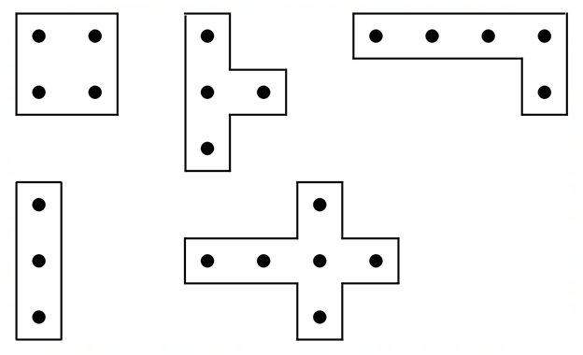

Optional rules
- Both students add an extra shape with four dots, but the coordinates must be connected using horizontal and vertical lines.
- Students do not need to say when a whole shape has been guessed.
- Each student chooses one special coordinate on their own board and labels it as a mirror. When the other player guesses this coordinate, it counts as multiple guesses at once. The guessed coordinate is marked as usual, and the four neighbouring coordinates one unit away in each direction (up, down, left and right) are also treated as guessed.
- Add a third or fourth player to the group. Each person guessing states a coordinate which applies to all of the other people, who are playing at once.

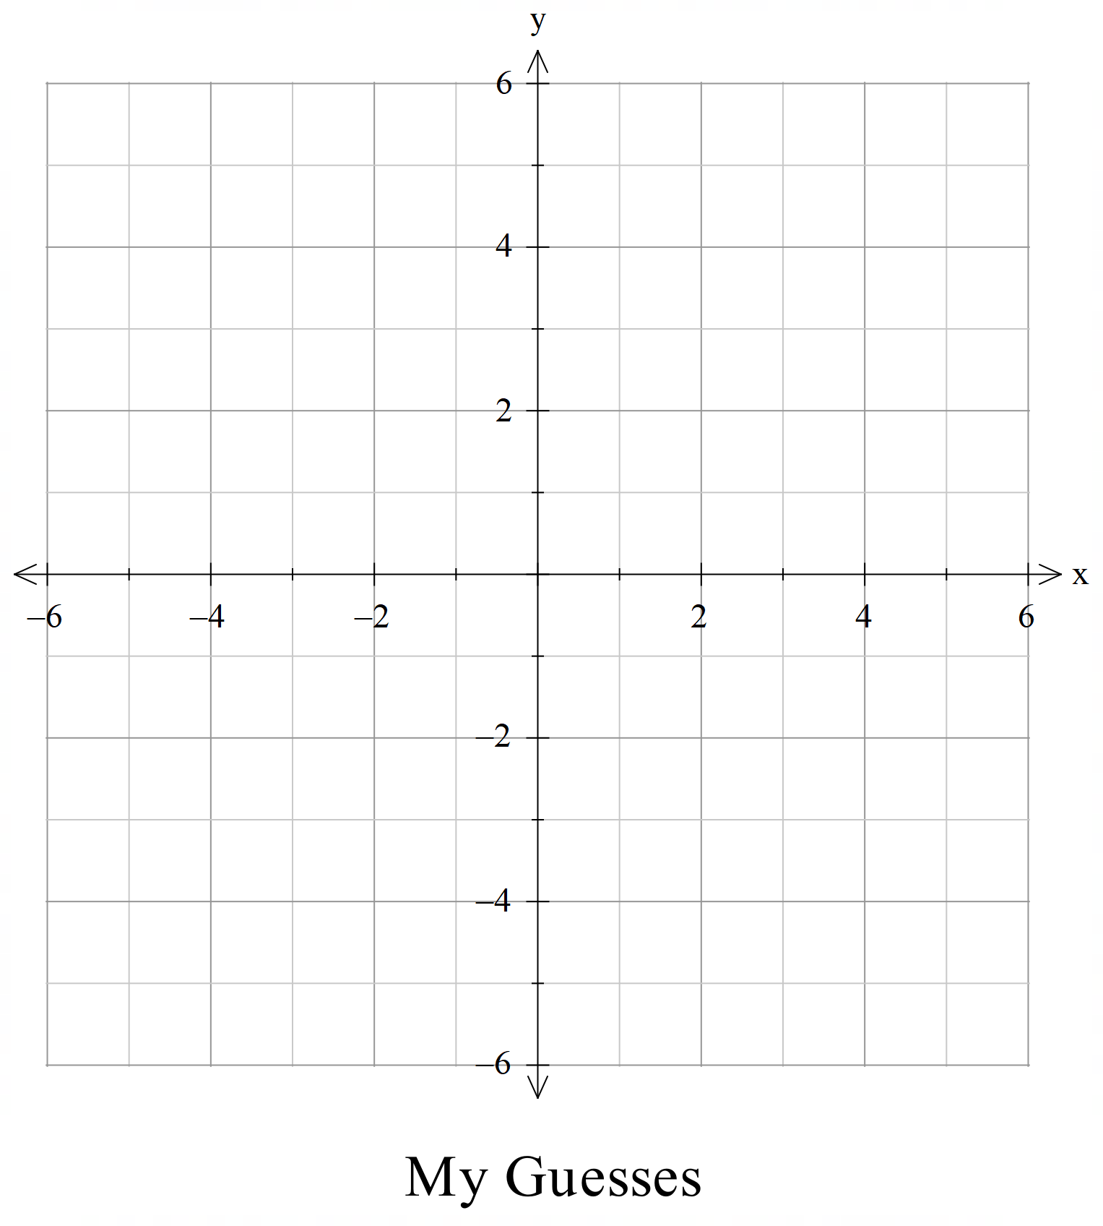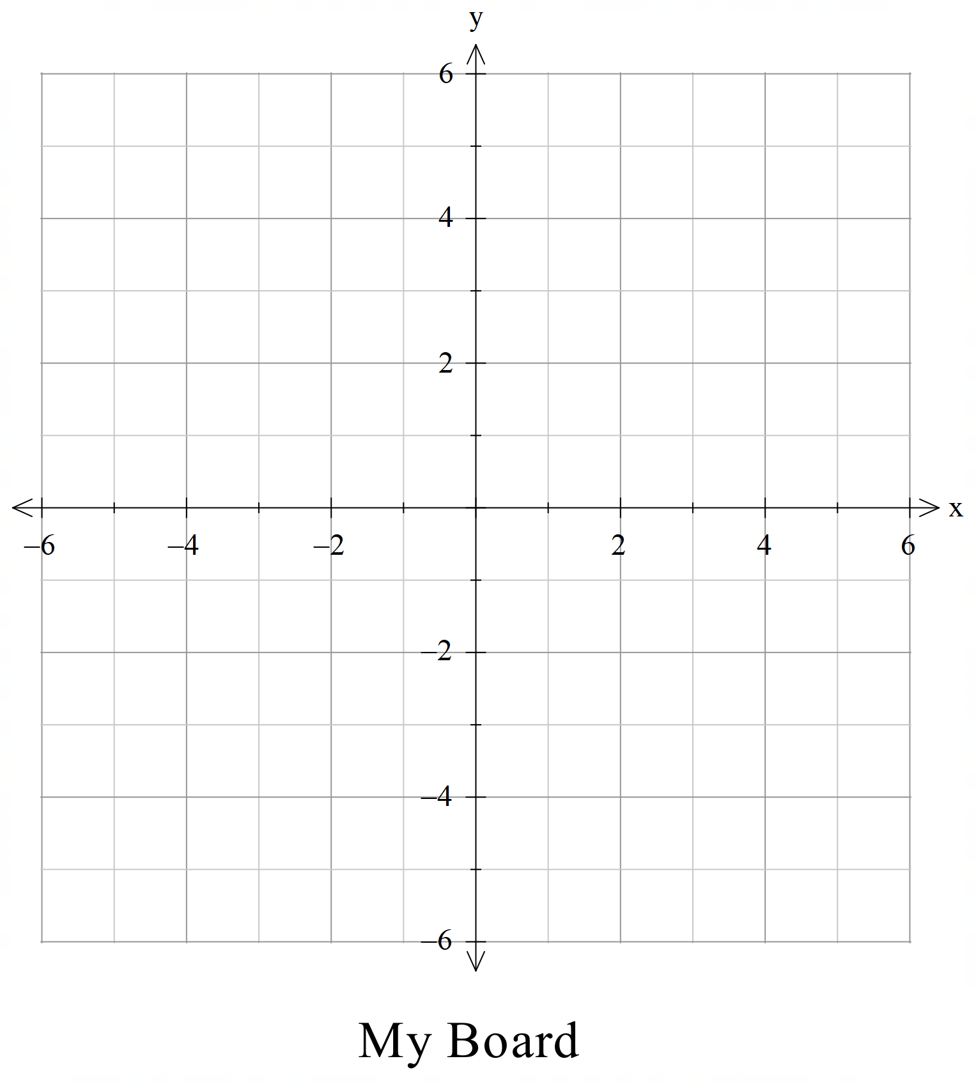

Cartesian plane and coordinates – midpoint

Lesson 2

Instructions for teacher
This activity provides students with an opportunity to explore the midpoint between coordinates in all four quadrants of the Cartesian plane. This activity allows students to investigate and explore, or be guided by the teacher as required. Encourage students to challenge themselves by working in all four quadrants, working with a mix of odd and/or even coordinates and trying to figure out the pattern.
Students may work together in groups to collect a larger amount of data quickly. It could be posed to the class that they try and determine the midpoints of every pair of coordinates. This could result in a discussion about the best approach to present all this information in an organised way.

Learning task: Cartesian plane and coordinates – midpoint
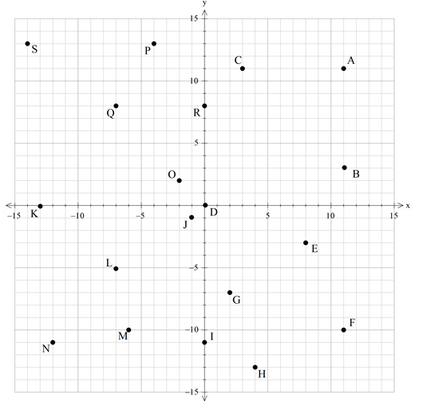
Choose at least 10 different pairs of coordinates and determine the midpoint for each pair. You can choose any points you are confident working with. Write the name and coordinates of each point you are using in the table provided. Once you are confident finding any midpoint by inspecting the graph, analyse coordinate pairs and their midpoints and see if there are any patterns in the numbers.

First point | x-coordinate | y-coordinate | Second point | x-coordinate | y-coordinate | Midpoint | x-coordinate | y-coordinate
A (11, 11) | 11 | 11 | B (11, 3) | 11 | 3 | (11, 7) | 11 | 7

How could you find the midpoint between any two coordinates?

Pythagoras proof template

Lesson 5

Instructions for teacher
The following is one example of a physical representation of Pythagoras’ theorem. Many representations exist; determine the best possible representation for the classroom context.

Learning task: Pythagoras proof template
Cut out the following and arrange to make a single square. In your workbook, describe the total area of your square.

Learning task: Pythagoras proof template
Cut out the following and arrange to make a single square. In your workbook, describe the total area of your square.

Right-angled triangles

Lesson 5

Instructions for teacher
This activity involves students measuring the sides of right-angled triangles and comparing the squares of these measurements to develop their own version of Pythagoras’ theorem. Students are to work in mixed-ability groups (3–4 students) to discover the relationship $a^{2}+b^{2}=c^{2}$.

Learning task: Right-angled triangles
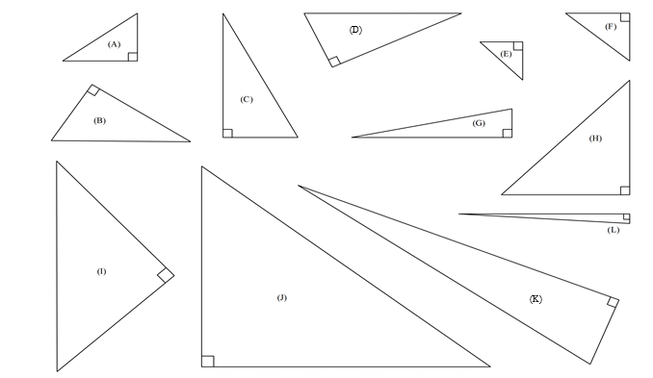
Measure the side lengths of the triangles to the nearest millimetre and record your measurements in the table. Once you have completed the table, find a rule that describes the relationship between side lengths of the triangle.

Triangle | Short leg (a) | Short leg (b) | Long leg (c) | $$a^{2}$$ | $$b^{2}$$ | $$c^{2}$$
A
B
C
D
E
F
G
H
I
J
K
L

Ski resort planning

Lesson 9

Instructions for teacher
This learning task allows students to investigate gradient in the context of a ski resort. Students start by ranking the ski slopes from the easiest to the hardest (1–10, where 1 is the easiest and 10 is the hardest) depending on the slope. From here, students develop a specific classification of slopes, comparing their length to their height.
After students have explored and defined the gradient in this context, they design their own ski resort, meeting certain classifications of slopes.
If required, allocate more time to the teaching and learning sequence to fully explore this activity.
Images to rank and classify slopes
Provide each group of students with a copy of each of the images on the following pages.

  SLOPE 1 |   SLOPE 2
  SLOPE 3 |   SLOPE 4
  SLOPE 5 | 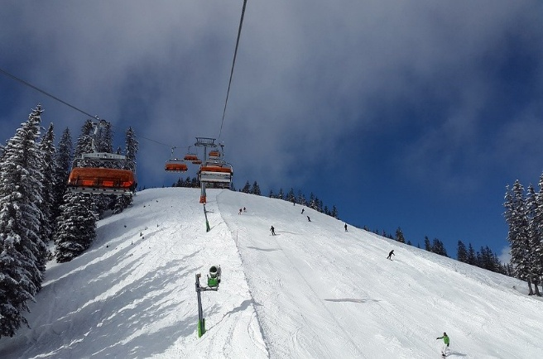  SLOPE 6
  SLOPE 7 | 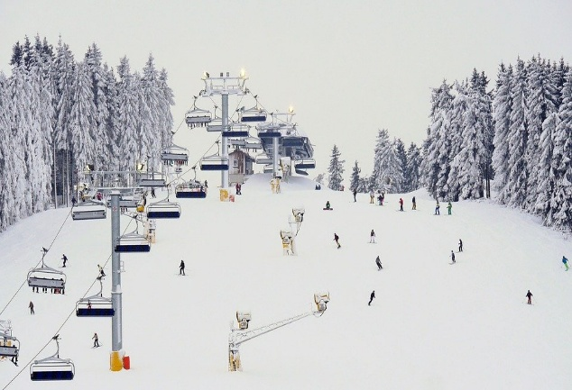  SLOPE 8
  SLOPE 9 | 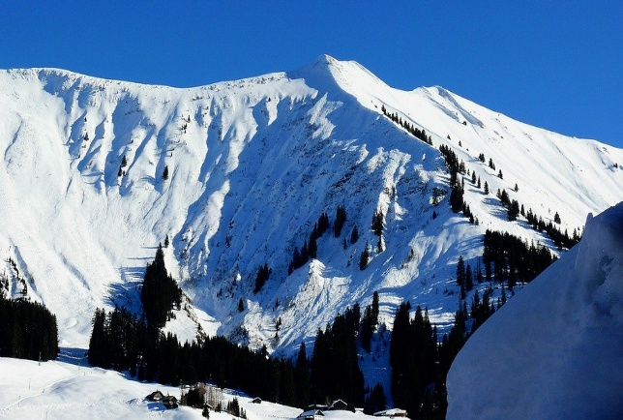  SLOPE 10

Learning task: Ski resort planning
In your group of up to four students, you will work together to create your own ski resort. To do this, you will need to determine the slope of different ski runs. This is called the gradient. Follow the steps in each part to create your own ski resort with a range of exciting ski runs.

Part 1: Classifying slopes
Your teacher will provide your group with 10 images of ski slopes. Sort the images into rank order according to their slopes (easiest to hardest). Number the images from 1–10 to reflect your rank order (1 being the easiest ski slope to 10 being the hardest ski slope).
- What are the key features of an easy slope?
- What are the key features of a hard slope?
- Is there a measurable feature which can be used to determine if a ski slope is easy, medium or hard?

Part 2: Features of a slope
Mathematicians like to be able to talk about things using numbers and measurements. In your group, determine all the possible features that could be used to talk about the white dashed ski slope shown below.

Identify all possible features of a slope that could be used to describe or measure how steep it is.
Compare the white ski slope (broken line) to the yellow ski slope (solid line). Decide which slope is more difficult to ski down and explain why. Use the features you identified to justify your answer. Are any of the features you identified not useful when comparing these two slopes?

Part 3: Measuring the slopes
Draw a line on each image that you think best represents its slope. Choose two points on the line you have drawn for each slope. Determine the vertical and horizontal distance between these points by measuring to the nearest mm on your images. Record this information in the table below.
Slope rank (easiest to hardest) | Vertical distance | Horizontal distance | Gradient  (complete later)
1
2
3
4
5
6
7
8
9
10
Do you think that you can get an accurate measurement of each of the slopes from your images? Explain.

What extra information would make your measurements more accurate?

What might be stopping your measurements from being as accurate as possible?

Part 4: A model of a ski slope
Below is a two-dimensional cross-section of a ski resort. Each of the 10 slopes is shown as a straight line on the diagram. Determine the coordinates of each point, indicated by the letters A to K. Record your results in the table below. Leave the gradient table blank for now. 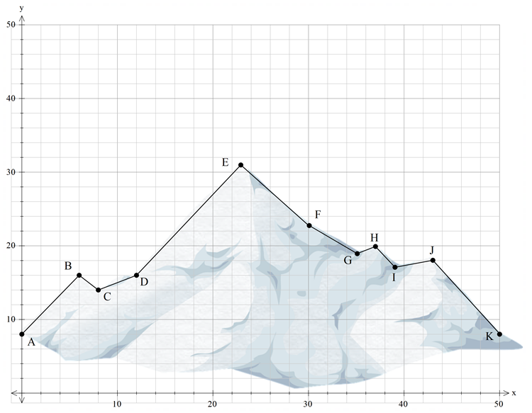

 | A | B | C | D | E | F | G | H | I | J | K
Coordinates

 | AB | BC | CD | DE | EF | FG | GH | HI | IJ | JK
Slope rank
Gradient

 | A | B | C | D | E | F | G | H | I | J | K
Coordinates

 | $$\overline{AB}$$ | $$\overline{BC}$$ | $$\overline{CD}$$ | $$\overline{DE}$$ | $$\overline{EF}$$ | $$\overline{FG}$$ | $$\overline{GH}$$ | $$\overline{HI}$$ | $$\overline{IJ}$$ | $$\overline{JK}$$
Gradient (complete later)

Part 5: The gradient
In mathematics, the gradient is the ratio of the vertical change compared to the horizontal change.
It is expressed as a fraction:
$\left[gradient=\frac{change in vertical distance}{change in horizontal distance}\right] or \left[m=\frac{rise}{run}\right]$. 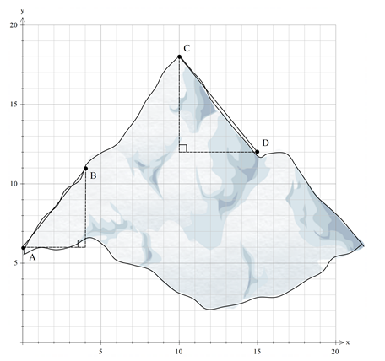
When this fraction is evaluated, it determines the steepness of a slope. Some examples are shown below.
Gradient $\overline{AB}$ = $\frac{change in vertical distance}{change in horizontal distance}$
= $\frac{5}{4}=1.25$
Note: this slope is going up when moving from left to right. This means the slope is positive.
Gradient $\overline{CD}$ = $\frac{change in vertical distance}{change in horizontal distance}$
=$-\frac{6}{5}=-1.2$
Note: this slope is going down when moving from left to right. This means the slope is negative.
If you need a ski lift to go left to right, the slope is positive. If you can ski down the slope to go left to right, the slope is negative.
Calculate the gradient for each of the slopes in Part 3 and Part 4. Remember to check if they are positive or negative.

Part 6: Design your own ski slopes
Use the Cartesian plane on the following page to design your own ski slopes, like those shown in Parts 4 and 5. You will need to consider the following points.
- You must have at least one easy, one medium and one hard slope. An easy slope has a gradient between zero and one, a medium slope has a gradient of exactly one and a hard slope has a gradient greater than one.
- You must have appropriate ski lifts to each slope. These cannot have a gradient greater than two.
- You must have one flat section for cross-country skiing. What is the gradient of this section?
- When you have completed your design, decide on an appropriate scale to convert your distances to real-life measurements. Label your real-life distances on your design.

Capital coordinates

Lesson 10: Distance between two points

Instructions for teacher
Students use a map with an approximate scale to determine the straight-line distance between each Australian capital city. Students determine the approximate coordinates of each capital city, determine the horizontal and vertical distances between these points and then determine the straight-line distance between these points.
Extension
Year 9 optional content: This activity is intended to help students develop their understanding of Pythagoras’ theorem into the distance formula, $d=\sqrt{{\left(x_{2}-x_{1}\right)}^{2}+{\left(y_{2}-y_{1}\right)}^{2}}$. Question and prompt students to guide their development of this formula, looking at how to calculate the horizontal or vertical distance using the coordinates.

Learning task: Capital coordinates
Use the map of Australia, Pythagoras’ theorem and the approximate locations of the capital cities to determine the straight-line distance between each city.
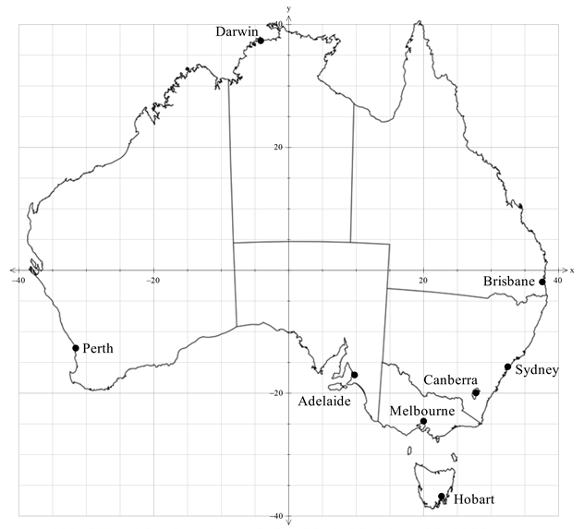
Coordinates:
Perth |  | Darwin |  | Hobart
Adelaide |  | Canberra |  | Brisbane
Melbourne |  | Sydney
Determine the distance between each city. Each unit on the map represents approximately 50 km in real life. Record your calculated distances in the white boxes and the actual distances in the shaded boxes of the table below.
 | Perth | Darwin | Adelaide | Melbourne | Canberra | Sydney | Hobart | Brisbane
Perth | ×
Darwin |  | ×
Adelaide |  |  | ×
Melbourne |  |  |  | ×
Canberra |  |  |  |  | ×
Sydney |  |  |  |  |  | ×
Hobart |  |  |  |  |  |  | ×
Brisbane |  |  |  |  |  |  |  | ×
Extension: What equation could you use to go straight from the coordinates of each location to the distance between the two points?

Cartesian plane template

Lesson 11

Instructions for teacher
This learning activity allows students to create their own mathematics problems. Organise students into mixed-ability groups of four. Each student starts by drawing a pair of points (two coordinate sets) on the top-left Cartesian plane, labelling them then passing the diagram to the student on their left. This student determines the midpoint, the gradient and the distance between these two points. They then add a new pair of points to the next Cartesian plane and pass the page to their left again. Each student will determine the midpoint, gradient and distance between the two points for each graph. Continue until the students solve one, then two, then three and then four problems.
When all four students have solved 10 problems, the group will compare their answers. Where there is a discrepancy, students work together to determine the correct approach.

Learning task: Cartesian plane template
Using the Cartesian planes on the next page, your group will create a set of practice questions. Starting with the top-left Cartesian plane, add two points, labelling the coordinates. Pass this to the person on your left. This person is to determine the midpoint, the gradient and the distance between these two points. They will show their working in their own workbook. Once they have calculated this, they will add two points to the next Cartesian plane and pass the page to the left again. This person will now determine the midpoint, the gradient and the distance between these two points for both completed Cartesian planes on the page. Repeat the process until every Cartesian plane on every page has two points drawn on them, and each student has solved at least 10 problems.

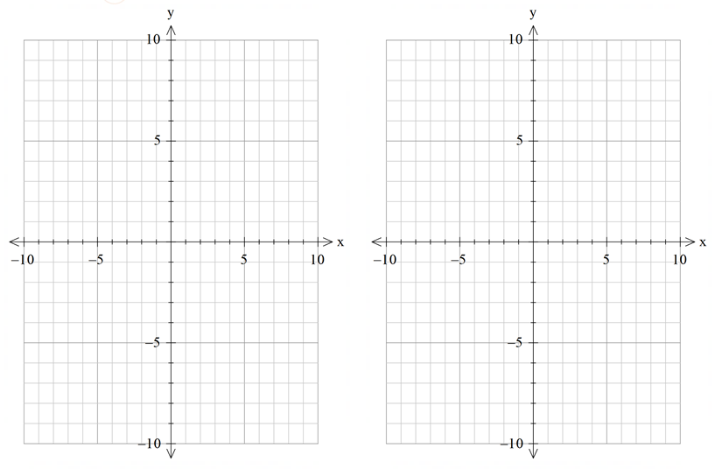

Appendix B
Formative assessment task
Pythagoras and beyond

Task details
Title Pythagoras and beyond
Description Students explore whether Pythagoras’ theorem holds true when using other shapes beyond the square formed on the sides of a right-angled triangle.
Ways of assessing Written work
Evidence to be collected Individual student work sample/work sheet
One-to-one interviews may be used at any time in the assessment process to record anecdotal evidence and to clarify student understanding
Suggested time Up to one lesson in class
Differentiation Teachers should differentiate their teaching and assessment to meet the specific learning needs of their students, based on their level of readiness to learn and their need to be challenged. Where appropriate, teachers may either scaffold or extend the scope of the assessment tasks.

Content descriptions

Number and algebra

Linear and non-linear patterns and relationships
- Use the Cartesian plane to explore finding the distance, gradient and midpoint between two points

Measurement and geometry

Two-dimensional space and structures
- Use Pythagoras’ theorem to determine the perimeter and area of shapes involving right-angled triangles, in both exact and decimal approximation form. Investigate and apply the converse of Pythagoras’ theorem to establish whether a triangle is right-angled

Task preparation

Prior learning
Students have completed seven lessons in their unit on coordinate geometry, including lessons on midpoints and distance between two points, as well as Pythagoras’ theorem.
Students have determined the area of shapes, such as triangles, circles and rectangles, in previous years.

Resources
- calculator
- ruler
- protractor

Pythagoras and beyond – Task sheet
On the following pages, you will find a series of diagrams involving right-angled triangles. You will be determining the areas of the shapes which are made using the sides of these triangles and compare them using your knowledge of Pythagoras’ theorem.
            - Triangle ABC is a right-angled triangle. (15 marks)
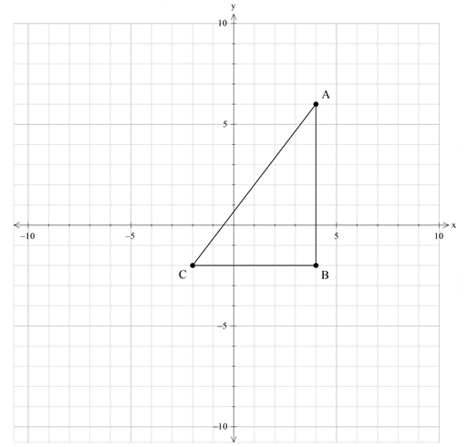
              - Determine the lengths of AB and BC. Use these to determine the length of AC. (4 marks)

              - Determine the midpoint of each of the line segments $\overline{AB}$, $\overline{BC}$ and $\overline{AC}$. Mark these as D, E and F respectively on the diagram in 1a. Show your working in the space provided. (3 marks)

              - Answer the following questions by adding to the diagram in 1a. and showing your working in the space provided.
          - Draw a square using line $\overline{AD}$ as the left-hand side.
          - Draw a second square using line $\overline{BD}$ as the left-hand side.
          - Repeat this process, drawing two squares along each side of the right-angled triangle. If you need help for the slanted squares, use the point $(-6, 1)$.
          - Calculate the area of each of the squares you have formed.
          - What do you notice about the relationship between the areas of the rectangles?
(8 marks)

2. Follow the steps to complete the diagram, then answer the questions. (10 marks)
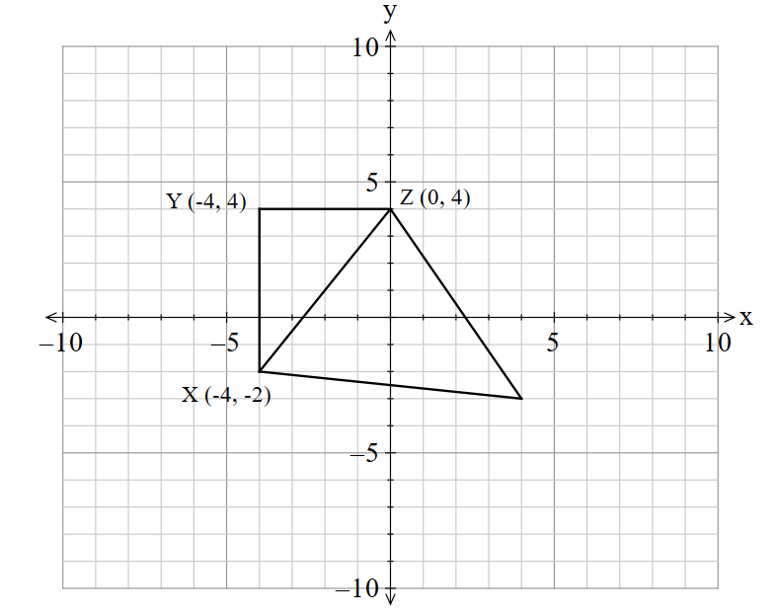
        - Triangle XYZ has been drawn on the Cartesian plane below.

        - Determine the lengths of XY and YZ. Use these to determine the length of XZ. Answer to 2 decimal places. (4 marks)

An isosceles triangle is drawn on each side of the right-angled triangle. The height of each triangle is the same as the base length.

c. Draw two more isosceles triangles on the diagram in 2a. using $\overline{XY}$ and $\overline{YZ }$ as the bases. Calculate the area of all three isosceles triangles. What do you notice about the relationship between the areas? (6 marks)

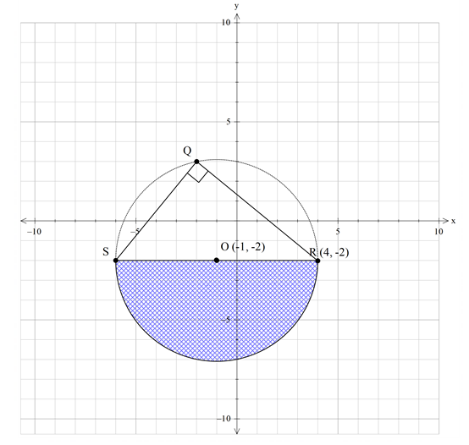
3. The following diagram has been created by drawing a circle with a centre of $(-1, -2)$and a radius of 5 units. Thales’ theorem states that a triangle created by the diameter and any point on the circumference of the circle always has a right angle. (15 marks)
a. Marcia looks at the diagram and assumes the point Q must be $(-2, 3)$. Use Pythagoras’ theorem to determine whether Marcia is correct. If she is incorrect, determine the correct $y$-coordinate of the point which intersects the circle’s circumference at $x=-2$. (4 marks)

Use the diagram to solve the problem below.
Semicircles have been drawn on each side of the right-angled triangle QRS (shown below), using each side as the diameter. Investigate whether the area of these semicircles satisfy a relationship similar to Pythagoras’ theorem. Show all working, leaving your answers in exact form where possible. Explain why this relationship does or does not work. (11 marks)
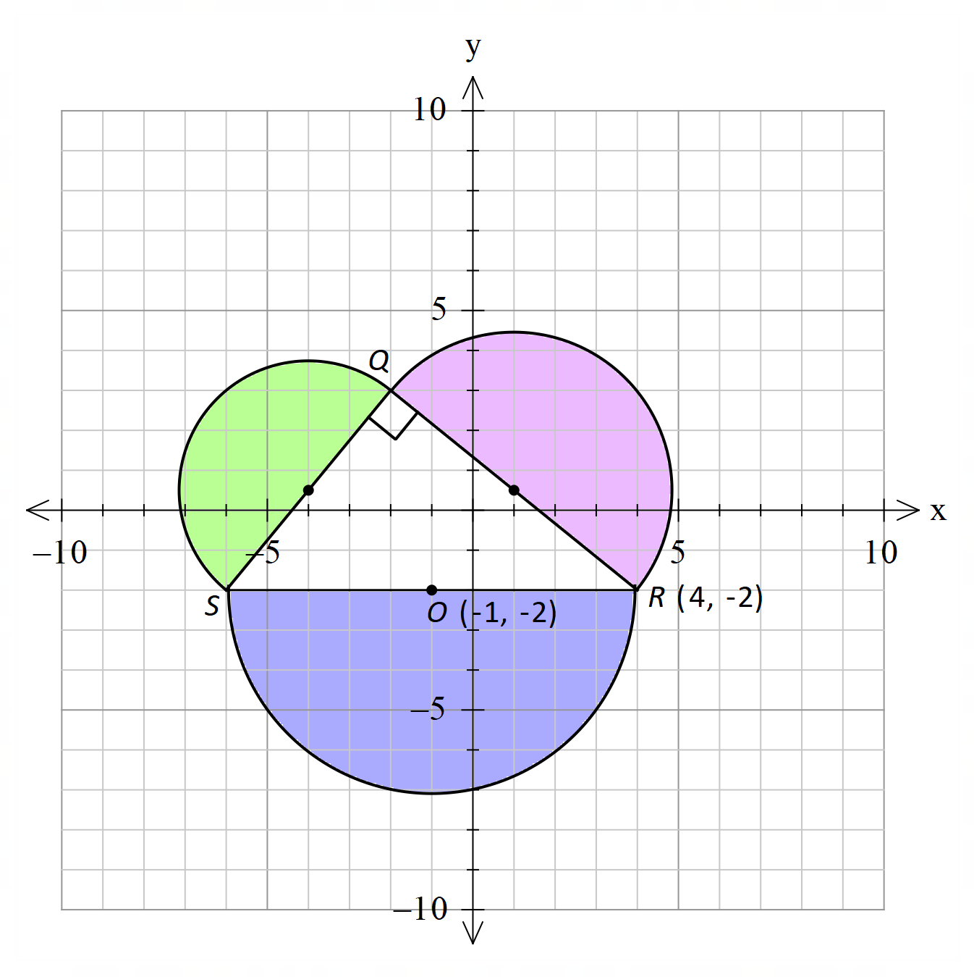

Formative assessment task – Checklist
Monitor each behaviour throughout the full scope of the assessment task. Rate each behaviour as follows: R – rarely, S – sometimes, C – consistently.
 | Determines vertical and horizontal distances between given points | Determines the midpoint of a line segment by inspection | Calculates the distance between two given points | Calculates the midpoint of a line segment | Uses Pythagoras' theorem to determine the length of the hypotenuse with diagram | Solves problems involving distance on the Cartesian plane | Draws a labelled diagram to model familiar situations | Applies Pythagoras' theorem to solve complex problems | Is the student above, at or below the expected standard?
Name

Marking key
Description | Marks
Question 1
              - $AB = 8 units$
$$BC = 6 units$$
$${AC}^{2}={AB}^{2}+{BC}^{2}$$
$$=8^{2}+6^{2}$$
$$AC=\sqrt{100}=10 units$$
Determines the horizontal length of BC and the vertical length of AB [1 mark each] | 2
Applies Pythagoras’ theorem to determine the length of AC | 1
Expresses the length of AC using appropriate units | 1
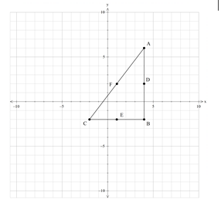
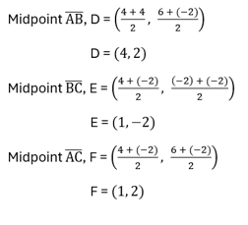
Note: the use of the midpoint formula is extension and not required for scoring full marks.
Labels the midpoint of AB, BC and AC on the diagram [1 mark each] | 3
Uses the midpoint formula to calculate the hypotenuse’s midpoint | yes/no
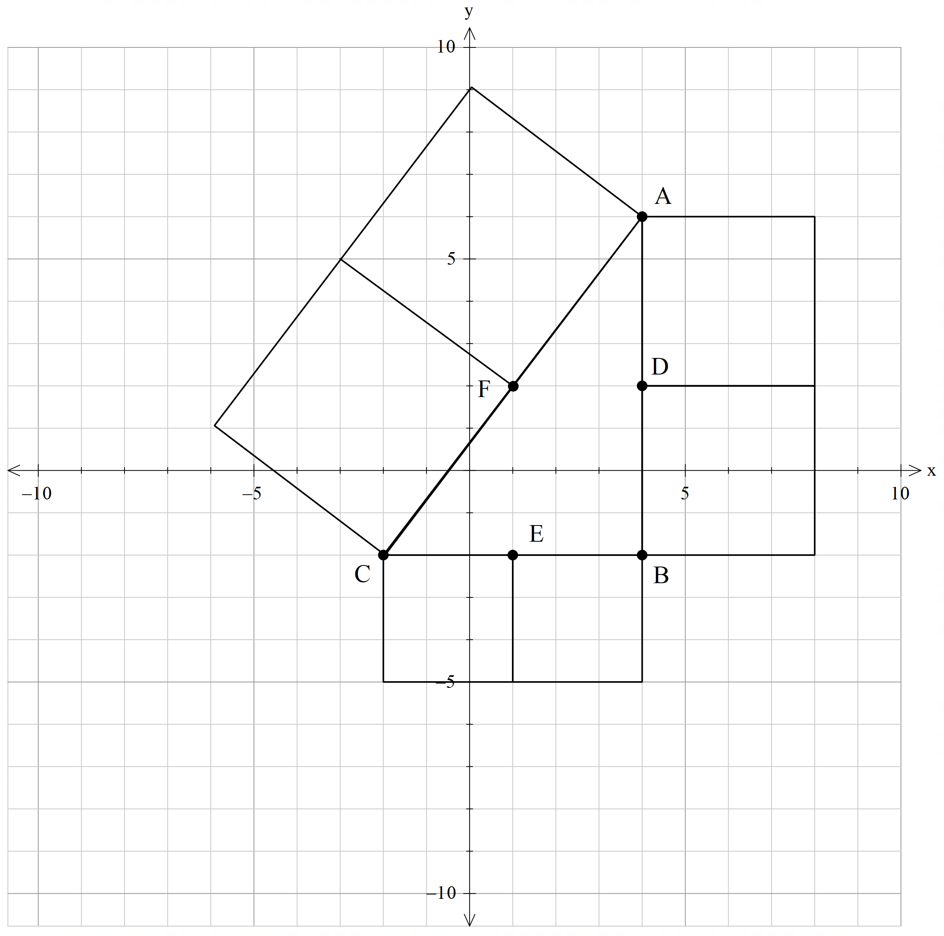$Area \left(right\right)$ $=L×W$
c.
$=4×8$ $=32 units^{2}$
$Area \left(bottom\right)$ $=L×W$ $=3×6$ $=18 units^{2}$
$Area \left(slant\right)$ $=L×W$ $=5×10$ $=50 units^{2}$

The sum of the area of two squares forming a rectangle on each of the short sides of a right-angled triangle is equal to the sum of the area of two squares forming a rectangle on the hypotenuse. This follows the general pattern of Pythagoras’ theorem.
Uses the midpoint to draw two squares on each side of the triangle [1 mark each side] | 3
Calculates the area of each pair of squares [1 mark each] | 3
Identifies that the area of the short side rectangles sums to the area of the hypotenuse's rectangle | 1
Compares this relationship to Pythagoras’ theorem | 1
Subtotal | /15
Question 2
$$XY=6 units$$
$$YZ=4 units$$
$$XZ^{2}=XY^{2}+YZ^{2}$$
$$XZ^{2}=6^{2}+4^{2}$$
$$XZ=\sqrt{52}=7.21 units$$
Identifies the horizontal length of YZ and the vertical length of XY [1 mark each] | 2
Applies Pythagoras’ theorem to determine the length of XZ | 1
Expresses the length of XZ using appropriate units | 1
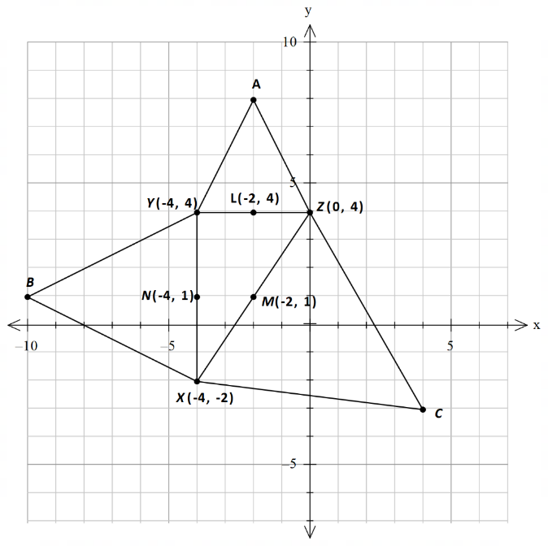
$$Area ∆AYZ=\frac{1}{2}×b×h$$ $=\frac{1}{2}×4×4$
$$=8 units^{2}$$
$$Area ∆BXY=\frac{1}{2}×b×h$$ $=\frac{1}{2}×6×6$ $=18 units^{2}$
$$Area ∆CXZ=\frac{1}{2}×b×h$$
$=\frac{1}{2}×7.21×7.21$
$=26 units^{2}$
Plots the apex of the other isosceles triangles at (−2, 8) and (−10, 1) and draws in the isosceles triangles [1 mark each] | 2
Calculates the area of each triangle using area = $\frac{1}{2}$ $×$ base $×$ height [1 mark each] | 3
Makes comparison between the sum of the area of the smaller triangles and the area of the largest triangle | 1
Subtotal | /10

Description | Marks
Question 3
Marcia is incorrect because the hypotenuse of triangle OQT is 5 units, so the height cannot be 5 units.
$OQ$ $=5 units$
$OT$ $=1 unitQT^{2}$ $=OQ^{2}-OT^{2}$
$QT^{2}$ $=5^{2}-1^{2}$
$QT$ $=\sqrt{24}=4.90$
Therefore, the coordinates of Q must be $(-2, -2+4.90)$ or $(-2, 2.9)$ and not $(-2, 3).$
Identifies that Marcia is not correct | 1
Provides adequate reasoning why Marcia is not correct | 1
Uses Pythagoras’ theorem to determine the vertical distance of line QT (height of triangle) | 1
Identifies the $y$-coordinate correctly | 1
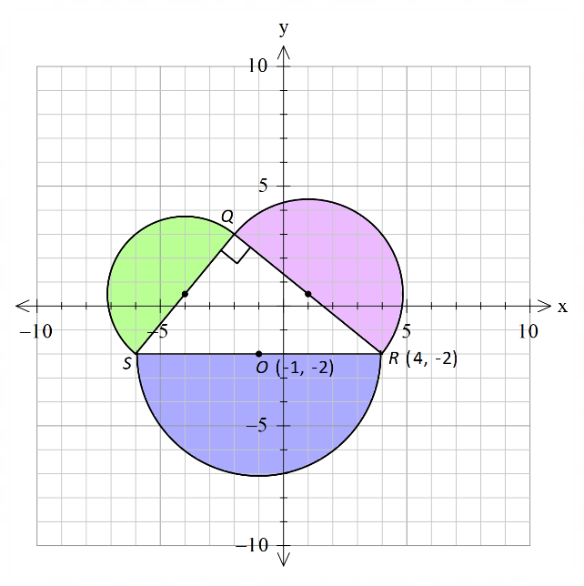
Green circle
Diameter $\text{= QS}$
$$QS^{2}=4^{2}+{4.90}^{2}$$
$$QS^{2}=16+24.01$$
$$QS=\sqrt{40.01}=6.32 units$$
Radius $=6.32÷2=3.16 units$
Area $= \frac{1}{2}×r^{2}×π$
$$=\frac{1}{2}×3.16^{2}×π$$
$$=5π=15.71 units^{2}$$
Red circle
Diameter $=QR$ Area
$QR^{2}=6^{2}+{4.90}^{2}$ $=\frac{1}{2}×r^{2}×π$
$QR^{2}=36+24.01$ $=\frac{1}{2}×3.87^{2}×π$
$QR=\sqrt{60.01}=7.75 units$ $=7.5π≈23.56 units^{2}$
Radius $=7.75÷2=3.87 units$
Blue circle
Diameter = SR = 10 units
Radius = 5 units
Area $=\frac{1}{2}×r^{2}×π$
$$=\frac{1}{2}×5^{2}×π$$
$$=12.5π=39.27 {units}^{2}$$

The sum of the area of the two semicircles drawn on the short sides of a right-angled triangle is equal to the sum of the area of the semicircle drawn on the hypotenuse. This follows the general pattern of Pythagoras’ theorem. The theorem is still true because to find the area of the semicircles, the radius is squared, and Pythagoras is based on square areas.
Uses Pythagoras’ theorem to calculate the lengths of QS and QR [1 mark each] | 2
Uses QT (height of triangle) value of 4.90 ($\sqrt{24}$) to calculate QS and QR | 1
Uses QS and QR to determine radius of circles [1 mark each] | 2
Calculates the area of the semicircles using the appropriate radius [1 mark each] | 3
Expresses answers as exact values | 1
Makes comparison between the sum of the area of the smaller semicircles and the area of the largest semicircle | 1
Relates this to Pythagoras’ theorem, discussing the squared radius in each case | 1
Subtotal | /15
Total | /40

Appendix C
Summative assessment task
Pythagoras’ TV-rem

Task details
Title Pythagoras’ TV-rem
Description Students investigate and apply coordinate geometry and Pythagoras’ theorem in relation to TV-related questions
Ways of assessing Written work
Evidence to be collected Individual student task sheet
Suggested time One lesson in class
Differentiation Teachers should differentiate their teaching and assessment to meet the specific learning needs of their students, based on their level of readiness to learn and their need to be challenged. Where appropriate, teachers may either scaffold or extend the scope of the assessment tasks.

Content descriptions

Number and algebra

Linear and non-linear patterns and relationships
- Use the Cartesian plane to explore finding the distance, gradient and midpoint between two points

Measurement and geometry
Two-dimensional space and structures
- Use Pythagoras’ theorem to determine the perimeter and area of shapes involving right-angled triangles, in both exact and decimal approximation form. Investigate and apply the converse of Pythagoras’ theorem to establish whether a triangle is right-angled

Task preparation

Prior learning
Students are in the last week of their unit on Number and algebra, and Measurement and geometry. Students have developed their skills to determine the midpoint of two points located on the Cartesian plane, the gradient of two points on the Cartesian plane and the distance between two points using Pythagoras’ theorem.

Resources
- calculator
- ruler

Instructions to teacher
This summative assessment is in the form of a response task. Students work individually under test conditions to respond to the prompts to demonstrate their level of understanding of Pythagoras’ theorem and coordinate geometry. The questions allow students to explore the applications of Pythagoras’ theorem in relation to the making and selling of televisions.
Provide support to students where required and indicate this on their work. For students who have low literacy skills, scaffold questions 3 and 4 to allow them to access the mathematics appropriately.
This assessment provides opportunities for students to demonstrate a range of specific skills. The way in which students apply these skills will help to determine the achievement of students in this unit. Observations of how the students have achieved their solution, rather than the solution itself, allow for a detailed evaluation of their behaviours and achievement within this unit.

Pythagoras’ TV-rem – Task sheet
      - Televisions have an advertised size, which is determined by the length from one corner of the screen to the opposite corner (rounded to the nearest cm). This measurement is of the screen only and does not include any part of the plastic frame which holds the screen in place and houses the electronic components.
Determine the advertised size, the width or the height as required of the television screens pictured. (5 marks)
              - Determine the advertised size of this TV. (1 mark)
105 cm
60 cm
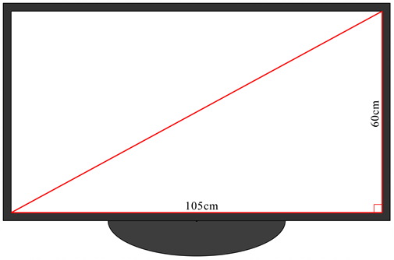

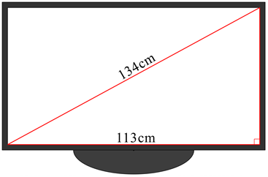
              - Determine the height of this TV. (2 marks)
134 cm
113 cm

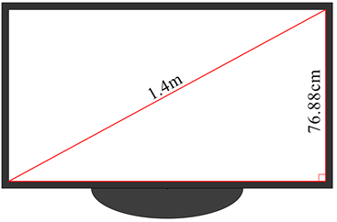
              - Determine the width of this TV. (2 marks)
1.4 m
76.88 cm

2. Follow the instructions below. (17 marks)
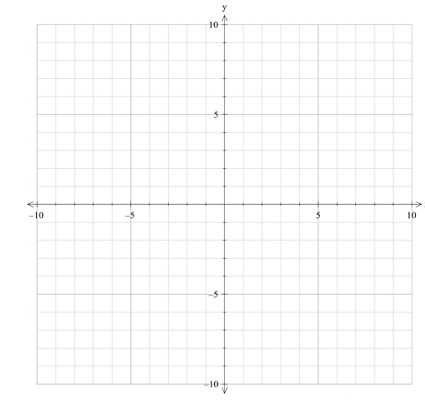
a. Plot A $(-4, 6),$ B $(6, 6)$, C $(2, -2)$and D $(-8, -2)$, then draw the resulting parallelogram. (2 marks)

b. Plot and label E, the midpoint of $\overline{BC}$, then determine the length and gradient of $\overline{DE}$.
(4 marks)

c. Point E is also the midpoint of $\overline{DF}$. Determine the coordinates of F. Explain how you got these coordinates. (3 marks)

d. When F is connected to B and E, the points form an irregular pentagon, AFECD. What is the perimeter of this pentagon? (8 marks)

3. The blueprint of a television has been placed on a Cartesian plane, with each unit representing 1 cm. The power cord and the TV aerial cord at the back of the television need to be attached appropriately. (14 marks)
- To attach the aerial cord, the midpoint of the top edge of the television screen is marked ‘C’. The aerial cord is then connected at the midpoint (A) of the line segment joining C to the bottom right corner of the television.
- To attach the power cord, the midpoint of the line segment from C to the top right corner is marked ‘D’. A line is then drawn from D to the bottom right corner of the television. The midpoint (P) of this line is where the power cord is placed.
a. Represent the location of these two cords on the diagram below, clearly labelling all relevant points. Show any calculations in the space provided below. (6 marks)
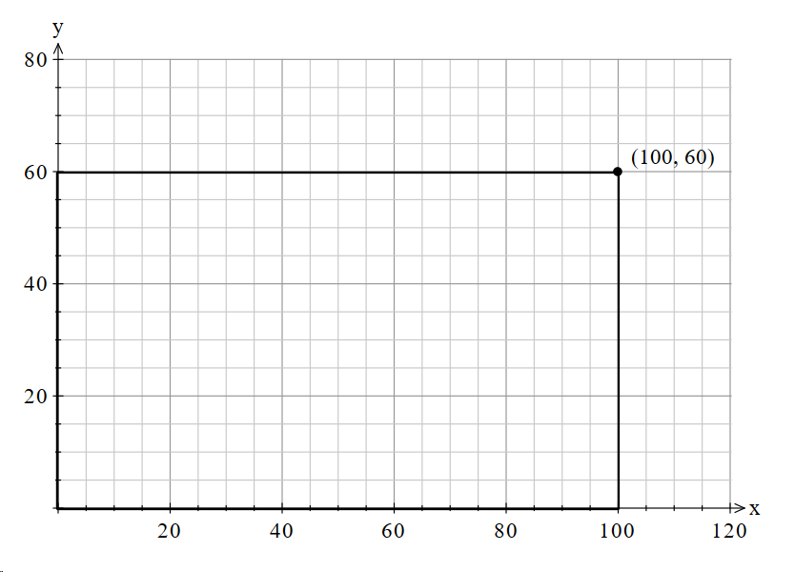

b. The power cord connects in a straight line inside the television from P to a light at $\left(0, 0\right),$which indicates whether the power is on or off. Determine the length of the power cord inside the television. (2 marks)

c. Is the triangle formed by $(0, 0)$, $(100, 0)$ and the attachment point of your power cord (P) a right-angled triangle? Support your answer with appropriate evidence. (6 marks)

4. Televisions are comprised of three main parts: (18 marks)
- the glass screen
- the plastic casing
- the electronics.
These parts are all made in separate factories and then transported, using the roads shown in the diagram below, to a warehouse located at (8, 8). The manufacturers want to move the existing warehouse, so it reduces the total distance travelled for the component parts. To do this, they will relocate the warehouse to location A, B, C or D.
              - Determine the coordinates of point M, the midpoint of the electronics and plastics factories.
(2 marks)
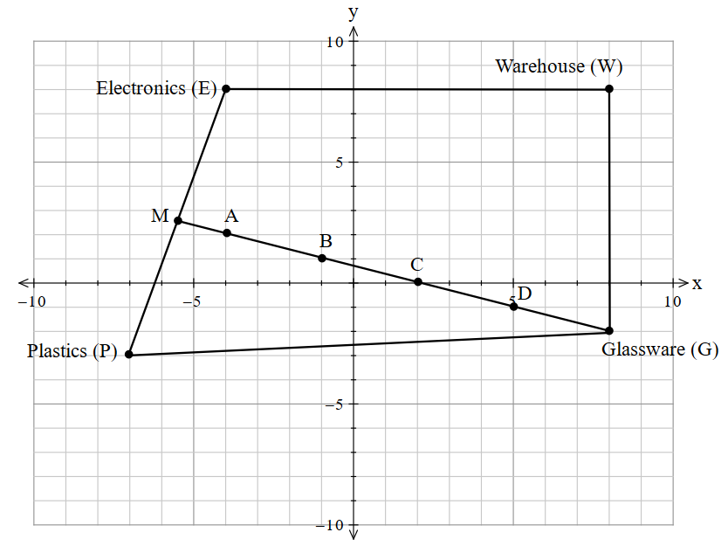

  - Calculate the gradient and length of the line from point M to the glassware factory. (3 marks)

  - Determine which new location (A, B, C or D) will provide the shortest distance to travel from all the factories to the warehouse. Justify your choice. (12 marks)

Marking key
Description | Marks
Question 1
        - $Advertised size^{2}={60}^{2}+105^{2}=3600+11 025$
$$Advertised size=120.93 cm ≈121 cm$$
        - ${Height}^{2}=134^{2}-{113}^{2}=17 956-12 769$
$Height=72.02 cm ≈72 cm$
        - ${Width}^{2}=140^{2}-{76.88}^{2}=19 600-5910.53$
$$Width=117.00 cm≈117 cm$$
Calculates the length of the hypotenuse from a diagram using Pythagoras’ theorem | 1
Identifies other side lengths are found through using subtraction with Pythagoras’ theorem | 1
Calculates the side length other than the hypotenuse using Pythagoras’ theorem [1 mark each] | 2
Rounds answers appropriately | 1
Subtotal | /5
Question 2
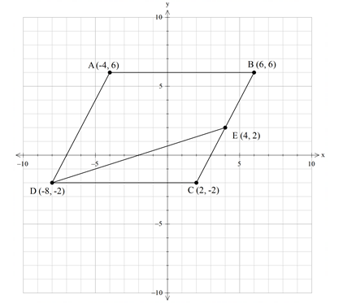
Plots points A, B, C and D accurately | 1
Draws parallelogram | 1
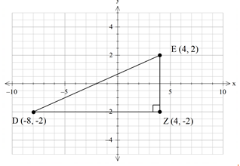
$$Midpoint of BC, E =(4, 2)$$
(shown on previous page)
$$DE^{2}=DZ^{2}+EZ^{2}$$
$$DE^{2}=\sqrt{{\left( 4-\left(-8\right)\right)}^{2}+{\left(2-\left(-2\right)\right)}^{2}}$$
$$DE=\sqrt{160}=12.65 units$$
$$Gradient of \overline{DE}=\frac{4}{12}=\frac{1}{3}$$
Clearly plots and labels point E | 1
Identifies vertical and horizontal change from D to E | 1
Calculates length DE using distance formula or Pythagoras’ theorem | 1
Calculates gradient of DE using vertical and horizontal change | 1
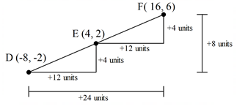
$$\left(4, 2\right)= \left(\frac{-8+x}{2},\frac{-2+y}{2}\right)$$
$$8=-8+x$$
$$x=16$$
$$4=-2+y$$
$$y=6$$
∴ $F=(16, 6)$ or E is 12 units across and 4 up from D, so F will be 12 units across and 4 up from E.
Note: using the midpoint formula is optional content. Students may show other appropriate calculations or reasoning to determine the midpoint.
Uses an appropriate approach to determine the x-coordinate of F | 1
Uses an appropriate approach to determine the y-coordinate of F | 1
Explains their answer, justifying the mathematics used (any appropriate approach) | 1
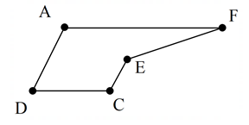
Length $AF$ = 20 units
Length $DC$ = 10 units
Length $EF$ = $DE$ = 12.65 units
Length $CE^{2}=2^{2}+4^{2}=20$
Length $CE$ = $\sqrt{20}=4.47 units$
Length $AD$ = $2×CE$= 2 $×$ 4.47 = 8.94
Total perimeter = 20 + 10 + 12.65 + 4.47 + 8.94 $≈$ 56.06 units
Determines the length of horizontal lines, AF and DC [1 mark each] | 2
Determines the length of EF using an appropriate method | 1
Determines the length of CE using Pythagoras’ theorem or distance formula (optional) | 1
Determines the length of AD using an appropriate method | 1
Recognises that DE = EF, or that CE is $\frac{1}{2}$ of AD, using this to calculate the lengths | 1
Calculates the total perimeter using all previous measurements | 1
Includes appropriate units and rounding | 1
Subtotal | /17
Question 3
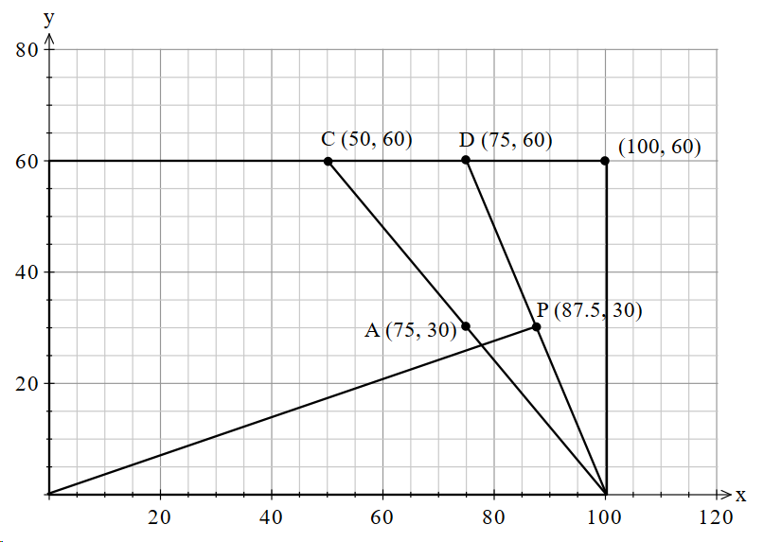
Aerial cord (A) $=(75, 30)$

Power cord (P)$=\left(87.5, 30\right)$

Determines the location of C and D from the statement [1 mark each] | 2
Locates the midpoint of both line segments (graphically or algebraically) [1 mark each] | 2
States the coordinates of the aerial cord (A) [1 mark] and the power cord (P) [1 mark] | 2
Coordinates of the light: (0, 0).
Coordinates of the power cord: (87.5, 30).
$$Length^{2}=87.5^{2}+{30}^{2}$$
$$Length^{2}=7656.25+900$$
$$Length =\sqrt{8556.25}=92.5 cm$$

Identifies the vertical and horizontal components of the right-angled triangle formed | 1
Uses Pythagoras’ theorem to calculate the length | 1
c.
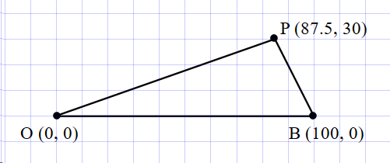
If right-angled, then
$$OB^{2}=OP^{2}+PB^{2}$$
$$OP=92.5 cm \left(from question b.\right)$$
$$PB^{2}={12.5}^{2}+30^{2}$$
$$PB=\sqrt{1056.25}=32.5 cm$$
$$0B^{2}=92.5^{2}+{32.5}^{2}$$
$$0B^{2}=9612.5$$
$$OB=\sqrt{9612.5}=98.04 cm≠100 cm$$
Therefore, △OPB is not a right-angled triangle.
Identifies Pythagoras’ theorem required to check for a right angle | 1
Identifies OB as longest side | 1
Determines the length of PB | 1
Determines the length of OB | 1
Compares calculated length of OB to actual length | 1
Identifies the triangle is not right-angled | 1
Subtotal | /14
Question 4
Coordinates of M $=\left(-5.5, 2.5\right)$
Identifies the x-coordinate of the midpoint | 1
Identifies the y-coordinate of the midpoint | 1
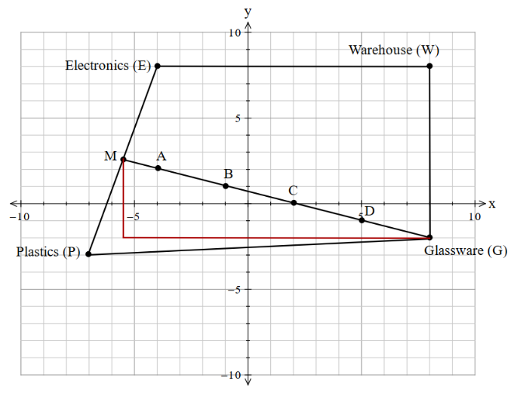
$Gradient \overline{MG}$ = $\frac{rise}{run}$
$$=\frac{-4.5}{13.5}$$
$$=-\frac{1}{3}$$
$$Length {MG}^{2}=4.5^{2}+{13.5}^{2}$$
$$=20.25+182.25$$
$$=202.5$$
$$MG=\sqrt{202.5}$$
$$=14.23 units$$
Determines magnitude of gradient | 1
Determines direction of gradient | 1
Calculates the length of $\overline{MG}$ using an appropriate method | 1
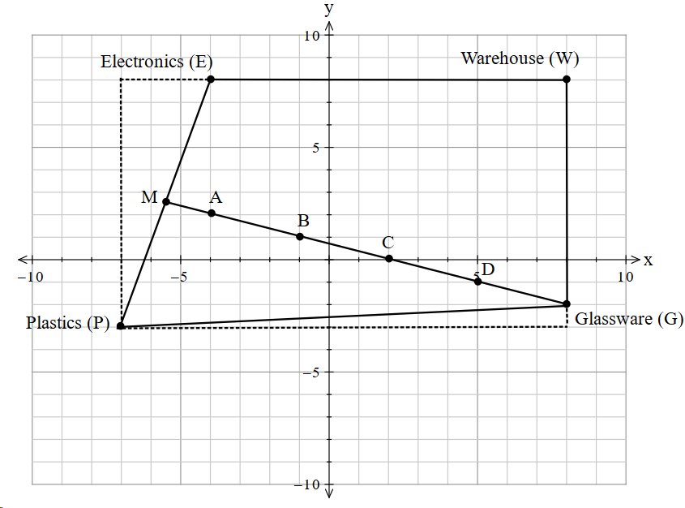
Need to check total distance if the warehouse is moved to location A, B, C or D

New warehouse location A
Total distance = EA + PA + GA
EA = EM + MA
EM = $\sqrt{{1.5}^{2}+{5.5}^{2}}$ = 5.70 units
MA = $\sqrt{{1.5}^{2}+{0.5}^{2}}$ = 1.58 units
∴ EA = 5.70 + 1.58 = 7.28 units
PA = EA as M represents the midpoint
∴ PA = 7.28 units
GA = $\sqrt{4^{2}+{12}^{2}}$ = 12.65 units
Total distance = 7.28 + 7.28 + 12.65 = 27.21 units
Using reasoning to explain that moving the warehouse from A to B will increase the distance travelled, as AB will need to be travelled twice (once from the Electronics factory and once from the Plastics factory). In comparison, the distance of travel from the Glassware factory has only been reduced by one lot of AB. Therefore, total distance to travel if the warehouse moves to B will be greater than A.

New warehouse location B
or
Total distance = EB + PB + GB
EB = EM + MB
MB = $\sqrt{{4.5}^{2}+{1.5}^{2}}$ = 4.74 units
EM = 5.70 units
∴ EB = 4.74 + 5.70 = 10.44 units
PB = EB as M represents the midpoint
∴ PB = 10.44 units
GB = $\sqrt{3^{2}+9^{2}}$ = 9.49 units
Total distance = 10.44 + 10.44 + 9.49 = 30.37 units

New warehouse location C
Using reasoning similar to above to explain that moving the warehouse from B to C will increase the distance travelled.

or
Total distance = EC + PC + GC
EC = EM + MC
EC = 13.61 units
PC = EC = 13.61 units
GC = $\sqrt{2^{2}+6^{2}}$ = 6.32 units
Total distance = 13.61 + 13.61 + 6.32 = 33.54 units
New warehouse location D
or
Using reasoning similar to above to explain that moving the warehouse from C to D will increase the distance travelled.

Total distance = ED + PD + GD
ED = PD = 16.77 units
GD = 3.16 units
Total distance = 16.77 + 16.77 + 3.16 = 36.7 units

The best location with the shortest distance to travel between all factory locations to the new warehouse is A = 27.21 units.
Determines the distance from the Electronics factory to a chosen location (A, B, C or D) | 1
Determines the distance from the Plastics factory to a chosen location | 1
Determines the distance from the Glassware factory to a chosen location | 1
Determines the total distance from all factories to a chosen location | 1
Determines the distance from the Electronics and Plastics factories to a second location  Or  Explains the change in distance from the Electronics and Plastics factories to the warehouse if the warehouse is moved to a second location | 1
Determines the distance from the Glassware factory to a second location  Or  Explains the change in distance from the Glassware factory to the warehouse if the warehouse is moved to a second location | 1
Determines the total distance from all factories to a second location  Or  Explains the total change in distance if the warehouse is moved to a second location | 1
Determines the distance from each factory to a third location  Or  Explains reasoning for the change in distance for a third location | 1
Determines the total distance from all factories to a third location  Or  Explains the total change in distance if the warehouse is moved to a third location | 1
Determines the distance from each factory to a fourth location  Or  Explains reasoning for the change in distance for a fourth location | 1
Determines the total distance from all factories to a fourth location  Or  Explains the total change in distance if the warehouse is moved to a fourth location | 1
Concludes that the best location for the warehouse will be at point A | 1
Subtotal | /17
Total | /53

Acknowledgements
Lesson sequence
Lesson 4 Street map adapted from: OpenStreetMap. (n.d.). [Graphic of a street map in Wembley, Perth]. Retrieved October, 2025, from https://www.openstreetmap.org/#map=17/-31.93738/115.81433
Used under an Open Data Commons Open Database licence.
Appendix A Slope 1 image adapted from: Vieli, J. (2019). [Photograph of a snowy mountainscape with trees and a blue sky]. Retrieved October, 2025, from https://pixabay.com/photos/winter-nature-trees-season-4680713/
Slope 2 image adapted from: Pixabay. (2021). [Photograph of two skiers in the snow]. Retrieved October, 2025, from https://pixabay.com/photos/cross-country-skiing-skiers-ski-5908416/
Slope 3 image adapted from: van de Wal, R. (2015). [Photograph of a person wearing white and red goggles skiing downhill]. Retrieved October, 2025, from https://pixabay.com/photos/skiing-girl-sun-snow-winter-ski-1723857/
Slope 4 image adapted from: miaalthoff. (2017). [Photograph of a person wearing a blue and yellow ski suit skiing downhill]. Retrieved October, 2025, from https://pixabay.com/photos/snow-winter-sport-skier-mountain-3090067/
Slope 5 image adapted from: Carli, M. (2017). [Photograph of tall trees on a snowy slope]. Retrieved October, 2025, from https://pixabay.com/photos/winter-snow-snow-covered-wintry-2949606/
Slope 6 image adapted from: Simon. (2017). [Photograph of a chairlift on a steep snowy slope]. Retrieved October, 2025, from https://pixabay.com/photos/chairlift-alpine-skiing-skiing-ski-2080001/
Slope 7 image adapted from: [Photograph of a group of people hiking in the snow]. (n.d.). Retrieved October, 2025, from https://www.pickpik.com/backcountry-skiiing-winter-hike-hike-winter-cold-run-149647
Slope 8 image adapted from: Westendarp, E. (2017). [Photograph of a chairlift and people skiing in the snow]. Retrieved October, 2025, from https://pixabay.com/photos/winterberg-north-slope-hochsauerland-1961027/
Slope 9 image adapted from: Kofler, P. (2016). [Photograph of a person skiing downhill past a building in the snow]. Retrieved October, 2025, from https://pixabay.com/photos/skier-ski-piste-to-ski-winter-1274666/
Slope 10 image adapted from: moritz320. (2016). [Photograph of a snowy mountain with trees]. Retrieved October, 2025, from https://pixabay.com/photos/winter-mountains-snow-1159196/
Part 2: Features of a slope photograph adapted from: Walkerssk. (2016). [Photograph of a snowy mountainscape with drawn slope lines]. Retrieved October, 2025, from https://pixabay.com/photos/alps-mountains-the-snow-winter-1368034/
Part 4: A model of a ski slope image adapted from: Glitch. (2013). Alpine Landscape Cone top Snow 01b Al1 [Clipart]. Retrieved October, 2025, from https://openclipart.org/detail/208716/alpine-landscape-cone-top-snow-01b-al1
Part 5: The gradient image adapted from: Glitch. (2013). Alpine Landscape Cone top Snow 01a Al1 [Clipart]. Retrieved October, 2025, from https://openclipart.org/detail/208715/alpine-landscape-cone-top-snow-01a-al1
Map of Australia adapted from: Clker-Free-Vector-Images. (2012). [Outline of Australia with state/territory borders]. Retrieved June, 2021, from https://pixabay.com/vectors/australia-continent-geography-map-23497/


sss

