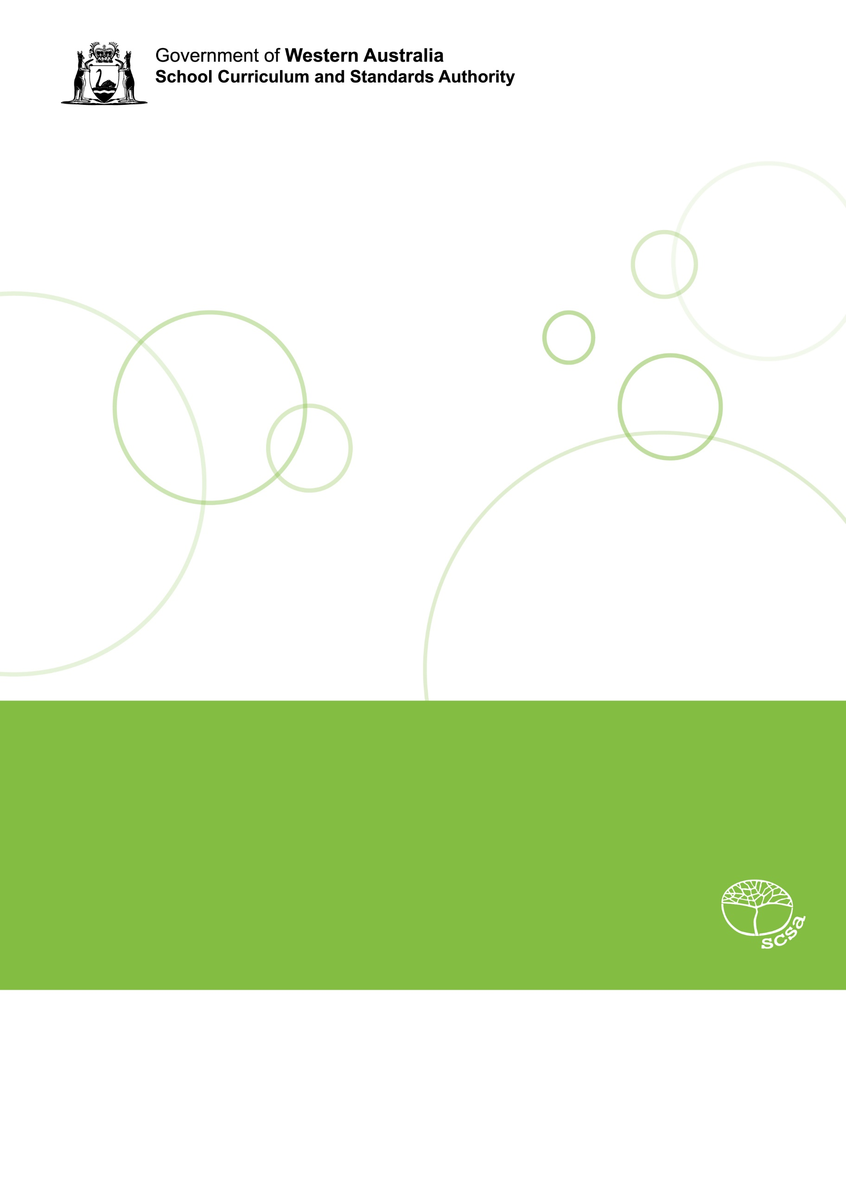
Science: Chemical sciences
Teaching, learning and assessment exemplar
Year 7
Separating mixtures
Acknowledgement of Country
Kaya. The School Curriculum and Standards Authority (the Authority) acknowledges that our offices are on Whadjuk Noongar boodjar and that we deliver our services on the country of many traditional custodians and language groups throughout Western Australia. The Authority acknowledges the traditional custodians throughout Western Australia and their continuing connection to land, waters and community. We offer our respect to Elders past and present.
Background
This teaching, learning and assessment exemplar (the exemplar) has been developed by the School Curriculum and Standards Authority (the Authority) as part of the School Education Act Employees (Teachers and Administrators) General Agreement 2017 (Clause 61.1–61.3).
Copyright
© School Curriculum and Standards Authority, 2025
This document – apart from any third-party copyright material contained in it – may be freely copied, or communicated on an intranet, for non-commercial purposes in educational institutions, provided that the School Curriculum and Standards Authority (the Authority) is acknowledged as the copyright owner, and that the Authority’s moral rights are not infringed.
Copying or communication for any other purpose can be done only within the terms of the Copyright Act 1968 or with prior written permission of the Authority. Copying or communication of any third-party copyright material can be done only within the terms of the Copyright Act 1968 or with permission of the copyright owners.
Any content in this document that has been derived from the Australian Curriculum may be used under the terms of the Creative Commons Attribution 4.0 International licence.
Disclaimer
Any resources such as texts, websites and so on that may be referred to in this document are provided as examples of resources that teachers can use to support their learning programs. Their inclusion does not imply that they are mandatory or that they are the only resources relevant to the course. Teachers must exercise their professional judgement as to the appropriateness of any they may wish to use.
Contents
The Western Australian Curriculum 1
The Science curriculum 1
This exemplar 2
Catering for diversity 2
Safety 2
Using this exemplar 3
Links to electronic resources 3
Best practice 4
Teaching and learning 4
Assessing 4
Reflecting 4
What’s in the mixture? 5
Year level description 6
Achievement standard 7
Lessons 1–14 9
Appendix A 31
Appendix B 43

The Western Australian Curriculum
The Western Australian Curriculum and Assessment Outline (the Outline – https://k10outline.scsa.wa.edu.au/) sets out the mandated curriculum, guiding principles for teaching, learning and assessment, and support for teachers in their assessment and reporting of student achievement. The Outline recognises that all students in Australian schools, or international schools implementing the Western Australian Curriculum, are entitled to be given access to the eight learning areas described in the Alice Springs (Mparntwe) Education Declaration, December 2019.

The Science curriculum
The mandated curriculum is presented in the year level syllabus documents.
The Science curriculum delivers a sequential and age-appropriate progression of learning with the following key elements:
- a year level description that provides an overview of the context for teaching and learning in
the year
- a series of content descriptions, populated through strands and sub-strands, that sets out the knowledge, understanding and skills that teachers are expected to teach and students are expected to learn
- an achievement standard that describes an expected level that the majority of students are achieving by the end of a given year of schooling. An achievement standard describes the quality of learning (e.g. the depth of conceptual understanding and the sophistication of skills) that would indicate the student is well-placed to commence the learning required in the next year.

This exemplar
This Science exemplar articulates the content in the Outline and approaches to teaching, learning and assessment reflective of the Principles of Teaching, Learning and Assessment. This exemplar demonstrates a sequence of teaching and learning, including suggested assessment points, for 14 lessons.

Catering for diversity
This exemplar provides a suggested approach for the delivery of the curriculum and reflects the rationale, aims and content structure of the learning area. When planning the learning experiences, consideration has been given to ensuring that they are inclusive and can be used in, or adapted for, individual circumstances. It is the classroom teacher who is best placed to consider and respond to (accommodate) the diversity of their students. Reflecting on the learning experiences offered in this exemplar will enable teachers to make appropriate adjustments (where applicable) to better cater for students’ gender, personal interests, achievement levels, socio-economic, cultural and language backgrounds, experiences and local area contexts.

Safety
Science learning experiences may involve the use of potentially hazardous substances and/or hazardous equipment. It is the responsibility of the school to ensure that duty of care is exercised in relation to the health and safety of all students and that school practices meet the requirements of the Work Health and Safety Act 2011 (Cth), in addition to relevant State health and safety guidelines.

Using this exemplar
This teaching, learning and assessment exemplar provides suggestions to support the delivery of the mandated curriculum content. The exemplar provides:
- a teaching and learning sequence
- the mandated curriculum content to be taught at each point of the teaching and learning sequence, suggested resources, sample assessment task and marking key
- the number of lessons to deliver the teaching and learning experiences
- learning intentions and support notes that may provide focus questions and additional information and/or examples to assist with the interpretation of curriculum content
- support notes to assist teachers to unpack the content and support teaching and
learning experiences
- teaching and learning experiences that outline the structure of the lesson. These explicitly state each activity that the lesson will progress through and the key focus area for that activity.

Links to electronic resources
This sequence of lessons may utilise electronic web-based resources, such as videos and image galleries. Teachers should be present while an electronic resource is in use and close links immediately after a resource, such as a video, has played to prevent default ‘auto play’ of additional videos. Where resources are referred for home study, they should be uploaded through Connect, or an equivalent system, that filters advertising content.

Best practice

Teaching and learning
The teaching and learning opportunities offered in this exemplar are not exhaustive. Thus, teachers are encouraged to make professional decisions about which learning experiences, and the sequence in which they are delivered, are best suited to their classroom context, taking into account the availability of resources and student ability.
This sample may prove a useful starting point for amplifying creativity in the classroom, while presenting the embedded expectations of the Western Australian Curriculum: Science.
Teachers may find opportunities to incorporate the General Capabilities and the Cross-curriculum Priorities into the teaching and learning program.
Ways of teaching – teachers can locate additional information on the Ways of teaching from the School Curriculum and Standards Authority (the Authority) website https://k10outline.scsa.wa.edu.au/home/wa-curriculum/learning-areas/science/overview/science-ways-of-teaching.

Assessing
Assessment, both formative and summative, is an integral part of teaching and learning. Assessment should arise naturally out of the learning experiences provided to students. In addition, assessment should provide regular opportunities for teachers to reflect on student achievement and progress. As part of the support it provides for teachers, this exemplar includes suggested assessment points. It is the teacher’s role to consider the contexts of their classroom and students, the range of assessments required, and the sampling of content descriptions selected to allow their students the opportunity to demonstrate achievement in relation to the year level achievement standard. Teachers are best placed to make decisions about whether the suggested assessment/s are used as formative or summative assessment and/or for moderation purposes.
Ways of assessing – a range of assessment strategies that can enable teachers to understand where students are in their learning is available on the Authority website https://k10outline.scsa.wa.edu.au/home/wa-curriculum/learning-areas/science/overview/science-ways-of-assessing.

Reflecting
Reflective practice involves a cyclic process during which teachers continually review the effects of their teaching and make appropriate adjustments to their planning. The cycle involves planning, teaching, observing, reflecting and replanning.
This exemplar supports reflective practice and provides flexibility for teachers in their planning. The exemplar shows how content can be combined and revisited throughout the year. Teachers will choose to expand or contract the amount of time spent on developing the required understandings and skills according to their reflective processes and professional judgements about their students’ evolving learning needs.

What’s in the mixture?
This teaching and learning sequence will develop students’ understanding of the differences between pure substances and how to separate them. In addition to explicit teaching, students are provided with opportunities to engage and explore the techniques used to separate mixtures building on prior learning, before being provided with more-complex mixtures.
The teaching and learning sequence enable students to develop the knowledge and skills to determine the components of a complex mixture, select a range of separation techniques that can be applied in order to obtain samples of each of the original components and communicate their findings effectively. This prepares them to confidently apply their understanding in the summative assessment.

Year level description
In the early adolescence phase of schooling, students align with their peer group and begin to question established conventions, practices and values. Teaching and learning programs assist students to develop a broader and more comprehensive understanding of the contexts of their lives and the world in which they live.
Science provides opportunities for students to continue developing their understanding of important concepts and making connections between different areas of science and applications observed in their daily life.
In Year 7, students explore the diversity of life on Earth and continue to develop their understanding of the role of classification in ordering and organising information. They use and develop models, such as food chains and food webs, to represent energy flow in ecosystems and predict impacts of human activity. They use the particle theory to explain the motion and arrangement of atoms and molecules in the different states of matter and select appropriate techniques to separate pure substances from mixtures. They explore different types of celestial objects, investigate relationships in the Earth-Sun-Moon system and use models to predict and explain events. They consider the impact of forces acting on objects, represent and predict the effects of unbalanced forces on motion and determine the type of mechanical advantage provided by simple machines.
Students propose questions and make predictions based on scientific knowledge. They recognise risks when planning and conducting reproducible investigations. Students construct appropriate representations to organise and process data. They analyse data to describe patterns and relationships and use evidence to support conclusions. Students identify possible sources of error in their methods and suggest improvements. They use appropriate language and text features for their purpose and audience when communicating their ideas and findings. Students examine situations where development of scientific knowledge has benefited from collaboration and influenced the development of human activity.

Achievement standard
By the end of the year:
Students use classification tools to classify and group organisms based on observable features. They represent the flow of energy in ecosystems and predict the impacts of human activity. They describe the motion and arrangement of atoms and molecules in solids, liquids and gases and describe techniques to separate pure substances in a mixture. They can classify celestial objects based on their observable properties and describe how the relative positions of Earth, the Sun and Moon affect phenomena on Earth. They can identify situations when friction, gravitational, magnetic and electrostatic forces are acting, represent and predict the effects of unbalanced forces on motion and identify the type of mechanical advantage provided by simple machines.
Students plan and conduct reproducible investigations to test relationships and aspects of scientific models. They identify risks involved in conducting investigations. They use equipment to generate and record data with precision. They construct appropriate representations to organise data and information. They analyse data and information to describe patterns and relationships. They identify possible sources of error in methods and suggest improvements to their methods. They identify evidence to support their conclusions and support or dispute claims. They select and use language and text features appropriately for their purpose and audience when communicating their ideas and findings. They identify situations where development of scientific knowledge has benefited from collaboration and has influenced the development of human activity.



Lessons 1–14
Separating mixtures

Lesson 1: Mixtures
The Western Australian Curriculum content addressed in this lesson is below.
Science understanding
Chemical sciences
- Mixtures, including solutions, contain a combination of pure substances that can be separated based on their physical properties; a variety of techniques can be used to separate mixtures, including sieving, magnetic separation, decantation, filtration, evaporation, crystallisation, chromatography and distillation
Science inquiry
Planning and conducting
- Select and use equipment to generate and record data with precision, using digital tools as appropriate
Processing, modelling and analysing
- Construct appropriate representations, including tables, graphs, models and mathematical relationships, to organise and process data and information
- Analyse data and information to describe patterns and relationships, identify anomalies and draw conclusions based on evidence

Resource
- Activity 1: Mixtures and pure substances (Appendix B)
Teacher information
- Pure substances have a consistent or fixed composition. All samples of a pure substance will have the same composition, for example, a compound or element.
- Mixtures consist of two or more pure substances physically combined. Two mixtures consisting of the same pure substances will not necessarily have the same composition.
- Heterogeneous mixtures have a different composition and physical properties within the mixture, e.g. granite. Heterogeneous mixtures can usually be identified visually due to the presence of multiple phases.
- Homogeneous mixtures have consistent composition and physical properties within the mixture; for example, solutions.
- Colloids are homogeneous mixtures of insoluble substances that do not separate over time and cannot be separated by simple separation techniques; for example, milk is a colloid as there are tiny fat globules distributed throughout this liquid.
- Gels are a type of colloid where the mixture takes on some of the properties of a solid; for example, jelly.
- Many of the mixtures students encounter at home will be colloids and, as such, are not necessarily easily recognised as mixtures.
Lesson outline
Learning intentions:
Students will:
- describe the characteristics of a pure substance
- describe the characteristics of a mixture
- compare heterogeneous and homogeneous mixtures
- describe the properties of a colloid and gel
- use observation to differentiate between heterogeneous mixtures, and homogeneous mixtures and pure substances.
Introduction
- Complete a brainstorm activity to determine what students already know about pure substances and mixtures. Use this information to adjust the structure and pace of the lesson sequence.
- Discuss the following focus questions as a starting point leading into Activity 1.
- What is a pure substance?
- What is a mixture?
- What are examples of mixtures and pure substances around the home?
- Can we tell the difference between a pure substance and a mixture just by looking at them?
- Collate responses from the class on the board and clarify misconceptions identified.
Lesson activities
Activity 1
- Demonstrate and explain the procedure for Activity 1 and the safety procedures to be followed.
- Instruct students to complete Activity 1: Mixtures and pure substances (Appendix B).
Students practise describing observations of materials as well as identifying the visible differences between mixtures and pure substances.
- Bring class together for a discussion to summarise the types of observations students have made.
- Use the following focus questions for discussion:
- Water and sodium chloride solution look the same. How could we tell the difference between them?
- How do we know jelly and mayonnaise are mixtures? Do they look like mixtures?
Activity 2
- Building on students’ observations and the class discussion, explicitly teach the definitions of:
- pure substance
- mixture
- homogeneous
- heterogeneous
- colloid
- gel.
- Instruct students to take notes on the presented information.
Concluding activity
- Provide students with a glossary sheet (Appendix B), or have students start their own glossary to record the definitions they encounter throughout the unit.

Lesson 2: Separating solids
The Western Australian Curriculum content addressed in this lesson is below.
Science understanding
Chemical sciences
- Mixtures, including solutions, contain a combination of pure substances that can be separated based on their physical properties; a variety of techniques can be used to separate mixtures, including sieving, magnetic separation, decantation, filtration, evaporation, crystallisation, chromatography and distillation
Science inquiry
Planning and conducting
- Select and use equipment to generate and record data with precision, using digital tools as appropriate
Processing, modelling and analysing
- Construct appropriate representations, including tables, graphs, models and mathematical relationships, to organise and process data and information
- Analyse data and information to describe patterns and relationships, identify anomalies and draw conclusions based on evidence

Resources
- Activity 2: Separating solids (Appendix B)
- Naadan Meme – Winnowing
https://www.youtube.com/watch?v=nuYYI0DLgkA
- Gold Panning Ireland – Gold panning 101: Everything beginners need to know
https://www.youtube.com/watch?v=cQlDtWkZV0Y
Teacher information
- Density is a measure of the mass of a substance in a given volume. Students may often use terms, such as ‘lighter’ and ‘heavier’ instead of ‘more dense’ or ‘less dense’.
- Picking is a physical separation method that relies on the components of the mixture being of sufficient size to pick up. Tidying a bedroom or sorting washing would be examples of picking students have used around the home.
- Winnowing is a separation technique used to separate husks from grains. The mixture is dropped or tossed through the air and the less dense husks blow away with the air movement.
- Panning relies on the different densities of the components of the mixture. Through water movement, the less dense components will be washed away, leaving the denser materials, such as gold, in the pan.
- Magnetic separation can be used where one component of a mixture is attracted to magnets. Iron (and iron alloys) is the most common example of a magnetic material, although there are other elements and compounds that will be attracted to magnets, such as nickel and cobalt.
Lesson outline
Learning intentions:
Students will:
- state that mixtures can be separated due to the different physical properties between the components of the mixture
- explain how solids with different densities can be separated
- explain how solids with different magnetic properties can be separated
- describe the following separation techniques:
- picking
- winnowing
- panning
- magnetic
- explain how, as technology improves, separation techniques become more effective.
Introduction
- Complete a brainstorm activity to elicit prior knowledge based on the following focus questions.
- Why might we want to be able to separate mixtures into their components?
- Where are mixtures separated around the home (e.g. sorting a washing basket of clean clothes)?
Lesson activities
Activity 1
- Introduce mixtures by displaying samples of mixtures for students to observe and separate (the samples can be the mixtures from Activity 2).
- Conduct a class discussion to consider the focus question – how might we separate these mixtures? Use students’ prior understandings to lead to the following techniques:
  - magnetic separation
  - panning
  - picking
  - winnowing.
- Collate suggested techniques from the class on the board and introduce any technique not mentioned. The concepts of density and magnetism may be discussed as a possible method for separation.
- Instruct students to take notes on the collated information.
Activity 2
- Demonstrate and explain the procedure for Activity 2 and the safety procedures to be followed.
- Instruct students to complete Activity 2: Separating solids (Appendix B).
- During this activity, students practise several separation techniques for solids with different densities and magnetic properties.
Activity 3
- Ask students to identify the advantages and disadvantages of each technique. This can be done as a Think-Pair-Share routine.
- Students are to summarise the advantages and disadvantages under the notes taken previously about the separation techniques.
Concluding activity
- Discuss the student observations from the activity and review the properties of solid mixtures that allow them to be separated.
Optional activities
Research questions:
- How could the mixtures from Activity 2 be separated more effectively?
- Allocate different separation techniques to different groups.
- Focus students on the use of technology.
- Use a jigsaw activity for students to present their findings to their peers.
- Jelly looks like a solid and could be considered a mixture. Can the components of jelly be separated?

Lessons 3–4: Decanting and filtration
The Western Australian Curriculum content addressed in these lessons is below.
Science understanding
Chemical sciences
- Mixtures, including solutions, contain a combination of pure substances that can be separated based on their physical properties; a variety of techniques can be used to separate mixtures, including sieving, magnetic separation, decantation, filtration, evaporation, crystallisation, chromatography and distillation
Science inquiry
Planning and conducting
- Select and use equipment to generate and record data with precision, using digital tools as appropriate
Processing, modelling and analysing
- Construct appropriate representations, including tables, graphs, models and mathematical relationships, to organise and process data and information
- Analyse data and information to describe patterns and relationships, identify anomalies and draw conclusions based on evidence

Resources
- Activity 3: Decanting and filtration (Appendix B)
- Video demonstration of the simplest method for folding filter paper, such as:
  - Folding fluted filter paper
https://www.youtube.com/watch?v=hY3XuXa0YuE
- Activity 4: Filtering suspensions (Appendix B)
Teacher information
Two lessons have been allocated to this topic as students may require more time to complete the suggested activity. Additional activities have been suggested to complement the activity.
- The process of filtering separates mixtures of components with significantly different particle sizes. The filter has ‘gaps’ in its structure which allows the smaller particles in a mixture to pass through while retaining the larger particles. The component of the mixture with the smaller particle size is called the filtrate, while the component with the larger particle size that is retained in the filter is called the residue.
- Sieving is a physical separation technique that passes material through a sieve to separate particles of different sizes. Passing flour through a sieve would be an example that students may have observed at home.
- Decanting is a quick separation technique where most of a liquid is poured off the top of a mixture with a solid and some of the liquid remains in the original container. Decanting examples include red wine (where there may be solid in the bottom) or in cooking (where most of a liquid, such as hot fat, may be poured off).
- Filtration around the home may include water filters for drinking water, pool filters, vacuum cleaners, air conditioners.
- Suspensions are mixtures of small solid particles in a liquid, where the solid will separate over time. Suspensions are different from colloids, in that colloids do not separate over time.

Lesson outline
Learning intentions:
Students will:
- explain how to separate substances with different particle sizes (e.g. solids and liquids)
- describe the separation technique of filtration
- define the following terms:
- filtrate
- residue
- suspension
- demonstrate different ways to fold filter paper
- describe where decanting and filtering are used around the home.
Introduction
- Review the expected prior knowledge:
- properties of solids, liquids and gases
- calculating a percentage.
- Provide students with a sand and water mixture.
- In groups, students brainstorm responses to the focus questions:
How could we separate these two components and obtain the maximum amount of each?
What physical properties are present for these separation methods to be used?
Lesson activities
Activity 1
- Demonstrate and explain the procedure for Activity 3 and the safety procedures to be followed.
- Instruct students to complete Activity 3: Decanting and filtration (Appendix B).
Students compare the effectiveness of the separation techniques of decanting and filtering.
Activity 2
- Use a sieve to demonstrate the process of filtering is dependent upon particles of different sizes being present.
- Introduce examples of suspensions (e.g. corn flour in water) and how they are different from sand/water mixtures by showing students examples of both and how quickly the solid settles in each sample after being agitated.
Activity 3
- Demonstrate and explain the procedure for Activity 4 and the safety procedures to be followed.
- Instruct students to complete Activity 4: Filtering suspensions (Appendix B).
- Students investigate the difference between filtering a sand/water mixture and a suspension, such as cornflour/water.
- At the end of the activity, students should recognise that, while suspensions can be filtered, filtration may not be the most efficient method to separate them.
Activity 4
- Explicitly teach the:
- separation techniques of decanting and filtering
- physical properties that are present for these separation methods to be used
- concept of suspensions
- limitations of both separation techniques.
- Instruct students to take notes and draw diagrams on the presented information.
Concluding activity
- Discuss the student observations from the activities and review the properties of mixtures that allow them to be separated by filtration or decantation.
- Students could hand their activity sheets to the teacher or share their findings with students from different groups
Optional activities
- Students identify where decanting and filtration are used around the home.
- Students compare the rate of filtration between fluted filter paper and filter paper folded in the simpler way. This will introduce the concept of rate to students.

Lesson 5: Solutions
The Western Australian Curriculum content addressed in this lesson is below.
Science understanding
Chemical sciences
- Mixtures, including solutions, contain a combination of pure substances that can be separated based on their physical properties; a variety of techniques can be used to separate mixtures, including sieving, magnetic separation, decantation, filtration, evaporation, crystallisation, chromatography and distillation
Science inquiry
Planning and conducting
- Select and use equipment to generate and record data with precision, using digital tools as appropriate
Processing, modelling and analysing
- Analyse data and information to describe patterns and relationships, identify anomalies and draw conclusions based on evidence

Resource
- Activity 5: Soluble, insoluble and solutions (Appendix B)
Teacher information
- A solution is a homogeneous mixture. Commonly the solution is a solid, liquid or gas dissolved in a liquid.
- Solutes dissolve to form a solution (and are identified by being present in the smaller amount).
- Solvents dissolve solutes (and are identified by being present in the larger amount).
- Solutions involving water as the solvent are called aqueous solutions.
- Where liquids dissolve in each other in any ratio, they are known as miscible, for example, alcohol (ethanol) and water.
- Substances that do not dissolve in a solvent are considered to be insoluble. Note that soluble and insoluble are not absolutes.
- Liquids that do not dissolve in each other are immiscible.
- Boiling point is the change of state that occurs at a single temperature. It is characterised by the formation of gas bubbles throughout the liquid.

Lesson outline
Learning intentions:
Students will:
- define the following terms:
- solute
- solvent
- soluble
- insoluble
- miscible
- immiscible
- identify the solute and solvent in a solution.
- use the particle model to explain the process of dissolving.
Introduction
- Review homogeneous and heterogeneous mixtures.
- In groups, students brainstorm responses to the focus question:
- What happens when salt is added to water?
- Conduct a class discussion to review student ideas.
Lesson activities
Activity 1
- Demonstrate and explain the procedure for Activity 5 and the safety procedures to be followed.
- Instruct students to complete Activity 5: Soluble, insoluble and solutions (Appendix B).
This activity demonstrates the formation of solutions and introduces students to the concepts of solutions and solubility. Guide students in how to write the appropriate observations for these mixtures.
Activity 2
- Explicitly teach the following:
- the concepts of solution, solute, solvent and saturated solution
- introduce the concepts of insoluble, miscible and immiscible
- the particle model to explain the process of dissolving.
- Instruct students to take notes and draw diagrams on the presented information.
Concluding activity
- Quiz the students about their understanding of the terms solution, solute and solvent regarding the dissolving process.
Optional activities
- Make mayonnaise – demonstrates the use of an emulsifier to allow immiscible liquids to combine.
- Make saturated solutions.

Lessons 6–7: Separating the components of a solution
The Western Australian Curriculum content addressed in these lessons is below.
Science understanding
Chemical sciences
- Mixtures, including solutions, contain a combination of pure substances that can be separated based on their physical properties; a variety of techniques can be used to separate mixtures, including sieving, magnetic separation, decantation, filtration, evaporation, crystallisation, chromatography and distillation
Science inquiry
Planning and conducting
- Select and use equipment to generate and record data with precision, using digital tools as appropriate
Processing, modelling and analysing
- Construct appropriate representations, including tables, graphs, models and mathematical relationships, to organise and process data and information
- Analyse data and information to describe patterns and relationships, identify anomalies and draw conclusions based on evidence

Resource
Activity 6: Separating the components of a solution (Appendix B)
Teacher information
Two lessons have been allocated to this topic as students may require more time to complete the suggested activity. Additional activities have been suggested to complement the activity.
- Boiling point is the change of state that occurs at a single temperature. It is characterised by the formation of gas bubbles throughout the liquid.
- Evaporation is the change of state that occurs at a range of temperatures and occurs at the surface of a liquid. It is a much slower change of state than boiling.
- Evaporation and crystallisation are separation techniques used to recover the solid from a solution. The solution is either left for the liquid to evaporate at room temperature or is heated to speed up the process. As the liquid volume decreases, the solid precipitates or crystallises from the solution.

Lesson outline
Learning intentions:
Students will:
- define the following terms:
  - distillate
  - boiling point
  - evaporation and crystallisation
- explain that evaporating and distilling are separation techniques used for mixtures where the components have different boiling points and solubilities
- identify and label the components of a distillation apparatus.
Introduction
- Conduct a class discussion to review the concept covered in the previous lesson, including:
  - solution, solute and solvent
  - the dissolving process.
Lesson activities
Activity 1
- Review lighting a Bunsen burner.
- Note: if students have not already learned this skill, this is an opportunity for students to earn their Bunsen burner licence.
Activity 2
- Demonstrate and explain the procedure for Activity 6 and the safety procedures to be followed.
- Instruct students to complete Activity 6: Separating the components of a solution (Appendix B).
During this activity, students investigate the use of evaporation and distillation to separate the components of a solution.
Activity 3
- Explicitly teach the following:
- the concepts of distillate, boiling point, evaporation and crystallisation
- the difference between boiling and evaporation
- that evaporating and distilling are separation techniques used for mixtures where the components have different boiling points and solubilities
- identification and names of the components of a distillation apparatus.
- Instruct students to take notes and draw diagrams on the presented information.
Concluding activity
- Conduct a discussion regarding the student results from Activity 6.
Optional activity
- Crystal size is determined by several factors, including the rate of cooling. Research how crystal size is controlled in the making of ice cream and explain why it is important to control crystal size.

Lessons 8–9: Separation of seawater
The Western Australian Curriculum content addressed in these lessons is below.
Science understanding
Chemical sciences
- Mixtures, including solutions, contain a combination of pure substances that can be separated based on their physical properties; a variety of techniques can be used to separate mixtures, including sieving, magnetic separation, decantation, filtration, evaporation, crystallisation, chromatography and distillation
Science inquiry
Planning and conducting
- Select and use equipment to generate and record data with precision, using digital tools as appropriate
Processing, modelling and analysing
- Construct appropriate representations, including tables, graphs, models and mathematical relationships, to organise and process data and information
- Analyse data and information to describe patterns and relationships, identify anomalies and draw conclusions based on evidence
Evaluating
- Reflect on scientific investigations, including evaluating the quality of the data collected, and identifying improvements
- Construct evidence-based arguments to support conclusions or evaluate claims

Resource
- Activity 7: Separation of seawater (Appendix B)
Teacher information
Note: Two lessons have been allocated to this topic as students may require more time to complete the suggested activity.
- Boiling point is the change of state that occurs at a single temperature. It is characterised by the formation of gas bubbles throughout the liquid.
- Evaporation is the change of state that occurs at a range of temperatures and occurs at the surface of a liquid. It is a much slower change of state than boiling.
- Evaporation and crystallisation are separation techniques used to recover the solid from a solution. The solution is either left for the liquid to evaporate at room temperature or is heated to speed up the process. As the liquid volume decreases, the solid precipitates or crystallises from the solution.

Lesson outline
Learning intentions:
Students will:
- define the following terms:
  - boiling point
  - evaporation and crystallisation
- identify the solute and solvent in a solution
- explain that evaporating and distilling are separation techniques used for mixtures where the components have different boiling points and solubilities.
Introduction
- Brainstorm the following focus questions:
  - What’s in seawater?
  - How can we tell if there is more than one type of dissolved salt?
- Discuss student responses to introduce Activity 7.
Lesson activities
Activity 1
- Demonstrate and explain the procedure for Activity 7 and the safety procedures to be followed.
- Instruct students to complete Activity 7: Separation of seawater.
During this activity, students will use the technique of evaporation to separate and analyse the components of a solution (seawater). This could take more than one lesson.
Activity 2
- Conduct a class discuss on the student observations and results from the activity.
Concluding activity
- Students write a summary report of the separation of seawater.

Lesson 10: Fractional distillation
The Western Australian Curriculum content addressed in this lesson is below.
Science understanding
Chemical sciences
- Mixtures, including solutions, contain a combination of pure substances that can be separated based on their physical properties; a variety of techniques can be used to separate mixtures, including sieving, magnetic separation, decantation, filtration, evaporation, crystallisation, chromatography and distillation
Science inquiry
Processing, modelling and analysing
- Construct appropriate representations, including tables, graphs, models and mathematical relationships, to organise and process data and information
- Analyse data and information to describe patterns and relationships, identify anomalies and draw conclusions based on evidence

Resources
- Activity 8: Fractional distillation (Appendix B)
- Video demonstrations of separation of solutions, such as:
  - Fractional distillation (University of Minnesota)
https://www.youtube.com/watch?v=ceaOFiB1DMI&feature=emb_logo
  - Fractional distillation (Fuse School)
https://www.youtube.com/watch?v=PYMWUz7TC3A.
Teacher information
- Boiling point is the change of state that occurs at a single temperature. It is characterised by the formation of gas bubbles throughout the liquid.
- Evaporation is the change of state that occurs at a range of temperatures and occurs at the surface of a liquid. It is a much slower change of state than boiling.
- Evaporation and crystallisation are separation techniques used to recover the solid from a solution. The solution is either left for the liquid to evaporate at room temperature or is heated to speed up the process. As the liquid volume decreases, the solid precipitates or crystallises from the solution.
- Distillation is a separation technique that can be used to recover one or more liquids from a mixture. In the process of distillation, the liquid is heated until it boils. The gas then travels through the use of a condenser and is collected.
- When a mixture of liquids with different boiling points undergoes distillation, the gases can be collected at different temperatures and the cooled distillate collected separately, which is fractional distillation. The various distillates are also called fractions.

Lesson outline
Learning intentions:
Students will:
- define the following term:
- fractional distillation
- identify and label the components of a distillation apparatus.
Introduction
- Introduce the idea that the petrol we put in our cars is just one component of crude oil. Discuss the process used to extract the different components from crude oil as a lead into activity 8.
Lesson activities
Activity 1
- Demonstrate and explain the procedure for Activity 8 and the safety procedures to be followed.
- Instruct students to complete Activity 8: Fractional distillation (Appendix B).
Demonstrate the fractional distillation of a crude oil mixture.
- Students participate in a group discussion to summarise their observations around:
  - viscosity
  - flammability
  - amount of soot produced.
- Groups rank the fractions for each of these properties.
- Groups share their discussion summaries with the class.
Activity 2
- Explicitly teach the:
  - concept of fractional distillation
  - identification and names of the components used for fractional distillation.
- Instruct students to take notes and draw diagrams on the presented information.
Concluding activity
- Conduct a discussion about where else fractional distillation could be used?
Optional activity
- Research activity (either as an in-class or homework activity)
What are the following fuels used for?
  - hexane
  - octane (petrol)
  - kerosene (paraffin)

Lesson 11: Chromatography
The Western Australian Curriculum content addressed in this lesson is below.
Science understanding
Chemical sciences
- Mixtures, including solutions, contain a combination of pure substances that can be separated based on their physical properties; a variety of techniques can be used to separate mixtures, including sieving, magnetic separation, decantation, filtration, evaporation, crystallisation, chromatography and distillation
Science inquiry
Questioning and predicting
- Propose investigable questions and make predictions based on scientific knowledge to explore scientific models, identify patterns and test relationships
Processing, modelling and analysing
- Analyse data and information to describe patterns and relationships, identify anomalies and draw conclusions based on evidence

Resource
- Activity 9: Paper chromatography (Appendix B)
Teacher information
- The mobile phase is the solvent that moves up the stationary phase (or the paper).
- The colours that are less soluble in water (or the solvent) will be closer to the starting line of the chromatograph, while the more soluble colours will be closer to the solvent front.
- Similarly, the stronger the attraction of the colours for the paper, the smaller the distance they will travel up the stationary phase.

Lesson outline
Learning intentions:
Students will:
- explain that paper chromatography can be used to separate substances with different solubilities in different solvents
- explain that chromatography is used to separate small quantities of mixtures (i.e. it is a micro technique)
- define the following terms:
  - stationary phase
  - mobile phase
  - chromatograph.
Introduction
- Conduct a class discussion to review students’ prior knowledge of the following concepts:
  - solubility
  - safety procedures around using food in the laboratory
  - colours and paints as mixtures.
Lesson activities
Activity 1
- Explicitly teach the following:
  - chromatography as a separation technique
  - the components of a chromatography set up, so that students are able to label their own diagrams
  - the process of chromatography in terms of solubility and adherence to the paper or stationary phase.
- Instruct students to take notes and draw diagrams on the presented information.
Activity 2
- Demonstrate and explain the procedure for Activity 9 and the safety procedures to be followed.
- Instruct students to complete Activity 9: Paper chromatography (Appendix B).
During this activity students look at separating substances based on their differing solubilities in a solvent and their ability to adhere to paper.
Activity 3
- Use group discussion to compare results:
  - which colours were mixtures, and which were pure colours
  - any issues with the investigation and how it could be improved
  - where might chromatography be used in the real world.
Concluding activity
- Bring the class together for discussion about group findings.

Lessons 12–14: Summative assessment
The Western Australian Curriculum content addressed in these lessons is below.
Science understanding
Chemical sciences
- Mixtures, including solutions, contain a combination of pure substances that can be separated based on their physical properties; a variety of techniques can be used to separate mixtures, including sieving, magnetic separation, decantation, filtration, evaporation, crystallisation, chromatography and distillation
Science inquiry
Questioning and predicting
- Propose investigable questions and make predictions based on scientific knowledge to explore scientific models, identify patterns and test relationships
Planning and conducting
- Plan and conduct reproducible investigations to answer questions; recognising and managing risks and considering ethical issues
- Select and use equipment to generate and record data with precision, using digital tools as appropriate
Processing, modelling and analysing
- Construct appropriate representations, including tables, graphs, models and mathematical relationships, to organise and process data and information
Communicating
• Communicate ideas, findings and information for specific purposes and audiences, including selection of appropriate content, language and text features, using digital tools as appropriate

Resource
- Assessment task: What’s in the mixture? (Appendix A)
Teacher information
- Students work in groups to plan and conduct separation activity. Students then work independently, under test conditions, for one 50-minute lesson to write up the investigation.

Lesson outline
Learning intentions:
Students will:
- decide on and justify the appropriate separation techniques for a given context
- communicate the findings of research to a specific audience
- apply the appropriate separation techniques to separate a mixture into its components.
Introduction
- Follow the instructions provided in the assessment task in Appendix A.
Lesson activities
Activity
- In groups, students plan how they will separate the mixture so they can provide the teacher with the individual components. During the planning lesson, students draft their method and provide their teacher with a list of required materials for the next lesson.
- In the second lesson, students conduct the separation and provide the separated components to the teacher.
- In the third lesson, students individually complete a write-up of the investigation.

Appendix A
Assessment task
What’s in the mixture?

Task details
Title What’s in the mixture?
Description Students plan, selecting the most appropriate separation techniques, and conduct the separation of a mixture
Type of assessment Summative
Ways of assessing Practical activity and completion a report
Evidence to be collected Samples of separated substances and written report
Suggested time Three 50-minute lessons
Differentiation Teachers should differentiate their teaching and assessment to meet the specific learning needs of their students, based on their level of readiness to learn and their need to be challenged. Where appropriate, teachers may either scaffold or extend the scope of the assessment tasks.

Content descriptions
Science understanding
Chemical Sciences
- Mixtures, including solutions, contain a combination of pure substances that can be separated based on their physical properties; a variety of techniques can be used to separate mixtures, including sieving, magnetic separation, decantation, filtration, evaporation, crystallisation, chromatography and distillation
Science inquiry
Questioning and predicting
- Propose investigable questions and make predictions based on scientific knowledge to explore scientific models, identify patterns and test relationships
Planning and conducting
- Plan and conduct reproducible investigations to answer questions; recognising and managing risks and considering ethical issues
- Select and use equipment to generate and record data with precision, using digital tools as appropriate
Processing, modelling and analysing
- Construct appropriate representations, including tables, graphs, models and mathematical relationships, to organise and process data and information
Communicating
• Communicate ideas, findings and information for specific purposes and audiences, including selection of appropriate content, language and text features, using digital tools as appropriate

Key concepts
The properties of substances determine separation techniques

Instructions for teacher
This activity requires students to plan, selecting the most appropriate separation techniques, and conduct an experiment to separate a mixture of a minimum of three components and produce samples of each component of the mixture. It is recommended that the mixture contain a soluble compound, insoluble compound and another one or two components that can be separated through sieving, magnetic separation, winnowing or picking.
Materials
- Mixtures for separation (components to be listed on mixture container)
- Equipment as requested by students, which is likely to include:
  - magnet
  - sieve
  - distilled water
  - evaporating basin
  - Bunsen burner, tripod and mat
  - filter and filter paper
  - petri dishes or similar to hold separated samples
  - safety glasses.

Instructions for students
- Provide a mixture containing at least three different components (the identity of the components will be provided).
- In groups, students plan how they will separate the mixture so they can provide the teacher with the individual components. During the planning lesson, students draft their method and provide their teacher with a list of required materials for the next lesson.
- In the second lesson, students conduct the separation and provide the separated components to the teacher.
- In the third lesson, students individually complete a write-up of the investigation.

Task sheet
Investigation: What’s in the mixture?
Your task is to select and apply the most appropriate separation techniques to separate the components of the supplied mixture. You will provide your teacher with the separated components in addition to a written report. The planning and practical part of the activity will/may be done as a group, but your written report must be completed independently.
Lesson 1
- Identify the separation techniques you will be using and prepare a detailed method for the separation of your mixture.
- List all the equipment you need and provide this to your teacher before the end of the lesson.
Lesson 2
- Conduct your experiment.
- Provide the separated components to your teacher.
Lesson 3
- Individually complete a written report and hand it to your teacher.

Investigation: What’s in the mixture?
Student name:
Group members:
Questioning and predicting
Write the question to be investigated. (1 mark)

Planning and conducting
List the equipment required for the investigation. (2 marks)

Describe two safety risks and/or ethical issues in this investigation, and suggest how they can be managed or controlled. (4 marks)
Safety risks and/or ethical issues | How they can be managed or controlled
1.
2.
Write the method for this investigation. (7 marks)

Draw a labelled diagram or provide a digital representation of the equipment set-up. (2 marks)
Describe your observations and record your results in an appropriate table. (3 marks)
Table title: _________________________________________________________________________________

Processing data
Provide the samples of your separated mixture to your teacher. (3 marks)
Analysing data
Write a conclusion for this investigation. Support your conclusion using data from the investigation. (2 marks)

Evaluating
State the difficulties experienced when conducting this investigation and describe how the difficulties experienced could be overcome. (4 marks)
Difficulties experienced | Possible solutions
Communicating
Communicates using appropriate scientific language, conventions and representations. (2 marks)

Marking key
Description | Marks
Questioning and predicting
Writes a question that can be investigated and is reasonable. | 1
Subtotal | /1
Planning and conducting
Selects appropriate equipment required to conduct the investigation. | 1
Provides detail, e.g. size of glassware, quantity, etc. | 1
Subtotal | /2
Identifies safety risks and/or ethical issues associated with the investigation. | 1–2
Suggests ways to minimise the risks. | 1–2
Subtotal | /4
Provides a method that contains sufficient detail to allow replication.
Details include:
- logical sequence of steps | 1
- sufficient information to allow replication/repetition | 1–3
- collection of data  - appropriate separation techniques used. | 1–3
Subtotal | /7
Draws a clear diagram or provides a digital representation that includes:  - correctly set up equipment  - correctly labelled image/s. | 1  1
Subtotal | /2
Draws a table that includes:  - appropriate title  - appropriate column headings  - observations recorded. | 1  1  1
Subtotal | /3
Processing data
Supplies the components separated from the mixture. | 3
Subtotal | /3
Analysing data
States a relevant conclusion. | 1
Supports the conclusion using observations from the investigation. | 1
Subtotal | /2
Evaluating
Identifies relevant difficulties experienced when conducting the investigation.  May include reference to, but not limited to: quality of the data, choice of equipment and correct use of equipment. | 1–2
Describes how to overcome difficulties with the process. | 1–2
Subtotal | /4
Communicating
Communicates using appropriate scientific language, conventions and representations. | 1–2
Subtotal | /2
Total | /30

Appendix B
Teaching and learning – Resources

Teaching resources

Glossary
Instructions to teachers
Provide a glossary list, such as the one on the next page, where students complete the definitions as they work through the topic with space available for them to add additional words. Alternatively, students can generate their own glossary. This will provide a useful tool when students are revising.
Instructions for students
Add definitions as new words are encountered during the topic.

Glossary: Separation techniques
As you move through this topic, add definitions for the words below. There is space below for any terms that are not listed that you would like to add.
Key term | Definition
boiling
chromatograph
chromatography
colloid
density
dissolving
distillate
evaporation
filtrate
filtration
fraction
gel
heterogeneous mixture
homogeneous mixture
immiscible
insoluble
magnetic separation
miscible
mixture
mobile phase
panning
picking
pure substance
residue
soluble
solute
solution
solvent
stationary phase
suspension
winnowing

Activity 1: Mixtures and pure substances
Instructions to teachers
Students practise their observation skills as well as identify the visible differences between mixtures and pure substances.
Materials
- a range of mixtures and pure compounds, such as the suggested list below, set up in stations around the classroom labelled from A onwards:
  - sand and iron filings
  - water
  - sodium chloride solution (unsaturated)
  - sulfur
  - calcium carbonate chips in water
  - corn starch and water
  - jelly
  - granite
  - mercury (must be in a sealed container)
  - soda water
  - oil and water
  - copper(II) sulfate solution (unsaturated)
  - mayonnaise
- Task sheet: Mixtures and pure substances
Note: the table on the Task sheet: Mixtures and pure substances will need to be extended for the appropriate number of stations.
Provide students with the identity of the substances at each station after they have completed their observations, but before they commence the processing of results.
At the end of the activity, bring the class together to compare results. Use the discussion to help students also develop definitions for homogeneous and heterogeneous mixtures.
Instructions to students
- Write definitions for pure substances and mixtures.
- Observe a range of mixtures and pure substances to determine if they can be categorised visually. The mixtures should include solutions as well as heterogeneous mixtures.
- Move around the room in small groups through each station. Each group will decide if the substance at the station is a pure substance, mixture or they are unable to make a determination. The students will be expected to be able to justify their decisions.
- On completion of the activity, discuss findings in groups and then as a class.

Task sheet: Mixtures and pure substances
Investigation questions
- How do we identify mixtures and pure substances by observation?
- Do some mixtures and pure substances look the same?
Write your predictions for the questions above.

Write a definition for
Pure substance
Mixture
Review your definitions at the end of the activity.
Instructions
Move around the stations that have been set up around the room.
At each station, describe fully what you observe in the table provided, including information such as:
- colour
- solid, liquid or gas present.
Decide whether you have a pure substance, a mixture or you are unable to tell.
Results
Complete the table below
Station | Observations | Pure substance, mixture or unable to tell
A
B
C
Processing of results
Summarise your results by completing the following table.
Pure substance | Mixture | Unable to tell
How did you determine which stations were pure substances or mixtures?
Pure substances:

Mixtures:

Why were you unable to decide whether some stations were pure substances or mixtures?

As result of your investigation and group and class discussions, write new versions of your definitions for pure substances and mixtures.
Pure substances:

Mixtures:

Add some new definitions of additional words below.
1:

2:

Activity 2: Separating solids
Instructions to teachers
During this activity, students practise several separation techniques for solids with different densities and magnetic properties. Students should recognise that these methods are labour intensive, and there are now mechanical separation techniques used instead.
Mixtures for each separation technique have been suggested below, but any suitable mixture could be used.
Adjust the task sheet to provide spaces for student responses or ask students to record their observations and complete the processing of results in a notebook.
Materials
Per group/station
- approximately 0.5 cup of sand and sawdust mixture (50/50 by volume) for winnowing
- approximately 0.5 cup of sand and small iron nails mixture for picking (this will be reset by each group)
- approximately 0.5 cup of sand, soil and pebble mixture for panning
- approximately 0.5 cup of sand and iron filings mixture for magnetic separation (this will be reset by each group)
- 4 x plates
- 1 x bowl suitable for panning
- 1 x large tub of water
- 1 x magnet wrapped in plastic
- 2 pairs of tweezers
Per student
- Task sheet: Separating solids
Method
- Set up the four separation methods as stations around the classroom and outside. If there is sufficient equipment, set up two or three stations of each.
- Teachers may either demonstrate the winnowing and panning techniques or show students videos that demonstrate the methods before the students start the practical activity.
- Use plastic wrap to cover the magnets so that the iron filings are easily removed from the magnet and can also be recovered.
Instructions to students
- Move through the stations, record observations of each technique and consider how effective each method is at separating the components of the mixture.
- Reset the mixtures for picking and magnetic separation before moving to the next station.

Task sheet: Separating solids
In this activity you will be introduced to the following methods for separating solids of different densities or properties:
- picking
- winnowing
- sieving
- panning
- magnetic separation.
Picking is a very simple technique that can be used when there is a visual difference between large components of a mixture.
Grains and chaff were separated by using a technique called winnowing, where the grain/chaff mixture was either tossed in the air or dropped. The lighter chaff would be blown out of the mixture.
Gold panning was used to separate gold from a soil and pebble mixture, often in river beds using water and the circular motion of a pan to wash off the lighter materials as gold is one of the heaviest metals.
A small number of materials have the property that they are attracted to magnets. If a mixture contains one component that is magnetic, it can easily be removed using this technique.
Instructions
You will move around the room between the four stations.
Picking
Remove the nails from the mixture using tweezers.
Winnowing
Obtain the sand from the mixture using the method you watched on the video or demonstrated by your teacher.
Panning
Obtain the pebbles from the mixture using the method you watched on the video or demonstrated by your teacher.
Magnetic separation
Use the magnet to collect the iron filings from the mixture. Do not remove the plastic wrapping on the magnet.
Results
Draw a table to record your results (in the space on the next page) and record your observations of each technique and how effective you think each is as a separation method.
Processing of results
- Summarise the advantages and disadvantages of each separation technique.
- These methods are labour intensive. Research and describe how the following mixtures are now separated using technology:
- wheat grains and chaff
- gold.

Activity 3: Decanting and filtration
Students compare the effectiveness of decanting and filtration as separation methods.
Prior knowledge: Students should be able to calculate a percentage. Alternatively, a spreadsheet could be set up so that students can enter their data and obtain the percentage.
Instructions to teachers
Materials
Per group
- approximately 50 g fine sand
- water
- 4 x 250 mL beakers
- 1 x 50 mL measuring cylinders
- 1 x filter funnel and stand
- 2 x filter paper
- balance
Per class
- sieve
- rock and sand mixture
- large beaker
- 100 g of sand
Per student
- Task sheet: Separating solids from liquids
Method
- Demonstrate the process of decanting.
- Introduce the technique of filtration by using a sieve with a rock and sand mixture. Students should identify that the smaller particles pass through the sieve, while the large particles are retained. This can then be referred to during the discussion about filtration and filter paper.
- Demonstrate how to fold fluted filter paper. (See after the Task sheet: Separating solids from liquids for the images)
- Aggregate and compare the data from the class and compare to individual group results and then lead a discussion about errors and why multiple trials are used in investigations.
Instructions to students
- Prepare two sand and water mixtures. Determine the mass of the sand and water in each mixture and use this information to determine which method produced the best separation.

Task sheet: Separating solids from liquids
There are many ways to separate solids and liquid mixtures. In this activity you will investigate two methods and determine which is the more effective at separating a mixture of sand and water.
Write a prediction for this investigation.

Materials
- 4 x 250 mL beakers
- sand
- water
- balance
- 2 x filter paper
- filter funnel and stand
- 50 mL measuring cylinder
Method
- Label four beakers 1 to 4.
- Place beaker 1 on a balance and record its mass.
- Add a quantity of sand to beaker 1 and record the new mass.
- Add approximately 50 mL of water to beaker 1 and record its mass.
- Calculate the mass of sand and mass of water.
- Repeat this process with beaker 2 so that you now have two sand and water mixtures where the masses in beaker 2 are the same as beaker 1.
Decanting
- Record the mass of beaker 3.
- Decant the water from one mixture into the clean beaker.
- Record the mass of the beaker with the water.
- Calculate the mass of water decanted.
Filtering
- Record the mass of the filter paper.
- Fold the filter paper and place it in the filter.
- Record the mass of beaker 4.
- Filter the second sand and water mixture by pouring the liquid down a stirring rod into the filter paper.
- Once filtering has finished, record the mass of the beaker and the water.
- Calculate the mass of water in beaker 4.
Results
Complete the following tables with your data
Decanting
Mass (g)
Mass of beaker 1
Mass of beaker 1 and sand
Mass of beaker 1 and sand and water
Mass of water before decanting
Mass of beaker 3
Mass of beaker 3 and decanted water
Mass of water decanted
Filtering
Mass (g)
Mass of beaker 2
Mass of beaker 2 and sand
Mass of beaker 2 and sand and water
Mass of water before filtering
Mass of beaker 4
Mass of beaker 4 and water after filtering
Mass of water filtered

Processing of results
Calculate the percentage of water obtained from each separation method.

Which method was more efficient at separating out the water, and why?

If one technique is better at separating solids and liquids, why would the other technique be used?

Label the diagram below.
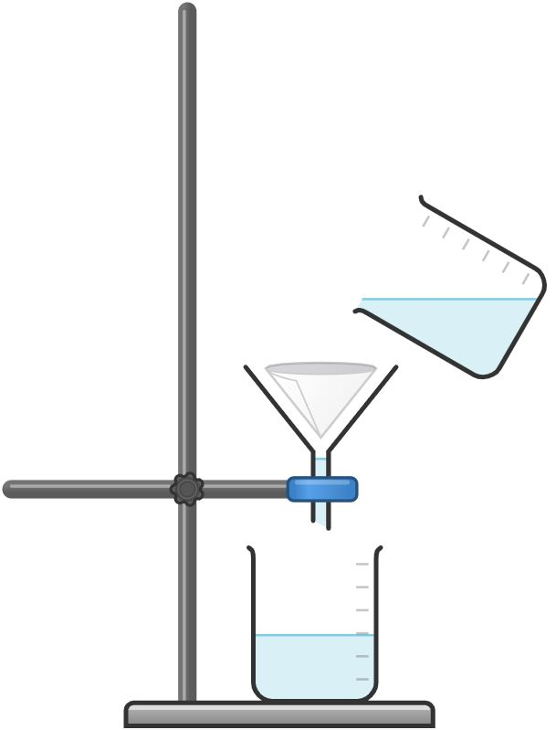
Diagram created with Chemix.
Evaluating
Suggest how this investigation could be improved.

Was your prediction correct? Justify your answer.

Activity 4: Filtering suspensions
Focus question
- How long does it take to filter a suspension compared to a sand and water mixture?
Instructions to teachers
Introduce the focus question for the investigation.
Outline the problem to the students. Students plan and conduct an investigation in groups, while a possible write-up could be completed individually.
Students plan, conduct and evaluate their investigation.
Materials
Per group (students are likely to request the following)
- ≈ 5 g cornflour
- ≈ 5 g sand
- 2 x 250 mL beakers
- 2 x 100 mL beakers
- filter funnel and stand
- 2 x filter paper
- balance

Activity 5: Soluble, insoluble and solutions
Demonstration
Focus question
- What happens when salt is added to water?
Instructions to teachers
This demonstration is designed to introduce students to the concepts of solutions and solubility. This activity can also be done as a group investigation.
Materials
- 4 large beakers
- coloured soluble salt, for example copper(II) sulfate or potassium permanganate
- coloured insoluble salt, for example, copper(II) carbonate
- ethanol or methylated spirits
- oil
- soda water (or other carbonated drink)
- video of ammonia fountain
- Task sheet: Solutions and solubility
Method
- Half fill the four large beakers with water and set across the front bench.
- To beaker 1 add a sufficient quantity of the soluble solid to dissolve and colour the water. Do not add an excess of the solid. Potassium permanganate produces a strong colour change with a small mass.
- To beaker 2 add a small quantity of insoluble salt.
- To beaker 3 add ethanol or methylated spirits.
- To beaker 4 add oil.
Highlight the difference between colourless and clear when describing solutions. Students should recognise that all solutions are clear, but only some are colourless.
Instructions to students
- Make observations for each beaker and record on the Task sheet: Solutions and solubility.

Task sheet: Solutions and solubility
In Activity 1, you will have found it difficult to visually tell the difference between liquids and homogenous solutions of liquids. In this activity we will investigate solutions and solubility.
Instructions
Observe the four mixtures and record your observations on the table below.
Beaker | Substance added | Observation | Soluble or insoluble
1
2
3
4
Processing of results
How did you decide whether the solid added to the beaker was soluble or insoluble?

Does a suspension involve a soluble or insoluble solute? Justify your answer.

Is air a solution? Justify your answer.

Activity 6: Separating the components of a solution
Focus questions
Complete a Think-Pair-Share activity using focus questions for activity on the task sheet:
- How do we separate the components of a solution that cannot be separated by any of the techniques we have used so far?
- How do we collect the solid from a solution with a dissolved solid?
- How do we collect a liquid from a solution?
Instructions to teachers
The distillation part of the activity can be done as either a group activity or a demonstration depending on the equipment available.
Explain to students the difference between evaporation and boiling as changes of state.
Space can be added to the task sheet for students to complete the questions, or use a notebook.
Review the following:
- safety when heating liquids
- use of tongs for the transfer of hot glassware
- wait for glassware to cool before cleaning.
Materials
Per group
- ≈ 100 mL copper(II) sulfate solution
- evaporating basin
- petri dish
- Bunsen burner, tripod, mat and pipe clay triangle
- heat proof mat
- boiling tube
- bent tubing and stopper
- 100 mL beaker
- retort stand and clamp
Per student
- Task sheet: Separating solutions
Method
Stand and clamp
Tubing
Boiling tube
and solution
Bunsen burner
Collection beaker
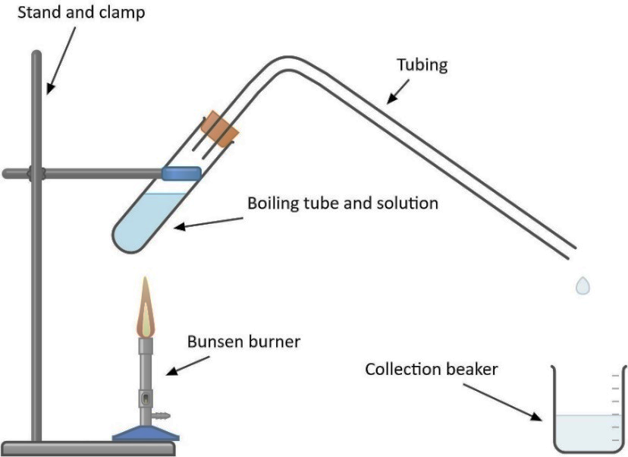
Diagram created with Chemix.
If the students are conducting the distillation experiment in groups, use a set-up similar to the one above.
Instructions to students
- Compare the outcomes of evaporation at room temperature and boiling point to obtain the solute from the solution.
- Compare the crystal size of the solute produced.

Task sheet: Separating solutions
In this activity you will investigate how to separate solutions and obtain either the solute or both the solute and solvent.
Method
Evaporation and crystallisation
- Half fill a petri dish with the copper(II) sulfate solution and leave to one side. This will be left until all of the liquid has evaporated (this may take several days).
- Half fill an evaporating basin with copper(II) sulfate solution and set up the equipment as shown in the diagram below:
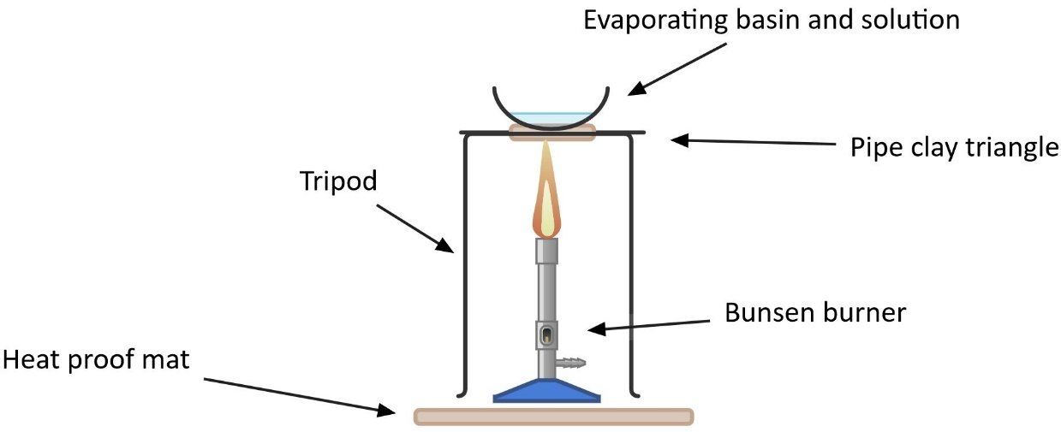
Evaporating basin and solution
Tripod
Pipe clay triangle
Bunsen burner
Heat proof mat
Diagram created with Chemix.
- Heat the evaporating basin gently until most of the liquid has been boiling away.
- Turn off the Bunsen burner and let the remaining liquid evaporate.
Safety point: do not heat until all liquid has gone as the hot solid will start to spit.
Distillation
- Set up the distillation apparatus on a heat proof mat as shown in the diagram.
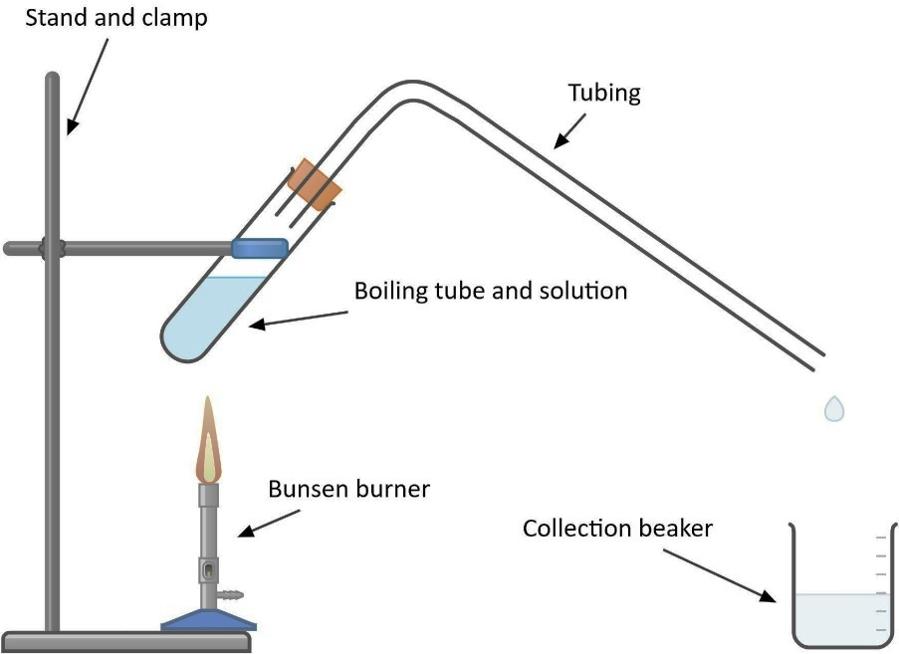
Stand and clamp
Tubing
Boiling tube
and solution
Bunsen burner
Collection beaker
Diagram created with Chemix.
- Record the colour of the solution in the test tube.
- Gently heat the boiling tube and the collect the liquid produced. If the solution is heated too vigorously, it will boil over into the tubing.
- Record the colour of the liquid in the collection beaker.
Results
Draw up a table and record your observations.
Processing of results
What components of the mixture can you obtain samples of in:
- evaporation and crystallisation?
- distillation?
Describe the differences you observed between the solids produced by slow evaporation (the solution you put in the petri dish), and by heating the evaporating basin over a Bunsen burner.
Identify, through research, where evaporation and crystallisation, and distillation are used outside of the laboratory.
Research question
How is coffee decaffeinated?

Activity 7: Separation of seawater
Focus question
- Does seawater only contain one type of dissolved salt?
Instructions to teachers
This separation is based on the different solubilities of the salts at different temperatures.
Brainstorm with students what they know about the components of seawater.
As the students heat the ‘seawater,’ the calcium carbonate will precipitate out first, followed by calcium sulfate and then sodium chloride. It is likely there will be some calcium sulfate present when the calcium carbonate is tested.
Artificial seawater should be used for this experiment to ensure the outcome. Real seawater could be used in addition and the results compared.
Remind students how to write a report for a practical activity and provide them with the task sheet.
Due to the amount of heating, remind students about safety, and the wearing of safety glasses and aprons or lab coats at all times.
Materials
Per class
- artificial seawater
  - carbon dioxide
  - 500 mL limewater
  - 1.5 L distilled water
  - calcium sulfate
  - 30 g sodium chloride
Per group
- 200 mL artificial seawater (instructions below)
- 250 mL beaker
- 2 x 100 mL beakers
- 1 mol L⁻¹ hydrochloric acid (provide in dropper bottles)
- filter paper
- filter funnel and stand
- watch glass
- evaporating basin
- Bunsen burner
- heat proof mat
- tripod
- gauze mat
- dropper
- safety glasses
Per student
- Task sheet: Is there more than one type of dissolved solid in seawater?
Artificial seawater – this will produce enough for 10 groups of students
- Bubble carbon dioxide through 500 mL of limewater and 1.5 L of distilled water until the solution is completely colourless and the cloudiness has disappeared.
- Saturate the solution with calcium sulfate.
- Dissolve about 30 g of sodium chloride.
- Filter the solution if necessary.
Instructions to students
- Read the instructions for this experiment very carefully as there are more steps than most of the other activities they have completed.
- Make a mark at 60 mL on the 260 mL beaker and 30 mL on the 100 mL beaker.
- Write down their observations at each stage.

Task sheet: Is there more than one type of dissolved solid in seawater?
In this activity you will heat a sample of seawater and collect the solids that precipitate at different points. To consider how you tell that you have different types of solids, you will perform a simple chemical test, with the addition of hydrochloric acid, to look for different reactions.
Complete a write-up for this activity and hand it to your teacher for feedback.
Materials
- 150 mL of seawater
- 250 mL beaker
- 2 x 100 mL beakers
- 1 mol L⁻¹ hydrochloric acid
- filter paper
- filter and stand
- watch glass
- evaporating basin
- Bunsen burner
- heat proof mat
- tripod
- gauze mat
- dropper
- safety glasses
Method
- Set up your equipment as shown in the diagram.
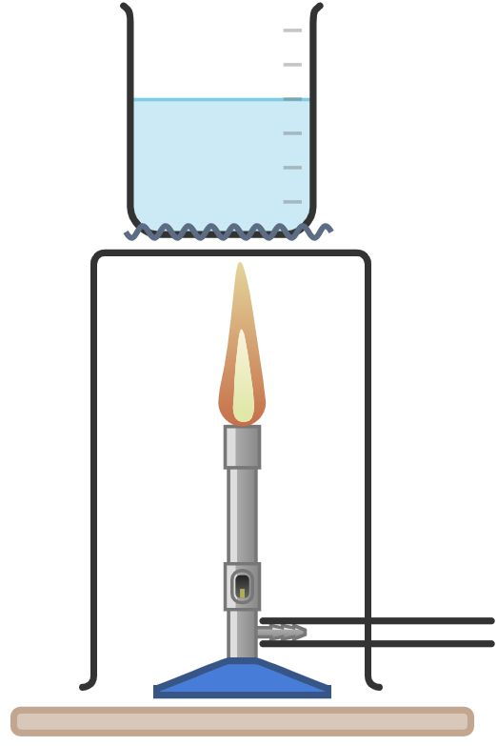
Diagram created with Chemix.
- Add 150 mL of seawater to the 250 mL beaker.
Stage 1
- Boil the seawater until the liquid level reaches approximately 60 mL. A solid should have precipitated at this point.
- Turn off the Bunsen burner and allow the mixture to cool.
- Decant the remaining seawater into a 100 mL beaker, leaving the solid in the 250 mL beaker.
- Add a few drops of hydrochloric acid to the solid in the 250 mL beaker and record your observations.
Stage 2
- Place the 100 mL beaker of remaining seawater on the gauze mat and boil until there is about 30 mL of seawater remaining. More solid should have precipitated by this point.
- Filter the seawater into a second 100 mL beaker.
- Transfer the filtrate from the beaker to an evaporating basin.
- Place the filter paper containing the filter solid on a watch glass and add a few drops of hydrochloric acid. Record your observations.
Stage 3
- Place the evaporating basin on the gauze mat and continue to heat.
- Turn off the Bunsen burner just before all of the liquid has boiled away and let the remaining liquid evaporate at room temperature.
- Once all of the liquid has evaporated, add a few drops of hydrochloric acid and record your observations.
Results
Draw a table to record your observations of the solid and the reaction with hydrochloric acid at each stage.
Processing of results
- How do you know that the white solids separated at each stage were different?
- Research and provide a list of what substances are commonly found in seawater.
- What dissolved substance is found in the greatest quantity in seawater?
- Which of the three solids you produced is most likely to be the dissolved solid from the previous question? Justify your answer.

Activity 8: Fractional distillation
This activity can be done as a demonstration if Quickfit style apparatus is available. Otherwise, videos of fractional distillation can be sourced from the internet. This activity should not be done as a student activity due to the flammability of the fractions obtained.
Fractional distillation is a process used to separate a mixture of liquids with different boiling points. It has extensive real-world applications.
An artificially created crude oil can be used for this demonstration if a real sample is not available. The following liquids can be combined to form the artificial crude oil.
- hexane boiling point 69 °C
- octane (petrol)
- kerosene (above 150 °C)
As some products of this distillation are very flammable, a heat mantle/hot plate must be used. When each fraction is burned, the heavier fractions should be less flammable and produce more soot than the lighter fractions.
Instructions to teachers
Explain that the generation of soot is evidence of incomplete combustion of the fuel.
Explain why the water is funnelled up the Liebig condenser.
Point out that the positioning of the thermometer at the top of the arm is important for collecting the fractions at the appropriate temperatures.
Students draw up a table to record their observations.
Collect the fractions and demonstrate the different properties and have students record their observations.
Outline the components of the mixture to students.
Materials
- photos of refineries with visible fractional distillation columns, or other real world fractional distillation applications
- Quickfit or similar equipment for fractional distillation
- heating mantle
- ‘crude oil’ mixture
- 100 mL beakers
- large evaporating basins
- wax tapers
- Task sheet: Fractional distillation

Method
- Set up the fractional distillation apparatus as shown in the diagram on the Task sheet.
- Heat the mixture gently, collecting the distillate in 100 mL beakers from
  - room temperature to 100 °C
  - 100 °C to 140 °C
  - 140 °C and above (the remaining liquid in the round bottom flask).
- Pour a small amount of the fractions into three large evaporating basins.
- Set fire to each fraction and have students record their observations about flammability, flame colour and amount of soot produced.
Instructions to students
- Label apparatus as the teacher goes through the different pieces of glassware
- Draw up a table to record their observations.
- Predict which fraction will be the most flammable.

Task sheet: Fractional distillation
You have used distillation to obtain the liquid from a solution of two substances, but what about mixtures of liquids that contain more than two substances? Fractional distillation is a technique that can be used to separate mixtures of liquids with different boiling points. In this activity your teacher will demonstrate the fractional distillation of crude oil and you will observe some of the different properties of those liquids.
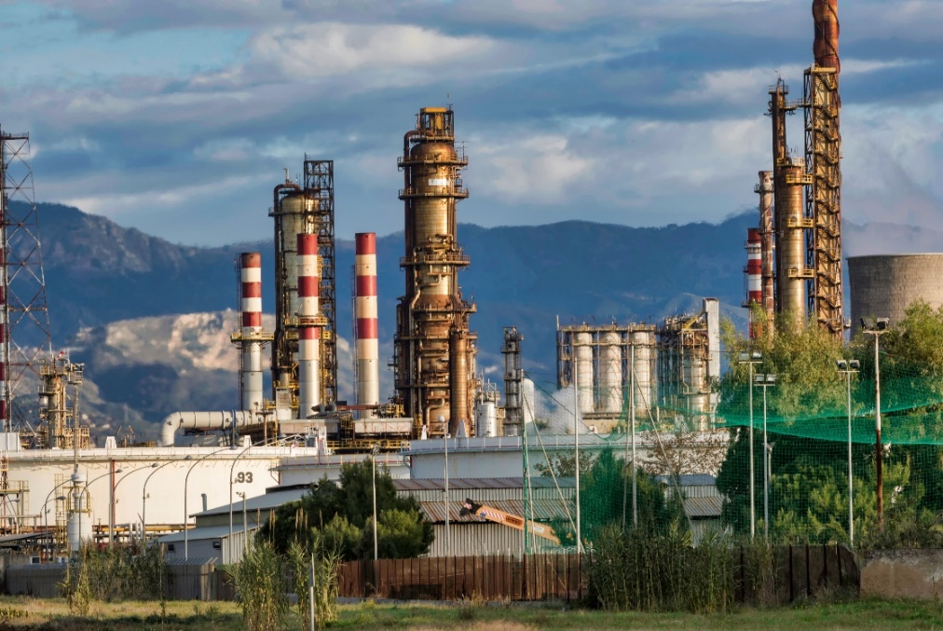
Oil refinery Image: Giordano, 2018
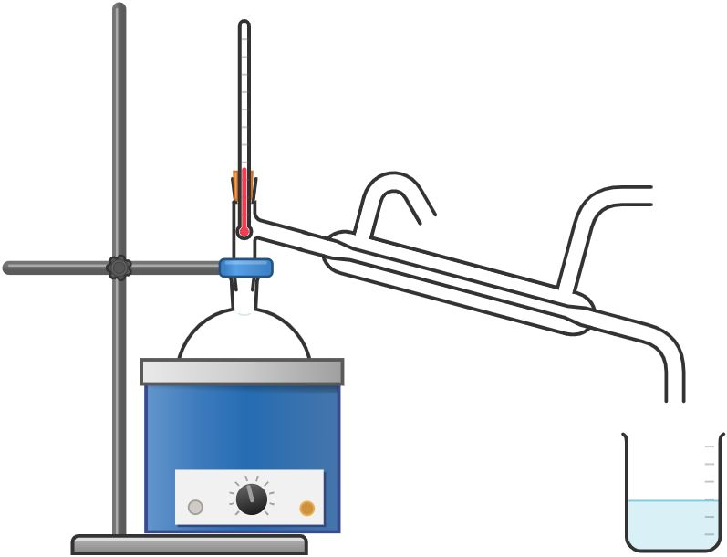
Diagram created with Chemix.
Label the parts of the distillation apparatus.

Your teacher will collect the distillate produced during the following temperature ranges:
- room temperature to 100 °C
- 100 °C to 140 °C
- above 140 °C (which will be the liquid remaining in the round bottom flask).
Draw up a table in the space below to record the following observations for each fraction:
- viscosity
- flammability
- how much soot is produced.

Activity 9: Paper chromatography
This activity looks at separating substances based on their differing solubilities in a solvent and their ability to adhere to paper.
Instructions to teachers
While this activity can be done in groups, if done individually, all students will be able to access a chromatograph.
Teacher to check set-ups before students insert the paper into the beaker, with a particular focus on the water level in the beaker.
Materials
Per group
- Different coloured coated lollies or coloured markers (approximately six colours)
- chromatography paper
- 250 mL beaker or chromatography tank
- distilled water
- 6 x watch glasses (if using coloured lollies)
- droppers
Per student
- Task sheet: Are the colours on lollies a mixture or pure substance?
This can also be done with narrow strips of chromatography paper (one for each colour) placed in test tubes.
If using coloured markers, these will need to be pre-tested to make sure they demonstrate an adequate range of colour separation.
After students have prepared their chromatography paper and added water to the beaker, but before placing the paper in the beaker, the teacher should check the water level to make sure it will be below the pencil line.
The activity sheet can be modified for either coloured lollies or coloured markers.
Instructions to students
- Set up the chromatography paper as shown in the diagram.
- Aim to make the spot as dark as possible while keeping it as small as possible.
- If using a beaker, the paper is curled into a cylinder and can be fastened with staples.
- The water level in the beaker must be below the line on which the samples have been placed.
- The paper will be left in the beaker until the water is approximately 1 cm from the top of the paper.
- Observe what happens as the chromatogram develops.
- Do not consume any coloured lollies used after the experiment.

Task sheet: Are the colours on lollies a mixture or a pure substance?
In this task you will see which lolly colours are mixtures and which are single colours by using a technique called chromatography.
Which colours do you think are mixtures? Write your prediction below.

Instructions
- Draw a pencil line approximately 1 cm from the bottom along the long side of the chromatography paper.
- On the pencil line, make marks 1 cm apart and 2 cm in from each end.
- Put a couple of drops of water in a watch glass and dip a lolly into the water. Rub the wet lolly on the first pencil mark. You may need to do this several times until there is a good amount of colour on the pencil mark. Dispose of the lolly.
- Repeat this process for each coloured lolly as shown in the diagram below.
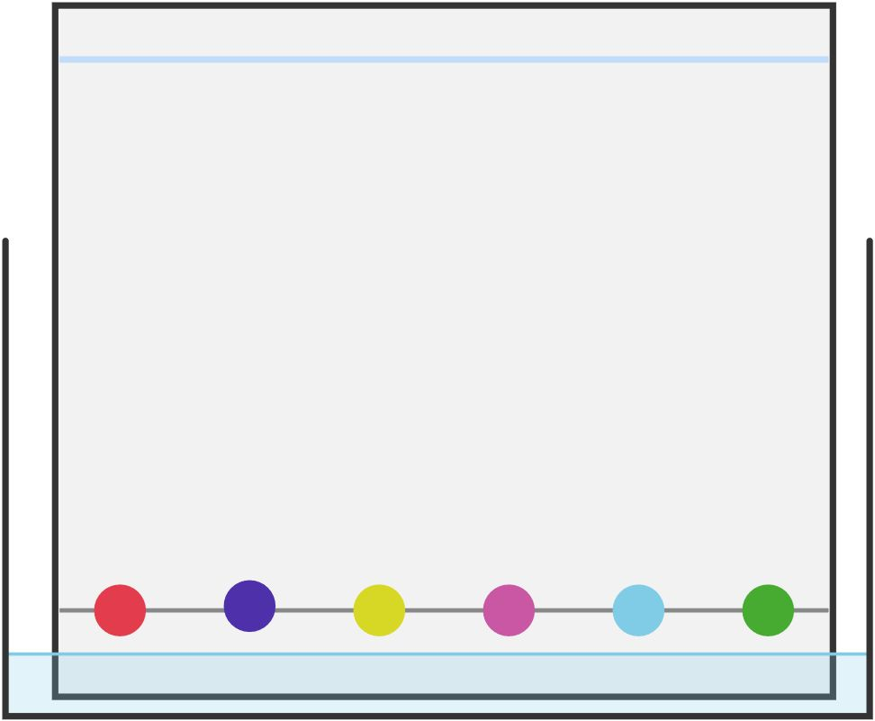
Diagram created with Chemix.
- Curl the chromatography paper into a column and staple at the top and bottom.
- Place approximately half a centimetre of water into the 250 mL beaker.
- Place the chromatography paper into the beaker, making sure that the water level is below the pencil line.
- Once the water has moved up the paper until it is approximately 1 cm from the top, remove the paper, remove the staples and lay it out to dry.
Processing of results
- On your chromatograph, label each colour in the mixtures.
- Which colours are the most soluble in water? Justify your answer.
- What types of mixtures might be best separated by paper chromatography?
- Explain how the components of the mixture are separated through paper chromatography.
- Identify two ways in which this investigation could have been improved.
- There are many different types of chromatography. Research one of the following types of chromatography and write a paragraph, comparing and contrasting it with paper chromatography. If appropriate include a diagram in your answer.
  - Thin layer chromatography
  - Column chromatography
  - Gas chromatography.

Acknowledgements
Appendix B
Task sheet: Separating
solids from liquids Diagram created with: Chemix. (2024). Retrieved from https://chemix.org
Activity 6: Separating
the components of a
solution Diagram created with: Chemix. (2024). Retrieved from https://chemix.org
Task sheet: Separating
solutions Diagrams created with: Chemix. (2024). Retrieved from https://chemix.org
Task sheet: Fractional
distillation Giordano, N. (2018). [Photograph of an oil refinery station]. Retrieved December, 2025, from https://pixabay.com/photos/refinery-petrolium-fossil-gas-3400043/
Diagram created with: Chemix. (2024). Retrieved from https://chemix.org
Task sheet: Are the
colours on lollies
a mixture or a
pure substance? Diagram created with: Chemix. (2024). Retrieved from https://chemix.org



