Assessment task
Year level | 6
Learning area | Mathematics
Subject | Patterns and Algebra
Title of task | Stacking Oranges
Task details
Description of task | To produce a poster, frieze or multimedia presentation of the patterns, diagrams, sequences, rules, predictions and justifications arising from the different features of constructed pyramids.
Type of assessment | An investigation and individual student presentation
Purpose of assessment | To inform moderation practices and gather evidence to ascertain student achievement in relation to the standard
Assessment strategy | Group investigation leading to individual student presentation.
Evidence to be collected | - Observation checklist on Construction of Pyramids  - Anecdotal notes  - Individual student presentations (e.g. PowerPoint, poster, report, photo board)
Suggested time | 1 week
Content description
Content from the Western Australian Curriculum | Construct simple prisms and pyramids  Continue and create sequences involving whole numbers, fractions and decimals  Describe the rule used to create the sequence  Identify and describe properties of prime, composite, square and triangular numbers
Proficiencies | Understanding | Fluency | Problem Solving | Reasoning
Task preparation
Examples of prior learning tasks | First Steps in Mathematics  - Four Cube Houses – FSiM Space p91  - Building – FSiM Space p91  - Drawing a Cube – FsiM Space p92  - Triangle Toothpick Design – FSiM Number Bk2 p218, 230 & 241  - River Crossing – FSiM Number Bk2 p218  - Picture Frames – FSiM Number Bk2 p218  - Sticky Instructions – FSiM Number Bk2 p239  - Triangular Numbers – FSiM Number Bk2 p238  - Dot Patterns – FSiM Number Bk2 p238  ReSolve  - Real World Algebra: Chicken Box Patterns  - Painted Cubes (https://resolve.edu.au/assessing-reasoning-year-6-exemplars?lesson=3798)  Scootle  - Circus Towers: Square Stacks  - Number Patterns  - Bridge Builder: Triangles 1
Helpful YouTube Viewing Resources
- Square orange Stack. YouTube (2:29)
- Tetra with Oranges. YouTube (4:49)
Assessment differentiation | Teachers should differentiate their teaching and assessment to meet the specific learning needs of their students, based on their level of readiness to learn and their need to be challenged.  Assessment differentiation is assisted by the judicious use of ‘starting’ and ‘extending’ prompts (see teacher instructions below the task)
Assessment task
Assessment conditions | - ‘Small Group Exploration and Observations’ using suitable manipulatives, to assist in formulating patterns. Discussion of ideas between students should be encouraged with the teacher using ‘starting’ and ‘extending’ prompts as required (approximately 1 lesson)  - observation checklist to be used by teacher when students are constructing pyramids  - ‘Individual Reasoning’ of sequences, rules and task planning (approximately 1 lesson)  - preparation and delivery of ‘Individual Presentation’ using the resources listed below (approximately 3 lessons)  - one to one interview may be used at any time in assessment process to record anecdotal evidence and to clarify student understanding
Resources | ‘Year 6 Mathematics Task – Stacking Oranges’ sheet  Marbles, foam balls, cubes or similar items  Reusable adhesive material  A3 Card for poster (Note A3 is maximum size for students’ presentations)  Camera/Ipad/phone for production of photographs  Computers  Grid paper  Rulers  Glue  Scissors  Coloured pencils

Instructions for teachers
Inform students that the purpose of the ‘Year 6 Mathematics Task – Stacking Oranges’ is to construct pyramids, develop sequences, explore patterns, find rules and explain their reasoning.
They will be required to clearly demonstrate their best understanding of:
- the construction of simple prisms and pyramids
- the continuation and creation of sequences involving whole numbers
- describing rules used to create sequences
- the properties of prime, composite, square and triangular numbers.
The task consists of a series of lessons involving:
- small group exploration and observations
- individual reasoning
- an individual presentation
Teachers may use ‘starting’ and ‘extending’ prompts if or when required and record the level of support provided.
Examples of ‘starting’ prompts:
- Encourage students to take a systematic approach in their explorations.
- Suggest they build square-based pyramids with side lengths of 2, 3, 4 and 5 in the bottom layer (you may allocate a different base side length to each student member in the group).
Prompt students to:
- draw diagrams of the patterns formed by the number of oranges in the bottom layer from the smallest to the largest stacks built
- draw diagrams of the patterns formed by the number of oranges on each side of the stack from the smallest to the largest stacks built.
- Encourage them to count how many oranges are in the smallest to the largest stacks.
- Suggest they write down the sequences resulting from the numbers of oranges in the patterns formed in their diagrams of the different sized stacks.
- Encourage them to investigate and develop rules based on the number of oranges in each layer, on each side and in total for the stack and to justify and test their rules.
Examples of ‘extending’ prompts. You could ask:
- How would you predict the number of oranges in a square-based pyramid:
- in each layer
- on each side
- in total for a very large stack of oranges?
- Given a square-based pyramid containing a stack of 650 oranges, how could you work out how many oranges would be in the bottom layer? (The number may be altered.)
- Oranges arrive at a shop in boxes of 138. If 9 boxes are delivered, how could you work out the largest square-based pyramid stack that can be built using these oranges? Would there be any oranges left over? (numbers can be altered)
- What is the same and what is different about the sequences produced by looking at the layers, the sides and the total number of oranges in different square-based pyramids?

Possible extension activity (beyond this task)
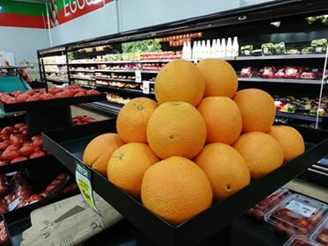
The base of the oranges stacks do not have to be squares. This picture shows oranges stacked in the shape of a pyramid with a rectangular base.

Consider pyramid stacks that have:
- rectangular bases other than a square. For example, the bottom layer could be 2 x 3 or 3 x 4 or 4 x 5 etc. (see picture)
- an equilateral triangle as the base.
What patterns, sequences and rules can you find for orange stacks formed in these kinds of pyramids?

Note: A range of materials may be used to explore the same mathematical concepts.
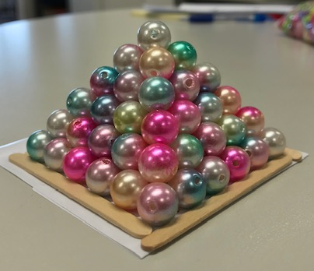
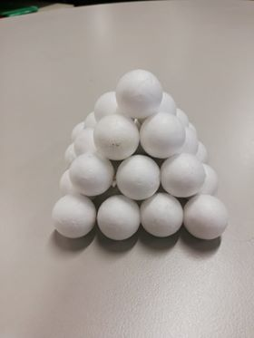

- Teachers are encouraged to expose students to the language in the task prior to administering.

Year 6 Mathematics Task – Stacking Oranges
Oranges are often stacked in pyramids for display in supermarkets.
There are many patterns in these displays.
For this task, you will use the materials provided to construct and explore the patterns in stacked orange pyramids.
You must then produce your own poster, frieze or multimedia presentation to show your findings. You must include diagrams, photos, sequences, description and justification of any rules used to create patterns you find in the pyramids.
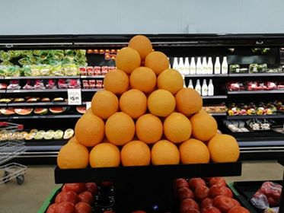Small Group Exploration and Observations:
This photo shows oranges stacked in the shape of a pyramid with a square base.
Use the materials provided to build pyramid stacks with different sized square bases.
Look for patterns in your stacks.
In your group, explore, discuss and make drawings and jottings of any patterns and sequences you see in your constructions.
Determine:
- how many oranges will be in each layer?
- how many oranges will be visible on each side of the stack?
- how many oranges in the whole stack?
Individual Reasoning
Working on your own, reflect on the stacking oranges task and plan your presentation on paper.
You will need to:
- Investigate and develop sequences and rules based on the patterns found by you and your group.
- Explain and justify how the rules work using examples.
- Explain how you can use these rules to predict the number of oranges:
- in each layer for square-based pyramids you have not yet built
- on each side for square-based pyramids you have not yet built
- in total for square-based pyramids you have not yet built.
- Explain how you can use these rules to predict the number of oranges:
- in each layer for very large stacks of oranges that are too big for you to build
- on each side for very large stacks of oranges that are too big for you to build
- in total for very large stacks of oranges that are too big for you to build.

- Explain how you can work out the number of oranges in the bottom layer and on one side of a stack if you only know the total number of oranges used to build it.
Individual Presentation
Create your own poster, frieze or multimedia presentation to show all your findings.
- Use diagrams, photos, sequences, descriptions and rules to show the patterns arising from the number of oranges in each layer, on each side and in total for square-based pyramid stacks.
- You must provide explanations of the patterns and the reasoning behind the rules you found.
- Show and justify how to use your rules to calculate the number of oranges needed in each layer, on each side and in total, for stacks of oranges you have not yet built.
- Show and justify how to use your rules to calculate the number of oranges needed in each layer, on each side and in total, for very large stacks of oranges.
- Show and justify how to use your rules to calculate the number of oranges in the bottom layer and on one side of a stack if you have been told the total number of oranges.
- You may include extra information from the ‘extending prompts’ suggested by your teacher.
Note: You may need to explain your presentation to your teacher, class or group.

Marking key for individual presentation
Description | Marks
Constructing Pyramids (from Observation Checklist – see attached)
Constructs square-based pyramids independently | 2
Constructs square-based pyramids with guidance | 1
Subtotal | 2
Diagrams of 2D patterns resulting from orange stacks
Correctly interprets and draws a series of layers and sides of multiple, different sized, square-based pyramid orange stacks | 4
Correctly interprets and draws a series of layers or sides of multiple, different sized, square-based pyramid orange stacks | 3
Correctly interprets and draws the layers and sides of one square-based pyramid orange stack | 2
Correctly interprets and draws the layers or sides of one square-based pyramid orange stack | 1
Subtotal | 4
Recording sequences of patterns
Correctly writes at least four terms of a sequence to model the total number of oranges in square-based pyramids of increasing size | 3
Correctly writes at least four terms of another sequence to model layers and sides of the square-based pyramids of increasing size | 2
Correctly writes at least four terms of a sequence to model layers or sides of the  square-based pyramids of increasing size | 1
Subtotal | 3
Recognising sequences of patterns
References square and triangular numbers in the sequences | 2
References either square or triangular numbers in the sequences | 1
Subtotal | 2
Describing rules
Correctly describes rules for layers, sides and total number in squared-based pyramid stacks | 3
Correctly describes rules for layers or sides or total number in squared-based pyramid stacks of increasing size | 2
Attempts to describe rules for squared-based pyramid stacks of increasing size | 1
Subtotal | 3
Continuing sequences
Correctly continues all sequences for squared-based pyramid stacks beyond constructed pyramids | 2
Correctly continues some sequences for squared-based pyramid stacks beyond constructed pyramids | 1
Subtotal | 2
Justifying rules
Correctly explains the reasoning of all rules for squared-based pyramid stacks | 2
Correctly explains the reasoning of some rules for squared-based pyramid stacks | 1
Subtotal | 2
Using rules to predict
Correctly uses all rules to make predictions for large square-based pyramid stacks | 2
Correctly uses some rules to make predictions for large square-based pyramid stacks | 1
Subtotal | 2
Using rules in reverse
Correctly determines the number of oranges in the bottom layer and the side given the total number of oranges | 2
Correctly determines the number of oranges in the bottom layer or the side given the total number of oranges | 1
Subtotal | 2
Language and Communication
Uses correct mathematical terminology and notation to produce a presentation containing clear, organised, unambiguous explanations and descriptions and includes appropriate and complete diagrams, sequences and rules | 4
Uses correct terminology and notation to produce a presentation containing some explanations and descriptions and includes appropriate and complete diagrams, sequences and rules | 3
Uses some mathematical terminology and notation to produce a presentation containing appropriate diagrams, sequences and rules related to the task | 2
Produces a presentation containing diagrams, sequences and rules related to the task | 1
Subtotal | 4
Total Marks | 26

Construction of Pyramids Observation Checklist ()
Name | Cannot Construct Pyramids (0 marks) | Constructs Pyramids with Prompts  (1 mark) | Constructs Pyramids Independently  (2 marks)

