Sample assessment task
Year level | 6
Learning area | Languages
Subject | French: Second Language
Title of task | Pendant mon temps libre (During my free time)
Task details
Description of task | Students demonstrate their knowledge and understanding of vocabulary, language structures and grammatical items related to free time.  In Part A they demonstrate their skills in writing a personal profile, and select a person from the profiles supplied by the teacher to respond to two questions.  In Part B they demonstrate their skills in speaking by engaging in a conversation with their teacher, to share information about themselves.
Type of assessment | Summative
Purpose of assessment | This assessment aims to determine student learning at the time of the assessment. It establishes information on the students’ ability to write and speak in French, using descriptive and expressive language to exchange information and opinions about free time.
Assessment strategy | Short response – write responses in French to questions in a survey  Oral performance – participate in a conversation
Evidence to be collected | Completed task sheet  Audiovisual recording of the conversation
Suggested time | Part A – 25 minutes  Part B – 2 minutes
Content description
Content from the Western Australian Curriculum | Communicating  Initiate interactions with others, using descriptive and expressive language to exchange information and relate experiences about free time  Participate in routine exchanges to express feelings, opinions and personal preferences  Gather, compare and respond to information and supporting details from a range of written, spoken, digital and multimodal texts related to their personal and social worlds  Experiment with bilingual dictionaries and/or online translators, considering the relative advantages or limitations of each resource  Understanding  Explain and apply features of intonation, pronunciation and writing conventions used in different contexts and types of texts  Use context-related vocabulary and develop and apply knowledge of grammatical elements in simple spoken and written texts to generate language for a range of purposes, including:  - using je/tu/il/elle/on/nous/vous/ils/elles + present tense of regular -er, -ir and -re verbs and of high-frequency irregular verbs such as avoir, être, aller and faire  - using the indicative plus the infinitive, for example, J’aime jouer au tennis; Ils vont faire du surf, and le futur proche, for example, Je vais partir.  - formulating questions using Est-ce que… ? and experimenting with inverted form of the verb, or changed intonation, for example, Est-ce que tu joues de la guitare ?; Joues-tu de la guitare ?; Tu joues de la guitare ?  - understanding and using negative constructions, for example, Tu ne viens pas au cinéma ? and including the use of de after a negative verb form, for example, Je n’ai pas de photos  - using exclamations to indicate agreement, disagreement, intention or understanding, for example, D’accord !; Mais non !; Bien sûr !; Voilà !
Task preparation
Prior learning | Students have prior knowledge of and exposure to:  - a variety of texts related to free time activities, expressing opinions and preferences  - context-related vocabulary  - grammatical structures, including: the present and the near future tenses  - the textual conventions of a conversation  - using a bilingual dictionary.
Assessment differentiation | Teachers should differentiate their teaching and assessment to meet the specific learning needs of their students, based on their level of readiness to learn and their need to be challenged.  Where appropriate, teachers may either scaffold or extend the scope of the assessment tasks.
Assessment task
Assessment conditions | Part A is to be completed by students working individually.  The conversation in Part B takes place between the teacher (or another speaker of French) and the student.
Resources | Task sheet  Stimulus cards – profiles  Conversation script  Bilingual dictionary  Recording device

Instructions for teacher
Prior to administering the task, students will need to be:
- exposed to a variety of texts related to free time activities, expressing opinions and personal preferences
- taught context-related vocabulary, such as:
  - names of interests; for example, sports, hobbies, and musical instruments
  - reasons to like/dislike an interest; for example, C’est ennuyeux/intéressant/fatiguant.
  - with whom an interest is undertaken; for example, avec ma cousine, tout(e) seul(e), avec mon équipe
  - times of the day or week when an interest is done; for example: avant/après l’école, le dimanche
- taught grammatical elements, including:
  - the present tense of –er verbs, avoir, être, faire and aller
  - the near future tense, that is, the present tense of aller + infinitive
  - negative constructions; for example, Il ne va pas au club de tennis.
  - forming questions with Est-ce que… ? and inversion of the subject and verb; for example, Joues-tu d’un instrument ?
- exposed to the textual conventions of a survey and a conversation, and provided with opportunities to practise them
- taught how to use a dictionary – either in print or online.
Activities to scaffold the task
Teachers:
- provide spoken and written texts related to interests and students answer questions about them, respond to statements by indicating true or false, draw images that reflect information in the texts and/or complete a timetable.
Students:
- survey each other to find the most popular interests/musical instruments played and present the information to others
- design a poster that reflects themselves and their interests
- interview others about their interests
- compare information about interests/hobbies/sports played in a French-speaking country and Australia
- prepare a presentation for the class about their interest(s), including information such as how often, when, where, why and with whom they partake in the activity, costs and/or advantages of the activity
- use dictionaries to research vocabulary related to interests
- write a shape poem that reflects a sport or hobby
- view an audiovisual clip of people engaging in an interest and write the voice-over
- write a paragraph or give a talk as if they were a person from one of the profiles in the assessment task.

Task
Part A Questionnaire: Quels sont tes passe-temps préférés ?
Part A is preparation and scaffolding for Part B.
Students read the survey Questionnaire: Quels sont tes passe-temps préférés ? and respond to the questions in French.
For questions 6 and 7, students select one of the three profiles on which to base their responses.
Suggested activity before administering Part B:
- Students survey others in the class with the support of their completed questionnaire. They offer their opinions orally (J’aime… ; Je suis d’accord.; Je ne suis pas d’accord.; Moi, je préfère… )
- From the survey results, students find one person with whom they have the most in common. They decide on an activity that they are going to do together after school, or share with the class why they have chosen to do an activity with the person they have identified with (similarities and differences in likes and dislikes using simple and compound sentences). They interview one another using similar questions to the script for Part B.
Part B Echange d’information
Students engage in a conversation with the teacher sharing opinions about free time activities.
Task administration script
The script provides the structure of the conversation with the student.
Teacher: | Bonjour.
Student: | (Student responds to the greeting).
Teacher: | Quel est ton passe-temps préféré ?
Student: | (Student provides a response to the question).
Teacher: | Pourquoi aimes-tu… ?
Student: | (Student provides a response to the question).
Teacher: | Qu’est-ce que tu vas faire ce week-end ?
Student: | (Student provides a response to the question).
Teacher: | Qui vas-tu inviter (Dominique, Sophie ou Éloïse) ?
Student: | (Student provides a response to the question).
Teacher: | Pourquoi as-tu choisi… ? / Pourquoi Dominique/Sophie/Éloïse ? / Est-ce qu’il/elle aime le sport comme toi ?
Student: | (Student provides a response to the question).
Teacher: | Merci, au revoir.
Student: | (Student ends the conversation with a phrase of leave taking).

Instructions to students
Pendant mon temps libre
Part A Questionnaire : Quels sont tes passe-temps préférés ?
Read the survey and answer the questions in full sentences, in French.
For questions 6 and 7, base your responses on one profile selected from the three provided by your teacher.
Look up any unfamiliar vocabulary in a dictionary.
1 | Fais-tu du sport ?  Oui, je _________________________________________________________________________  Non, je ________________________________________________________________________
2 | Pourquoi ou pourquoi pas ?
3 | Est-ce que tu préfères regarder la télé ou aller au cinéma ? Pourquoi ?
4 | Quel est ton passe-temps préféré ? Pourquoi ?
5 | Qu’est-ce que tu vas faire ce week-end ?
6 | Qu’est-ce que tu fais d’habitude le week-end ?
7 | Avec qui fais-tu cette activité ? Pourquoi ?

Stimulus cards – Profiles
Refer to one of the following stimulus cards to respond to questions 6 and 7.
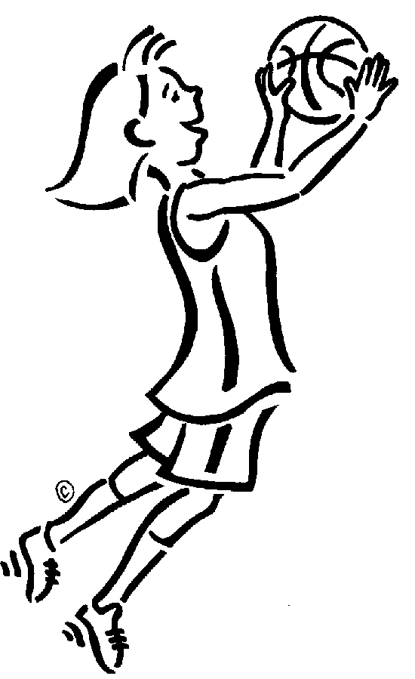
Nom | Éloïse |  | Nom | Dominique
Age | 13 |  | Age | 11
Passe-temps préférés | le basket et le patinage |  | Passe-temps préférés | les films et le cinéma
Aime le sport ? | oui |  | Aime le sport ? | oui, un peu
Avec qui ? | ses amies |  | Avec qui ? | son frère
Quand ? | le samedi |  | Quand ? | le week-end
[Image: Hicks, M.A. (n.d.). Girl playing basketball. Retrieved March, 2016 from http://school.discoveryeducation.com/clipart/clip/grlbskbl.html
Licensed from the Clip Art Gallery on DiscoverySchool.com]
[Image: Hicks, M.A. (n.d.). Boy taking test. Retrieved March, 2016 from http://school.discoveryeducation.com/clipart/clip/dmbtest.html
Licensed from the Clip Art Gallery on DiscoverySchool.com]

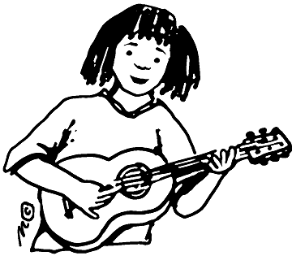
Nom | Sophie
Age | 12
Passe-temps préférés | la musique et jouer de la guitare
Aime le sport ? | non, mais elle aime la natation
Avec qui ? | sa sœur
Quand ? | le samedi ou le dimanche
[Image: Hicks, M.A. (n.d.). Playing guitar. Retrieved March, 2016 from http://school.discoveryeducation.com/clipart/clip/guitar-player.html
Licensed from the Clip Art Gallery on DiscoverySchool.com]
Part B Echange d’information
Share your opinions about free time activities in a conversation with your teacher who will ask you some questions.
Prepare information about:
- your favourite pastime and why it is your favourite
- what you are going to do over the weekend
- who you are going to do the activity with and why. (Hint: use the stimulus card)
You may use your survey from Part A as support, but try to talk as freely as possible and give any extra information you think is appropriate.
Be prepared to speak with your teacher for approximately two minutes.

Sample marking key
Part A Questionnaire: Quels sont tes passe-temps préférés ?
Content | Marks
Writes to express own, and ask others their, opinions and feelings about free time activities, with some supporting detail. | 3
Writes to express some opinions about free time activities. Attempts to write questions to enquire about others’ opinions about free time activities. | 2
Limited attempt at writing simple responses and questions about free time activities. | 1
Subtotal | 3
Grammar | Marks
Writes with simple and compound sentences, and applies grammatical elements mostly accurately. Uses present and near future tenses mostly successfully and makes sound attempts at questions. | 3
Writes with simple sentences, making an occasional attempt at compound sentences. Applies grammatical elements with some accuracy. Present and near future tenses are sometimes unsuccessful. Intended meaning is clear. | 2
Limited use of simple sentences and application of grammatical elements. Frequent errors making meaning unclear. | 1
Subtotal | 3
Vocabulary | Marks
Uses an appropriate range of relevant vocabulary. Spelling is mostly correct, including the use of accents. | 3
Uses some variety of vocabulary that is generally relevant. Some inconsistency with spelling but meaning is clear. Attempts are made at using accents correctly. | 2
Limited use of relevant vocabulary. Poor spelling often impedes comprehension. | 1
Subtotal | 3
Support | Marks
Uses a bilingual dictionary and/or resources independently, if necessary. | 3
Requires some support in accessing a bilingual dictionary and/or resources. Some teacher support given (for example, scaffolding, modelling). | 2
Requires significant support to complete the task. | 1
Subtotal | 3
Part A total | 12

Sample marking key
Part B Echange d’information
Content | Marks
Responds to all questions in full sentences and provides extra information without prompting. | 4
Responds to all questions in full sentences. | 3
Responds to most questions or responds to all questions in phrases. | 2
Presents little information. | 1
Subtotal | 4
Grammar and vocabulary | Marks
Uses simple and compound sentences, including present and near future tenses mostly accurately. Errors usually appear in more complex structures. Uses a range of well-rehearsed and less-rehearsed vocabulary. | 4
Uses simple and compound sentences, including present and near future tenses mostly accurately. Errors usually appear in more complex structures. Uses a range of well-rehearsed vocabulary. | 3
Uses sufficient vocabulary to communicate information. Sentences are generally simpler. Errors are present but meaning is clear. | 2
Gives short responses and meaning is not always clear. | 1
Subtotal | 4
Pronunciation and intonation | Marks
Uses clear and accurate pronunciation and intonation. | 3
Uses accurate pronunciation and intonation inconsistently, but meaning is clear. | 2
Inaccurate pronunciation impedes comprehension at times. | 1
Subtotal | 3
Comprehension and fluency | Marks
Readily offers responses and speech flows well. Self-correction occurs if necessary. | 3
May not comprehend all questions. Attempts to ask for repetition, but requires some support from the second speaker. Attempts to self-correct. | 2
Requires considerable support. Conversation is directed by the second speaker. | 1
Subtotal | 3
Part B total | 14
Total | 26

