Western Australian Curriculum
Science
Teacher resources
Years 7–10

Acknowledgement of Country
Kaya. The School Curriculum and Standards Authority (the Authority) acknowledges that our offices are on Whadjuk Noongar boodjar and that we deliver our services on the country of many traditional custodians and language groups throughout Western Australia. The Authority acknowledges the traditional custodians throughout Western Australia and their continuing connection to land, waters and community. We offer our respect to Elders past and present.
Copyright
© School Curriculum and Standards Authority, 2026
This document – apart from any third party copyright material contained in it – may be freely copied, or communicated on an intranet, for non-commercial purposes in educational institutions, provided that the School Curriculum and Standards Authority is acknowledged as the copyright owner, and that the Authority’s moral rights are not infringed.
Copying or communication for any other purpose can be done only within the terms of the Copyright Act 1968 or with prior written permission of the School Curriculum and Standards Authority. Copying or communication of any third party copyright material can be done only within the terms of the Copyright Act 1968 or with permission of the copyright owners.
Any content in this document that has been derived from the Australian Curriculum may be used under the terms of the Creative Commons Attribution 4.0 International licence.
Disclaimer
Any resources such as texts, websites and so on that may be referred to in this document are provided as examples of resources that teachers can use to support their learning programs. Their inclusion does not imply that they are mandatory or that they are the only resources relevant to the course.

Contents
Guide to using this resource 2
Prefixes of the metric system 3
Units for base quantities 3
Units for other common quantities 3
Periodic table of the elements 4
Year 7 5
Biological sciences 5
Earth and space sciences 6
Year 8 7
Biological sciences 7
Earth and space sciences 8
Chemical sciences 9
Physical sciences 10
Year 9 11
Chemical sciences 11
Physical sciences 12
Year 10 13
Biological sciences 13
Chemical sciences 14
Physical sciences 16
Acknowledgements 17

Guide to using this resource
This teacher resource is designed to support the implementation of the Western Australian Curriculum: Science in Years 7–10.
Teachers have the flexibility to use this resource according to context and teaching need. They may choose to distribute the whole document to students to use in class and/or for assessments, or to provide extracts relevant to specific year levels and content area/s.

Prefixes of the metric system
Factor | Prefix | Symbol | Factor | Prefix | Symbol
10⁶ | mega | M | 10⁻² | centi | c
10³ | kilo | k | 10⁻³ | milli | m
 |  |  | 10⁻⁶ | micro | μ

Units for base quantities
Physical quantity |  | Unit
Quantity name | Quantity symbol | Unit name | Unit symbol
length | ● | metre | m
mass | m | kilogram | kg
time | t | second | s
electric current | I | ampere | A
temperature | T | degree Celsius | °C

Units for other common quantities
Physical quantity |  | Unit
Quantity name | Quantity symbol | Unit name | Unit symbol
volume | V | litre | L
force | F | newton | N
resistance | R | ohm | Ω
voltage | V | volt | V
wavelength | λ | metre | m
frequency | f | hertz | Hz
velocity | v | metres per second | m s^{–1}
acceleration | a | metres per second per second | m s^{–2}

Periodic table of the elements
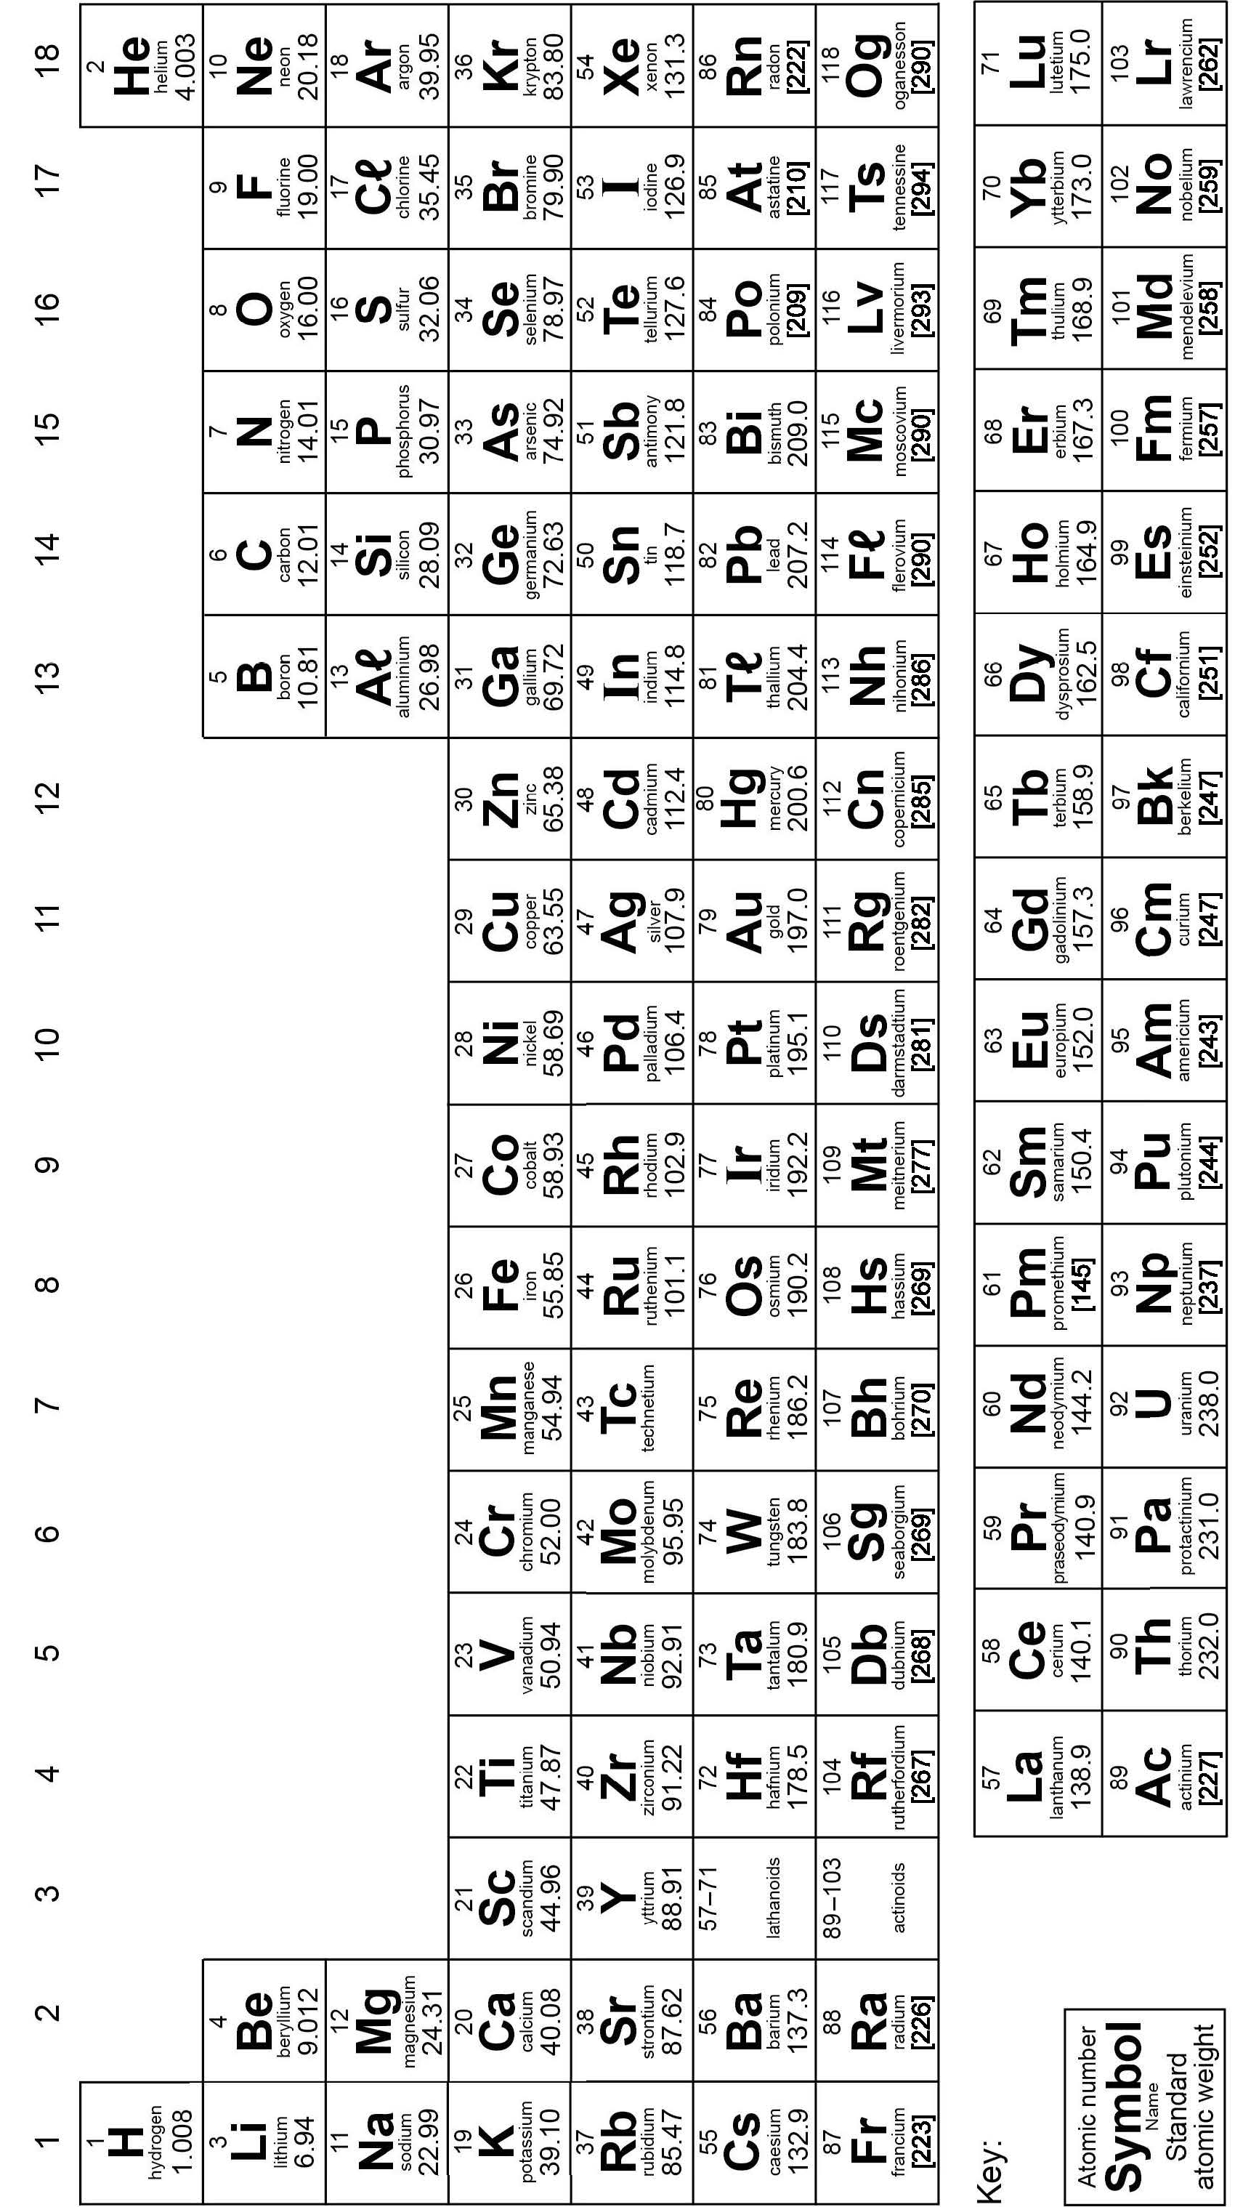
Data: International Union of Pure and Applied Chemistry, 2022.

Year 7

Biological sciences

Hierarchical classification
Kingdom
Phylum
Class
more diversity
more similar
Order
Family
Genus
species

Dichotomous keys
Flow chart or graphical key
snake frog bird mammal
No scales
Scales
Feathers
No feathers
No hair or fur

Hair or fur
mammal
snake
frog
bird

Written or tabular key
1a Scales ... snake
1b No scales ... go to 2
2a Feathers ... bird
2b No feathers ... go to 3
3a Hair or fur ... mammal
3b No hair or fur ... frog

Earth and space sciences

Lunar phases
Lunar phases are the same in the southern and northern hemispheres but the appearance of the moon in each hemisphere is inverted. The phases of the moon in the southern and northern hemispheres are represented below. The white area represents the part of the moon visible from the Earth.
Phases of the moon – southern hemisphere
New moon | Waxing crescent | First quarter | Waxing gibbous | Full moon | Waning gibbous | Last quarter | Waning crescent
 |  |  |  |  |  |  | 

Phases of the moon – northern hemisphere
New moon | Waxing crescent | First quarter | Waxing gibbous | Full moon | Waning gibbous | Last quarter | Waning crescent
 |  |  | 

Graphics: De Wulf, n.d.

Year 8

Biological sciences

Calculating magnification
Ocular lens magnification | Objective lens magnification | Total magnification
×10 | ×4 | 40 ×
×10 | ×10 | 100 ×
×10 | ×40 | 400 ×

Low power (40 ×) High power (400 ×)

Estimating cell size
The following procedure can be used to estimate the size of a cell:
- Use a plastic ruler or mini grid to measure the diameter of the field of view (dFOV) in millimetres (mm).
- Convert the diameter of the field of view to micrometres (μm).
- Estimate the number of cells that will fit across the dFOV.
- Divide the dFOV by the number of cells.

Example:
The magnification is 100 ×
dFOV = 2.5 mm = 2500 µm
Approximately 3 cells fit across the dFOV
$$\text{thus}, \text{size of cell}=\frac{2500}{3}=\sim 833 \text{μm}$$

Earth and space sciences

Classifying minerals

Lustre
Describes the way minerals reflect light from their surface. Lustre can be classified as:
- Glassy – look like glass
- Pearly – like the surface of a pearl
- Metallic – shiny like the surface of a metal
- Dull – no reflection
- Earth – has a surface texture like soil.
Mohs hardness scale
The hardness of a mineral is its resistance to being scratched. Mohs hardness scale can be used to classify hardness.
Rank position on Mohs scale |  | Standard reference mineral | Approximate equivalents
softest
 | 1 | talc
 | 2 | gypsum | fingernail
 | 3 | calcite | copper coin
 | 4 | fluorite
 | 5 | apatite | window glass
 | 6 | feldspar | steel knife blade
 | 7 | quartz
 | 8 | topaz | masonry drill bit
 | 9 | corundum
 | 10 | diamond
hardest

Density
$$\text{density}=\frac{\text{mass}}{\text{volume}}$$
Cleavage
Some minerals cleave or split along planes due to their structure. Broken surfaces of mineral specimens can be classified as:
- Perfect – always flat, mirror like
- Good – sometimes flat, mirror-like surfaces
- Poor – occasionally flat, mirror-like surfaces
- None – no cleavage.

Chemical sciences

Symbols for common elements
Element name | Element symbol | Element name | Element symbol
Hydrogen | H | Chromium | Cr
Helium | He | Iron | Fe
Lithium | Li | Cobalt | Co
Beryllium | Be | Nickel | Ni
Boron | B | Copper | Cu
Carbon | C | Zinc | Zn
Nitrogen | N | Bromine | Br
Oxygen | O | Silver | Ag
Fluorine | F | Iodine | I
Neon | Ne | Tin | Sn
Sodium | Na | Barium | Ba
Magnesium | Mg | Platinum | Pt
Aluminium | A | Gold | Au
Silicon | Si | Mercury | Hg
Phosphorus | P | Lead | Pb
Sulfur | S | Uranium | U
Chlorine | C
Argon | Ar
Potassium | K
Calcium | Ca

Names and formulae for the molecules of common elements
Name | Formula
Hydrogen | H₂
Nitrogen | N₂
Oxygen | O₂
Fluorine | F₂
Chlorine | C₂
Iodine | I₂

Names and formulae of common compounds
Name | Formula
Water | H₂O
Carbon dioxide | CO₂
Sulfur dioxide | SO₂
Ammonia | NH₃
Methane | CH₄
Glucose | C₆H₁₂O₆
Acetic acid | CH₃COOH
Hydrochloric acid | HC
Sulfuric acid | H₂SO₄
Sodium chloride | NaC
Copper(II) sulfate | CuSO₄

Physical sciences

Electrical circuit diagram symbols
Name | Symbol | Name | Symbol
electrochemical cell | 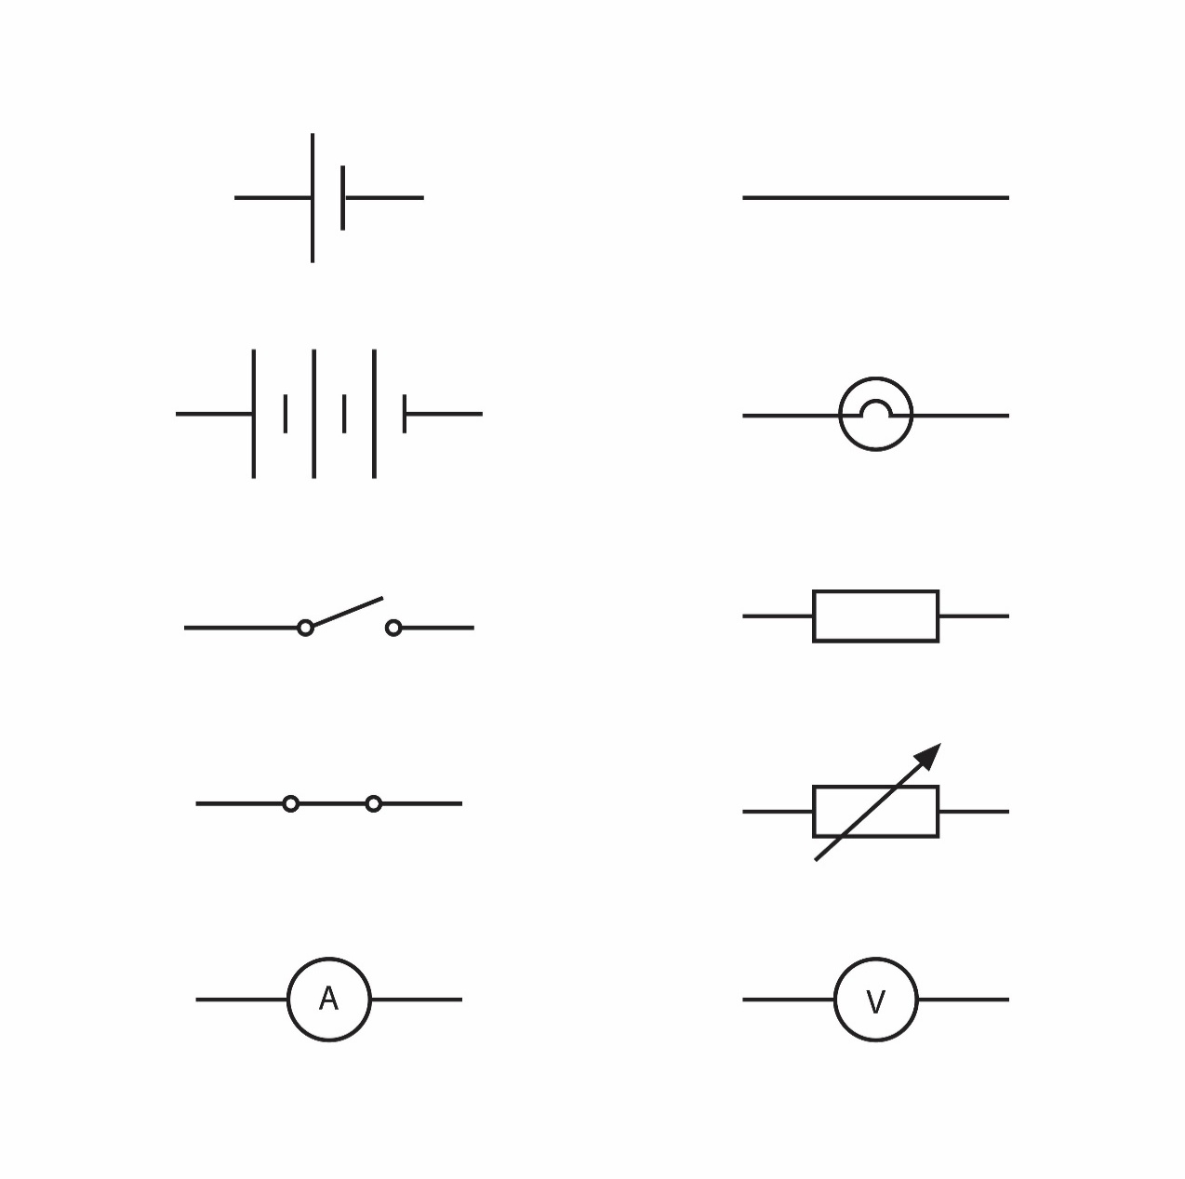 | conductor wire | 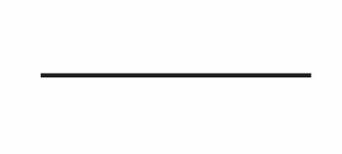
battery | 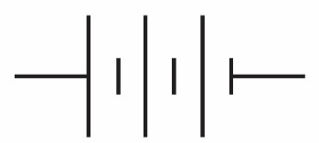 | light globe
open switch | 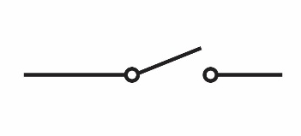 | resistor | 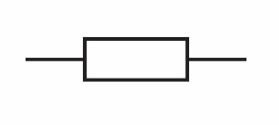
closed switch | 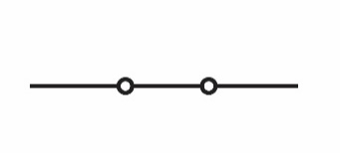 | variable resistor | 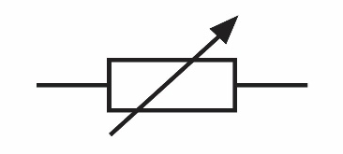
ammeter | 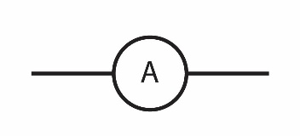 | voltmeter | 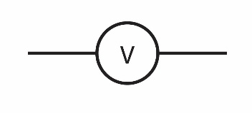

Year 9

Chemical sciences

Activity series of selected metals
 | Metal | Symbol
Most reactive  Least reactive | Lithium | Li | Reacts with oxygen  Reacts with acids  Reacts with cold water  Reacts with boiling water
Most reactive  Least reactive | Caesium | Cs
Most reactive  Least reactive | Rubidium | Rb
Most reactive  Least reactive | Potassium | K
Most reactive  Least reactive | Sodium | Na
Most reactive  Least reactive | Barium | Ba
Most reactive  Least reactive | Strontium | Sr
Most reactive  Least reactive | Calcium | Ca
Most reactive  Least reactive | Magnesium | Mg
Most reactive  Least reactive | Aluminium | A
Most reactive  Least reactive | Titanium | Ti
Most reactive  Least reactive | Manganese | Mn
Most reactive  Least reactive | Zinc | Zn
Most reactive  Least reactive | Chromium | Cr
Most reactive  Least reactive | Iron | Fe
Most reactive  Least reactive | Cobalt | Co
Most reactive  Least reactive | Nickel | Ni
Most reactive  Least reactive | Tin | Sn
Most reactive  Least reactive | Lead | Pb
Most reactive  Least reactive | Copper | Cu
Most reactive  Least reactive | Tungsten | W
Most reactive  Least reactive | Mercury | Hg
Most reactive  Least reactive | Silver | Ag
Most reactive  Least reactive | Gold | Au
Most reactive  Least reactive | Platinum | Pt

Common monatomic and polyatomic ions
Ion name | Formula |  | Ion name | Formula
ammonium | $${NH}_{4}^{+}$$ |  | bromide | $${Br}^{-}$$
copper(I) | $${Cu}^{+}$$ |  | chloride | $${Cl}^{-}$$
hydrogen | $$H^{+}$$ |  | fluoride | $$F^{-}$$
lithium | $${Li}^{+}$$ |  | hydrogencarbonate | $${HCO}_{3}^{-}$$
potassium | $$K^{+}$$ |  | hydroxide | $${OH}^{-}$$
silver | $${Ag}^{+}$$ |  | iodide | $$I^{-}$$
sodium | $${Na}^{+}$$ |  | nitrate | $${NO}_{3}^{-}$$
barium | $${Ba}^{2+}$$ |  | carbonate | $${CO}_{3}^{2-}$$
calcium | $${Ca}^{2+}$$ |  | oxide | $$O^{2-}$$
copper(II) | $${Cu}^{2+}$$ |  | sulfate | $${SO}_{4}^{2-}$$
iron(II) | $${Fe}^{2+}$$ |  | sulfide | $$S^{2-}$$
lead(II) | $${Pb}^{2+}$$ |  | nitride | $$N^{3-}$$
magnesium | $${Mg}^{2+}$$ |  | phosphate | $${PO}_{4}^{3-}$$
zinc | $${Zn}^{2+}$$
aluminium | $${Al}^{3+}$$
iron(III) | $${Fe}^{3+}$$

Physical sciences

Electromagnetic spectrum
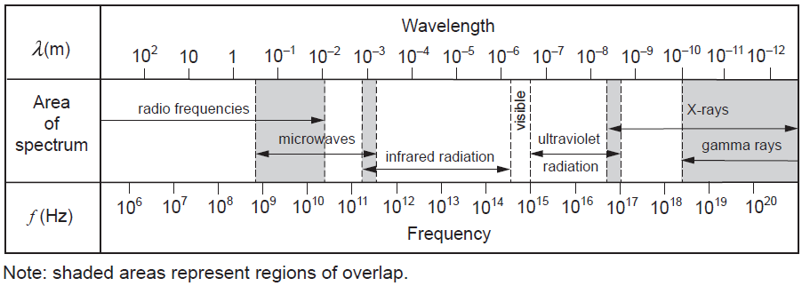

Year 10

Biological sciences

DNA nitrogenous bases
Nitrogenous base | Abbreviation
adenine | A
cytosine | C
guanine | G
thymine | T
Nitrogenous base pairs:
- Adenine and thymine
- Guanine and cytosine.

Representing alleles
Upper case – dominant (B)
Lower case – recessive (b)
- Representation of autosomal alleles as genotype – BB, Bb and bb
- Representation of sex-linked alleles as genotype – X^{B}X^{b} and X^{b}Y, where X represents the female chromosome and Y the male chromosome.

Pedigree chart
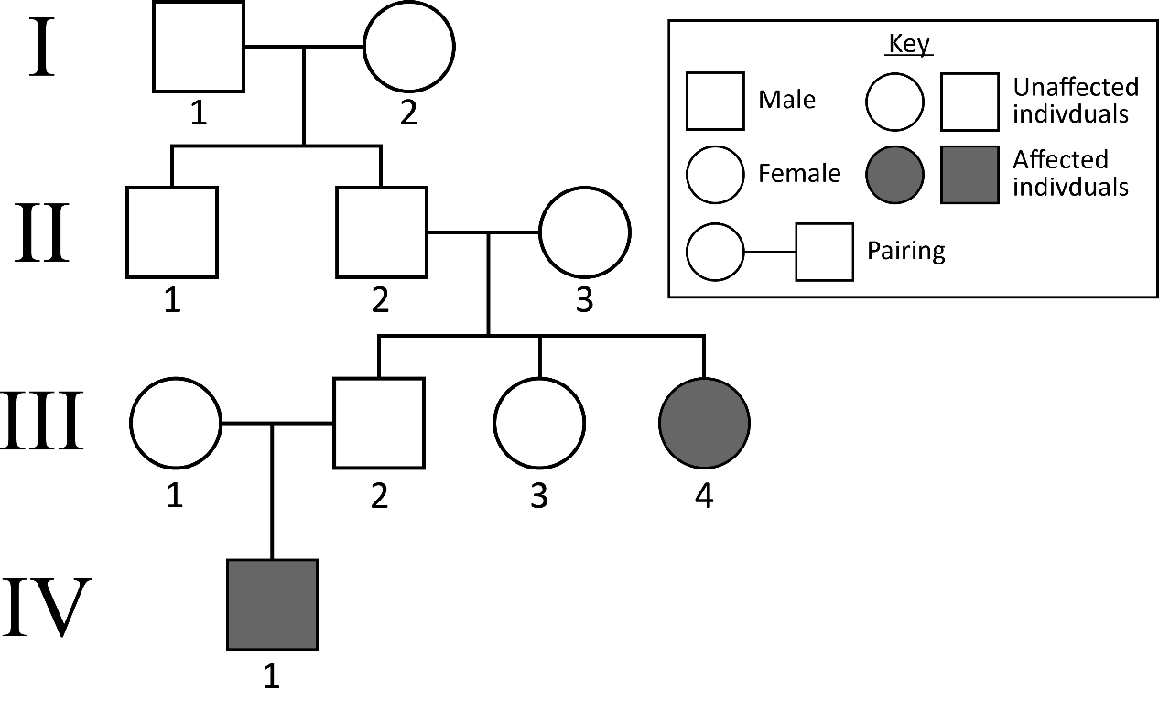
- Roman numerals denote generations.
- Arabic numerals denote individuals within each generation.
- Offspring listed in birth order.

Punnett square
Possible genetic contribution of the other parent
Offspring genotype possibilities
Possible genetic contribution of one parent

 | B | B
B | BB | BB
b | Bb | Bb
This Punnett square shows the possible genotype combinations for a dominant/recessive pattern of inheritance; this would mean all offspring would display the dominant phenotype.

Chemical sciences

Common monatomic and polyatomic ions
Ion name | Formula |  | Ion name | Formula
ammonium | $${NH}_{4}^{+}$$ |  | bromide | $${Br}^{-}$$
copper(I) | $${Cu}^{+}$$ |  | chloride | $${Cl}^{-}$$
hydrogen | $$H^{+}$$ |  | acetate (ethanoate) | $${CH}_{3}COO^{-}$$
lithium | $${Li}^{+}$$ |  | fluoride | $$F^{-}$$
potassium | $$K^{+}$$ |  | hydrogencarbonate | $${HCO}_{3}^{-}$$
silver | $${Ag}^{+}$$ |  | hydroxide | $${OH}^{-}$$
sodium | $${Na}^{+}$$ |  | iodide | $$I^{-}$$
barium | $${Ba}^{2+}$$ |  | nitrate | $${NO}_{3}^{-}$$
calcium | $${Ca}^{2+}$$ |  | carbonate | $${CO}_{3}^{2-}$$
cobalt(II) | $${Co}^{2+}$$ |  | oxide | $$O^{2-}$$
copper(II) | $${Cu}^{2+}$$ |  | sulfate | $${SO}_{4}^{2-}$$
iron(II) | $${Fe}^{2+}$$ |  | sulfide | $$S^{2-}$$
lead(II) | $${Pb}^{2+}$$ |  | nitride | $$N^{3-}$$
magnesium | $${Mg}^{2+}$$ |  | phosphate | $${PO}_{4}^{3-}$$
manganese(II) | $${Mn}^{2+}$$
nickel(II) | $${Ni}^{2+}$$
strontium | $${Sr}^{2+}$$
zinc | $${Zn}^{2+}$$
aluminium | $${Al}^{3+}$$
chromium(III) | $${Cr}^{3+}$$
iron(III) | $${Fe}^{3+}$$

Common acids and bases
Acid name | Formula |  | Base name | Formula
acetic acid | $$\text{C}{\text{H}}_{\text{3}}\text{COOH}$$ |  | ammonia* | $${NH}_{3}$$
hydrochloric acid | $$\text{HC}l$$ |  | sodium hydroxide | $$NaOH$$
nitric acid | $$\text{HN}{\text{O}}_{\text{3}}$$ |  | potassium hydroxide | $$KOH$$
carbonic acid | $${\text{H}}_{\text{2}}\text{C}{\text{O}}_{\text{3}}$$ |  | calcium hydroxide | $$Ca{\left(OH\right)}_{2}$$
sulfuric acid | $${\text{H}}_{\text{2}}\text{S}{\text{O}}_{\text{4}}$$ |  | magnesium hydroxide | $$Mg{\left(OH\right)}_{2}$$
phosphoric acid | $${\text{H}}_{\text{3}}\text{P}{\text{O}}_{\text{4}}$$ |  | *In aqueous solution ammonia (NH₃) produces NH₄⁺ and OH– ions

pH scale
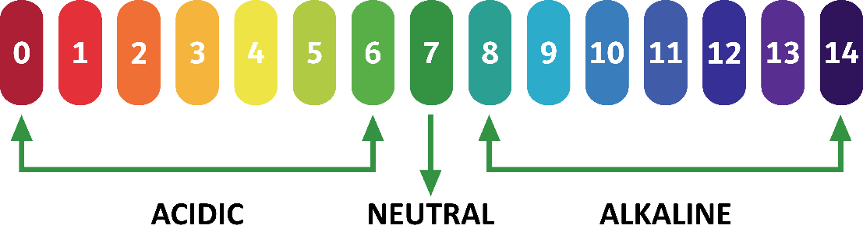

Solubility rules for ionic solids in water
Soluble in water
Soluble | Insoluble
Most chlorides | AgC
Most bromides | AgBr
Most iodides | AgI, CuI, PbI₂
All nitrates | No exceptions
All ethanoates | No exceptions
Most sulfates | SrSO₄, BaSO₄, PbSO₄
Insoluble in water
Insoluble | Soluble
Most hydroxides | NaOH, KOH, Ba(OH)₂, NH₄OH*, AgOH**
Most carbonates | Na₂CO₃, K₂CO₃, (NH₄)₂CO₃
Most phosphates | Na₂PO₄, K₂PO₄, (NH₄)₃PO₄
Most sulfides | Na₂S, K₂S, (NH₄)₂S
*NH₃ dissolves in water to form both NH₃(aq) and the ions NH₄⁺(aq) and OH–(aq)
**Ag⁺(aq) reacts with OH–(aq) to form insoluble Ag₂O
Soluble = more than 0.1 mole dissolves per litre
Insoluble = less than 0.01 mole dissolves per litre

General chemical reactions for predicting products
Acid + metal hydroxide (base) → salt + water
Acid + metal oxide (base) → salt + water
Acid + metal → salt + hydrogen gas
Acid + carbonate → salt + water + carbon dioxide gas
Acid + hydrogencarbonate → salt + water + carbon dioxide gas

Physical sciences

Motion, forces and energy
Time difference | $$t=t_{f}-t_{i}$$
Displacement | $$s=x=x_{f}-x_{i}$$
Average velocity | $$v=\frac{Δx}{Δt}=\frac{x_{f}-x_{i}}{t_{f}-t_{i}}$$
Equations of motion | $$a= \frac{∆v}{∆t}=\frac{v_{f}-v_{i}}{t_{f}-t_{i}} v_{f}=v_{i}+aΔt \\ s=v_{i}Δt+\frac{1}{2}a{Δt}^{2}$$
Force | $$\text{Σ}F=ma$$
Weight force | $$F_{weight}=mg$$

Mechanical energy
Kinetic energy | $$E_{k}=\frac{1}{2}mv^{2}$$
Gravitational potential energy | $$E_{p}=mgΔh$$
Conservation of energy | $$ΣE_{i}=ΣE_{f}$$  For an object moving up or down in a gravitational field  $${∆E}_{k}= {∆E}_{p}$$
Work done | $$W=ΔE$$
Key to symbols
$t$ = time in seconds (s)
$s$ = displacement in metres (m)
$x$ = distance in metres (m)
$v$ = velocity in metres per second (m s^{–1})
$a$ = acceleration in metres per second per second (m s^{–2})
$F$= force in newtons (N)
$m$ = mass in kilograms (kg)
$g$ = acceleration due to gravity (Mean acceleration due to gravity on Earth = 9.80 m s^{–2})
$h$ = height of an object above a reference point in a gravitational field
The subscripts $i$ and $f$ indicate the final and initial states, respectively. For example, $v_{i}$ represents the initial velocity of an object and $v_{f}$ represents the object’s final velocity.

Acknowledgements
Periodic table Data from: International Union of Pure and Applied Chemistry. (2022). IUPAC Periodic Table of the Elements. Retrieved June, 2025, from https://iupac.org/what-we-do/periodic-table-of-elements/
Lunar phases Southern hemisphere graphics from, and northern hemisphere graphics adapted from:
De Wulf, C. (n.d.). 01 Nomoon Openclipart c. 01 [Graphic]. Retrieved December, 2025, from https://openclipart.org/detail/119851/01-nomoon-openclipart-c-01
De Wulf, C. (n.d.). 08 Waningcrescent Openc 01 [Graphic]. Retrieved December, 2025, from https://openclipart.org/detail/119809/08-waningcrescent-openc-01
De Wulf, C. (n.d.). 07 Lastquarter Openclip 01 [Graphic]. Retrieved December, 2025, from https://openclipart.org/detail/119815/07-lastquarter-openclip-01
De Wulf, C. (n.d.). 06 Waninggibbous Opencl 01 [Graphic]. Retrieved December, 2025, from https://openclipart.org/detail/119821/06-waninggibbous-opencl-01
De Wulf, C. (n.d.). 05 Fullmoon Openclipart 01 [Graphic]. Retrieved December, 2025, from https://openclipart.org/detail/119845/05-fullmoon-openclipart-01
De Wulf, C. (n.d.). 04 Waxinggibbous Opencl 01 [Graphic]. Retrieved December, 2025, from https://openclipart.org/detail/119827/04-waxinggibbous-opencl-01
De Wulf, C. (n.d.). 03 Firstquarter Opencli 01 [Graphic]. Retrieved December, 2025, from https://openclipart.org/detail/119833/03-firstquarter-opencli-01
De Wulf, C. (n.d.). 02 Waxingcrescent Openc 01 [Graphic]. Retrieved December, 2025, from https://openclipart.org/detail/119839/02-waxingcrescent-openc-01

