Assessment task
Year level | 7
Learning area | Humanities and Social Sciences
Subject | Geography
Title of task | How liveable is your community?
Task details
Description of task | Accompanied by their teacher, students walk around their local area and record all the features of the urban environment that they see, both physical (natural) and cultural (made by human beings), into a fieldwork booklet  If needed, the fieldwork booklet can be completed via virtual fieldwork using a resource like Google maps, individually or as a class  Students will complete an extended piece of writing, based on their prior knowledge, classroom lessons and fieldwork observations, about the liveability of a place, and the community they live in.
Type of assessment | Summative
Purpose of assessment | To assess students’ understanding of key geographical concepts and skills as they apply to an evaluation of liveability in their local area
Assessment strategy | Written responses, graphic organiser (e.g. field work booklet, note taking) and visual representation (e.g. map)
Evidence to be collected | - Fieldwork booklet inclusive of sketch map  - Extended written response
Suggested time | - Fieldwork – two to three hours  - Sketch map – 1 hour  - In class written task – 50 minutes
Content description
Content from the Western Australian Curriculum | Knowledge and Understanding  - The factors that influence the decisions people make about where to live and their perceptions of the liveability of places  - The influence of accessibility to services and facilities on the liveability of places  - The influence of environmental quality on the liveability of places
Humanities and Social Sciences Skills
Questioning and Researching
- Use a variety of methods to collect relevant information and/or data from a range of appropriate sources, such as print, digital, audio, visual and fieldwork
- Represent information and/or data using appropriate formats to suit audience and purpose (e.g. tables/graphs, visual displays, models, timelines, maps, other graphic organisers)
Analysing
- Interpret information and/or data to identify key relationships and/or trends displayed in various formats (e.g. change over time in a series of images, identify spatial distributions from a map)
- Identify points of view/perspectives, attitudes and/or values in information and/or data (e.g. from tables, statistics, graphs, models, cartoons, maps, timelines)
Communicating and Reflecting
- Represent information and/or data using appropriate formats to suit audience and purpose (e.g. tables/graphs, visual displays, models, timelines, maps, other graphic organisers)
- Develop texts, particularly descriptions and explanations, using appropriate
subject-specific terminology and concepts that use evidence to support findings, conclusions and/or arguments, from a range of sources
Task preparation
Prior learning | Students have prior knowledge of the key concepts, geographical mapping skills and the conventions of constructing a sketch map.  Students will have completed in class learning activities on the relevant syllabus knowledge and understandings content.
Assessment differentiation | Teachers should differentiate their teaching and assessment to meet the specific learning needs of their students, based on their level of readiness to learn and their need to be challenged.  Where appropriate, teachers may either scaffold or extend the scope of the assessment tasks.
Assessment task
Assessment conditions | Students complete the extended written task under test conditions. During the task, students may refer to their fieldwork booklets only.
Resources | Fieldwork booklet
Key concepts | Place, Space, Environment, Interconnection, Sustainability, Scale, Change

Instructions for teacher
Prior learning suggested activities and resources for the teacher:
- Revise the following key concepts as they relate to liveability: space, place, scale, interconnections, change, environment, sustainability.
- Define what is meant by the term liveability and the difference between cultural and physical features.
- Liveability: An assessment of what a place is like to live in, using particular criteria, for example, environmental quality; crime and safety; education and health provision; access to shops and services; recreational facilities and cultural activities.
- Physical features are features of the earth, such as landforms, vegetation, climate and water supply.
- Cultural features are manmade features, such as buildings, roads, bridges, hospitals, schools, playgrounds, swimming pools, public transportation.
- Urban environment is an area where there is human settlement and contains such things as houses, shops, schools, roads and railways. Urban environments can refer to towns, cities, suburbs.
- Discuss how liveability is measured can vary from person to person depending on what the person values. Students consider how a person’s perspective on liveability may be determined by age, background, physical abilities, religious beliefs etc.
- Ask students how would they determine the liveability of one place compared to another. Is there some kind of scale for measuring the liveability of cities?
- Students brainstorm a list of criteria they would use to measure the liveability of an area.
- Discuss the following with students:
- As it happens, there are a number of scales and rankings of the liveability of the world's cities. One of the best known is the Global Liveability Report, produced annually by the Economist Intelligence Unit (EIU). Among the factors considered in its ranking of the ‘world's most liveable cities’ are:
- stability (lack of civil unrest, crime and violence)
- healthcare
- culture
- education
- infrastructure
- environment.
- Based on these criteria, mid-sized cities in the more developed countries of the world generally dominate the ‘Top 10’.
- Internationally, the quality of life in Australia is considered to be very high.
- This perception, combined with the relatively small populations of Australian cities, means that our cities perform well in these rankings. Will this continue if the populations of Australia's major cities grow as expected? https://education.abc.net.au/home#!/digibook/1278012/wheres-the-best-place-to-live Chapter 5

Push / Pull Factors
Have students complete the table below showing all the factors they like (pull factors) and the features they dislike (push factors) about where they live. Include both cultural and physical features.
Push Features  What would repel people from living in a certain place? | Pull Features  What would attract people to live in a certain place?
Using the following source of information, design a visual display of the factors that make a suburb liveable.
https://www.domain.com.au/news/what-makes-a-suburb-liveable-the-16-factors-that-make-or-break-a-neighbourhood-20160730-gqhdkw-281398/

Essential services and facilities
- Ask students the following questions:
  - What is the difference between a service and facility?
  - What makes a service or facility essential?
- Students to write down their responses.
- Show the https://www.youtube.com/watch?v=h65tGO2tojQ
- Ask students the following questions.
  - What services and facilities did they see and what they notice missing?
  - Do they have access to the services and facilities that they notice missing in the video?
  - What would they miss and how would their daily life change if they did not have access to these services and facilities?
- Students make a list of the 10 essential services and facilities they see as important for a good quality of life and explain their ranking in a paragraph ____________________________________________________________________________________________________________________________________________________________________________________________________________________________________________________________________________________________________________________________________________________________________
- Watch the video below and discuss with students, what factors may the people in the video list as important? https://playingout.net/ Make your street a place to play
- Using the following website as a guide have students in groups evaluate a range of public spaces in their city and/or community.
  - What makes a great place https://www.pps.org/article/grplacefeat
- Have students select a public place they are familiar and get them to create a sketch map of the public space locating all of the features, which they have identified as making it either a great place or a not so great place.
- Prior to students beginning this task, revise all of the mapping conventions required to construct a sketch map and provide students with sample sketch maps.
- Inform students that the sketch map should include all the conventions of mapping: North Point, legend (appropriate use of symbols/labels to identify features), title and scale (appropriate spatial location and distribution of liveable features).
- Students can use Google maps as a source to construct their sketch map.
- This is a great tutorial on how to use Google maps Step inside map Kings park https://www.youtube.com/watch?v=tio7xSc8x4s.
- Sample sketch maps
- https://www.bgpa.wa.gov.au/calendar/details/395-meet-wa-artist-trudi-pollard?pop=1&tmpl=component
- https://www.perthbouncycastlehire.com.au/wp-content/uploads/2018/05/2018-WA-Day-Festival-Map-Elizabeth-Quay-FINAL-APPROVED.jpg
Good resource on how to teach sketch mapping
https://ccea.org.uk/learning-resources/geography-lesson-idea-mapwork
Organise to take the students for a walk around the local community for half a day. During the fieldwork, teachers may:
- encourage students to create ‘how’ questions relating to their observations of the area, and develop ideas and draw conclusions on cultural and physical features and their uses
- model identification of cultural and physical features during the field trip
- point out features and the uses of the features
- use geographical language and make reference to features to illustrate the relevant key concepts,
e.g. identify interconnections among features.
After completing the field work provide one additional lesson for students to complete sketch map.
You may wish to have students complete the following survey
http://www.geogspace.net.au/files/Core/Exemplars/Yr7/ select 17.5.1 Neighbourhood liveability survey
The survey is included as part of assessing the liveability of places found at: http://www.geogspace.net.au/Core%20units/Years%207-8/Exemplars/y7-exemplars-y7-illus5.php

Instructions to students

How liveable is your community?

Conditions

This task is to be completed in class under standard test conditions

Time for the task: 40 minutes
___________________________________________________________________________________________
Think about the work you completed in class, look at your fieldwork booklet and answer the following questions.
- Explain the term ‘liveability’, including why and how liveability can be measured in different ways. You must include examples in your explanation. (5 marks)
_________________________________________________________________________________________________________________________________________________________________________________________________________________________________________________________________________________________________________________________________________________________________________________________________________________________________________________________________________________________________________________________________________________________________________________________________________________________________________________________________________________________________________________________________________________________________________________________________________________________________________________________________________________________________________________________________________________________________________________________________________________________________________________________________________________________________________________________________________________________________________________________________________________________________________________________
- How liveable is your local community? (8 marks)
In your answer you need to:
- discuss what features of your community make it liveable (remember your definition)
- consider all the different groups of people within your community and how their needs are met
e.g. different age groups and interest groups
- include specific examples to support your discussion, referring to both cultural and physical features
- your overall conclusion about how liveable is your local community.
_____________________________________________________________________________________________________________________________________________________________________________________________________________________________________________________________________________________________________________________________________________________________________________________________________________________________________________________________________________________________________________________________________________________________________________________________________________________________________________________________________________________________________________________________________________________________________________________________________________________________________________________________________________________________________________________________________________________________________________________________________________________________________________________________________________________________________________________________________________________________________________________________________________________________________________________________________________________________________________________________________________________________________________________________________________________________________________________________________________________________________________________________________________________________________________________________________________________________________________
______________________________________________________________________________________________________________________________________________________________________________________________________________________________________________________________________________________________________________________________________________________________________________________________________________________________________________________________________________________________________________________________________________________________________________________________________________________________________________________________________________________________________________________________________________________________________________________________________________________________________________________________________________________________________________________________________________________________________________________________________________________________________________________________________________________________________________________________________________________________________________________________________________________________________________________________________________________________________________________________________________________________________________________________________________________________________________________________________________________________________________________________________________________________________________________________________________________________________________________________________________________________________________________________________________________________________________________________________________________________________________________________________________________________________________________________________________________________________________________________________________________________________________________________________________________________________________________________

Fieldwork booklet
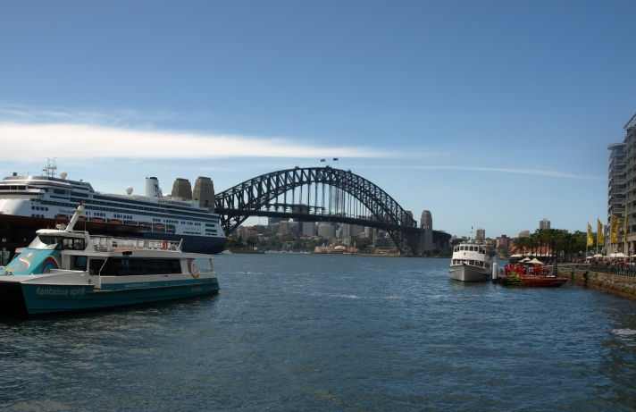
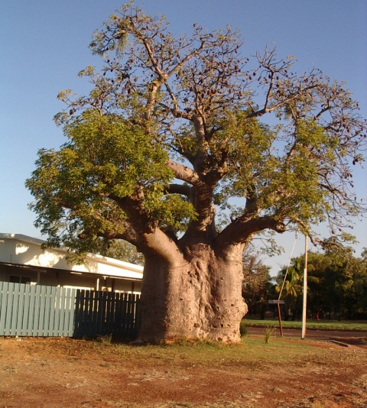
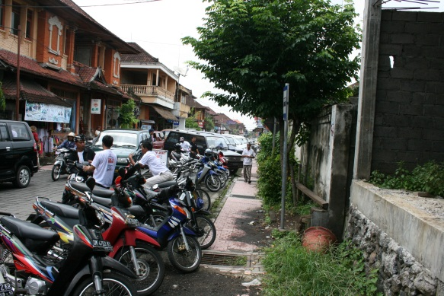
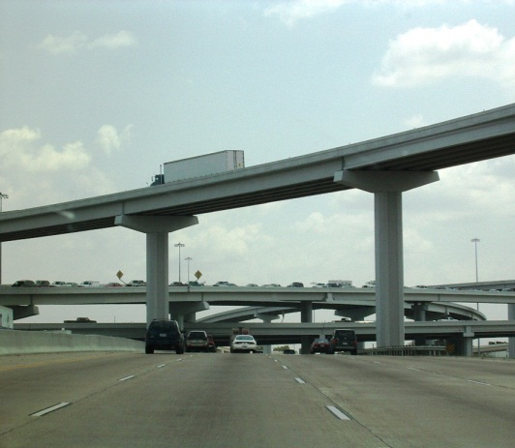
[Photographs by courtesy of writer.]
How liveable is your community?
There are many factors that influence where people live. A liveable city/suburb has characteristics which can be classified into various areas. This field trip will help you to gain an understanding about urban settlements and the concept of liveability.
The sketch map will be completed in class in the lesson following the field trip.
If needed this fieldwork booklet can be completed via Google maps

Observation walk around your community
You need to complete your booklet carefully as you will be doing an in-class writing task based on your fieldwork.
- Record all the features of the urban environment that you see, both physical (natural) and cultural (man-made) and describe any interconnections that you can see between the features.
Physical features | Cultural features

Interconnections between features
- Record specific examples of the urban functions in your neighbourhood and describe how the example relates to one of the following key geographical concepts.
Concepts: space, place, scale, interconnections, change, environment, sustainability
Urban function | Specific examples | Key concept
Retail, e.g. shops |  | Example: is this space arranged in any specific pattern?
Commercial, e.g. businesses
Residential, e.g. homes
Recreational, e.g. parks
Educational, e.g. school
Special purpose, e.g. hospital
- Record specific examples of the urban functions in your neighbourhood which would make it more liveable to certain groups of people in the community.
Group | Urban function/s
Example: Young families | Parks with playground equipment
Teenagers
Cyclists
List as many different groups as you can think of and provide an example of the urban functions that are available in your suburb.
- List examples of any areas and/or features which needs improving
Area | Why/how it needs improving

Sketch map
In the space below, draw a sketch map to design a community, which maximises liveability. You need to consider what makes a community liveable and will it address the needs of all the people living in the community. Your sketch needs to contain the following:
- orientation (north point) | - legend (key)
- title | - scale (ensure all features are proportional to each other)

Key

Marking key
Description | Marks
Question 1: Define liveability
Explains in detail the term liveability, including why and how liveability can be measured in different ways. Includes relevant and specific examples in the explanation.  Applies relevant geographical terminology and concepts to develop explanation. | 5
Explains briefly the term liveability, including why and how liveability can be measured in different ways. Includes relevant examples in the explanation.  Applies relevant geographical terminology and concepts to develop explanation. | 4
Describes the term liveability, including why or how liveability can be measured in different ways. Include relevant examples in the explanation.  Uses some relevant geographical terminology or concepts to develop description. | 3
Describes briefly the term liveability, provides limited examples.  Uses some geographical terminology. | 2
Makes an accurate generalised statement about liveability. | 1
Subtotal | 5
Answer could include but is not limited to:
Liveability – an assessment of what a place is like to live in, using criteria like environmental quality, crime and safety, education and health provision, access to shops and services, recreational facilities and cultural activities
Liveability is based on a list of personal criteria, which can change and vary according to an individual’s circumstances and perceptions of liveability. A variety of factors can influence our perceptions of the liveability of places, e.g. age, income, wealth, employment, aspirations, interests, location, climate. Perceptions can change over time due to personal circumstances and situations.
Question 2: Extended answer
Discusses in detail the level of liveability of their community, with detailed reference to specific relevant examples.  Considers multiple perspectives, identifying specific features (or lack of features) in their community and makes detailed connections between the features with specific groups of residents in their community and how this may determine people’s perspectives on the liveability of the community.  Applies relevant geographical terminology and concepts to develop discussion. | 7–8
Discusses the level of liveability of their community, with reference to specific relevant examples.  Considers some perspectives, identifying some features (or lack of features) in their community and makes some links between the features with specific groups of residents in their community.  Applies some relevant geographical terminology and concepts to develop discussion. | 5–6
Explains briefly the level of liveability of their community, with reference to some relevant examples.  Provides general statements about other perspectives, identifying some features (or lack of features) in their community, and makes some limited links between the features with specific groups of residents in their community.  Uses some geographical terminology and/or concepts. | 3–4
Makes generalised statements about the liveability of their community. | 1–2
Subtotal | 8
Sketch map
Comprehensively designs an urban area that integrates all the characteristics of a liveable community, including environmental, social and economic, e.g. natural bushland (not just parks), rivers, schools, health centres, shopping centres, libraries.  Correctly uses all conventions of mapping: orientation, legend (appropriate use of symbols/labels to identify features), title and scale (appropriate spatial location and distribution of liveable features).  Demonstrates an understanding of the characteristics of liveability and the design of the sketch map is inclusive of addressing the needs of all residents. | 7–8
Designs an urban area that integrates most of the characteristics of a liveable community, including environmental, social and economic, e.g. natural bushland (not just parks), rivers, schools, health centres, shopping centres, libraries.  Correctly uses most mapping conventions: orientation, legend (appropriate use of symbols/labels to identify features), title and scale (appropriate spatial location and distribution of liveable features).  Demonstrates an understanding of the characteristics of liveability and the design of the sketch map is inclusive of addressing the needs of most residents. | 5–6
Designs an urban area that integrates a few of the characteristics of a liveable community, environmental, social and economic, e.g. natural bushland (not just parks), rivers, schools, health centres, shopping centres, libraries.  Correctly uses some mapping conventions: orientation, legend (appropriate use of symbols/labels to identify features), title and scale (appropriate spatial location and distribution of liveable features).  Demonstrates an understanding of the characteristics of liveability and the design of the sketch map is inclusive of addressing the needs of some residents. | 3–4
Creates a mostly incomplete sketch map of an urban area with limited identifiable features  using limited mapping conventions. | 1–2
Subtotal | 8
Fieldwork booklet
Complete a fieldwork booklet that contains detailed, organised, relevant information, about all sections of the fieldwork, using relevant geographical terminology. | 4
Complete a fieldwork booklet that contains organised, relevant information, about most sections of the fieldwork, using relevant geographical terminology. | 3
Completes a fieldwork booklet that contains some relevant brief information, about some sections of the fieldwork, using some relevant geographical terminology. | 2
Completes a fieldwork booklet that contains brief generalised incomplete statements. | 1
Subtotal | 4
Total | 25

