Assessment task
Year level | 7
Learning area | Mathematics
Subject | Measurement and Geometry
Title of task | Perimeter and area
Task details
Description of task | Students will sketch rectangles, triangles and parallelograms according to specific conditions for perimeter and area.
Type of assessment | Summative
Purpose of assessment | This task may be used to determine a student’s achievement against the Judging Standards assessment pointers for the measurement and geometry strand, including the proficiencies of knowledge, understanding, reasoning and problem solving.
Assessment strategy | An in-class task in two parts (Parts A and B) conducted under test conditions.
Evidence to be collected | Completed task
Suggested time | 2 x 1-hour lessons or equivalent
Content description
Content from the Western Australian Curriculum | Establish the formulas for areas of rectangles, triangles and parallelograms, and use these in problem-solving  Classify triangles according to their side and angle properties and describe quadrilaterals
Task preparation
Prior learning | Students are familiar with the difference between perimeter and area of shapes and the formulas for the perimeter and area of rectangles, triangles and parallelograms.  They are familiar with the properties of rectangles and parallelograms, and can distinguish between right, acute and obtuse-angled triangles.
Assessment differentiation | Teachers should differentiate their teaching and assessment to meet the specific learning needs of their students, based on their level of readiness to learn and their need to be challenged.  Where appropriate, teachers may either scaffold or extend the scope of the assessment tasks.
Assessment task
Assessment conditions | - Test conditions
Resources | - Grid paper
Instructions for teacher
Assessment activity
The assessment task has two sections and is conducted over two periods to give all students the opportunity to demonstrate what they can do.
The size of the required perimeters and areas prohibits students from using grid paper to sketch the actual size of the required shapes; however, grid paper may provide assistance for some students.
The marking key outlines a range of observable behaviours and skills which provide evidence of achievement against the Judging Standards assessment pointers.

Instructions to students
This task provides an opportunity for you to demonstrate what you know about the perimeter and area of rectangles, triangles and parallelograms. You will also be asked to produce clear mathematical diagrams that provide information but do not have to be to scale.
You may use grid paper.
Part A
- Sketch a diagram of a rectangle, a triangle and a parallelogram so that each shape has a perimeter of 180 units.
Clearly label the lengths on your diagrams. Justify the lengths you have chosen for each of your shapes.
- Sketch a diagram of a rectangle, an obtuse-angled triangle and a parallelogram so that each shape has an area of 180 square units.
Clearly label the dimensions on your diagrams. Justify the dimensions you have chosen for each of your shapes.
- Sketch a diagram of a rectangle, an acute-angled triangle and a parallelogram so that each shape has an area of half a square metre (5000 cm²) and one side measuring 40 cm.
Clearly label the dimensions on your diagrams. Justify the dimensions you have chosen for each of your shapes.
Part B
- A farmer wants to construct two temporary enclosures for some cattle. He has 400 m of portable fencing. He wants to use all the fencing and to make two paddocks of equal size that share a common fence.
Draw diagrams and clearly show the dimensions of three different ways the farmer could construct the paddocks.
State which of your three designs provides the greatest total area for the cattle and justify your decision with calculations.

Sample marking key
Part A
Description | Marks
Question 1
Labelled sketch of a rectangle, triangle and parallelogram, each with a perimeter of 180 units. | 3
Justification of dimensions of the rectangle (add to 90 units). | 1
Justification of lengths of sides of triangle (add to 180 units). | 1
Justification of lengths of adjacent sides of parallelogram (add to 90 units). | 1
Subtotal | 6
Description | Marks
Question 2
Labelled sketch of rectangle, obtuse-angled triangle and parallelogram, each with an area of 180 square units. | 3
Justification of dimensions of rectangle refers to product of length and width as 180 square units. | 1
Justification of dimensions of parallelogram refers to product of base and perpendicular height as 180 square units. | 1
Justification of dimensions of obtuse-angled triangle refers to half the product of triangle’s base and perpendicular height and where product is 360 square units. | 2
Subtotal | 7
Description | Marks
Question 3
Labelled sketch of a rectangle, with one side 40 cm and length of other side giving a product of half a square metre e.g. 40 cm x 125 cm = 5000 cm² . | 2
Labelled sketch of acute-angled triangle and parallelogram shows length of base as 400 mm (or relevant conversion) and perpendicular height as other dimension. | 4
Justifications of dimensions of shapes refer to compatibility of units  e.g. m², m or cm², cm or mm², mm. | 1
Justification of dimensions of rectangle recognises one side is 40 cm and other a correct factor of half a square metre (expressed in square centimetres). | 2
Justification of dimensions of acute-angled triangle and parallelogram recognises base as 40 cm and correct length of perpendicular height. | 3
Subtotal | 12

Part B
Description | Marks
Question 4
Labelled sketch of two identical rectangles with a common side of length n and the width of each rectangle as $\frac{400-3n}{4}$ e.g. common length 20 m, width of each rectangle = $\frac{400-3×20}{4}$ = 85 m  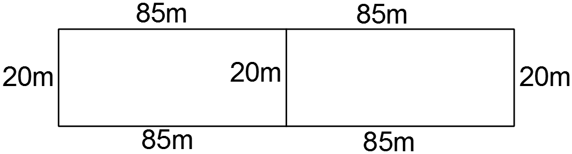 | 3
Labelled sketches of two more diagrams containing identical rectangles as above but for different values of n | 6
Calculates total area of each of the three paddocks drawn and states the paddock that has the greatest total area | 4
Subtotal | 13
Total | 38

