Sample assessment task
Year level | 6
Learning area | Languages
Subject | Italian: Second Language
Title of task | Parliamoci del tempo libero!
Task details
Description of task | Students demonstrate their knowledge and understanding of vocabulary, language structures and grammatical items related to free time.  In Part A students demonstrate their skills in comprehending spoken texts by accessing and summarising key information from the descriptions of free time preferences.  In Part B students demonstrate their skills in speaking Italian by exchanging information in a conversation with a partner about free time and negotiating arrangements for an outing on the weekend.
Type of assessment | Summative
Purpose of assessment | This assessment aims to determine student learning at the time of the assessment. It establishes information on the students’ ability to ability to comprehend and to convey information from spoken texts. It also establishes information on the student’s ability to exchange information about free time, and to negotiate and solve a problem as to secure an invitation for a shared experience.
Assessment strategy | Short response – listen for information in spoken Italian text  Oral performance – participate in a conversation
Evidence to be collected | Part A – Completed task sheets  Part B – Audiovisual recording of conversation
Suggested time | Part A – 20 minutes  Part B – 20 minutes preparation with a partner, 10 minutes practice, then 3 minutes presentation per pair
Content description
Content from the Western Australian Curriculum | Communicating  Initiate interactions with others, using descriptive and expressive language to exchange information and relate experiences about free time  Participate in routine exchanges to express feelings, opinions and personal preferences about people, things and places  Collaborate with partners in guided tasks to plan events or activities to showcase their progress in learning and using Italian, developing projects or budgeting for a shared event  Gather, compare and respond to information and supporting details from a range of written, spoken, digital and multimodal texts related to their personal and social worlds  Convey information, ideas and opinions related to their personal and social worlds, selecting appropriate written, spoken, digital and multimodal texts, to suit specific audiences and contexts  Engage in intercultural experiences, describing aspects of language and culture that are unfamiliar and discussing their own reactions and adjustments  Understanding  Explain and apply features of intonation, pronunciation and writing conventions such as understanding that there are both grave accents (è)and acute accents (perché)  Use context-related vocabulary and develop and apply knowledge of grammatical elements in simple spoken and written texts to generate language for a range of purposes, including:  - expressing positive and negative preferences using adverbs to intensify the meaning, for example, Mi piace molto la cioccolata; Non mi piace tanto ballare  - expressing negation, for example, Noi non guardiamo la televisione; Non pratico lo sport  - formulating questions and requests, for example, Cosa fai il weekend?; Dove andiamo stasera?  - recognising the position of adverbs in sentences, for example, Non vado mai in città/al cinema  - using all forms of the present tense of regular and some irregular verbs to present situations and events, including those in the immediate future, for example, using avere, essere, stare, giocare, dormire, fare, leggere, scrivere, andare in sentences such as Ti piace giocare a carte o preferisci giocare a pallone?; Domani sera andiamo al ristorante per la cena  using the perfect tense of common verbs such as essere + andare, avere + vedere and giocare to relate experiences, for example, Domenica pomeriggio Alex ed io siamo andati in citta. Abbiamo visto un film e poi abbiamo mangiato una pizza  Understand how Italian texts use language in ways that create different effects and suit different audiences
Task preparation
Prior learning | Students have prior knowledge of and exposure to:  - a variety of texts and text types related to free time  - context-related vocabulary; for example, i passatempi, gli sport, i giorni  - grammatical items, including: expressing positive and negative preferences using adverbs to intensify the meaning, expressing negation, formulating questions and requests, recognising the position of adverbs in sentences, using all forms of the present tense of regular and some irregular verbs to present situations and events, including those in the immediate future, using the perfect tense of common verbs such as essere + andare, avere + vedere and giocare to relate experiences  - the textual conventions of a conversation.
Assessment differentiation | Teachers should differentiate their teaching and assessment to meet the specific learning needs of their students, based on their level of readiness to learn and their need to be challenged.  Where appropriate, teachers may either scaffold or extend the scope of the assessment tasks.
Assessment task
Assessment conditions | Task is to be completed by students working in pairs. They plan and practise together and then participate in a conversation.
Resources | Task sheets  Italian/English – English/Italian dictionary  Recording devices  Blank paper
Instructions for teacher
Prior to administering the task, introduce to/revise with students:
- a variety of written, spoken and audiovisual texts related to free time
- vocabulary and expressions related to:
  - free time activities, days of the week, times
  - exchanging information about what they did, do, like to do on the weekend free time activities; for example, i passatempi, gli sport, i giorni, likes and dislikes
  - negotiating arrangements, including greetings and salutations, making, accepting and refusing an invitation.
- grammatical structures, including;
  - expressing positive and negative preferences using adverbs to intensify the meaning
  - expressing negation
  - formulating questions and requests
  - recognising the position of adverbs in sentences
  - using all forms of the present tense of regular and some irregular verbs to present situations and events, including those in the immediate future
  - using the present perfect tense of common verbs such as essere + andare, avere + vedere and giocare to relate experiences
taught the textual conventions of a conversation and provided with opportunities to practise them.
Provide opportunities for students to engage in activities such as:
- responding to spoken and written texts about free time activities and making arrangements, for example,
  - Cpia Smart – CPIA di Udine – Come passi il tempo libero?
https://www.youtube.com/watch?v=JIYuR2nZO2M
  - Jacopo – Cosa hai fatto il fine settimana? – sub ita
https://www.youtube.com/watch?v=3mSUf_t3hh4
  - Istituto Il David Italian language school Florence – Mini dialogo: Invitare un'amica al cinema
https://www.youtube.com/watch?v=HpKIHnUoWdM
  - Kappa Language School – Invitare, accettare, rifiutare in italiano L2 – Allo stadio (activity 3)
https://www.kappalanguageschool.com/invitare-accettare-rifiutare-allo-stadio-italiano-l2/
  - Audio Lingua – Silvia: Invito a una festa
https://audio-lingua.eu/spip.php?article3839&lang=fr
- responding to images associated with free time and making arrangements
- completing grammatical and vocabulary exercises, such as,
  - Wordwall – Nel tempo libero mi piace
https://wordwall.net/it/resource/8822101/italiano-l2/nel-tempo-libero-mi-piace
  - Italian.ToLearnFree.com – Infinitive
https://italian.tolearnfree.com/free-italian-lessons/free-italian-exercise-55842.php
  - Live Worksheets – Essere o Avere
https://www.liveworksheets.com/worksheets/it/Italiano/Verbo_essere_e_verbo_avere/Essere_o_Avere_gb1343946la
  - Languages Online – The Perfect Tense
https://www.languagesonline.org.uk/Italian/Grammar/Perfect_Tense/Index.htm
- translating information from Italian to English and vice versa
- providing students with cue cards and asking that they use the information provided on the cards to ask their partner out, or to participate in an activity
- writing short texts about free time and making arrangements, for example, a dialogue between two friends where one is inviting the other to their birthday party.
Task

Parliamoci del tempo libero!
Part A Il tempo libero
Provide students with the task sheet.
Students listen to a conversation and a series of short descriptions and complete the related activities in English.
Prior to playing a recording of/reading the spoken texts, advise students to read the questions and predict:
- the type of information required to respond
- the Italian words they may expect to hear.
Students have 20 minutes to complete Part A.
They may use a bilingual dictionary to complete Part A of the task.
Transcript for Part A
Activity 1
Listen to Marco, Thomas and Anna talking about themselves. Based on the information they provide which of the images below belongs to each person. Write the letter for the corresponding picture next to the relevant name. You will hear each person speak twice.
Note: There are more pictures then people.
- Ciao Sono Marco, e sono molto sportivo. Mi piacciono molti sport ma preferisco il calcio. Il sabato gioco con la mia squadra.
- Sono Anna. Mi piace l’aria aperta e l’avventura. Il weekend mi piace fare il campeggio con mio padre e mio fratello. Andiamo in montagna.
- Mi chiamo Thomas. Il weekend mi piace stare a casa e rilassarmi il più possibile. Mi piace leggere e giocare ai videogiochi.
Activity 2
Alex and Sara are arranging an outing. Listen to their conversation and choose the response that best matches the information provided in the conversation. You will hear the conversation twice.
Alex: Vuoi prendere una pizza insieme?
Elena: Quando?
Alex: Giovedì, dopo scuola.
Elena: Mi dispiace, ho una lezione di violino.
Alex: Allora, ti va di andare a bowling domenica sera?
Elena: Mi piace molto il bowling, però mio padre non mi permette di uscire domenica sera. Possiamo andare sabato pomeriggio?
Alex: Sabato vado al cinema con mio fratello e un amico. Vuoi venire?
Elena: Sono libera, ma dipende. Quale film vedete?
Activity 3
Listen to Lidia, Cris and Enzo talk about their weekend activities.
Ciao sono Lidia. Sabato sono uscita con mia sorella Gianna. Siamo andate a fare le spese in centro e abbiamo preso una pizza e un gelato.
Sono Cris. Domenica sono stata a casa e ho guardato la televisione. Domenica sera sono andata a mangiare una pizza con la mia famiglia.
Mi chiamo Enzo. Venerdi sera sono andato a prendere una pizza con Paola. Dopo siamo andati al cinema. Domenica sono andato in spiaggia con il mio fratello.
Part B Cosa facciamo?
Students have a conversation with a classmate. The conversation begins with a discussion about what students did during the past weekend. This is followed by a conversation about their preferences for free time activities, and making arrangements for a shared activity.
Students:
- ask a question and provide information in response to two questions (their own and the question asked by their partner) about what they did the previous weekend. An example conversation has been provided in Diagram 1.
- ask a question, and a follow up question about free time preferences. Respond to a question and follow-up question from their partner
- make arrangements for a shared experience. Both students must include accepting and refusing an invitation.
The following are suggestions of questions that could be used in the conversation:
- Cosa hai fatto nel weekend? or Cosa hai fatto sabato sera?
- Sei andato al cinema nel weekend? or Hai giocato a ...?
- Ti è piaciuto?
- Qual è il tuo passatempo/sport preferito?
- Ti piace leggere?, Fai sport? or Vai in bici spesso?
- Vuoi venire ...? or Usciamo sabato pomeriggio?
Remind students of how to use E tu? to maintain a conversation and avoid repetition. They should include salutations and leave-taking in their conversation.
Explain to students that they will be marked on:
- Content – Have they included the information required by the task?
- Grammatical elements and vocabulary – Have they used full sentences, the names for a variety of activities, times, days of the week, verbs, and tenses?
- Pronunciation and intonation – Have they spoken clearly and used appropriate Italian pronunciation?
- Comprehension and fluency – Have they understood what their partners has asked/said and does their conversation flow?
Provide students with paper on which to plan their conversation.
Allow students 20 minutes to work in pairs to plan their conversation, including selecting the questions they will ask each other. Students then have 10 minutes to practise with their partner. Remind them to include ‘hellos’ and ‘goodbyes’ in their conversation.
Advise students that the conversation will be recorded.
Ask students to form groups of six and present their conversation to their group. One of the other students in the group records the conversation.
Diagram 1
Before providing students with the task sheet show/explain to them how the questions and responses may progress, using a visual, such as the following. Aspects of the visual could be used prior to assessment to discuss with students how to manipulate familiar language for their own purpose.
Person 1 asks a question about the previous weekend; for example,
Cosa hai fatto sabato?
Person 2 responds and asks for the same/similar information by either repeating the question or using other expressions; for example, E tu?; Tu, cosa hai fatto?
Sabato mattina ho fatto Karatè con i miei amici. E tu?
Person 1 responds; for example,
Sabato mattina sono andato/a in bici con mia sorella.
Person 2 asks an another question about the past weekend; for example,
Cosa hai fatto domenica pomeriggio?
Person 1 responds and asks for the same/similar information using E tu?; for example,
Ho giocato ai videogiochi. Tu, hai giocato ai videogiochi?
Person 2 responds asks about free time preferences; for example,
No. Ho letto e sono andato/a in piscina. Ti piace leggere?
Person 1 responds and asks another question; for example,
Sì, mi piace, ma preferisco ascoltare la musica. Ti piace ascoltare la musica?
Person 2 responds; for example,
Sì mi piace molto la musica.
Person 1 responds and suggests an activity and time; for example,
Vuoi venire a casa mia dopo scuola a giocare ai videogiochi e ascoltare la musica?
Person 2 accepts either the activity/time but refuses a detail (activity/time), giving a reason and an alternative; for example,
Mi dispiace, oggi non posso. Ho una lezione di Karatè. Vuoi venire a casa mia mercoledì alle quattro?
Person 1 refuses, giving a reason, and suggests another alternative, for example,
Mercoledì non posso vado in bici con mio padre. Sono libero/a venerdì. Possiamo fare qualcosa insieme.
Person 2 accepts, for example,
Va bene. Anch’io sono libero/a venerdì. Possiamo andare al cinema.

Instructions to students

Parliamoci del tempo libero!

Part A Il tempo libero 12 marks
There are three parts to this task part. You will hear a series of texts in Italian, a conversation and short descriptions, about free time activities and making arrangements. You are required to complete the questions related to the texts.
Note:
- you will hear each text twice
- use the space title ‘notes’ to make a note of what you hear
- you may use a bilingual dictionary to find the meaning of unfamiliar vocabulary
- you have 20 minutes to complete this task.
Part A.1 3 marks
Listen to Marco, Thomas and Anna talking about themselves. Based on the information they provide which of the images below belongs to each person. Label the corresponding picture with their name. Write the letter for the corresponding picture next to the relevant name.
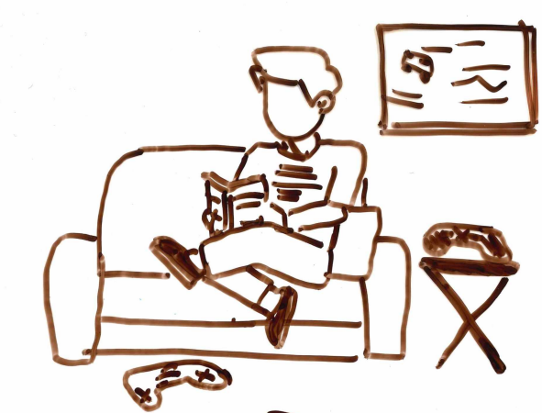
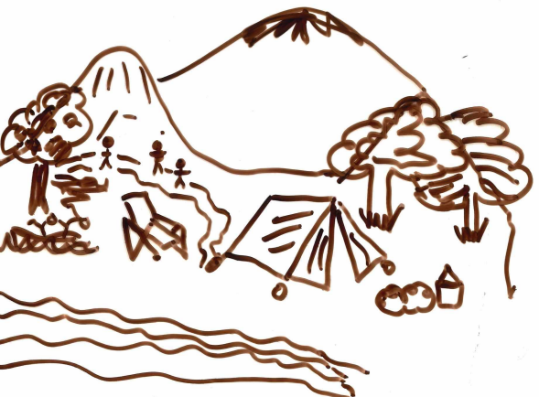
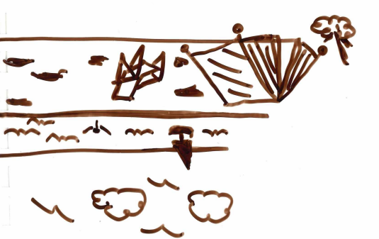
Marco ______________ Thomas ______________ Anna ______________
Cour text here
Dour text here
Aour text here
Bour text here
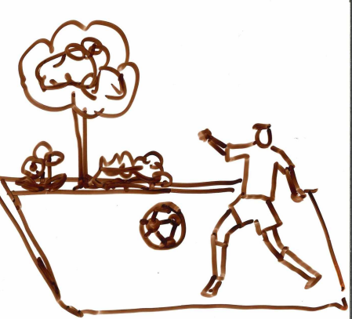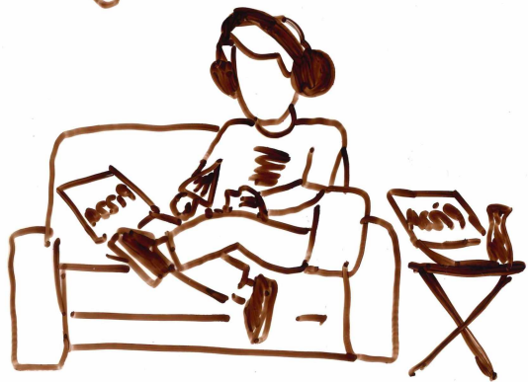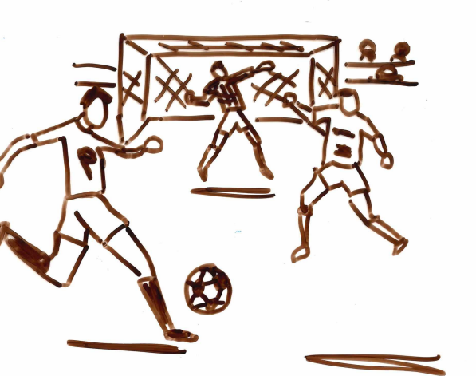
Four text here
Eour text here
Part A.2 4 marks
Alex and Sara are arranging an outing. Listen to their conversation and circle the ending to the sentence (a, b or c) that best matches the information provided in the conversation.
1. Alex wants to go for a pizza a) Thursday.
b) Saturday.
c) Sunday.
2. Sara is not available that day because she has a) school.
b) a violin lesson.
c) a party.
3. Sara cannot go bowling because a) her dad does not want her to go out Sunday night.
b) she is busy.
c) she is going out with her dad.
4. On Saturday Alex is a) going to the cinema with his family.
b) going to the cinema with his friend.
c) going to the cinema with his brother and a friend.
Part A.3 5 marks
Listen to Lidia, Cris and Enzo talking about their weekend activities and tick if the statements below are true or false.
Statement | True | False
Saturday Lidia went shopping with her sister in the city centre.
On Sunday Cris is going to watch TV at home.
Enzo went to see a film with Paola on Friday.
Enzo and his brother went to the beach on Saturday.
What activity did Lidia, Cris and Enzo all do? (Answer in English)
_____________________________________________________________________________________________

Part B Cosa facciamo? 24 marks
Write the script of a conversation with a classmate in which you discuss:
- what you did on the weekend
  - ask your partner two questions
  - respond to two questions asked by your partner
- your preferences for free time activities
  - ask your partner a question, and a follow-up question
  - respond to a question and follow-up question, asked by your partner
- arrangements for a shared experience (make, refuse and accept an invitation)
  - Person 1 suggests an activity on a particular day and at a particular time
  - Person 2 refuses giving a reason why, and suggests an alternative
  - Person 1 refuses giving a reason why, and suggests another alternative
  - Person 2 accepts.
Note: Decide with your partner who will go first (Person 1).
You have twenty minutes to prepare the questions and answers with your partner.
You may use your notes to prepare, and take notes on a sheet of paper during this time, but notes may not be used during the conversation.
Remember to use the appropriate greetings at the beginning and the end of your conversation.
Once you have completed your preparation, you will join with other pairs to form a bigger group (about six students). Each pair will present their conversation to the group. One of the group members will record your presentation.
You will be marked on:
- Content – Have you included the information required by the task?
- Grammatical elements and vocabulary – Have you used full sentences, the names for a variety of activities, times, days of the week, verbs, and tenses?
- Pronunciation and intonation – Have you spoken clearly and used appropriate Italian pronunciation?
- Comprehension and fluency – Have you understood what your partners has asked/said and does the conversation flow?

Sample marking key – Parliamoci del tempo libero!
Part A
Part A.1 | Marks
Marco F  Thomas B  Anna C | 1–3
Part A.2
1. a) Thursday  2. b) a violin lesson  3. a) her dad does not want her to go out Sunday night  4. c) going to the cinema with his brother and a friend | 1–4
Part A.3
Saturday Lidia went shopping with her sister in the city centre. TRUE  On Sunday Cris is going to watch TV at home. FALSE  Enzo went to see a film with Paola on Friday. TRUE  Enzo and his brother went to the beach on Saturday. FALSE | 1–4
Eat/go for Pizza | 1
Part A Total | 12

Sample marking key – Parliamoci del tempo libero!
Part B
Description | Marks
Content
Asks two questions (1 mark each) and provides information in answer to two questions (1 mark each). about last weekend | 1–4
Asks two questions about free time preferences (1 mark each) | 1–2
Provides information in answer to two questions about free time preferences (1 mark each) | 1–2
Makes an invitation including activity (1), day (1) and time (1) | 1–3
Refuses an invitation | 1
Accepts an invitation | 1
Includes salutation and leave-taking | 2
Subtotal | 15
Grammatical elements and vocabulary
Uses a wide range of vocabulary, and both simple and compound sentences are used mostly accurately. Use of present and present perfect tenses is mostly successful. Errors usually appear in more complex structures. | 3
Uses a sufficient range of vocabulary to communicate information. Sentences are generally simple but occasionally compound sentences are attempted. Use of present and present perfect tenses is sometimes successful. Errors are present but responses are mostly accurate and meaning is clear. | 2
Uses a limited range of vocabulary and one-word responses often given. Occasional short phrases are offered but meaning is not always clear. Present and present perfect tenses are used with limited success. | 1
Subtotal | 3
Pronunciation and intonation
Uses clear and accurate pronunciation and intonation. | 3
Displays some inconsistency with pronunciation and intonation, but meaning is clear. | 2
Uses predominantly inaccurate pronunciation and/or intonation, which impedes comprehension at times. | 1
Subtotal | 3
Comprehension and fluency
Comprehends the other speaker and responds readily. The interaction flows well.  Self-corrects if necessary. | 3
Comprehends some comments from the other speak; however, asks for/needs repetition or clarification and requires some support. Attempts self-correction. | 2
Requires considerable support to comprehend questions and/or respond, which affects fluency. | 1
Subtotal | 3
Part B total | 24
Total | 36

