Assessment task
Year level | 6
Learning area | Humanities and Social Sciences
Subject | Geography
Title of task | Characteristics of Australia and Asia
Task details
Description of task | Students interpret information using a table and photographs, and formulate conclusions about the differences in the economic, demographic and social characteristics between an Australia city (or their community) and selected countries in Asia.
Type of assessment | Formative and Summative
Purpose of assessment | To assess students’ understanding of key geographical concepts and skills as they apply to a diverse and connected world, particularly Australia and Asia
Assessment strategy | Data interpretation, photo interpretation and written responses
Evidence to be collected | Task 1 – Short answer response using data from statistics provided (table)  Task 2 – See, Think, Wonder written responses to photo (three parts)  Task 3 – Compare and contrast written response
Suggested time | Interpretation of data and written responses – 90 minutes or 30 minutes per task.
Content description
Content from the Western Australian Curriculum | Knowledge and Understanding  - The location of the major countries of the Asia region in relation to Australia and the geographical diversity within the region  - Differences in the economic characteristics (e.g. per capita income, energy consumption), demographic characteristics (e.g. population size, density) and social characteristics (e.g. life expectancy, education) of a selection of countries across the world
Humanities and Social Sciences Skills
Questioning and Researching
- Develop and refine a range of questions required to plan an inquiry
Analysing
- Interpret information and/or data collected (e.g. sequence events in chronological order, identify cause and effect, make connections with prior knowledge)
Evaluating
- Draw and justify conclusions, and give explanations, based on the information and/or data in texts, tables, graphs and maps (e.g. identify patterns, infer relationships)
Communicating and Reflecting
- Present findings, conclusions and/or arguments, appropriate to audience and purpose, in a range of communication forms (e.g. written, oral, visual, digital, tabular, graphic, maps) and using subject-specific terminology and concepts
Key concepts | Place, Interconnection, Environment, Scale
Task preparation
Prior learning | Students have prior knowledge of the main countries that make up Asia and the major economic, demographic and social characteristics of Australia and Asian countries.  Prior to the commencement of the task, ensure students have had the opportunity to become familiar with:  - the key geographical concepts – place, environment, interconnections and scale  - the terms, economic, demographic and social characteristics  - a thinking-strategy, such as See, Think, Wonder  - how to develop and refine a range of questions required to plan an inquiry.  Teachers may wish to revise some of these concepts prior to the commencement of this task.
Assessment differentiation | Teachers should differentiate their teaching and assessment to meet the specific learning needs of their students, based on their level of readiness to learn and their need to be challenged.  Where appropriate, teachers may either scaffold or extend the scope of the assessment tasks.
Assessment conditions | Students complete the extended written task under test conditions. During the task, students may refer to the information provided and their responses to Tasks 1 and 2.
Resources | Data, photographs, questions and answer sheets are provided.  Useful links:  - Worldmapper (https://worldmapper.org/)  - The World Happiness (https://worldhappiness.report/ed/2020/#read)  - Gap Minder (http://www.gapminder.org/)  - Dollar Street (https://www.gapminder.org/dollar-street)  - Kids in Other Countries (https://kidsinothercountries.org/)  - One World Centre (https://www.oneworldcentre.org.au/resources-for-teachers/teaching-activities/)  - World Bank (https://data.worldbank.org)  - World Geography Games (Asia) (https://world-geography-games.com/asia.html)

Prior learning – suggested activities
- Provide photographs, artefacts, maps and texts about Asia as a display in the classroom. Read or view texts about Asia.
- Familiarise students with the terms, economic, demographic and social characteristics. Include their definitions in a word wall or in a class display.
- Model and unpack the term, geographical diversity, to include information such as the climate, vegetation, landforms, types of settlements, population size, density, life expectancy, per capita income, energy consumption and so on. Discuss and define these terms and add to the word wall with activities such as those found in the Conventions sections of the First Steps Reading Map of Development. http://det.wa.edu.au/stepsresources/detcms/navigation/first-steps-literacy/
- Model and guide students to interpret various data tables for particular countries. Suitable data is available at World Bank (https://data.worldbank.org)
- Revise the location of the major countries of Asia on a world map in relation to Australia by playing online geography games such as those found at World Geography Games (Asia) (https://world-geography-games.com/asia.html)
- Provide students with graphs, atlases, maps and access to online maps such as Google Earth and Google Maps to explore the countries of Asia using student-formulated focus questions.
- Provide groups of students with two or three objects or photographs of a country in Asia. Use the See, Think, Wonder strategy to discuss them.
- Students write clues to play ‘Guess Which Country.’ Students choose (or are allocated) a country from the Asia region and write a number of clues for others to guess which country they have. Direct students to include information about economic, demographic and social characteristics in their clues. Share with the class and discuss.
- As a class, in small groups or individually, explore maps, graphs and/or tables to find information on a number of countries from across the world (including Asia).
- Review/identify a number of countries from across the world, including the Asia region, on a map.
- Provide a graphic organiser, such as retrieval chart or large pieces of paper, to record demographic information about a number of countries.

Moderation task: Instructions for teacher-suggested approach

Instructions for teachers
Teachers may do each of the three tasks on separate occasions, or do them together in one extended session.

Task 1 (approximately 30 minutes)
In this task students will interpret information/data provided about the economic, demographic and social characteristics of Australia and some Asian countries.
Distribute the table and questions. Give the students an opportunity to read the table and questions. Ensure all students understand the task by allowing them to ask questions and directing them to use the data given to answer all questions.
Explain to the students that they need to answer each question with as much information as they can and give data from the table to justify their answers where applicable.
Students answer the questions for Task 1 independently.
Teachers should collect Task 1 if the task is being completed over several lessons, but do not mark directly onto student work as they will be required to look at this for Task 3.

Task 2 (approximately 30 minutes)
In this task students will identify information represented in a number of photographs of India, and formulate questions suitable for an inquiry.
Distribute Task 2. Direct the students to examine the photographs provided, and explain the task to the students.
Explain to the students that they need to answer each question with as much information as they can and refer to the information from the images to justify their answers where applicable.
Students answer the questions for Task 2 independently.
Teachers should collect Task 2 if the task is being completed over several lessons, but do not mark directly onto student work as they will be required to look at this for Task 3.

Task 3 (approximately 30 minutes)
In this task students will need to use the table, photographs and answers from Tasks 1 and 2, as well as the photographs of Australia, to develop conclusions about Australia and India. Teachers may decide to make this more contextualised by providing photographs of their local community as an alternative to the ones provided here.
Distribute Task 3. If students completed Tasks 2 and 3 on separate occasions, give these back to the students now as a reference (they should be unmarked). Ensure students have a copy of the table.
Explain the task to students and let them know they may look at the table, their answers to the first two tasks and all the images provided.
Explain to students that the Venn diagram has been provided to help them plan their written response and they should not use up all their time completing this – teachers may wish to scaffold this and give students
10 minutes to complete the Venn diagram and signal when they should start the written response.
Students complete this independently under test conditions.

Instructions to students
Characteristics of Australia and Asia

Differences in the economic, demographic and social characteristics of Australia and Asia
Task 1: In this task you will interpret information/data provided to you about the economic, demographic and social characteristics of Australia and some Asian countries.
The table below shows statistics about the population of nine different countries, including Australia.

Table 1 – Economic, demographic and social data of nine countries
Economic, demographic and social data of nine countries
Nation | Population total in 2019  (rounded to nearest million) | Quality of life indicator %  Life expectancy in years | Quality of life indicator % population  Number of people who are undernourished ( do not get enough food) | Quality of life indicator  Rights – legal system, civil rights and freedom of expression  score/100 | Literacy/  education indicator  % of adults who can read and write
Australia | 25 | 83 | 3 | 95 | 99*
Cambodia | 16 | 70 | 15 | 19 | 81
China | 1.4 billion | 77 | 3 | 33 | 97
Hong Kong | 7.5 | 85 | 3 | 86 | 99**
India | 1.4 billion | 69 | 14 | 47 | 74
Indonesia | 271 | 72 | 9 | 44 | 96
Malaysia | 32 | 76 | 3 | 59 | 95
Philippines | 108 | 71 | 15 | 40 | 98
Vietnam | 96 | 75 | 6 | 34 | 95

Task 1: Use the table to answer the following questions.

Question 1
- Which country has the lowest life expectancy?

- What other indicators, in the table, may help explain this?

Question 2
- Which two countries have the lowest literacy levels?

- What do you notice about the other indicators for these countries?

Question 3
- In terms of the data presented in the table, which country is Australia most similar to? Explain why you think this.

Question 4
What country is Australia very different to? Explain why you think this.

Question 5
Based on the data provided in the table, apart from Australia, which country would you like to live in the most? Explain your choice.

Task 2: Images of India
The following images reflect economic, demographic and/or social characteristics of India.
Image 1
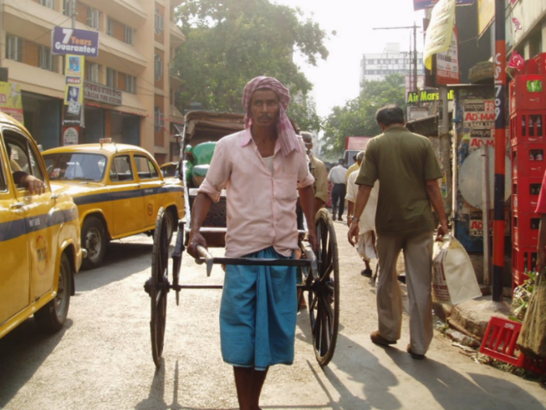
Image 2
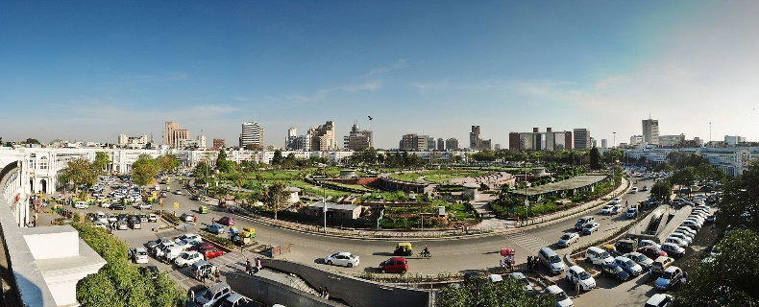
Image 3
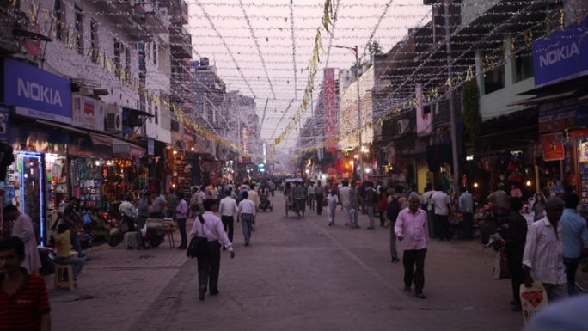
Image 4
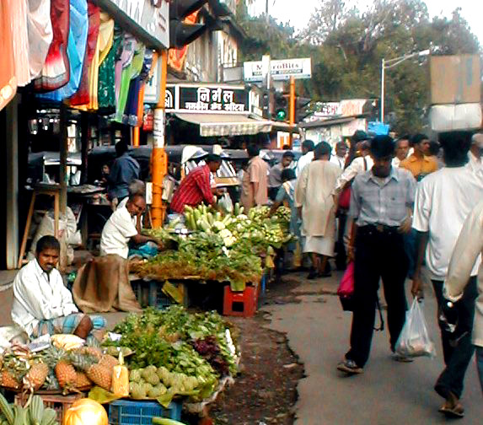
Use the images of India to complete these tasks.
- See – Describe the characteristics of what you can see in the images of India above.

- Think – Review the data for India in the table.
What connections can you make between the images and the data for India?

- Wonder – What do the images now make you wonder?
Using the images as your inspiration, create three questions that could be used as part of an inquiry into the economic, demographic and/or social characteristics of India.
- _____________________________________________________________________________________
_____________________________________________________________________________________
- _____________________________________________________________________________________
_____________________________________________________________________________________
- _____________________________________________________________________________________
_____________________________________________________________________________________

Task 3: Resource sheet
Image 1  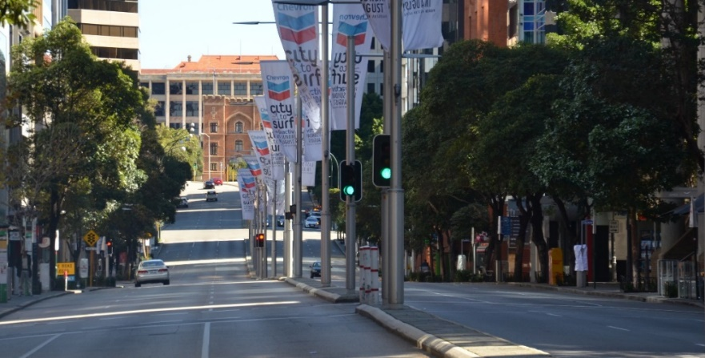 | Image 2  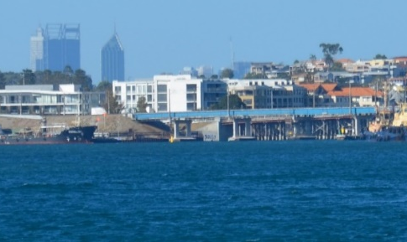
Image 3  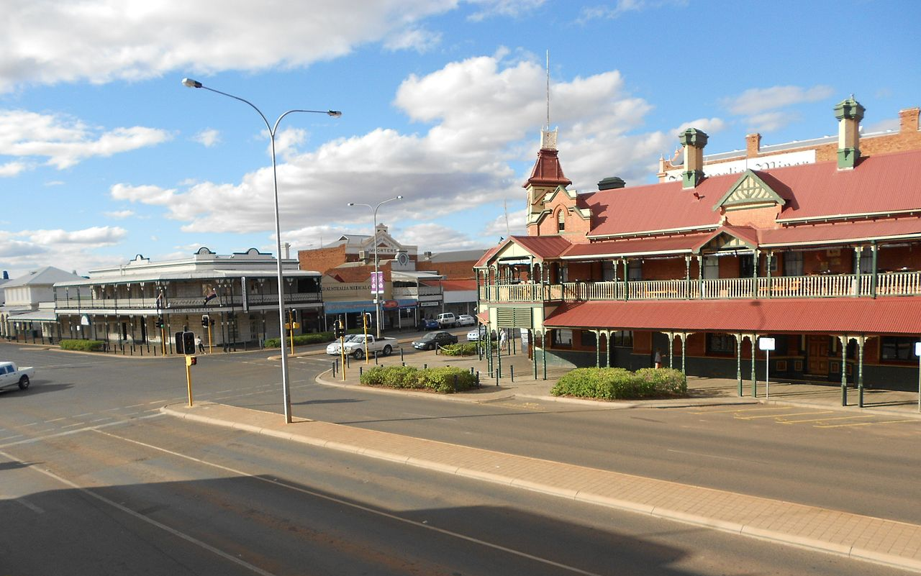 | Image 4  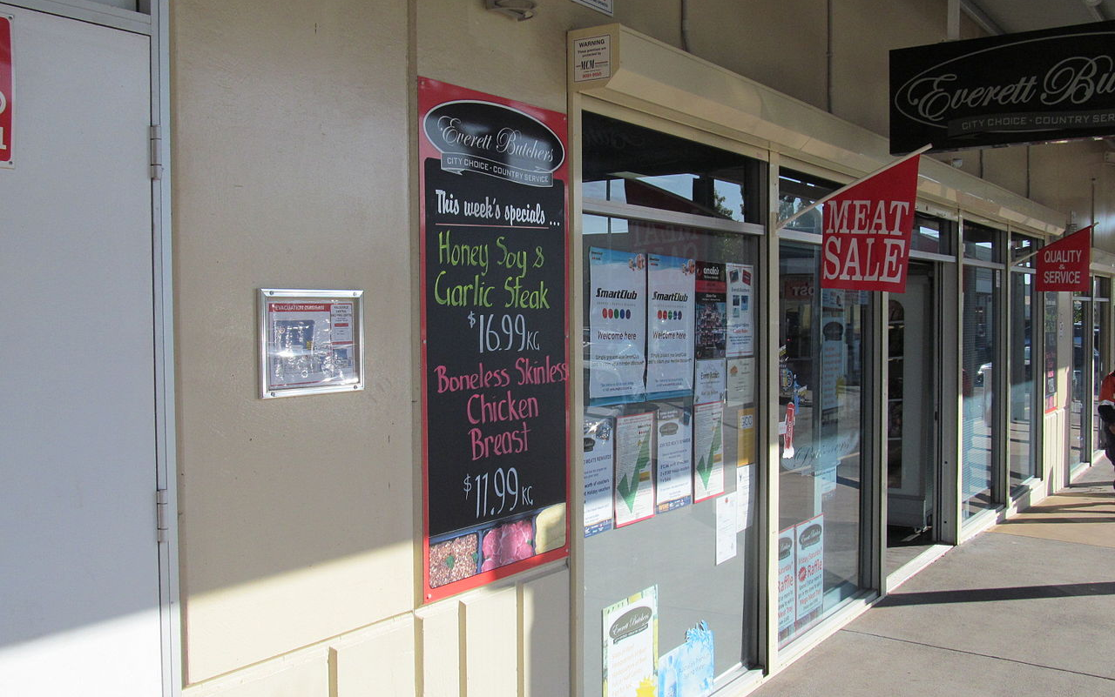

India
Your town/community

Task 3
Explain how life in India is similar to and different from life in Australia.
Using all the data available, and your own knowledge of your community, explain how life in India is similar to and different from life in your community or city in Australia.
Use and refer to information from all the sources, including:
- the table
- the photographs of India from Task 2
- the images of your country from Task 3
- all of the information you have provided in Tasks 1 and 2.

Marking key
Task 1: Response using data from statistics provided in the table
Description | Marks
What country has the lowest life expectancy?
What indicators, in the table above, may help explain this?
Identifies India as having the lowest life expectancy and uses data from the table to identify and explain a range of related indicators, such as high population, high percentage of undernourishment, poor legal systems and/or low levels of literacy. | 4
Identifies India as having the lowest life expectancy and uses data from the table to identify one or two indicators, such as high population, high percentage of undernourishment, poor legal systems and/or low levels of literacy. | 3
Identifies India as having the lowest life expectancy (1 mark), and/or attempts to explain this with some reference to the table (1 mark). | 1–2
Subtotal | /4
Which two countries have the lowest literacy levels?
How are these countries similar in other ways?
Identifies India and Cambodia as having the lowest literacy levels and identifies that both countries also have similarly low life expectancies and high levels of undernourishment. | 4
Identifies India and Cambodia as having the lowest literacy levels and that both countries also have similarly low life expectancies or high levels of undernourishment. | 3
Identifies India and/or Cambodia as having the lowest literacy levels. (1 mark each) | 1–2
Subtotal | /4
What country is Australia most similar to? Explain why you think this.
Explains why a country such as Hong Kong is similar to Australia.  Uses data from the table to make relevant and detailed connections, citing a number of indicators such as education levels, levels of nourishment and similar life expectancy. | 4
Describes why a country such as Hong Kong is similar to Australia.  Uses some data from the table to make relevant connections, citing one or two indicators from the table. | 3
Identifies why a country such as Hong Kong is similar to Australia.  Uses limited data from the table. | 2
Identifies a country with some similarities but does not explain their reasons. | 1
Subtotal | /4
What country is Australia very different to? Explain why you think this.
Explains in detail why a country such as Cambodia or China is very different to Australia.  Uses the data to contrast a number of indicators such as education levels, levels of nourishment or rights.  Note: a number of countries are suitable, answer depends on the indicators used. | 4
Describes why a country such as Cambodia or China is very different to Australia.  Uses some data to contrast one or two indicators.  Note: a number of countries are suitable, answer depends on the indicators used. | 3
Identifies why a country such as Cambodia or China is different to Australia.  Uses limited data from the table.  Note: a number of countries are suitable, answer depends on the indicators used. | 2
Identifies a country with some differences or gives a personal opinion. | 1
Subtotal | /4
Based on the data provided in the table, apart from Australia, which country would you like to live in the most? Explain your choice.
Provides a detailed conclusion (choice) based on relevant and accurate evidence which includes a range of indicators. | 4
Provides a conclusion (choice) based on relevant evidence which includes one or two indicators.  Uses some of the data as evidence or refers to it in a general way. | 2–3
States a simple choice based on a personal opinion. | 1
Subtotal | /4
Task 1 total | /20
Task 2: Photograph interpretation
Description | Marks
Question 1 – See
Describes a range of characteristics of the place in detail, including:  - vegetation  - pollution  - built features  - living conditions  - housing  - shopping resources  - overcrowding/slum conditions/density of population.  Applies relevant geographical terminology and concepts to develop description. | 3–4
Describes some characteristics of the place (see above).  Uses some geographical terminology and concepts. | 2
List some characteristics of the places in the photos. | 1
Subtotal | /4
Question 2 – Think
Makes detailed and relevant connections between the images and the data in the table, referring to:  - economic and social problems such as overcrowding, poverty, pollution and environmental decline  - the quality of life.  Uses relevant geographical terminology and concepts. | 3–4
Describes some of the challenges and/or problems occurring in the place in the photo.  Uses some geographical terminology. | 2
Identifies some of the challenges and/or problems occurring in the place in the photo.  Makes general statements. | 1
Subtotal | /4
Question 3 – Wonder
Constructs three focused, relevant questions that address the economic, demographic and social characteristics inspired by the images.  Uses relevant geographical terminology and concepts. | 3–4
Constructs at least two relevant questions that address some aspects of the economic, demographic and/or social characteristics of India inspired by the images.  Uses some geographical terminology and concepts. | 2
Constructs simple questions with a limited focus on the economic, demographic and/or social characteristics of India topic. | 1
Subtotal | /4
Task 2 total | /12
Task 3: Comparison – Explain how life in India is similar and/or different from life in Australia.
Description | Marks
Explains in detail the differences/similarities between life in India and Australia, including the economic, social and demographic characteristics.  Uses relevant geographical terminology and concepts to develop an explanation.  Includes relevant data from the table and/or photographs as evidence to support the comparison. | 7–8
Describes the differences/similarities between life in India and Australia, including the economic, social and demographic characteristics.  Uses mostly relevant geographical terminology and concepts to develop description.  Includes some data from the table and/or photographs to support the comparison. | 5–6
Identifies that life in India is different/similar to Australia.  Uses some relevant geographical terminology.  May make some reference to the table or photographs. | 3–4
Makes generalised statements about life in India and Australia. | 1–2
Task 3 total | /8
Total overall score | /40

Acknowledgements
Task 1
Table ‘Population total in 2019’ data from: The World Bank. (2019). Population, total. Retrieved February, 2021, from
https://data.worldbank.org/indicator/SP.POP.TOTL
Used under a Creative Commons Attribution 4.0 International licence.
‘Quality of life indicator %’ data from: The World Bank. (2018). Life expectancy at birth, total (years). Retrieved February, 2021, from https://data.worldbank.org/indicator/
SP.DYN.LE00.IN
Used under a Creative Commons Attribution 4.0 International licence.
‘Quality of life indicator % population’ data from: The World Bank: Food and Agriculture Organization. (2018). Prevalence of undernourishment (% of population). Retrieved February, 2021, from https://data.worldbank.org/indicator/SN.ITK.DEFC.ZS
Used under a Creative Commons Attribution 4.0 International licence.
‘Quality of life indicator’ data from: Eglitis, L. (2020). Comparison of quality of life worldwide. Retrieved February, 2021, from https://www.worlddata.info/quality-of-life.php
‘Literacy/education indicator’ data (excluding Australia and Hong Kong) from: The World Bank: UNESCO Institute for Statistics. (2020). Literacy rate, adult total (% of people ages 15 and above). Retrieved February, 2021, from https://data.worldbank.org/indicator/
SE.ADT.LITR.ZS
Used under a Creative Commons Attribution 4.0 International licence.
‘Literacy/education indicator’ data (Australia) from: Knoema. (2014). Australia – Adult (15+) literacy rate. Retrieved February, 2021, from https://knoema.com/atlas/Australia/
topics/Education/Literacy/Adult-literacy-rate
‘Literacy/education indicator’ data (Hong Kong) from: Knoema. (2014). Hong Kong – Adult (15+) literacy rate. Retrieved February, 2021, from https://knoema.com/atlas/Hong-Kong/topics/Education/Literacy/Adult-literacy-rate
Task 2
Image 1 Younger, G. (2005). Rickshaw - Calcutta, India [Photograph]. Retrieved March, 2021, from https://www.flickr.com/photos/gregor_y/13763395/
Used under a Creative Commons Attribution-ShareAlike 2.0 Generic licence.

Image 2 Kabi1990. (2011). Skyline at Rajiv Chowk [Photograph]. Retrieved March, 2021, from https://commons.wikimedia.org/wiki/File:Skyline_at_Rajiv_
Chowk.JPG
Used under a Creative Commons Attribution-ShareAlike 3.0 Unported licence.

Image 3 Pousman, B. (2011). Diwali decorations [Photograph]. Retrieved March, 2021, from https://flickr.com/photos/27202949@N00/6369680721
Used under a Creative Commons Attribution 2.0 Generic licence.

Image 4 Thattai, R. (2005). Bombay-market [Photograph]. Retrieved March, 2021, from https://commons.wikimedia.org/wiki/File:Bombay-market.jpg

Task 3
Image 1 JarrahTree. (2019). St George's Terrace on City to Surf Sunday [Photograph]. Retrieved February, 2021, from https://commons.wikimedia.org/wiki/File:St_George%27s_
Terrace_on_City_to_Surf_Sunday.jpg
Used under a Creative Commons Attribution 2.5 Australia licence.
Image 2 JarrahTree. (2015). Perth city skyline viewed from South Mole [Photograph]. Retrieved February, 2021, from https://commons.wikimedia.org/wiki/File:Perth_city_skyline_
viewed_from_South_Mole.jpg
Used under a Creative Commons Attribution 2.5 Australia licence.
Image 3 Raki_Man. (2012). Kalgoorlie – panoramio [Photograph]. Retrieved February, 2021, from https://commons.wikimedia.org/wiki/File:Kalgoorlie_-_panoramio.jpg
Used under a Creative Commons Attribution 3.0 Unported licence.
Image 4 Owens, A. (2013). Kalgoorlie Central SC - Everett Butchers [Photograph]. Retrieved February, 2021, from https://commons.wikimedia.org/wiki/File:Kalgoorlie_Central_
SC_-_Everett_Butchers.jpg
Used under a Creative Commons Attribution-ShareAlike 4.0 International licence.

